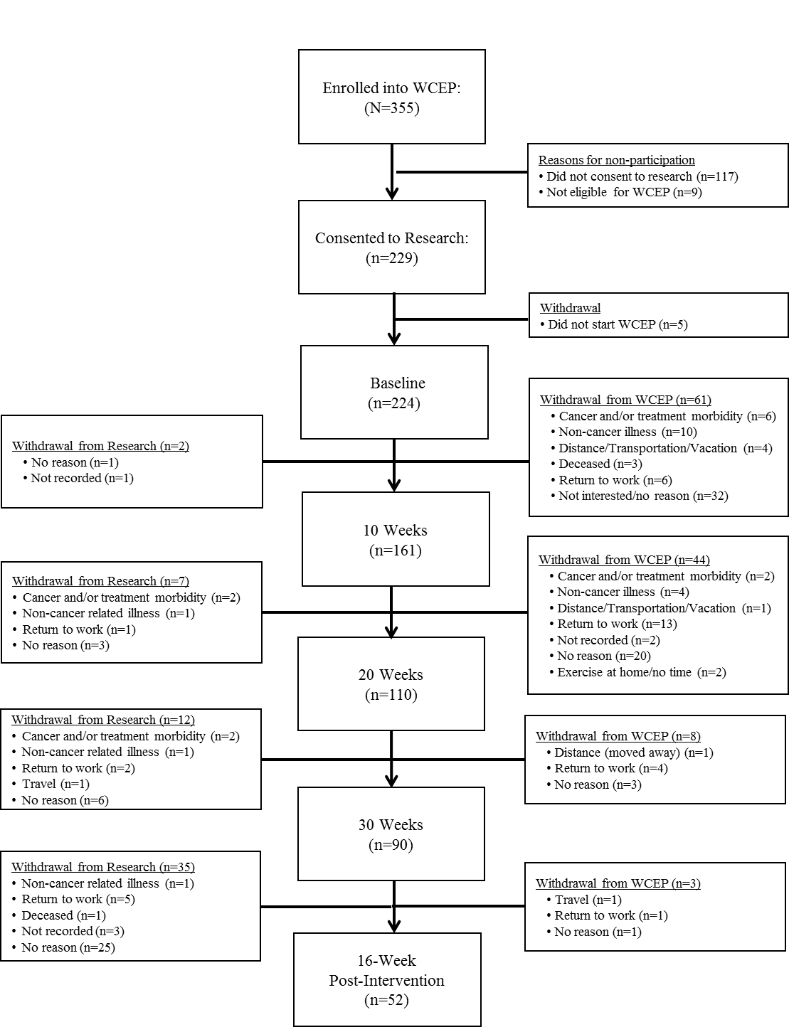

Figure 1. CONSORT Diagram

