  - Supporting information for:

Spring wildflower phenology and pollinator activity respond similarly to climatic variation in an eastern hardwood forest
Manuel Sevenello¹, Risa D. Sargent¹, Jessica R. K. Forrest¹

¹Department of Biology, University of Ottawa, 30 Marie-Curie, Ottawa, Ontario K1N 6N5, Canada

Table S1. Study plot locations in Gatineau Park, QC. All plots are between 130 to 200 m elevation.
Plot | Position
Plot 1 | N 45° 27′ 077″ W 75° 46′ 931″
Plot 2 | N 45° 27′ 074″ W 75° 46′ 820″
Plot 3 | N 45° 27′ 044″ W 75° 46′ 732″
Plot 4 | N 45° 26′ 996″ W 75° 46′ 715″
Plot 5 | N 45° 27′ 015″ W 75° 46′ 583″
Plot 6 | N 45° 26′ 944″ W 75° 46′ 592″
Plot 7 | N 45° 26′ 989″ W 75° 46′ 428″
Plot 8 | N 45° 26′ 892″ W 75° 46′ 392″
Plot 9 | N 45° 26′ 873″ W 75° 46′ 268″
Plot 10 | N 45° 26′ 945″ W 75° 46′ 287″

Table S2. Total number of observations and interval (in days) between sampling occasions of flower plots and bee bowls in each year.

 | Flower plots |  |  | Bee bowls
Year | Total | Interval | Period | Total | Interval | Period
2013 | 10 | 6 – 8 | Apr 11 to Jun 02 | 10 | 6 – 8 | Apr 11 to May 25
2014 | 12 | 2 – 7 | Apr 16 to Jun 09 | 7 | 5 – 9 | Apr 19 to May 27
2015 | 14 | 3 – 5 | Apr 16 to Jun 02 | 7 | 5 – 8 | Apr 16 to May 30
2016 | 19 | 1 – 3 | Apr 17 to May 30 | 7 | 5 – 6 | Apr 17 to May 27
2017 | 20 | 1 – 3 | Apr 15 to Jun 10 | 8 | 5 – 9 | Apr 15 to Jun 01
2018 | 18 | 1 – 3 | Apr 10 to May 30 | 6 | 5 – 9 | Apr 22 to May 30

Table S3. Plant taxa present in the study plots, showing criteria used to select focal taxa (Anemone spp. and Trillium grandiflorum).

Species | Present 3 or more years | Present in >1 quadrat per year | Present on 3 or more sampling occasions | Insect-pollinated (reference)
Aquilegia canadensis
Alliaria petiolata
Dicentra cucullaria |  | ×
Erythronium americanum | × | ×
Galium spp.
Anemone acutiloba & A. americana | × | × | × | Yes (Motten, 1986)  (Bernhardt, 1976)
Maianthemum racemosum | × | ×
Mitella diphylla
Polygonatum pubescens |  |  | ×
Rosa spp.
Sanguinaria canadensis | ×
Saxifraga virginiensis |  | ×
Thalictrum dioicum | × | × | × | No (Kaplan and Mulcahy, 1971)
Trillium grandiflorum | × | × | × | Yes (Case and Case, 1997)

Table S4. Numbers of bees collected in Gatineau Park in each year, summed across plots. Relative abundance (percent of a particular bee taxon relative to the total number of bees collected in that year) is given in parentheses.

 |  | Year
Family | Taxa | 2013 | 2014 | 2015 | 2016 | 2017 | 2018
Andrenidae | Andrena spp. | 20 (26.7) | 253 (35.9) | 169 (37) | 271 (31.8) | 137 (25) | 117 (32.7)
Apidae | Bombus spp. | 3 (4) | 2 (0.3) | 2 (0.4) | 9 (1) | 7 (1.3) | 0 (0)
 | Nomada spp. | 15 (20) | 179 (25.4) | 84 (18.4) | 192 (22.5) | 195 (35.6) | 109 (30.4)
 | Ceratina spp. | 3 (4) | 6 (0.9) | 11 (2.4) | 54 (6.3) | 6 (1.9) | 8 (2.2)
Colletidae | Colletes spp. | - | 6 (0.9) | 1 (0.2) | 12 (1.4) | 11 (2) | 3 (0.8)
Halictidae | Lasioglossum spp. | 28 (37.4) | 235 (33.4) | 160 (35) | 292 (34.3) | 160 (29.2) | 102 (28.5)
 | Halictus spp. | - | - | 8 (1.7) | 30 (3.5) | 17 (3.1) | 4(1.1)
 | Augochlora spp. | - | - | 3 (0.6) | 6 (0.7) | - | 3 (0.8)
Megachilidae | Osmia spp. | 6 (8) | 23 (3.2) | 22 (4.8) | 35 (4.1) | 15 (2.7) | 11 (3)
 | Total bees (100%) | 75 | 704 | 457 | 852 | 548 | 358

Table S5. Mean (SD) temperatures recorded by HOBO data-loggers and snowmelt dates across all plots.
Year | Day of year of snowmelt | April  degree-days > 0°C | April mean temperature (°C) | April temperature range (°C)
2013 | 103.9 (3.8) | 165.5 (27.6) | 5.3 (7.3) | −3.7 to 43.8
2014 | 103.0 (1.5) | 143.3 (30.0) | 4.6 (5.2) | −3.3 to 35.3
2015 | 101.0 (3.3) | 178.3 (25.3) | 5.6 (5.9) | −0.01 to 29.5
2016 | 105.1 (1.0) | 167.0 (34.3) | 4.5 (4.5) | −3.1 to 22.9
2017 | 100.2 (1.4) | 188.4 (19.5) | 5.8 (4.5) | 0.01 to 25.8
2018 | 110.2 (1.3) | 107.1 (23.7) | 3.3 (4.7) | −3.6 to 31.8

Table S6. Summary of AIC values for linear mixed models of the flowering and activity phenological events (first, peak, last, and period) in response to climatic variables: local surface degree-day accumulation (Local DDA, from March 1 until the mean date of each phenological response), regional surface degree-day accumulation (Regional DDA, mean surface temperature across all plots), air degree-day accumulation (air DDA, temperature records from Ottawa CDA weather station) and snowmelt day (Snow); year and plot were included as random factors. Bold numbers indicate the best-fit model. Models within 2 AIC units of one another are considered equally good.

Model | First | Peak | Last | Period
Anemone spp.
Local DDA | 124.6 | 122.7 | 134.1 | 150.7
Snow | 143.7 | 142.6 | 149.3 | 163.7
Local DDA + Snow | 128.1 | 121.2 | 136.2 | 153.6
Regional DDA | 145.71 | 154.4 | 151.5 | 166.1
Regional DDA + Snow | 148.2 | 153.9 | 153.9 | 169.5
Air DDA | 146.9 | 154.5 | 147.9 | 166.8
Air DDA + Snow | 149.1 | 149.4 | 151.2 | 170.4
T. grandiflorum
Local DDA | 246.5 | 310.7 | 290.3 | 326.2
Snow | 241.0 | 308.3 | 283.8 | 320.1
Local DDA + Snow | 250.3 | 314.5 | 293.9 | 329.2
Regional DDA | 242.6 | 308.1 | 282.7 | 323.1
Regional DDA + Snow | 247.1 | 312.2 | 287.3 | 326.3
Air DDA | 241.2 | 305.9 | 284.9 | 323.5
Air DDA + Snow | 245.8 | 310.1 | 288.9 | 326.8
Andrena spp.
Local DDA | 249.2 | 274.6 | 250.6 | 288.2
Snow | 263.6 | 288.0 | 270.3 | 313.1
Local DDA + Snow | 249.2 | 276.1 | 253.6 | 289.1
Regional DDA | 263.7 | 289.9 | 274.8 | 315.7
Regional DDA + Snow | 266.5 | 291.7 | 276.1 | 317.3
Air DDA | 263.6 | 290.0 | 275.5 | 315.2
Air DDA + Snow | 266.4 | 293.8 | 277.7 | 318.1
Lasioglossum spp.
Local DDA | 199.6 | 261.5 | 271.6 | 283.4
Snow | 217.2 | 286.9 | 287.0 | 300.3
Local DDA + Snow | 203.4 | 263.5 | 273.9 | 284.9
Regional DDA | 216.6 | 287.5 | 290.6 | 302.9
Regional DDA + Snow | 220.4 | 289.9 | 292.5 | 304.7
Air DDA | 215.0 | 288.1 | 290.1 | 302.5
Air DDA + Snow | 218.7 | 290.4 | 292.5 | 304.4
Nomada spp.
Local DDA | 226.3 | 245.7 | 250.5 | 255.1
Snow | 237.5 | 266.9 | 263.7 | 271.7
Local DDA + Snow | 228.6 | 247.9 | 251.8 | 257.6
Regional DDA | 238.4 | 270.5 | 267.4 | 273.7
Regional DDA + Snow | 241.5 | 272.1 | 269.7 | 276.3
Air DDA | 238.5 | 269.4 | 265.4 | 273.9
Air DDA + Snow | 241.7 | 271.9 | 268.6 | 276.3

Table S7. Effects of environmental variation on temporal overlap (Schoener’s index) between bees and flowering plants. Results from binomial generalized linear mixed models for SI, with snowmelt date (Snow) or temperature (DDA; degree-days accumulated from 1 March to 30 April) as fixed factors, and year and plot as random factors. Mean SI (standard deviation across ten plots and five years) are also reported.

Plant taxa | Overlap | Predictor | Sum Sq | F | P
Anemone | 0.62 (0.32) | DDA | 2.35 | 2.35 | 0.120
 |  | Snow | 1.01 | 1.01 | 0.314
T. grandiflorum | 0.15 (0.08) | DDA | 0.00 | 1.05 | 0.312
 |  | Snow | 0.02 | 3.94 | 0.082

Table S8. Effects of environmental variation on the number of overlapping days between bees and flowering plants. Results from generalized linear mixed models with Poisson distribution, number of overlapping days as response variable, snowmelt date (Snow) and temperature (DDA; degree-days accumulated from 1 March to 30 April) as fixed factors, and year and plot as random factors. Mean overlapping days (standard deviation across ten plots and five years) are also reported.

Plant taxa | Overlap | Predictor | Estimate | Std. Error | Z | P
Anemone | 15.4 (4.4) | DDA | 0.00 | 0.00 | 0.21 | 0.83
 |  | Snow | 0.10 | 0.09 | 1.12 | 0.26
T. grandiflorum | 7.8 (4.6) | DDA | 0.00 | 0.00 | 0.55 | 0.58
 |  | Snow | -0.12 | 0.12 | -1.01 | 0.31

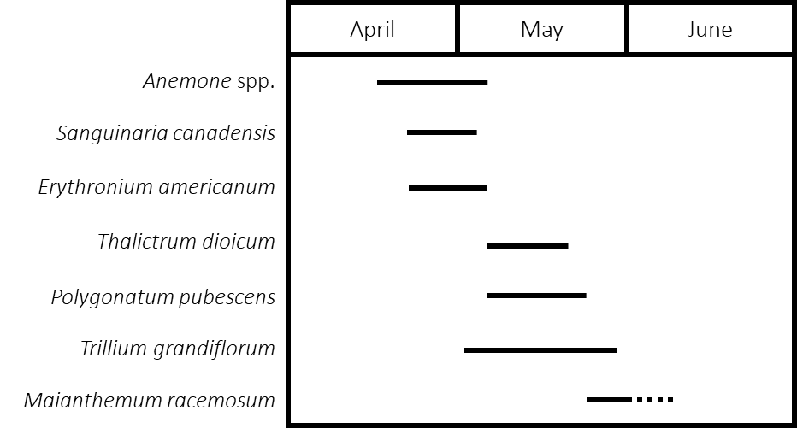
Figure S1. Flowering phenology of seven plant species recorded in the study plots. Horizontal solid lines represent mean flowering phenology across the six years of the study. The dotted line for Maianthemum racemosum indicates that the plant continued to flower after the last sampling occasion. The apparently shorter flowering periods of species other than Anemone and Trillium reflects low plant abundances in the study plots.

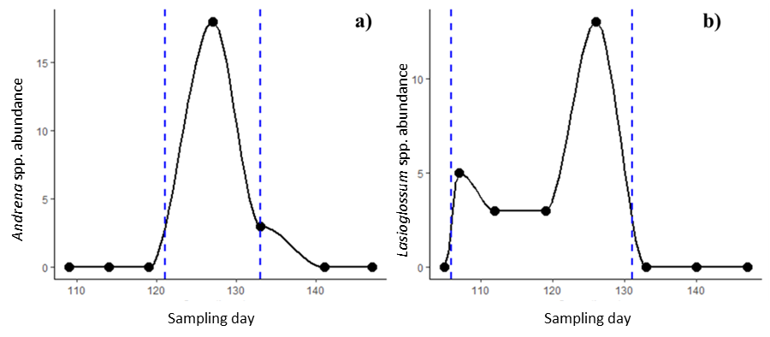
Figure S2. Examples of bee phenology, showing observed (points) and interpolated (lines) abundances. (a) Andrena spp. phenology in plot 9, 2014; (b) Lasioglossum spp. phenology in plot 8, 2016. Each point represents one insect sampling occasion; dashed lines indicate interpolated first and last activity days (i.e., days by which 10% and 90% of individuals, respectively, would have been observed).

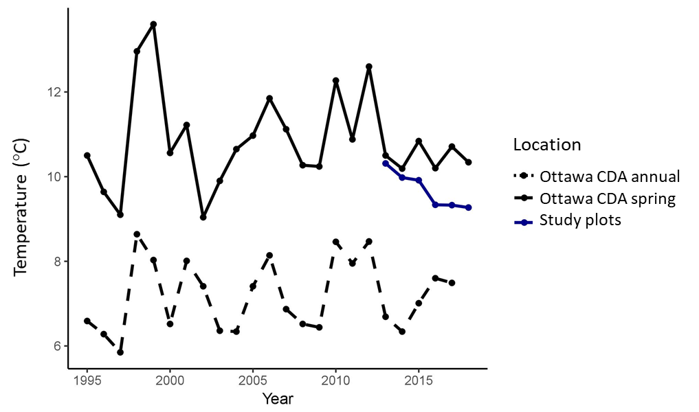
Figure S3. Interannual variation in temperature recorded by Ottawa CDA weather station and HOBO stations at the study site. The black lines represent mean annual temperature (dotted) and mean spring temperature (solid; March 20 – June 20) at the weather station. The blue solid line shows mean spring temperature at the study plots.

