The Effect of Education on Employment of Individuals Close to Retirement Age
By Yinghao Li
7647308

Major paper presented to the
Department of Economics of the University of Ottawa
in partial fulfillment of the requirements of the M.A. Degree
Supervisor: Professor Louis-Philippe Morin
ECO 6999

Ottawa, Ontario
August 2019

The Effect of Education on Employment of Individuals Close to Retirement Age

Abstract: In labour economics, numerous studies are looking at the link between education and earnings. Instrumental-variable models are often used because education is endogenous: worker ability is usually unobserved and hypothesized to be correlated with both education and earnings. Angrist and Krueger (1991) used quarter-of-birth as an instrument for education of compulsory school attendance on education and earnings. The instrument quarter-of-birth is referred to which quarter people are born, and it is related to education because Angrist and Krueger showed that people who are born in the 3rd and 4th quarter tend to have a higher education than people who are born in the 1st and 2nd quarter under the compulsory school law. In this paper, I use the same instrument to study the effect of education on the employment probability of retirement-age workers. Such information is not available in most censuses and surveys. I conclude that education increases the probability of employment: explicitly, one more year of education would increase the employment probability of retirement-age workers by 1- 8 percentage points, depending on the model used, people's age and marital status.

- Introduction
Education is always a top issue all around the world, especially in economics, it is one of the most important study topics. There is a positive relationship between education and earnings: more educated people have higher annual earnings (Griliches, Mason (1972), Glick, Miller (1956)). However, we know much less regarding the very-long run impact of education on workers. As an attempt to fill some of this gap, this paper investigates the effect of education on retirement decisions.

In labour economics, when studying the relationship between education and earnings, the IV method (or two-stage-least-square method) is generally used. When regressing the education on earnings, there is a problem that education is endogenous. This is because there are other independent variables in the error term correlated with education. One of these variables is ability. Individuals with greater ability tend to have higher education and higher grades. One of the most influential papers using IV to estimate the returns to education is Angrist and Krueger (1991). In their paper, the authors used quarter-of-birth as the instrumental variable. The authors found that quarter-of-birth affects education: people who are born later in the year tends to have more education than people who are born earlier in the year because people who are born later in the year reach the minimum age to drop out of school one school year later than people who are born early in the year (Angrist and Krueger, 1991). Figure I and II come from Angrist and Krueger (1991), and they illustrate clearly the principle.

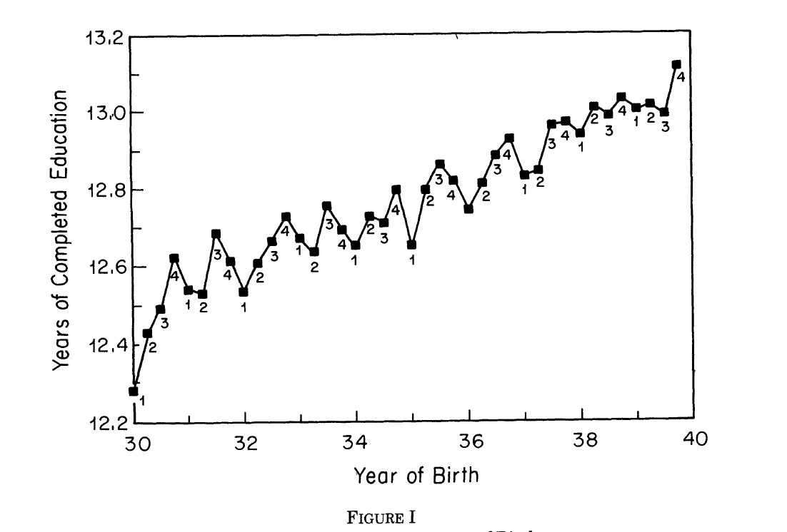
Source: Angrist and Krueger (1991)

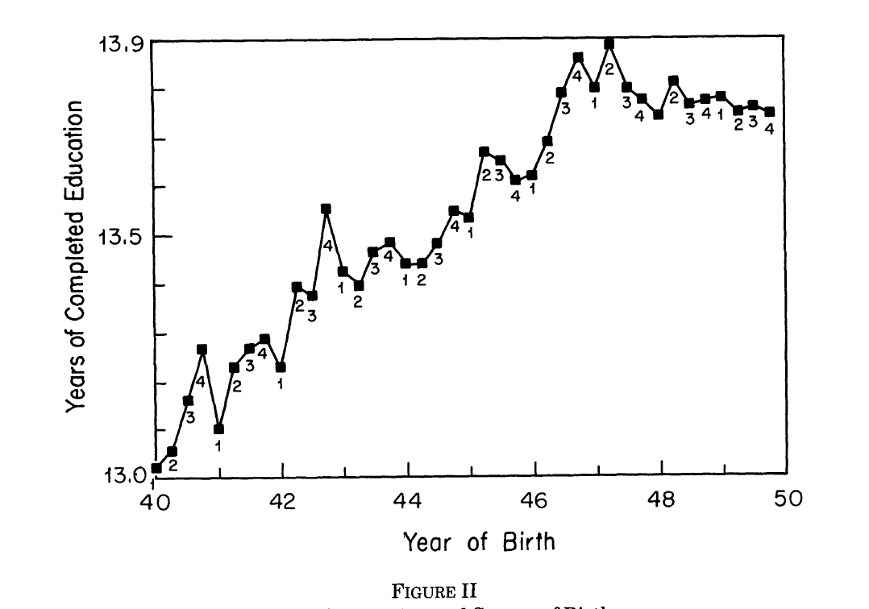
Source: Angrist and Krueger (1991)
Figure I shows the correlation between year-of-birth and years of completed education for people who were born between 1930-1939 and Figure II shows the same correlation for people who were born between 1940-1949. From these two graphs, we can have a clear view that people who were born earlier in the year tend to have fewer years of education when compared to people who were born later in the year. So, quarter-of-birth is correlated with years of education. There are some criticisms regarding the exclusion restriction of quarter-of-birth as an instrumental variable. For example, Card (2001) summarized a set of papers that criticized Angrist and Krueger's study. Bound, Jaeger, and Baker (1995) is one of the papers mentioned by Card. The authors said there exists a large number of weak instruments in Angrist and Krueger's IV model, and therefore the results asymptotically biased toward the OLS estimates. I wil explain the details in the next section. However, this instrument is still widely used as a benchmark, and the method used from Angrist and Krueger's paper that quarter-of birth used as the instrument for education are still relevant. Thus, in this paper, I use Angrist and Krueger's instrument to analyze the relationship between education and retirement decisions.

In this paper, I conduct OLS and TSLS regressions to estimate the effect of education on retirement decisions. The 1930-1960 U.S. surveys data and the 1970 and 1980 U.S. census were used in Angrist and Krueger's paper. I use the same data as Angrist and Krueger (1991) were using: the years from 1930-1960, and I use the 2005, 2010, and 2015 census data so that my study is comparable to Angrist and Krueger's. Unfortunately, the data do not contain information on respondents' retirement status, and therefore, I have to use the employment status of retirement-age individuals as a proxy for not being retired.

I find by using the IV method that there is a causal effect between education and employment status: if people have one more year of education, the probability of employment increases on average by 5-7 percentage points in the IV model, the exact number depends on marital status, people's age. According to this study, policymakers could enact new policies which encourage people to have more education. Next, in this paper, I will present my analysis processes, and I will state my results in detail.

- Literature Review
Firstly, I want to talk about the Angrist and Krueger’s paper. This paper is the benchmark study of labour economics. In this paper, the authors studied the effect of compulsory school attendance on education and earnings. When building the OLS model, there is the problem that education is an endogenous variable which correlates with the error term. To solve this problem, Angrist and Krueger used quarter-of-birth as an instrument and conducted the TSLS analysis. Quarter-of-birth was using as an instrument because there is a correlation between education and quarter-of-birth: the people who are born in early quarters of the year tend to leave school early than the people who are born in later quarters of the year because people who are born earlier are older when they start school and thus achieve the legal dropout age earlier (Angrist and Kruger, 1991). However, a lot of recent studies cast doubt on whether quarter-of-birth is a valid instrument because Angrist and Kruger did not have the F-test of endogeneity and in my study, it shows that this instrument is not valid and some of the TSLS coefficients are not statistically significant. The validity of Angrist and Kruger’s research still need to be further studied.

More than 2000 studies cite Angrist and Krueger (1991). However, to the best of my knowledge, no study has tried to estimate the effect of education on retirement using their identification strategy. A possible explanation is simply the lack of data on the topic. As a consequence, I review some research on the effect of education on health because health could be an essential channel through which education affects retirement decisions. Ross and Wu (1995) measure the correlation of education and health, salary, ability, and employment. In this study, the authors tested their model using cross-sectional analysis with two data sets, and longitudinal analysis are used to examine changes in health over time. The authors found there exists a relationship between education and health. Generally speaking, people who have a university education will have better health status, greater abilities, larger employment rate, higher salary, and greater happiness in life than people who have a high school education (Ross and Wu, 1995). Another related paper concludes that more years of formal education is correlated with healthier physical functioning and perceived health (Ross and Mirowsky, 1999). In this paper, the authors clearly stated that higher education people tend to have higher problem-solving abilities; higher skills; higher physical and mental health; healthier personal relationships with others. So, higher educated people will be generally healthier and live longer than the less educated people, and it shows clearly in these papers that higher educated people tend to work more and retire late. However, there may be an omitted variable bias issue in this paper. For example, the authors include formal schooling years, whether one has a college degree, and sociodemographic precursors of education such as sex, age, and parental education. Nonetheless, other independent variables are included in the error terms, such as grandparent's education, annual family income. All these omitted variables may cause a bias in this analysis.

There are more recent studies on education and health. Cutler and Lleras-Muney (2006) studied the effect of education on health in many aspects. In their study, they used the regression function $H_{i}=c+βE_{i}+X_{i}δ+ε_{i}$. $H_{i}$ standards for individual $i$’s health, $E_{i}$ standards for individual $i$’s years of completed education, and $X_{i}$ is a vector of individual $i$’s characteristics, such as race, gender, age, etc. And $c$ is a constant term and $ε$ is the error term. The authors focused on individuals age 25 above because these people have most likely completed their education and the authors wanted to measure the effect of one more year of education on health. The data come from the National Health Interview Survey (NHIS) in the United States. The coefficients are statistically significant in this paper and there are many conclusions and suggestions from this paper: Individuals with more years of education have lower mortality, are less likely to be hypertensive or suffer from diabetes, have healthier behaviors, and are more likely to exercise (Cutler and Lleras-Muney, 2006). The authors also find that the effect of education on health shows up across countries and this effect is larger for whites than for blacks. Through detail analysis, the authors have the conclusion that there are causal effects of education on health at lower levels of education but whether there exist the causal effects at higher levels of education is not known. Also, the authors tried to explain why education affects health: (1) Higher educated people have higher income and have greater resources so they have better access to health care; (2) Higher educated people have safer working environments and are provided health insurance; (3) Higher educated people have higher income, and thus may change an individual’s incentives to invest in health and improves one’s outlook on the future; (4) Higher educated people have better access to information and can improve their critical thinking skills; (5) Higher educated people may alter other important individual characteristics that affect health investments; (6) Higher educated people may have higher relative position or rank in society, and rank by itself will affect the health; (7) Higher educated people have larger social networks which provide financial and physical support which may in turn effect on health (Berkman 1995, Cutler and Lleras-Muney, 2006). This paper is an important study since it provides a rounded analysis on the effect of education on health and the reasons why education would affect health. This paper provides a comprehensive aspect of thinking in my study.

Another paper I want to mention is a Germany study of changes in compulsory schooling and the causal effect of education on health (Kemptner, Jürges, and Reinhold, 2011). This paper studied the compulsory schooling effect on health by using 1989, 1995, 1999, 2002 and 2003 these five years of German Microcensus and the cohorts include people who were born between 1930 and 1960 and who were living in the West German states. The authors used both the OLS model and the TSLS model to analyze the causal effect of education on health. In this paper, the instrumental variable is a dummy variable which indicates whether the compulsory schooling laws require 8 or 9 years of education for an individual’s education. The coefficients are statistically significant and it shows clearly that in the OLS model, there exists a causal effect of education on health: each additional year of education is associated with 1.8 percentage point lower probability of being overweight for men and 2.0 percentage point lower probability of being overweight for women (Kemptner, Jürges, and Reinhold, 2011). In the TSLS model, the appearance of the 9th grade of compulsory education leads an increase of about 0.6 years in school for the population, on average. Also, for men, one more year of education reduces the likelihood of suffering from long term illness by 4.1 percentage point, and 3.2 percentage points decrease in the likelihood of working disability, however for women, the results are not obvious (Kemptner, Jürges, and Reinhold, 2011). This paper provides a good specific country’s study on the causal effect of education on health.

The validity of Angrist and Krueger’s results and instrumental-variable strategy have attracted a significant amount of scrutiny from economists. Card (2001) summarized some important studies estimating the return to education. He concludes that the returns of education are different by the family background and ability so that IV is a consistent estimation of return on education. In Card (2001) study, criticism regarding the validity of Angrist and Krueger’s instruments came first in Bound, Jaeger and Baker (1995) who stated that the instrument quarter-of-birth is invalid. The authors stated that quarter-of-birth is weakly related to education because both the R² and the F-test of endogeneity are weak. Although the standard errors are reasonable on the estimate, the large sample they used is a nonnegligible effect (Bound, Jaeger and Baker, 1995). To clearly present the instrument quarter-of-birth is weakly correlated with education, the authors reexamined the study by Angrist and Krueger (1991) because there may exist finite-sample bias even in large samples. Through analysis, the authors get the conclusion that the use of the instrument can do more harm than good because the instrument can explain little of the education variation (Bound, Jaeger and Baker, 1995). This paper provides the study and criticism in detail why Angrist and Krueger’s instrument may be biased. This paper provides a more in-depth research of Angrist and Krueger’s paper and it inspires me for conducting my studies.

Staiger and Stock (1997), also analyzed the Angrist and Krueger’s study. Staiger and Stock used exactly the same data as in Angrist and Krueger, and the instrument is quarter-of-birth interacted with state and year-of-birth because Angrist and Krueger used quarter-of-birth interacted with year-of-birth as the instrument. In the regression analysis, the OLS schooling coefficient estimate is 0.063 and the IV schooling coefficient estimate is 0.098. The IV estimation coefficient is larger than the OLS, which is the same as in Angrist and Krueger’s model. In this paper, the authors developed an alternative asymptotic framework which used for approximating the statistics distribution in single-equation IV regression. There are three main contributions in this paper: the first one is that the TSLS and LIML finite sample results were being extended to a much broader set of applications; the second one is that for IV analysis, the many IV test statistics has acquired the joint asymptotic representations, which there are no counterparts studies in the literature before; and finally, these representations can facilitate summarizing the relationship between estimator bias and population parameter’s test size in a range of studies (Staiger and Stock, 1997). This paper has broadened the study of Angrist and Krueger as they were using the new asymptotic framework to conduct the approximation.

Kane and Rouse (1995) estimate the effect of college on earnings (two-year college attendance and four-year attendance). The authors found that the two-year college attendance on average earned 10 percent more than the people without a college degree and the returns for both the two-year attendance and the four-year attendance are similar: It is about 4-6 percent for every 30 credits completed. So, it can be inferred from this conclusion that the four-year college should give attendance higher money returns than the two-year college attendance because they completed more credits. Also, as the same of the other studies, the coefficient of IV estimation is larger than the coefficient of OLS estimation, the OLS estimation is biased downward. I will explain the reasons in conclusion.

Evidence regarding the effect of education on earnings is not restricted to the United States. Meghir and Palme (1999) examined the 1950 Swedish school reform effect on the earnings. Two different sets of data were used in the empirical studies and both the OLS and IV methods were used. The authors conclude that there is a large effect of the reform on the average years of education and the earnings. And this reform has a bigger effect for the lower education groups than the higher ones. Oreopoulos and Petronijevic (2013), found a 7-15 percent college premium for an extra year of studies for all college students, but the increases in earnings associated with college completion vary considerably. In this study, the authors gave some suggestions that before reaching a decision for college, prospective students must make an assessment on the costs and the values of entering the college, for example, the major to follow, the eventual occupation to pursue, anticipated future labor market earnings, the tuition fees, the likelihood of completion, etc. (Oreopoulos and Petronijevic, 2013).

Harmon and Walker (1995) summarized the four methods which have been used in previous work to deal with the endogenous problems: including an explicit proxy for ability; using twins to eliminate endogenous bias; treating ability as a fixed effect and use the panel data; and finally, exploiting the data natural variation by exogenous influences. These four methods are the ways we can deal with endogeneity problems. In this paper, Harmon and Walker studied the effect of education and earnings relationship in the United Kingdom and the coefficient estimates of OLS and IV are 0.061 and 0.153, respectively, which means that an extra year of education will increase the individual’s earnings by 6.1 percentage points in the OLS model and 15.3 percentage points in the IV model. It is clear that the return of schooling of OLS is smaller than the IV estimation and the authors believe that there exists a negative bias in the OLS estimate of the education-earnings relationship (Harmon and Walker, 1995).

In summary, there had no studies on the effect of education on retirement before so I would like to have a research on this topic. I included a bunch of papers studying the effect of education on health because this is related to the effect of education on retirement decisions. In this literature review, I also include the criticisms regarding Angrist and Krueger’s study and the studies relating weak instruments. These studies are valuable as they provide insightful opinions and suggestions. Based on these inspiring and learning, I conducted my investigation into the effect of education on retirement.

- (1) The Data
I obtained the census datasets from the IPUMS-USA (Ruggles et al., 2019). IPUMS is the acronym of Integrated Public Use Microdata Series and it is the world largest individual-level population database. I use the microdata samples from United States (IPUMS-USA) and it is a survey data. The retirement information is not available in the IPUMS data, so I used employment as a proxy for retirement. Employment is a good proxy at here because if one is employed, we know this person’s status is working. However, this proxy has some drawbacks as well, for example, a retired person might be employed again because of financial budget. We just ignore this situation at here and assume a person is either employed in the labour force or retired out of the labour force. I want to have a sample as similar as possible as the one analyzed by Angrist and Krueger (1991), so the sample data includes people who were born in 1930-1960 by using the 2005, 2010 and 2015 census data. I include the variables years of education, married dummy variable, employment dummy variable, year-of-birth dummy variable, quarter-of-birth dummy variable, and age to the square. For easy comparing, I subdivided the 1930-1960 time periods into three groups: 1930-1939, 1940-1949, and 1950-1959, and I examine each of the 10-year time period by 2005 census, 2010 census, and 2015 census data. The summary statistics are summarized in table 1. There are totally 9 tables and 72 regressions analysis in my study and the detail information of each cohort is depicted in table 1.

- (2) The Methodology
In this analysis, I created employment dummy variables and married dummy variables, which stand for employment status and married status and in the TSLS regression model, I created the year-of-birth dummy variables. Employment contains either full-time working or part-time working individuals. However, in my dataset, it does not contain the gender variable so there is no information about the gender. The TSLS model is the following:
${Educ}_{i}=X_{i}π+∑_{c}Y_{ic}δ_{c}+∑_{c}∑_{j}Y_{ic}Q_{ij}θ_{jc}+ϵ_{i}$ (1)
${demploy}_{i}=X_{t}β+∑_{c}Y_{ic}ξ_{c}+ρ{Educ}_{t}+μ_{i}$ (2)
In the first equation, $X_{i}$ is the vector of covariates, Educ is the education of the ith individual, $Q_{ij}$ is the quarter-of-birth variable indicating whether the individual was born in quarter j (j = 1,2,3), $Y_{ic}$ is the dummy variable which indicates whether the individual was born in year c (c = 1…,10),
and $∑_{c}∑_{j}Y_{ic}Q_{ij}θ_{jc}$ are the interaction effects of three quarter-of-birth dummies and nine year-of-birth dummies. In equation (2), ${demploy}_{i}$is the dummy variable indicating whether individual i is employed or not (i = 1 is employed). The coefficient $ρ$ in the second equation is the return to education. It is clear that if $μ_{i}$, the residual, is correlated with years of education due to omitted variable, the OLS regression of employment on education would be biased.

- The Analysis
In this section, I will list all the tables and the analysis processes. In each of the table, columns 1,3,5, and 7 are the OLS regressions with different variables included and columns 2,4,6, and 8 are the TSLS regressions with different variables included. In detail, each regression has years of education and 9 year-of-birth dummy variables. Married dummy variable and age-squared variables are added separately in columns 3,5 and 4,6. And lastly, these two variables are combined in the last two columns of each model. The age variable should not be included at here because there is the multicollinearity problem. If age variable is included at here, its coefficients will all be zero and it is not making sense. In the last row of each table, the F-test of each TSLS regression are listed. It is important to notice that in this paper, all of the TSLS F-test of endogeneity variable is smaller than 10, which indicates that the instrumental variable: the interaction between year-of-birth and quarter-of-birth, is a weak instrument. In fact, all of the F-test is smaller than 3 and they should be considered as weak instruments. In table 2, we test the people who were born in 1930-1939 and using the 2005 census data. In 2005, they were between 66-75 years old and it is very clear that there exists a causal relationship between education and employment: an extra year of education is associated with a 1.9 percentage point increase in the probability of employed. In the TSLS regression, the coefficient estimates are either 0.026 or 0.029. Because the instruments are weak and the numbers are not significant so we should use it as a reference. The difference between here is the marry: married people is associated with a 0.3 percentage point decrease in the probability of employed. From the table we should notice that the standard errors of TSLS are much larger than the OLS so the TSLS coefficients may not be as representative as the OLS coefficients.

As the same idea of table 2, table 3 shows the OLS and TSLS coefficients estimate of the return for people who were born in 1940-1949, 2005 census. In 2005, these people were 56-65 years old and we can see that in the OLS model, an extra year of education is associated with a 3.4 percentage point increase in the probability of employed and the married people would have an extra 1.7 percentage point increase in the probability of employed. In the TSLS model, there is a
0.9 percentage point increase in the probability of employed associated with an extra year of education and if marry is taking into account, there is a 1.1 percentage point increase in the probability of employed in associated with an extra year of education and the married people
would have a 2.6 percentage point increase in the probability of employed. Again, we should pay attention when the coefficients are not statistically significant. In the TSLS, the years of education coefficients are not statistically significant and the married coefficients are 5% level significant.

Table 4 shows the OLS and TSLS coefficients estimate of the return for people who were born in 1950-1959, and in the same 2005 census data, people are 46-55 years old. The return of education to employment are 3.6 percentage point and 8.6 percentage point for the OLS and TSLS, respectively. Which means that an extra year of education is associated with a 3.6 and 8.6 percentage point increase in the probability of employed respectively in OLS and TSLS model. If taking marry into account, the percentage point increase in the probability of employed are 3.5 and 8.9 for each additional year of education in the OLS and TSLS, and 5.9 and 3.8 percentage point increase in the probability of employed if the person is married, respectively in the OLS and TSLS model. As we can see, in 2005, the younger people tend to have a higher percentage point increase in the probability of employed for each additional year of education than the older people, both in the OLS and TSLS models. This can be easily understood because the younger people tend to work more and make more money so that they have a higher increase in the
probability of being employed while the older people are thinking about retiring so they have a lower increase in the probability of employed, for each additional year of education.

Next, I will show the 2010 census data of education on the effect of employment. Table 5, 6, 7 are OLS and TSLS coefficients estimate of people who were born in 1930-1939, 1940-1949 and 1950-1959, in 2010 census. In table 5, it shows a clear picture that an extra year of education is associated with a 1.2 percentage point increase in the probability of employed in the OLS model and for the married people, there is an additional 0.6 percentage point increase in the probability of employed. In the TSLS estimation, it is very strange to see that there is a negative effect of the education: Without the married dummy variable, an extra year of education is associated with a 1.4 percentage point decrease in the probability of employed. With the married dummy variable, an extra year of education is associated with a 1.3 percentage point decrease in the probability of employed, and there is an additional 2.2 percentage point increase in the probability of employed for the married people. If we refer back to table 1, we can see that the cohort people in table 5 just have a 11.43% employment rate, this employment rate is abnormally low and the years of education coefficients are not statistically significant, so the negative numbers here may not be accurate. The married coefficients are statistically significant and it indicates that whether married or not have a large effect on the employment decision for the 71-80 old people. In table 6, there are the people who are 61-70 years old. In all the OLS model, an extra year of education is associated with a 3 percentage point increase in the probability of employed and in the TSLS model, whether married or not have an effect on the employment decision: if not including married dummy variable, an extra year of education is associated with a 4.4 percentage point increase in the probability of employed. If married dummy variable is included, an extra year of education is associated with a 3.9 percentage point increase in the probability of employed and married people is associated with a 1 percentage point increase in the probability of employed.

In Table 7, it shows the relationship between employment and years of education for 51-60 years old people. Without the married dummy variable, an extra year of education is associated with a 4 percentage point increase in the probability of employed in the OLS model, as shown in column (1) and (3). If there is the married dummy variable, an extra year of education is associated with a 3.8 percentage point increase in the probability of employed and married people have an extra 9.2 percentage point increase in the probability of employed in the OLS model. In the TSLS model, the years of education coefficients estimate is 0.079 without the married dummy variable, which indicates an extra year of education is associated with a 7.9 percentage point increase in the probability of employed. In the TSLS model with the married variable, an extra year of education is associated with a 7.7 percentage point increase in the probability of employed and if people are married, there is an extra 7.2 percentage point increase
in the probability of employed. In the 2010 census data, it shows generally that the OLS models have smaller coefficients than TSLS models. Comparing tables 5,6 and 7 together, we can see that as people are getting older, the percentage point increase in the probability of employed is decreasing for one more year of education. As people are getting older, people have worse health status and less energy and they are thinking about retiring, so the probability of employed is
decreasing for one more year of education. In addition, whether people are married or not plays an important role for people’s employment decisions. Married people have a larger probability of employed, especially for the younger people, As stated previously, this is because younger married people usually have large financial pressures on housing, cars, and children education etc., and they tend to work harder and work more time for the money. So, the coefficients estimate for younger married people are larger than the older married people.

Finally, I would like to talk about the OLS and TSLS coefficients estimate of the return to education by using the 2015 census data. The people who were born in 1930-1939 were 76-85 years old in 2015; the people who were born in 1940-1949 were 66-75 years old in 2015; and the people who were born in 1950-1959 were 56-65 years old. Table 8,9, and 10 below show the coefficients estimate tables. In table 8 of the OLS model, an extra year of education is associated with a 0.8 percentage point increase in the probability of employed, as shown in column (1), and when the married dummy variable is included, it is very clear that married dummy variable is associated with a 1.2 percentage point increase in the probability of employed and one more year of education is associated with a 0.7 percentage point increase in the probability of employed. In the TSLS model, there is the negative effect again that one more year of education is associated with a 0.5 percentage point decrease in the probability of employed. In table 1, it shows that the cohort employment rate is only 7.06%, which is abnormally low, and the years of education coefficients are not statistically significant, so the number at here may not be accurate again. In table 9, there is the OLS and TSLS coefficients estimate of the return to education for people who were born in 1940-1949, measured in 2015 census. For these people aged 66-75 years old, when married dummy variable is excluded, an extra year of education is associated with a 2 percentage point increase in the probability of employed in the OLS regression and 6.4 percentage point increase in the probability of employed in the TSLS regression. And if the married dummy variable is included, in the OLS regression model, an extra year of education is associated with a 2 percentage point increase in the probability of employed and the married people will have an extra 1.2 percentage point increase in the probability of employed. In the TSLS example, an extra year of education is associated with a 6.5 percentage point increase in the probability of employed and the married people will have an extra 1.4 percentage point decrease in the probability of employed, which is different from the previous example that married people tend to have a positive effect on the probability of employed.

Finally, in Table 10, there is the OLS and TSLS coefficients estimate of the return to education for people who were born in 1950-1959, in 2015 census. We can see that for the 56-65 years old people, in the OLS regression, an extra year of education is associated with a 3.6 percentage point increase in the probability of employed. In the TSLS model, an extra year of education is associated with a 4.9 percentage point increase in the probability of employed. If there is the married dummy variable, in the OLS regression, an extra year of education is associated with a 3.4 percentage point increase in the probability of employed and the married people will have an extra 8.6 percentage point increase in the probability of employed. In the TSLS regression with the married dummy variable included, an extra year of education is associated with a 4 percentage point increase in the probability of employed and the for the married people, there is an extra 8.2 percentage point increase in the probability of employed.

- Conclusion:
In this paper, I investigated the relationship between education years and employment status for older individuals. I used the same data set as Angrist and Krueger (1991) so that I have the sample as similar as possible as the one analyzed by Angrist and Krueger. What is different in my data is that I am using the 2005, 2010 and 2015 census year to study the older individuals instead of using the 1970 and 1980 census. Through my analysis, I find that there is an effect of education on retirement decisions: When there is more education, the probability of employment will increase. And here are the major conclusions in detail: 1) The probability of employed of younger people is larger than the older people, for an extra year of education; however, this is only true in the OLS model, in the TSLS model, it is not obvious and there are even negative relationships between education years and employment decisions. The negative relationships may not be accurate because the employment rate for these cohorts are not representative, and the coefficient numbers are not statistically significant, so the readers need to be cautious when interpreting these results. 2) In this analysis, married dummy variable tends to have a significant effect on people's employment decisions. Married people have a larger probability of employed than unmarried people. This is making sense, one of the possible reasons is because the people who have families need more money, so they work harder and longer than single people. However, there may be other reasons as well. 3) Whether people married or not plays an important role in the retirement decision, and younger married people tend to have a more substantial increase in the probability of employed than older married people. Younger married people have a lot of financial burden than older married people: house mortgage, cars mortgage, children, and education. So, younger married people have a more considerable increase in the probability of employed than older married people. 4) Lastly, in general speaking, the TSLS coefficients estimate are larger than the OLS coefficients estimate. One of the reasons why the TSLS coefficients are larger than the OLS coefficients is because the Local Average Treatment Effects (LATE). This theorem says that an instrument can affects the outcome through a single known channel, has a first stage, and affects the causal channel of interest only in one direction can be used to estimate the average causal effect on the affected group (Angrist and Pischke, 2009). This theory explained why the TSLS estimates can be larger than OLS in absolute value. Another reason is that the OLS estimates is downward biased. More educated people usually have more abilities and thus more education. They have more knowledge in investments and thus more savings. These people may choose to retire earlier as they have enough wealth to have a high standard retiring life. So, this is another reason why the OLS coefficients are smaller than the TSLS coefficients. However, we should notice that the econometric F-test of the endogeneity of the instrument, which is the interaction of year-of-birth and quarter-of-birth, shows this instrumental variable is not strong and the TSLS analyzation may be not accurate at here, as it is shown in the tables that some of the TSLS coefficients are not statistically significant. The researchers and readers should notice this and be careful when using these study conclusions in further researches.

- References:
Angrist, J. D., and A. B., Krueger (1991) ‘Does compulsory school attendance affect schooling and earnings.’ The Quarterly Journal of Economics, Vol. 106, No. 4, 979-1014

Angrist, J. D., and J. S., Pischke (2009) Mostly Harmless Econometrics: An Empiricist’s Companion. Princeton, New Jersey: Princeton University Press

Berkman, L. F. (1995) ‘The role of social relations in health promotion.’ Psychosomatic Medicine, Vol. 57, No. 3, 245-254

Bound, J., D. A., Jaeger, R. M., Baker (1995) ‘Problems with instrumental variables estimation when the correlation between the instruments and the endogenous explanatory variable is weak.’ Journal of the American Statistical Association, Vol. 90, No. 430, 443-450

Card, D., (2001) ‘Estimating the return to schooling: progress on some persistent econometric problems.’ Econometrica, Vol. 69, No. 5, 1127-1160

Cutler, D. M., and A., Lleras-Muney (2006) ‘Education and health: evaluating theories and evidence.’ NBER Working Paper Series, Jul 2006, No.12352

Glick, P. C., and H. P., Miller (1956) ‘Education level and potential income.’ American Sociological Review, Vol. 21, No. 3, 307-312

Griliches, Z., and W. M., Mason (1972) ‘Education, income, and ability.’ Journal of Political Economy, Vol. 80, No. 3, S74-S103

Harmon, C., and I., Walker (1995) ‘Estimates of the economic return to schooling for the United Kingdom.’ The American Economic Review, Vol. 85, No. 5, 1278-1286

Kane, T. J., and C. E., Rouse (1995) ‘Labor-market returns to two-and four-year college.’ The American Economic Review, Vol. 85, No. 3, 600-614

Kemptner, D., H., Jürges, and S., Reinhold (2011) ‘Changes in compulsory schooling and the causal effect of education on health: evidence from Germany.’ Journal of Health Economics, Vol. 30, No. 2, 340-354

Meghir, C., and M., Palme (1999) ‘Assessing the effect of schooling on earnings using a social experiment.’ IDEAS Working Paper Series from RePEc, St. Louis, 2000

Mortimore, P., P., Sammons, L., Stoll, D., Lewis, and R., Ecob (1988) School matters: the junior years, Somerset, U.K.: Open Books.

Oreopoulos, P., and U. Petronijevic (2013) ‘Making college worth it: a review of the returns to higher education.’ The Future of Children, Vol. 23, No. 1, 41-65

Ross, C. E., and C.L., Wu (1995) ‘The links between education and health.’ American Sociological Review, Vol. 60, No. 5, 719-745

Ross, C.E., and J., Mirowsky (1999) ‘Refining the association between education and health: the effects of quantity, credential, and selectivity.’ Demography, Vol. 36, No. 4, 445-460

Staiger, D., and J. H., Stock (1997) ‘Instrumental variables regression with weak instruments.’ Econometrica, Vol. 65, No. 3, 557-586

Ruggles S., S. Flood, R. Goeken, J. Grover, E. Meyer, J. Pacas, and M. Sobek. IPUMS USA: Version 9.0 [dataset]. Minneapolis, MN: IPUMS, 2019

Whorton, J. E., and F.A., Karnes (1981) ‘Season of birth and intelligence in samples of exceptional children.’ Psychological Reports, 49, 649-650

