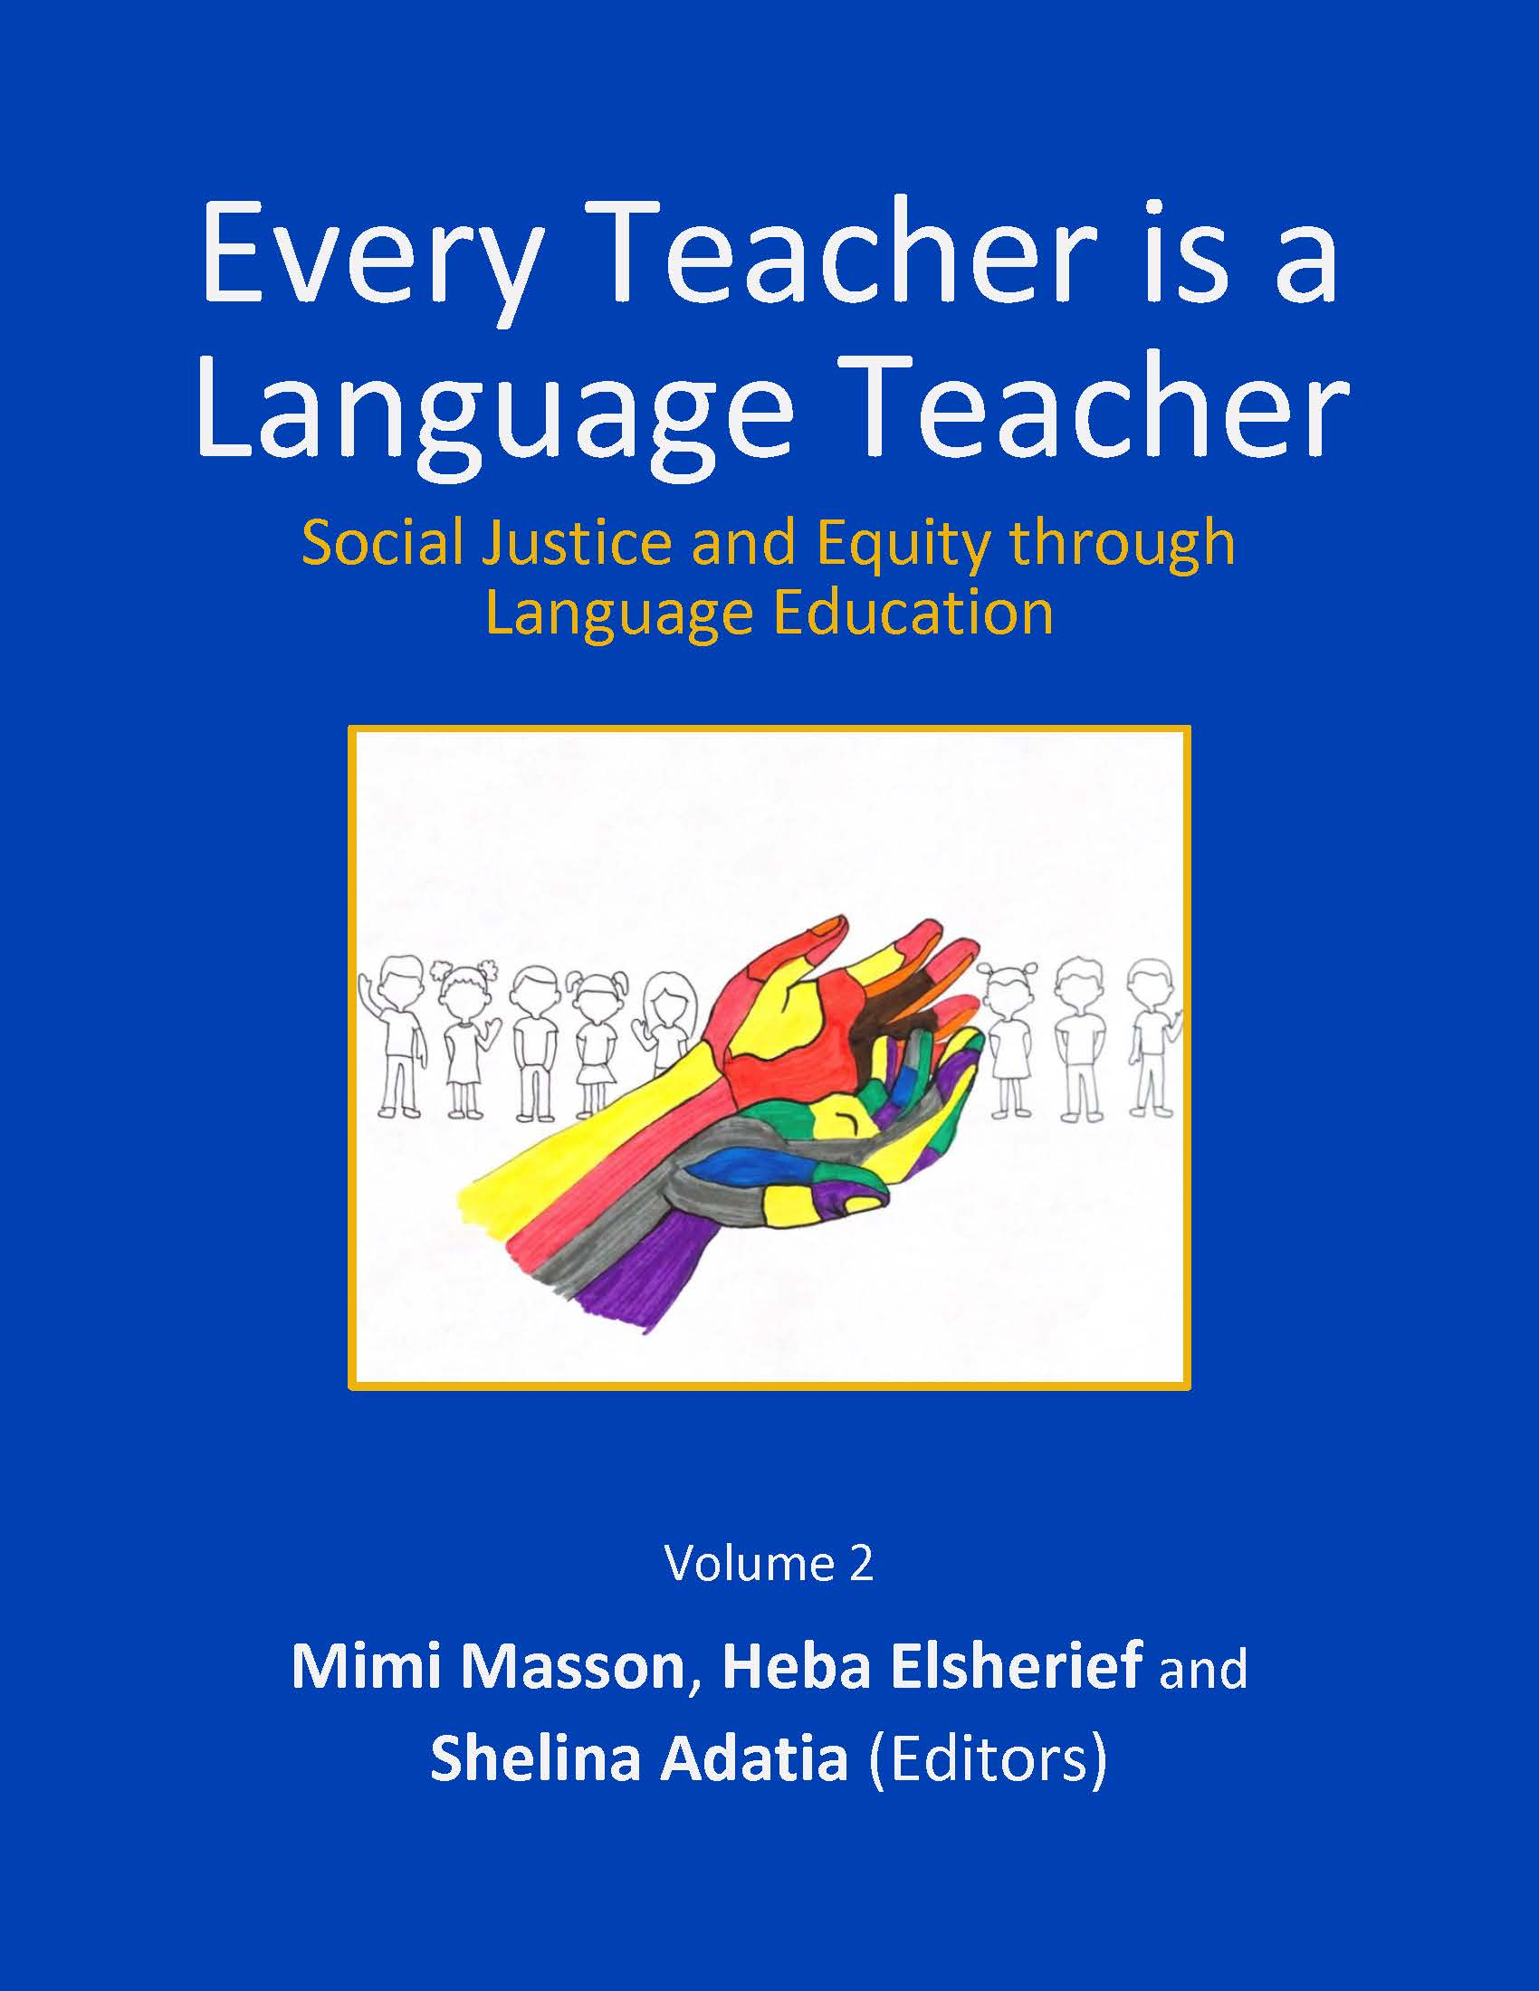

First published 2022
By University of Ottawa Second Language Education Cohort (cL2c) www.cl2cuottawa.ca

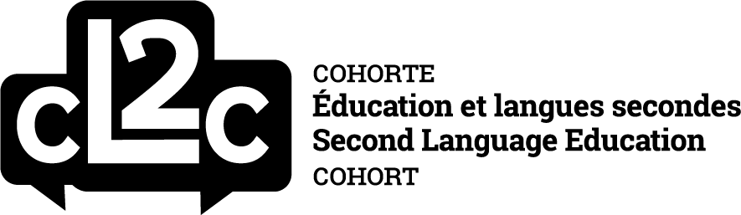

University of Ottawa
Faculty of Education
145 Jean-Jacques Lussier Private
Ottawa, Ontario K1N6N5

© The authors, 2022.

Unless otherwise indicated, this publication is made available under the following CC license:

Every Teacher is a Language Teacher: Social Justice and Equity through Language Education (Vol. 2) by Mimi Masson, Heba Elsherief, and Shelina Adatia (Eds.), University of Ottawa, is licensed under the Creative Commons Attribution-NonCommercial-ShareAlike 4.0 International License.
To view a copy of this license, visit http://creativecommons.org/licenses/by-nc-sa/4.0/ or send a letter to Creative Commons, PO Box 1866, Mountain View, CA 94042, USA.

Cover Image
“Every Teacher is a Language Teacher” by teacher candidate Lexie Elbaum
CC BY-NC
How to cite this book: Masson, M., Elsherief, H., & Adatia, S. (Eds.). (2022). Every teacher is a language teacher: Social justice and equity through language education (Vol. 2). University of Ottawa Second Language Education Cohort (cL2c). http://dx.doi.org/10.20381/ehd3-2t16

Contents

Introduction
Mimi Masson, Heba Elsherief, and Shelina Adatia 3
Chapter 1
Eyes Wide Open: Navigating Queer-Inclusive Teaching Practices in the Language Classroom for Pre-Service Teachers
Robert Grant 7
Chapter 2
Reaching Across the Language Aisle: Collaborative Inquiry into Cross-Curricular Plurilingual Pedagogy in FSL and ELA
Adam Kaszuba and Daniella M. Raposo 23
Chapter 3
An Extensive Reading Approach: Teaching and Learning Within and Beyond the Language Classroom
Chuan Liu 48
Chapter 4
Best Practices for Language Teaching and Learning: In-Person and Online
Krystina Raymond, Zein Abuosbeh, Michelle Chin,
Diana Burchell, and Xi Chen 69
Chapter 5
Communicating in Mathematics While Learning an Additional Language: Challenging Deficit Perspectives of Multilingual Students’ Learning of Mathematics
Fatima Assaf 89
Chapitre 6
Équité, diversité et inclusion dans le système éducatif canadien : La pédagogie sensible et adaptée à la culture pour les futur(e)s enseignant(e)s de FLS en Ontario
Eric Keunne 122
Chapter 7
Recognize Resilience: Challenge Your Perceptions of Refugee and Newcomer Students
Alaa Azan 136
Contributors……………………………………………………………………….149

Introduction
“The classroom remains the most radical space of possibility in the academy”
― bell hooks, Teaching to Transgress: Education as the Practice of Freedom

With the shift to online learning at the onset of the COVID-19 pandemic, these past two years have marked a change in the delivery of teacher education. During this time, and perhaps in part because of this drastic change, as a society, we have experienced a new wave of social conversations regarding matters of equity, diversity and inclusion (EDI). Certainly, the pandemic has highlighted the fissures in our social network in dire need of change. Our most vulnerable populations were quickly left behind -- elders abandoned in retirement homes, students without computers or internet at home facing issues accessing online schooling, and essential workers left without child care support -- raising questions about equity and how we care for each other during these trying times. Social activism, political debates and recent events in the news have turned our attention to such conversations as anti-Black racism, Indigenous history and land rights, acknowledging queer identities, women's right to make decisions over their own bodies, Islamophobia and ongoing racism in schools. While some might see bringing these conversations into the classroom as a temporary ‘trend’ in educational contexts, for us, it marks an essential moment of change in our culture of schooling.

If teachers are meant to prepare children for the future, one that is increasingly difficult to imagine due to the complexities of our time, then all of this signals to us the necessity to revisit the preparational needs of 21st century teachers. Teachers can, however, model and practice communities of care with their students. Their students are very well versed in issues of EDI – much more than many of us were growing up – and hyper-connected through social media. How teachers engage with these issues in their practice will set the tone for their students’ educational experiences. In Ontario, a major marker for much needed change in our schools came from the publication of reports from various school boards which brought to light ongoing racist and oppressive practices and systemic barriers for students and their families (HWDSB, 2020; OCDSB, 2019; PDSB, 2020). Shining light on these areas of education that were usually kept in the dark has led to a large-scale push across the province to better address these issues. As a result, teachers today must be familiar with the way that systemic oppression is reproduced in schools. They must also work on developing a critical awareness towards their practice through self-reflexivity in order to make shifts in the way they interact with students, the information they present, the way learning is assessed and curriculum delivery. Furthermore, the COVID-19 pandemic has meant that many teachers must now deliver content virtually to students. The classroom dynamics and learning experiences of students have shifted as well, with technological modalities becoming a norm in schools and the workplace. Some teacher candidates have had their entire preparational program delivered online. For teachers and students, this means rethinking the ways that we engage with course materials and each other. Both of these major shifts in teacher preparation raise important questions about how to deliver instruction such that it supports compassion, social justice and equitable access to education.
This volume is a result of our annual event, Every Teacher is a Language Teacher, held in 2021 and 2022 at the Faculty of Education of the University of Ottawa. Every year, we organize professional learning workshops for teacher candidates in our program. We invite seasoned teachers and young researchers (many of whom are also teachers!) doing their graduate work at the faculty to share methods, ideas, strategies and activities. Together, our community explores how to work with English and French language learners, as well as learners who come to the classroom with multiple languages in their repertoire. As research and experience have shown us, accessing students’ funds of linguistic and cultural knowledge is a powerful way to include students in the curriculum and center their contributions, identities, and experiences in the learning process. As a community of committed educators, we practice teacher learning with this same mindset – we draw from the personal and professional experiences of our guest presenters and teacher candidate attendees. Together, we speak to the social, cultural and political issues that matter in the classroom and share cutting-edge practices. The chapters in this book are intended for teachers who may or may not have a language teaching specialization. So as to promote equitable access to knowledge, we asked our presenters to write chapters based on their workshops and the experiences they had with our teacher candidates. They write in direct, accessible language and draw on the literature about language learning and teaching grounding their work in tried and tested initiatives. As such, for the reader, we hope the chapters will provide insight into what occurred during the workshops and how they can benefit from these professional learning sessions.

In his chapter, Eyes wide open: Navigating queer-inclusive teaching practices in the language classroom for pre-service teachers, Grant offers practical insights and strategies for teachers who wish to queer the classroom space. Acknowledging queer identities in the classroom is a way to ensure more equitable representation for students who do not always see themselves reflected in the curriculum and/or classroom materials. Taking on heteronormative thinking and practices that usually work as the ‘default’ in our classrooms, Grant works with the teachers in his workshop to identify and challenge oppressive ideologies by drawing on their past experiences in the classroom, the literature on queer pedagogy, and by critically examining classroom materials and textbooks.

In their chapter, Reaching across the language aisle: Collaboration inquiry into cross-curricular plurilingual pedagogy in FSL and ELA, Kaszuba and Raposo share a unique cross-curricular project they developed for plurilingual learners in a Vietnamese school that uses the Ontario curriculum. Working together, they designed classroom units and activities that would scaffold the students’ language development across the curriculum. By creating plurilingual fables and stories in English, French, and their first language, the students were able to work on their vocabulary, story-telling, drafting conventions, and express meaning and values closely associated to their cultural heritage. In this workshop, the participants can clearly see language alternance and curricular transversality, combined with a plurilingual stance to teaching. These pedagogical approaches to teaching literacy underscore the importance of acknowledging and working with students’ funds of knowledge as a point of departure to enhance their academic success.

Liu’s chapter, An extensive reading approach: Teaching and learning within and beyond the language classroom, offers teachers some evidence-based recommendations for developing learners’ literacy skills holistically. Specifically, the chapter provides a detailed description of the reading needs of English Language Learners (ELLs) that apply to Ontario K-12 contexts. Working with the teacher candidates who attended his workshop, Liu challenged unfounded assumptions teachers may have about working with ELLs and how these might further impede them from succeeding in the classroom. After unpacking these ideas, Liu shared the overarching principles of Extensive Reading and strategies associated with this approach. The chapter ends with a case-study of an extensive reading activity Liu undertook with his students.

In their chapter, Best practices for language teaching and learning: In-person and online, Raymond, Abuosbeh, Chin, Burchell, and Chen, offer teachers the necessary tools and insight for teaching online – a professional need that has grown in importance as part of the ongoing COVID-19 era. Working increasingly online, teachers need to prepare to promote oral communication, differentiate instruction, and assess writing, all in a virtual classroom setting. Throughout this workshop, the team of authors offered detailed explanations and examples of strategies to work on students’ oral language, phonological awareness, vocabulary, and literacy and writing. The tools offered to teachers here are promising ones to work across the curriculum, in such subjects as Math or Science, ensuring that students have equitable access and opportunities to develop their skills despite having to adapt to a new learning environment.

In her chapter, Communicating in mathematics while learning an additional language: Challenging deficit perspectives of multilingual students’ learning of mathematics, Assaf provides compelling evidence for Math teachers to rethink their cultural assumptions about how mathematical knowledge can be shared, taught, and demonstrated. Working from students’ own thinking and experiences with mathematical inquiries, the chapter illustrates the types of learning that is made possible. After working with attendees of the workshop to address their perceptions on learning mathematical concepts, Assaf uses a case-study set in an elementary classroom. Through it, Assaf gives detailed examples to illustrate how the students showcase their learning in unique and novel ways.

This volume offers one chapter in French, written by Eric Keunne. In his foundational chapter, Équité, diversité et inclusion : La pédagogie sensible et adaptée à la culture (PSAC) pour les futur(e)s enseignant(e) de FLS en Ontario, Keunne offers a review of culturally relevant and responsive teaching rooted on the principles of equity and inclusion, promoted by the Ontario Ministry of Education in French. As French resources in this area are limited, the chapter offers a much-needed review of the contextual preparational needs of Ontario FSL teachers. Working across three dimensions (personal, pedagogical, and institutional), Keunne worked with attendees of his workshop to rethink their underlying assumptions about language, culture, and identity in the classroom.

In the concluding chapter, Recognize resilience: Challenge your perceptions of refugee and newcomer students, Azan works with future teachers to enrich their understanding and compassion towards refugee and newcomer students to Canada. Taking on deficit-oriented discourses often applied to these learners, Azan tackles underlying assumptions that teachers might hold that impede these newly arrived students to reach their full potential in the classroom. Azan demonstrates the benefits of using a strength-based approach with these learners and provides concrete examples for teachers to work with and develop in their own practice.

At the heart of all of these chapters are the fundamental ideas of care and respect so needed to make learning a success. We believe that this book will be useful for teachers and teacher educators alike to work from the concrete, real-life experiences our contributors have shared. We are thrilled to present our guest presenters’ work in this open-access volume. From this workshop day, our community has created, we hope, a conversation sparker that you, dear reader, will want to share. We’ve made it easy for you: it comes with downloadable resources for teachers, available in PDF and Microsoft Word formats. If the recent changes we’ve experienced in schools and society have taught us anything, it’s that relationships built on trust, caring and sharing is what forms the basis of a healthy society. Promoting equity and inclusion in Ontario schools is a solution to ease the social inequity that hardships from these past few years have surfaced. It is the balm much needed to begin to heal old wounds. It is the point of contact we need to re-connect and re-humanize education. In fact, from the challenges presented by the COVID-19 pandemic, teachers, researchers, and teacher educators have emerged all the more creative and attuned to addressing students’ needs. And it’s an educational ‘trend’ worth continuing!

Mimi Masson, Heba Elsherief, and Shelina Adatia
Editors

References

Hamilton-Wentworth District School Board (HWSDB). (2020). Final report of the
external investigator for the Hamilton-Wentworth District School Board. https://www.hwdsb.on.ca/wp-content/uploads/meetings/Special-Board-Appendices-1612372125.pdf

Ottawa-Carleton District School Board (OCDSB). (2019). Valuing voices: Identity
Matters! 2019-2020 OCDSB student survey results.
https://ocdsb.ca/our_schools/indigenous_equity_human_rights/valuing_voices

Peel District School Board (PDSB). (2020). Review of the Peel District School Board.
https://www.ontario.ca/page/reports-review-peel-district-school-board
CHAPTER
1
Eyes Wide Open:
Navigating Queer-Inclusive Teaching Practices in the Language Classroom for Pre-Service Teachers

Robert Grant
University of Ottawa

Abstract
This workshop explores what it means to ‘queer’ the language classroom. Inspired in large part by the work of seminal thinkers in queering second language (L2) spaces (i.e., Liddicoat, 2009; Nelson, 2009; Paiz, 2020; Sunderland, 2018, 2021), the workshop offers practical insights and strategies that pre-service teachers can espouse to queer their classrooms. The workshop begins by asking participants about their comfort levels of integrating queer content into their classes: whether they imagine there will be pushback from stakeholders, as well as if they have received any proper training or tools on queering the classroom. We then move into unpacking what students know about queering in general: what it means, who it is for, and how it is enacted? Drawing on participants’ experiences both in and outside of education, the workshop will ascertain how schools typically default to normative (and heteronormative) ways of thinking, doing, and existing. The workshop aims to disrupt the heteronormativity that lies within tightly wrapped confines of schools to support queer learners, their perspectives and lived experiences. I hope participants leave the workshop feeling prepared to suffuse their classes with queer inquiries – that is, troubling all sexual identities.
Keywords: queer, LGBTQ+, inclusion, queer practices, FSL, second languages

Eyes Wide Open:

Navigating Queer-Inclusive Teaching Practices in the Language Classroom for Pre-Service Teachers

When I was a student learning French as a Second Language (FSL), I never felt heard. I remember going through family trees when we completed a unit in Grade 9 French. Everyone had a mom, a dad, some siblings, and mentioned their extended family: everything was nuclear. When we talked about our likes and dislikes, boys were often taught how to talk about sporting events, while girls were taught to describe shopping and clothes: everything was gendered. When we were taught about relationships, I was asked to use the newly acquired vocabulary to describe my ideal wife: everything was heteronormative. I played along because I didn’t want to “out” myself, and because, looking back, I don’t think I could have articulated what I even needed to see and learn. In any case, I didn’t get to learn how to express myself as a queer student, but I certainly learned how to as a straight learner. My feelings aligned with what several other scholars have written about in terms of the second language (L2) classroom (see Nelson, 2009; Paiz, 2020).

It has been well documented that learning an L2 is both a linguistic and social endeavour (De Vincenti et al., 2007; Miller, 2015; Nelson, 2010; Nguyẽ̂n & Kellog, 2005). An impetus to learn an L2 is to experience a world through new perspectives and lenses. This is particularly noteworthy for queer students where they can see themselves as queer language users and express their queer identity through their newly acquired language (Merse, 2015; Paiz, 2020). However, it is important to note that a learner “whose identity does not fit within the constructs of a particular community or classroom may not be fully engaged and learning within the particular group” (Yang, 2012, p. 52, as cited in Paiz, 2020) -- much like my own experience. In other words, if a student does not feel as though the content, material, or language will relate to their lives, they may refrain from learning the language.

These sentiments led me to think deeply about what it means to queer a classroom – and a language classroom in particular: Does it mean having representation? Having dialogue around the queer community? Teaching gender neutral language? I also wondered how ready teachers would feel to queer the classroom, and whether they have tools and strategies in place to do so. If not, how do teachers support their queer youth? Arguably, queer students are in every class – and if not, then these students might have friends or family members who are part of this community (Coulter et al., 2021; Sunderland, 2021). With the paucity of queer inclusion that I witnessed from my time as a student, paired with the limited exposure I offered to my students while teaching FSL, I knew it was necessary to dig deeper into ways of including queer folks in the language classroom. This was ultimately the drive for running such a workshop. As such, this paper aims to explore i) an overview of the key literature underpinning the creation of the workshop ii) the activities that were completed throughout the workshop, and iii) reflections about the workshop from both the participants and the facilitator.

Queer Issues and Perspectives in the Research Literature

Sexuality and L2 education have become an area of interest for applied linguistics (see Nelson, 2009), especially with the turn to poststructuralist thought in L2 research. Cynthia Nelson, a pioneer in L2 research on sexuality, was among the first to explore this topic in depth during a TESOL conference. In her 1993 presentation, she examines how heterosexism is woven into the very fabric of the classroom, as well as language teachers’ attitudes toward the language and the subject matter. This heterosexism often translates to a lack of support for queer teachers and students, and a disengagement in terms of learning the language, since much of the content was reserved for straight individuals (Nelson, 1993). A year later, Snelbecker (1994) examines how homophobia impacts queer teachers, causing other researchers (e.g., Britzman, 1995; Vandrick, 1997) to notice how virtually absent identity (and especially queer identity) is from the language classroom. Just as more attention grew to the paucity of research, the influx of research began to ensue. Paiz (2020) succinctly captures a detailed map of the queer L2 research that emerged from 2000-2010. They posit that much of the research in this timeframe was reserved for examining normative classrooms and language material (Gray, 2013), queer theory and queer inquiry in the classroom (Nelson, 2006), as well as the need to create more inclusive materials and classroom spaces (Liddicoat, 2009). Research after 2010 until now sheds light on questions of identity in the L2 classroom (Moore, 2016, 2019; Nguyen & Yang, 2015), tools and strategies to queer the classroom (Cahmann-Taylor et al., 2022; Paiz, 2020), and most recently, the inclusion of transexual and non-binary folks (Kean, 2020; Knisely, 2020a, b; Knisely & Paiz, 2021).

Heteronormativity

Much of the current queer L2 literature stems from the idea that classrooms and their material and teaching practices are heteronormative (Moita-Lopes, 2006; Tran-Thanh, 2020). Early queer theorist Michael Warner (1991) defines heteronormativity as “a hegemonic system of norms, discourses, and practices that constructs heterosexuality as both natural and superior to all other expressions of sexuality” (p. 129, as cited in Bangeas & Evripidou, 2021). This often occurs in simple daily activities where students have to talk about their days and routines (Liddicoat, 2009; Neto, 2018), as well as their families (Nelson, 2010). In their 2009 research, Liddicoat suggests that educators denote students’ queer usage of the language -- often in terms of the nouns and adjectives they use to describe their homosexual significant others -- as “linguistic failures”. This ultimately equates queer languaging (e.g., a male speaking about a male romantically, a woman speaking about a woman romantically, a non-binary person speaking about their love interest romantically, etc.) as a failure and as something that is restricted from the classroom. Similarly, a teacher in Moita-Lope’s (2006) study reveals that, even if queer focused conversations arise in the conversation, they are relegated by the teacher for a lack of comfort and training. The teacher in Moita-Lope’s study indicates that “she was aware of the relevance of the topic to the pupils, but did not know how to deal with it in class” (p. 38). With the fear and uncertainty of how to handle the conversation, the teacher shuts it down altogether. These sentiments are echoed in several other studies on teacher attitude and beliefs toward teaching queer content in the language class (see Curran, 2006; Dalley & Campbell, 2006; Page, 2016, 2017).

Teacher Attitudes and Beliefs Toward Queer Content in the L2 Classroom

Often, the decision to include queer content rests on the shoulders of the L2 teacher in the classroom. Many factors contribute to whether they include queer perspectives and voices, such as whether they are nervous to do so (Curran, 2006; Page, 2016), whether there will be pushback from their institutions or organizations (Rhodes & Coda, 2017), or whether they feel unprepared or simply unwilling to do so (Evripidou & Çavuşoğlu, 2015; Hermann-Wilmarth & Ryan, 2018). Even if teachers notice students probing further about the conversation of queer topics or show interest in them (see Moita-Lopes, 2006; Nelson, 2010), teachers decide not to engage in these topics of discussion because they do not see its relevance to the language classroom specifically (Ferfoljia & Robinson, 2004). The impetus of this workshop is tied directly to what the research reveals: teachers (both in-service and pre-service) do not always feel comfortable engaging in conversations around sexuality in the L2 classroom.

Workshop Activity 1: Setting the Scene for Queering the L2 Classroom

In this interactive workshop, I wanted to explore with pre-service teachers 1) what ‘queering’ the language classroom meant, 2) why it was necessary, and 3) some strategies to begin queering their classroom. A main component of queering the classroom involves building community with students (Paiz, 2020). In response, I began the workshop by inviting students to write their names in the chat function, followed by an adjective used to describe them. Although there were many participants, this activity gave me a general understanding of those attending, and offered an initial opportunity to build rapport with the participants. Following that, I asked students to use PearDeck – an interactive slideshow tool – in the form of a poll with four questions. The goal of this poll was to gauge participants’ comfortability and exposure to queer topics in the language classroom, their formal training on doing so, and the tentative pushbacks they may receive from students, parents, and stakeholders (see Figure 1).

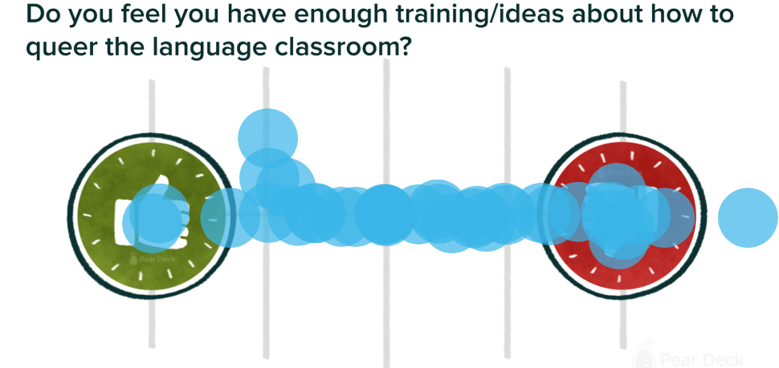
Figure 1
PearDeck Poll Question and Responses

Although some students indicated that they did have training and ideas, the majority of participants claimed that they had few ideas on how to queer the classroom, and did not have formal training on doing it. Their responses helped me guide the conversations I would have with the participants. It also allowed for a deeper discussion on why queer dialogue was perhaps missing from their educational experience, paired with why it is still a missing piece to their teaching puzzle now.

With the introductions set, I then wanted to explore how much participants knew about gendered language and heteronormative behaviours. As such, I had students use PearDeck again to complete a drawing activity where I read a dialogue about a family getting ready for their day (see Figure 2) but I - used only gender-neutral pronouns and terms.

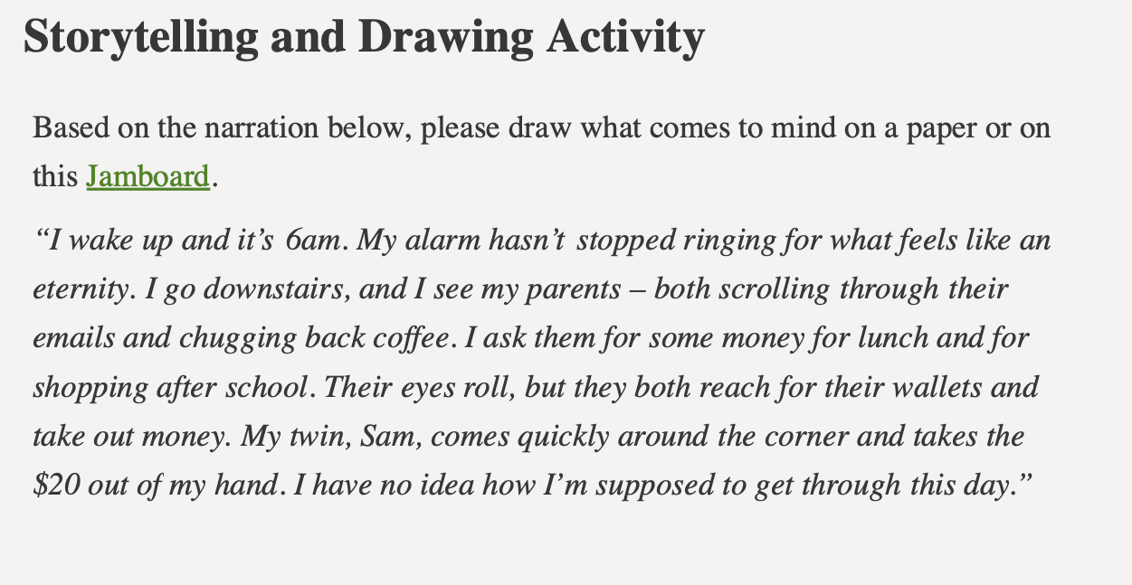
Figure 2
Drawing Activity

This activity was inspired by Paiz (2020). In their recent book, Queering the English language classroom: A practical guide for teachers, they outline that people have strict notions about what they think families are and who they entail, and doing such an activity can help students learn more about these preconceived notions. The drawings generated by the participants upheld similar assumptions: most drew a mom, dad, and a sibling. Collectively, we discussed what normativity and heteronormativity meant, and how it could be applied to their thinking through this mini activity. Some teacher candidates questioned the activity because they would naturally think of a mom and dad when referring to the word “parents” from the example as that is what the word means for them. Others noted that they noticed the gender-neutral language being used. In either case, this was exactly what I hoped to unpack: language is essential, and assumptions of normativity drive our language usage. As such, teacher candidates need to be deliberate in their use of language when they (eventually) teach a second language.

Then, we collectively went through what queering the language classroom might look like for teacher candidates, and why it was important to queer language classrooms. In particular, we discussed how teachers assume gender binaries of their students (Kinsley & Paiz, 2021), how teachers may feel resistant to infusing queer voices and perspectives into their classrooms (Liddicoat, 2009; Nelson, 2009), as well as how teachers often use materials that only reflect their straight learners (Gray, 2013; Paiz, 2015). However, in the language classroom, queering is of particular importance since students can talk about themselves: their hobbies, interests, loves, desires, feelings, and often get to role play these scenarios (Nelson, 2009; Paiz, 2020). Limiting this learning can contribute to students feeling alienation in the classroom community (Alessi et al., 2017; Dalley & Campbell, 2006; Nelson, 2009). This conversation nicely tied into the second activity that we completed together: Examining FSL Heteronormative Material.

Activity 2: Examining FSL Heteronormative Material

Since the participants already had a sense that their preconceived notions included normativity and heteronormativity perspectives (i.e., the drawing activity), I wanted to look at a few FSL materials that I have accumulated or gathered over the years as a practicing teacher to further examine how heteronormativity imbues language-related materials. In particular, I focused on four photos from an FSL textbook – each encompassing varying degrees of heteronormativity. I was curious to see if the participants noticed any levels of heteronormativity. This is noteworthy since several scholars have revealed that foreign language (FL) textbooks and accompanying material privilege heterosexual students and their perspectives (Gray, 2013; Paiz, 2015, 2018, 2019; Ruiz-Cecilia et al., 2020; Selvi & Kocaman, 2021; Shardakova & Pavlenko, 2004; Sunderland, 2018). In fact, in his 2013 analysis of U.K. produced textbooks, Gray indicates that there was “no reference to same-sexual orientation in any of the titles” (p. 49), which leads learners to question where their voices and identities fit within the limited confines of the hetero-L2 space. So, as I displayed each image, I pulled threads from Paiz’s (2015, 2020) work to establish where the heteronormativity lies for the participants. I also asked them reflective questions developed by Paiz (2020). These reflective questions included the following:

- “What relationships do we see represented in the text”,
- “What do we notice about the structure of these relationships as it related to gender, age, race, etc.”,
- “What does this suggest to us about what the text values”,
- “How are these views supported by graphic elements of the text”
- “Do the pictures that go with the text reinforce these ideas or others?”
- “Who is ignored by this view? Who is given preference?”
- “What would alternatives look like?” (Paiz, 2020, p. 98).

Although brief (due to time constraints), participants were able to see how the photographs in the selected materials solely focused on heterosexual individuals interacting with one another. The first photo presented a family tree where a (seemingly) grandpa and grandma duo were on top, followed by mom and dad, then coupled with their (presumed) children. In the subsequent photos, there were images and dialogues where boys talk about their girlfriends, and where boys ask girls which male actors they prefer. These photos acted as a springboard for a conversation around the types of material that are available, as well as the message that these photos send to students in the language classrooms. Ultimately, it became clear that queer folks in the FSL classroom were not represented – and that in general, individuals were predominately white. This can lead racialized students to feel misrepresented, much like queer students would. As Paiz (2020) outlines in his work, queer-inclusive materials (as well as non-racialized materials) are not always readily available, and one way to combat this is through his last two questions noted above:

“Who is ignored by this view? Who is given preference?
What would alternatives look like?” (p. 98).

Using such prompts, teachers can utilize the provided material in their L2 classroom, but through probing and exploring, teachers can discuss with their students the missing voices and identities in these pieces. Together, students and teachers can begin to critically think about what would make these works more inclusive.

Much of the conversation around this examination activity led participants to think about their own experiences within their schooling, both in terms of the material used and distributed, and general heteronormative assumptions. For example, one of the participants noted that they did not feel comfortable ‘coming out’ to their associate teachers (AT) because the AT did not provide a welcoming or safe space. This led the teacher candidate to feel disconnected from her AT, and consequently, the teacher candidate did not feel compelled to adopt queer inclusivity in their teaching either. Others shared personal anecdotes of their times navigating being gay in schools – most being relatively negative. However, one participant elaborated that they did not have a negative experience, largely because they saw themselves as a “shit disturber” and attempted to call out teachers and other students who upheld heteronormative assumptions. I thought that the duality (that is, the dichotomy of negative and positive) was a step in the right direction. Although it does not encompass all students, some are nonetheless standing up for what matters to them.

Furthermore, some students disclosed that their teachers in high school oriented their classes around a heteronormative standard. For example, a participant shared that their queer brother was asked what to do in case of impregnating a female during a health class. From what I gathered from the participant, it seemed as though the teacher remained oblivious – or perhaps ignorant – that their brother was gay and likely would not impregnate a woman. It is worth noting, too, that the participant’s brother was not given any information about same-sex sexual encounters – the only information provided was surrounding the opposite-sex. In these instances, it is problematic that educators are only offering limited information to the class, which could be quite dangerous for queer folks lacking knowledge around their own sexuality.

The conversation around heteronormativity in schooling spiraled into participants wondering how exactly to queer the classroom. An abundance of information was given, and experiences were shared, but some participants were still left questioning how to bring these thoughts back into their practice. As such, we had a conversation around how to practically queer the classroom (and the language classroom more specifically). Some participants spoke about their discomfort with the subject. In other words, they felt as though they did not know enough about the topic to include dialogue, perspectives, and differing voices related to queer folks. Paiz (2020) responds to this thought directly and notes that:
Too often, straight and LGBTQ+ educators alike worry that they ‘don’t know enough’ about LGBTQ+ issues or how to present them to their students in linguistically and ethically appropriate ways. Great! Investigate with your students and show them that being an expert means knowing how to explore possibilities and to look for answers across numerous sources of information.
(p. 80)

Our discussion, in turn, continued to weave and borrow many ideas from Paiz’s (2020) work. We talked about being vigilant about our representation. For instance, I asked the participants if they recall seeing any Pride flags in their classroom when they were students, or if they had any queer-inclusive posters around their classrooms. Many stated that they did not, but wanted to include them in their classrooms when they got their own. Further, Paiz (2020) discusses the idea of queering material. In doing so, they urge folks to look at who is silenced or privileged, who benefits from the material, and whether LGBTQ+ folks were part of an everyday conversation in classes, etc. The participants had a lot of thoughts to add about this, drawing mostly from their experiences as a student, but also how they would work together to make their classrooms more queer-inclusive when they enter the teaching profession more permanently. During this conversation, a few students mentioned their interest in joining or starting a Gay-Straight-Alliance (GSA) at their new schools. My goal with this workshop and these conversations was to help students feel motivated, inspired, and driven to begin making small changes within their community to better include queer folks.

Activity 3: Critique and Design Queer-Friendly Material

Much of the concern around queering the classroom from the participants stemmed from their lack of resources. They were unaware of how to add queer voices into places where they have not historically been present. One participant even noted that they could see how queering the classroom could be applicable to language classrooms, but that they were not entirely sure how this could apply to different classes and subjects – such as science or mathematics. This was the focus for our third and final activity. In this activity, I gave students access to three different language resources:

- a FSL family unit slideshow,
- an English ‘Romeo and Juliet’ question prompt, and
- an English as a second language (ESL) identity text lesson.

Before we began the activity, I informed the participants that teachers used these resources regularly. The goal was to use these pre-existing materials and simply adapt them – or to queer them – such that they did not have to ‘reinvent the wheel’ per se, but worked in such a way that queer folks and their perspectives were included in the lesson. I hoped that they would look at the material and examine whether or not there were traces of heteronormativity, and then, replace them or add more inclusive content that targets the same lesson objectives. To do so, I opened breakout rooms and allowed students to go into the room that corresponded most to their teaching interest – i.e., French, English, or ESL. One of the pitfalls of this activity was the time restraint. There was not enough time to go over the activity and the participants’ thoughts, perspectives, and proposed changes in depth. However, from the brief conversations I had with the participants after, it appeared that they appreciated working collaboratively with resources that were already created. Like I previously mentioned, it is easier to adapt something than recreate something from scratch.

Workshop Participants’ Reflections

Participants at the end of the workshop were invited to fill in a post-workshop survey to offer feedback. They were tasked with responding to four questions:

- How informative did you find the workshop?
- What were some takeaways from the workshop?
- What did you enjoy most about the workshop?
- What suggestions would you give to improve the workshop?

Although several attendees were present (upwards of 50), only six folks responded to the survey. The first question asked participants to rank the presentation from one to five – one being not at all informative, and five being very informative. Five respondents allotted the presentation five out of five, while one allotted it four out of five. This was promising in that it helped me to ensure that there was a balance of theory and content, as well as if students found the presentation useful for their practice.
In terms of major takeaways (in response to question two), many participants made similar comments: concrete practices to queer the classroom were the major takeaways. This is helpful to know, since the objective of the workshop was to learn how to queer the language classroom. More specifically, one participant noted that: “Cultivating community and inclusivity is easy.” Others noted that: “Including all the narratives rather than just heteronormative side is essential!”

This was perhaps the most important question for me, since I know how challenging, misleading, and even difficult it can be to queer the classroom. I wanted to offer tools and strategies to make this integration easier for teacher candidates, and these comments from participants cemented that it can be done in the classroom. I thought it was particularly helpful to know that regardless of the presence of resources or pedagogical tools, teacher candidates can always question the resources available to them with their students. Much like what we did during the second activity, students can critique, question, and comment on all available material, with teacher candidates asking questions as posed by Paiz (2020): whose voices are silenced or privileged, who benefits from the material and who does not benefit, etc. It is possible that, before the workshop, teacher candidates did not question the resources or structure of their classes because of their own educational experience. It is gratifying to know that they feel equipped to trouble all sexual identities when they go into their practice (Nelson, 2009; Paiz, 2018, 2020).

The third question sought to unpack what participants enjoyed the most about the workshop. Overall, it was clear that participants enjoyed the collaborative discussions and inclusive environment. In order to teach about and enact queer pedagogies, I wanted to establish a safe(r) space for folks to discuss their experience and perspectives, both as queer people and allies, throughout the workshop. To do so, I used humour, tried to refer to each participant’s name as often as possible, and really listened whenever they spoke. I also recapped what participants said, reframed their questions, extended their thoughts, and asked to expand whenever possible. These ideas are clearly seen through some of the participants’ comments:

Rob was extremely entertaining as a presenter and fostered a great open dialogue and safe space for all in the presentation.

That it was a relevant speaker that relates to our perspectives as well.

The atmosphere and inclusivity!

Many of the participants appeared thrilled by the dialogue and atmosphere that allowed for more inclusive conversations. As previously mentioned, it is important to build rapport with participants if I hope to engage in conversations around potentially sensitive topics with them. My goal for this relationship building, too, was to model how they might choose to do so with their students when they finish their initial teacher training program.

The final survey question that folks were asked to fill out focused on ways to improve the workshop. The answers for this section varied; however, there was a consensus that we needed more time for each activity and discussion. In fact, one respondent noted that: “Having a longer session would be great. There was so much to possibly unpack and Rob was a great facilitator!” This comment reveals that there was perhaps too much content embedded in the workshop, and not enough time to concretely work through each activity. As such, the presentation could have been augmented by having more concise and concrete information on the slideshow, followed by more structured and allotted time in the breakout rooms for folks to work through each activity.

Presenter Reflections

I went through a whirlwind of emotions before, during, and after presenting this workshop. Much of the content around queering the classroom, and the language classroom in particular, is dear to my heart. However, just because the content sparks joy for me does not necessarily mean that other folks share the same opinions – nor would students to whom they are presenting. For pre- and in-service teachers who are looking for ways to immediately queer the classroom – regardless of content area – I would recommend starting with including gender inclusive language. Several participants had questions around gender inclusive language. I knew how this applied to the FSL context with the use of different pronouns; however, I wish I knew a little bit more about appropriate terms in English. For example, a participant asked why “guys” was not the most appropriate term to call their students. While I had a general response to offer (largely in that not all of their students would refer to themselves as guys), I felt as though I could not fully elaborate on the reasoning. As such, I think it would be beneficial to have read a bit more on gender-inclusive language in the English classroom. This could have responded to the participants’ questions and could have helped other students in the workshop who had the same question.

Throughout the workshop, I felt the sense that many participants thought that “queering the classroom” was synonymous with “including queer folks into the content”. While inclusion is a good start, it is important to remember that while including, exclusion inevitably ensues as a result (Bollas, 2021). With this in mind, my hope is that the participants left with the sense that queering occurs through questioning rigid beliefs, disrupting normative behaviour, and thinking about why certain groups of people have been – and remain – oppressed, while others continuously have power in society. Despite potentially scant available resources, this can be done through dialogue with students by simply asking them “who is included in this text?”. Through this question, conversations about race, gender, sexual orientation, power, and privilege can surface and can lead to inherently ‘queer’ dialogue that permeates the classroom.

Conclusion

This workshop was rooted in exposing teacher candidates to the myriad of ways that queer identities are present in all classrooms at schools – and especially language classrooms – while also equipping teacher candidates with the tools needed to ‘queer’ their classrooms. As a queer student in the language classroom, I always felt like I didn’t belong, since most of the activities were centered around straight students and their lived experiences – from activities around families to future careers: everything was designed uniquely for heterosexual students. The goal of this workshop, then, was to introduce teacher candidates to the ways in which heteronormativity silently manifests itself throughout our thoughts, routines, and classroom expectations. Often, leading folks to default to a heteronormative way of thinking, which much of the research corroborates, occurs in the classroom (Paiz, 2020). The workshop aimed to shed light on relevant vocabulary, such as heteronormativity, normativity, queer, and LGBTQ+ to ensure that all participants understood the key terms for the presentation. The workshop also illustrated concrete examples of how heteronormativity lives in the confined walls of schools. And, with the help of participants, we unpacked ways to mitigate this heteronormativity to include all learners. Finally, participants had an opportunity to play around with three different resources – either FSL, English, or ESL – to put their newly acquired theory into practice by queering language material. Some participants revealed that this was their first time formally learning about queer bodies, ideologies, identities, and topics in an educational context. These sentiments kept my eyes wide open to the possibilities of even queering spaces, such as the teacher education program, where discussions around queer folks can happen more frequently. If we want to change the future of education, we have to start with those training to be educators.

References

Alessi, E. J., Sapiro, B., Kahn, S., & Craig, S. L. (2017). The first-year university
experience for sexual minority students: A grounded theory exploration. Journal
of LGBT Youth, 14(1), 71–92. https://doi.org/10.1080/19361.2016.1256013

Banegas, D. L., & Evripidou, D. (2021). Introduction: Comprehensive sexuality
education in ELT. ELT Journal, 75(2), 127–132. https://doi:10.1093/elt/ccaa085

Bollas, A. (2021). A critical discussion of inclusive approaches to sexualities in ELT.
ELT Journal, 75(2), 133–141. https://doi.org/10.1093/elt/ccaa075

Britzman, D. P. (1995). Is there a queer pedagogy? Or, stop reading
straight. Educational Theory, 45(2), 211–227.
https://doi.org/10.1111/j.1741-5446.1995.00151.x

Cahmann-Taylor, Coda, J., & Jiang, L. (2022). Queer is as a queer does: Queer L2
pedagogy in teacher education. TESOL Quarterly, 56(1), 130–153.
https://doi.org/10.1002/tesq.3044

Coulter, R. W. S., Colvin, S., Onufer, L. R., Arnold, G., Akiva, T., D’Ambrogi, E., &
Davis, V. (2021). Training pre-service teachers to better serve LGBTQ high
school students. Journal of Education for Teaching, 47(2), 234–254.
https://doi:10.1080/02607476.2020.1851137

Curran, G. (2006). Responding to students’ normative questions gays: Putting queer
theory into practice in an Australian ESL class. The Forum: Journal of
Language, Identity, and Education, 5(1), 85–96.
https://doi:10.1207/s15327701jlie0501_6

Dalley, P., & Campbell, M. D. (2006). Constructing and contesting discourses of
heteronormativity: An ethnographic study of youth in a francophone high school
in Canada. Journal of Language, Identity, and Education, 5(1), 11–29.
https://doi.org/10.1207/s15327701jlie0501_2

De Vincenti, G., Giovanangeli, A., & Ward, R. (2007). The queer stopover: How queer
travels in the language classroom. Electronic Journal of Foreign Language Teaching, 4(1), 58–72.

Evripidou, D., & Çavuşoğlu, C. (2015). English language teachers’ attitudes toward the
incorporation of gay- and lesbian-related topics in the classroom: The case of
Greek Cypriot EFL teachers. Sexual Research and Social Policy, 12, 70–80.
https://doi.10.1007/s13178-014-0176-3

Ferfoljia, T., & Robinson, K. H. (2004). Why anti-homophobia education in teacher
education? Perspectives from Australian teacher educators. Teaching Education,
15(1), 9–25. https://doi.org/10.1080/1047621042000179961

Finnessy, P. (2016). Examining the heteropatriarchy: Canadian and American male
teachers’ perspectives of sexual minority curriculum. Teaching Education, 27(1), 39–56. https://doi.org/10.1080/10476210.2015.1034684

Gray, J. (2013). LGBT invisibility and heteronormativity in ELT materials. In J. Gray
(Ed.), Critical perspectives on language teaching materials (pp. 40–63).
Palgrave Macmillan.

Hermann-Wilmarth, J. M., & Ryan, C. L. (2018). Navigating parental resistance:
Learning from responses of LGBTQ-inclusive elementary school teachers.
Theory into Practice, 58(1), 89–98. https://doi.org/10.1002/tesj.329

Kean, E. (2020). Locating transgender within the language of queer in teacher
education. Multicultural Perspectives, 22(2), 57–67.
https://doi.org/10.1080/15210960.2020.1741371

Knisely, K. (2020a). Le français non-binaire: Linguistic forms used by non-binary
speakers of French. Foreign Language Annals, 53(4), 850–876.
https://doi.org/10.1111/flan.12500

Knisely, K. (2020b). Subverting the culturally unreadable: Understanding the self
positioning of non-binary speakers of French. The French Review, 94(2),
149–168. https://doi.org/10.1353/tfr.2020.0280

Knisely, K. A., & Paiz, J. M. (2021). Bringing trans, non-binary, and queer
understandings to bear in language education. Critical Multilingual Studies,
9(1), 23–45.

Liddicoat, A. J. (2009). Sexual identity as linguistic failure: Trajectories of interactions
in the heteronormative language classroom. Journal of Language, Identity, and
Education, 8(2), 191–202. https://doi.org/10.1080/15348450902848825

Merse, T. (2015). Queer-informed approaches and sexual literacy in ELT: Theoretical
foundations and teaching principles. Language Issues, 26(1), 13–20.

Miller, S. J. (2015). A queer literacy framework promoting (a)gender and (a)sexuality
self-determination and justice. English Journal, 104(5), 37–44.

Moita-Lopes, L. P. (2006). Queering literacy teaching: Analyzing gay-themed
discourses in a fifth-grade class in Brazil. Journal of Language Identity and
Education, 5(1), 31–50. https://doi.org/10.1207/s15327701jlie0501_3

Moore, A. R. (2016). Inclusion and exclusion: A case study of an English class for
LGBT learners. TESOL Quarterly, 50(1). https://doi.org/10.1002/tesq.208
Moore, A. R. (2019). Interpersonal factors affecting queer second or foreign language
learners’ identity management in class. The Modern Language Journal, 103(2),
428–442. https://doi.org/10.1111/modl.12558

Nelson, C. (1993). Heterosexism in ESL: Examining our attitudes. TESOL Quarterly,
27(1), 143–150. https://doi.org/10.2307/3586966

Nelson, C. (2006). Queer inquiry in language education. Journal of Language, Identity
& Education, 5(1), 1–9. https://doi.org/10.1207/s15327701jlie0501_1

Nelson, C. D. (2009). Sexual identities in English language education: Classroom
conversations. Routledge.

Nelson, C. D. (2010). A gay immigrant student’s perspective: Unspeakable acts in the
language class. TESOL Quarterly, 44(3), 441–464. https://doi.org/10.5054/tq.2010.226853

Neto, J. N. (2018). Queer pedagogy: Approaches to inclusive teaching. Policy Futures
in Education, 16(5), 589–604. https://doi.org/10.1177/1478210317751273

Nguyẽ̂n, T. H., & Kellog, G. (2005). Emergent identities in on-line discussions for
second language learning. The Canadian Modern Language Review, 62(1),
111–136. https://doi:10.1353/cml.2005.0044

Nguyen, H., & Yang, L. (2015). A queer learners identity positioning in second
language classroom discourse. Classroom Discourses, 6(3), 221–241.
https://doi:10.1080/19463104.2015.1093952

Page, M. L. (2016). Teaching in the cracks: Using familiar pedagogy to advance
LGBTQ-inclusive curriculum. Journal of Adolescent and Adult Literacy, 60(6),
677–685. https://doi.org/10.1002/jaal.616

Page, M. L. (2017). From awareness to action: Teacher attitude and implementation of
LGBT-inclusive curriculum in the English language arts classroom. SAGE
Open, 1–15. https://doi:10.1177/2158244017739949

Paiz, J. M. (2015). Over the monochrome rainbow: Heteronormativity in ESL reading
texts and textbooks. Journal of Language and Sexuality, 4(1), 77–101.
https://doi.org/10.1075/jls.4.1.03pai

Paiz, J. M. (2018). Queering ESL Teaching: Pedagogical and materials creation issues.
TESOL Journal, 9(2), 348–367. https://doi.org/10.1002/tesj.329

Paiz, J. M. (2019). Queering practice: LGBTQ+ diversity and inclusion in English
language teaching. Journal of Language, Identity, and Education, 18(4),
266–275. https://doi.org/10.1080/15348458.2019.1629933
Paiz, J. M. (2020). Queering the English language classroom: A practical guide for
teachers. Equinox Publishing.

Rhodes, C. M., & Coda, J. (2017). It’s not in the curriculum: Adult English language
teachers and LGBQ topics. Adult Learning, 28(3), 99–106.
https://doi.org/10.1177/1045159517712483

Ruiz-Cecilia, R., Guijarro-Ojeda, J., & Macias-Marin, C. (2020). Analysis of
heteronormativity and gender roles in EFL textbooks. Sustainability, 13, 1–17.
https://10.3390/su13010220

Selvi, A. F., & Kocaman, C. (2021). (Mis/under-) representations of gender and
sexuality in locally-produced ELT materials. Journal of Language, Identity, and
Education, 20(2), 118–133. https://doi.org/10.1080/15348458.2020.1726757

Shardakova, M., & Pavlenko, A. (2004). Identity options in Russian textbooks. Journal
of Language, Identity, and Education, 3(1), 25–46.
https://doi.org/10.1207/s15327701jlie0301_2

Snelbecker, K. A. (1994). Speaking out: A survey of lesbian, gay, and bisexual teachers
of ESOL in the U.S. [Master’s thesis, School for International Training]. ERIC. https://eric.ed.gov/?id=ED375680

Sunderland, J. (2018). Inclusion and exclusion in foreign language education: A critical
over-view, with illustrations from studies of a German classroom for young secondary learners and of five Polish textbooks. International Journal of Applied Linguists, 29, 308–321. https://doi.org/10.1111/ijal.12241

Sunderland, J. (2021). Foreign language textbooks and degrees of heteronormativity and
representation and consumption. Language, Gender, and Sexuality, 29–46.
https://doi.org/10.1007/978-3-030-64030-9_2

Tran-Thanh, V. (2020). Queer identity inclusion in the EFL classroom: Vietnamese
teachers’ perspectives. TESOL Journal, 11(3), 1–16.
https://doi.org/10.1002/tesj.512

Vandrick, S. (1997). The role of hidden identities in the postsecondary ESL
classroom. TESOL Quarterly, 153–157.

CHAPTER
2

Reaching Across the Language Aisle:

Collaborative Inquiry into Cross-Curricular Plurilingual Pedagogy in FSL and ELA

Adam Kaszuba and Daniella M. Raposo
University of Ottawa Ontario College of Teachers,
Renaissance International School Saigon

Abstract
In Canadian schools, one challenge is to promote cross-curricular collaboration between French as a second language (FSL) and English Language Arts (ELA) teachers. This may be in part because the knowledge and skills of FSL teachers are often devalued during professional learning sessions, and this devaluation process begins during initial teacher education (ITE). In this chapter, we begin by reviewing an example of a unit planned between an FSL and ELA teacher which is informed by cross-curricular and plurilingual ideas. The student work produced from this unit was subsequently used as an object of collaborative inquiry during a professional learning workshop in an ITE program. Collaborative assessment of student work produced by cross-curricular plurilingual pedagogy is a useful tool to promote mutual understanding between FSL and ELA teacher candidates during the ITE program.
Keywords: plurilingual pedagogy, collaborative assessment, collaborative inquiry, professional learning, initial teacher education, cross-curricular, French as a second language, collaboration

Introduction

French as a second language (FSL) education is often placed at the bottom of Canadian curricular hierarchies. As such, the knowledge that FSL teachers bring to educational settings is devalued in comparison to their mainstream colleagues (Knouzi & Mady, 2014). Despite the fresh perspectives about language teaching, learning, and assessment that FSL teachers can offer, it is often challenging for these teachers to integrate themselves into professional learning contexts at their schools. As a result, FSL teachers may feel isolated as a lack of mutual understanding limits the success of cross-curricular initiatives. This challenge begins in the initial teacher education program (ITE), where the deficiency of professional learning structures which foster dialogue between FSL teacher candidates and their colleagues may limit their ability to enter into collaborative relationships once they graduate (Knouzi & Mady, 2014; Mason, 2017).

This chapter is divided into two parts. In the first section, the co-authors describe the planning of a cross-curricular plurilingual unit developed between an FSL teacher and a homeroom teacher (i.e., Adam and Daniella respectively) at an international school in Vietnam. In the second section, the first author, Adam, reflects on a workshop presented during the 2022 cL2c conference at the University of Ottawa, which engaged FSL and mainstream teacher candidates in the collaborative assessment of student work taken from that cross-curricular plurilingual unit. Finally, I discuss my thoughts on the proceedings of the workshop and the implications for using such a structure in ITE. When cross-curricular plurilingual student work is an object of inquiry, collaborative assessment may offer a common professional learning structure to promote mutual understanding between FSL and English language arts (ELA) teacher candidates, while respecting the unique professional learning trajectory for each of these groups of teachers.

Context

During the 2018-2020 academic years, I had the privilege to teach grades 6, 7, 8, and 9 as a core French teacher at an international school in southern Vietnam that based its educational system on the Ontario curriculum. FSL is offered to students from K-12. However, Vietnamese policy requires citizens to take Vietnamese language courses throughout their K-12 schooling. If parents wish for their children to take FSL during school hours, students must take these additional Vietnamese courses during the weekends. As a result, my classes constituted a heterogeneous mix of Vietnamese students, as well as international students, who knew a variety of first languages (L1s), often knew English as a second language (L2), and were learning French as an additional language (L3). The language levels of the students were just as diverse: several students had studied FSL at the school since Kindergarten, while a few students who had just immigrated to Vietnam had no formal schooling in either English or French.

Due to the Vietnamese-dominant student population, all teachers at the school are required to complete the English Language Learning Part 1 additional qualification as part of the conditions for their hire. Many of the ELA teachers quickly gained experience creating language-focused curriculum which attended to a situation where the majority of students were English language learners (ELLs). Moreover, many of these teachers also experienced the challenge of language learning themselves as they tried to integrate into the local Vietnamese community. This reality helped to foster understanding between the FSL and ELA teachers, as the latter had first-hand experience of the challenges FSL teachers face as they try to adapt their pedagogy to accommodate second language learning needs. Nevertheless, most of the professional learning opportunities at the school were geared towards ELLs, and like many FSL teachers in Canada, my professional learning needs often felt overlooked. In an attempt to foster my own learning, I reached out to Daniella, an experienced homeroom teacher at the school, to collaborate on a unit between her classroom and mine. We developed what I call cross-curricular plurilingual pedagogy. Below, I summarize the research driving this type of pedagogy as well as provide an overview of the unit.

Conceptual Framework

It has been established for quite some time that high levels of language proficiency in multiple languages has positive effects for student learning (Cummins, 1979). However, creating a pedagogy that supports high levels of language proficiency in multiple languages has been a challenge in Canada. Common in teachers’ practice are two misconceptions which Cummins (2007) labels the monolingual principle and the two solitudes assumption. The monolingual principle holds that instruction in a language should only occur in that language, leading to classrooms often characterized by “English only” or “French only” zones. The two solitudes assumption posits that there should be linguistic separation between what occurs in the FSL and the homeroom classrooms. The implications of these misconceptions are troubling for newcomers to Canada. In ITE, there are few expectations that ELA teacher candidates learn how to scaffold language learning experiences for ELLs (Cummins, 2014). Moreover, although FSL teacher candidates may have more knowledge about second language learning pedagogy, their personal experiences with language learning may impact the extent to which they address ELL student needs during FSL instruction (Mady et al., 2017). As the ELL population in Canada continues to grow, it is vital that all teacher candidates have an opportunity to participate in professional learning experiences which challenge the monolingual principle and the two solitudes assumption. When FSL and ELA teachers aim to create cross-curricular pedagogy, they can work together to develop a practice where ELL students are supported across learning contexts.
Many researchers have focused on conceptualizing pedagogy which allows students to use their L1 as a scaffold to learn additional languages (the L2 and the L3). Moore (2001) calls her iteration of this type of pedagogy a didactique de l’alternance (pedagogy of alternation): in her view, there are two ways in which educators can support the use of the L1 in their classrooms: through language alternance and curricular transversality. Below, I briefly explain what these terms mean and then connect them to recent studies which put them into action.

Language Alternance

Also referred to as code-switching (Grosjean, 2010), plurilingualism (Piccardo, 2016), and translanguaging (Palmer et al., 2014), language alternance as a pedagogical strategy involves finding opportunities for language-minority students to actively use their L1 at any moment during classroom activities. From a Deweyen perspective, when teachers allow their students to use the L1 in the classroom, they are creating conditions which cohere language learning experiences. Language alternance allows these students to activate past experiences as they use that language and connect it to the current learning context; in doing so, this approach validates their linguistic knowledge and history. Moreover, when students learn a concept in two languages, they are able to better discern the difference between the concept and its label, which helps develop the students’ cross-linguistic skills. This strategy is just as beneficial for the learning of language majority students as it is for ELLs (Prasad & Lory, 2020). Recognizing the impact of language alternance, Cummins and Persad (2014) conceived a writing unit in an ELL classroom which favored the use of the L1 as a scaffold to writing in the L2. As a pre-writing activity, students used the L1 to brainstorm ideas for writing a fairytale, and then used this to guide their drafting of the story in the L2. This pedagogical activity helped deepen students' knowledge in both languages and demonstrates the falsity of the monolingual principle.

Curricular Transversality

Curricular transversality is the implementation of similar language activities and strategies within and across curriculum areas. By using similar language strategies, educators are able to develop students’ metalinguistic knowledge, which are skills related to language decoding, manipulation, and production that can be applicable to any text. For example, if a teacher provides an explicit strategy which students can utilize to identify key information in a text during English, that teacher can reference the same strategy while students are reading a text in Science. With regards to the ELA and FSL curricula, many of the overall expectations in the strands (Reading, Writing, Speaking, listening) are formulated similarly, allowing a natural point of entry for curricular transversality. Recognizing this overlap in their context, Lyster et al. (2009) created the Bilingual Read Aloud Project. During this project, the researchers aimed to create a collaborative literacy unit between the French immersion teachers and their ELA homologues. After finding teachers who shared a similar collaborative vision, the researchers facilitated sessions to plan how a literacy unit would unfold. They found three books available in French and English. In order to foster cross-linguistic transfer, the teachers planned to alternate the reading of chapters in each language (i.e., chapter 1 in English, chapter 2 in French, etc). Unfortunately, there were few follow-up activities that were collaboratively planned between the teachers; nevertheless, the teachers and the researchers noticed that such a cross-curricular unit increased student motivation. Such literacy projects help teachers overcome the two solitudes assumption by demonstrating how the integration of common concepts and vocabulary in each language context can benefit student learning.

Cross-Curricular Plurilingual Pedagogy

Moore (2001) suggests that pedagogical approaches which fuse language alternance and curricular transversality offer powerful alternatives which can support inclusive practices and student learning in the classroom. Building on this idea, the unit I conceived for my FSL classroom is a combination of the projects conducted by Cummins and Persad (2014) and Lyster et al. (2009) and is an example of what I call cross-curricular plurilingual pedagogy. In what follows, I describe the planning and déroulement of the unit as well as the student work which results from it. This student work became the object of discussion for teacher candidates during my workshop at cL2c.

As part of my teaching program, I conceived a 6-week unit which fulfilled the Grade 7 core French curriculum writing strand expectations. Before I had left for Vietnam, I purchased a French-Vietnamese bilingual book entitled Le Mât du Têt (Nguyên & Quang, 2006). This book is based on a Vietnamese fairytale which gives an account of the origins of Vietnamese New Year. I thought this fairytale was appropriate and culturally-relevant for both domestic and international students studying in Vietnam. Indeed, many of my Vietnamese students quickly recognized the story, which helped them understand the text when it was delivered in French. After working through different writing strategies throughout the unit, students were then tasked with writing their own plurilingual fairytale in two or more languages. In my class, they were permitted to use their first language during the pre-writing, publishing, and reflecting stages of the writing process.

Prior to starting the unit, I had reached out to Daniella to ask her if she would be interested in participating in this unit, which she gladly accepted. Although I had wished that the unit was unfolding at the same time in both of our classrooms, there was not much space in her long-range plans to introduce an entirely new unit at that point in the year. Thus, her involvement in the project was limited to the summative task, which was the creation of the plurilingual fairytale. Instead of alternating chapters like Lyster et al. (2009), we alternated steps of the writing process between the two classrooms. Daniella launched the unit in her classroom by asking three students to alternate turns in a read-aloud of the fairytale in French, Vietnamese, and English. Then, she gave the students time in her class to work on the English draft of the fairytale. As the students had already finished the prewriting stage in my classroom, they knew what to do when working on this project in their homeroom. Both Daniella and I supported the students as they revised and edited their drafts, and then gave them additional time to work on the final, published copy in the two or more languages. The most interesting outcome from this project was the single final product shared between the FSL and homeroom contexts, which Daniella and I could individually use for assessment purposes. After the project was finished, both of us asked students to reflect on the process. In Figure 1, we highlight how the different stages of the writing process for the summative task were distributed across our two classrooms, as well as the language in which these stages were conducted.

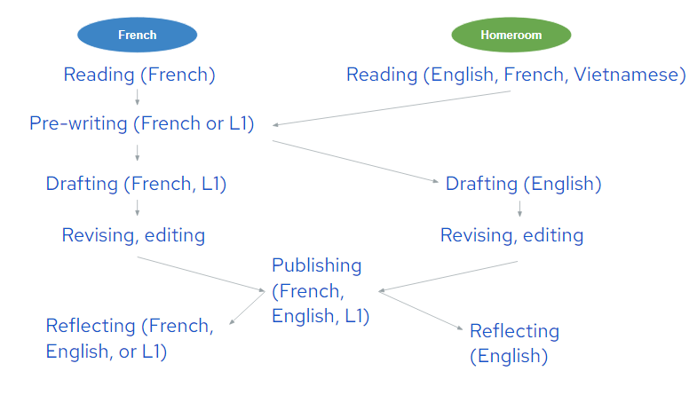
Figure 1
Stages of the Writing Process

As demonstrated in Figure 1, the stages of the writing process were divided between the FSL and homeroom classrooms. The languages in which the students worked are indicated in brackets. There are multiple points of entry at which language alternance can be introduced into the writing process. In addition to using the L1 as a pre-writing scaffold like Cummins and Persad (2014), we encouraged students to use their L1 during the publishing and reflecting stages. It is at these stages that the student is not being evaluated so much on the content of their writing as they are on their other metalinguistic strategies. Therefore, the teacher does not need to understand what is written in order to be able to assess the students’ ability to brainstorm (i.e., pre-writing), to organize the presentation of a text (i.e., publishing), to create visuals (i.e., publishing), or to reflect on helpful strategies in the writing process (i.e., reflecting). For students who submit their reflection in an L1 other than English and French, we used translation software or asked another student to translate it.

In Figure 2, we provide an example of a student’s final product for this unit. This student, an emigrant from Korea, had started the academic year with almost no instruction in English and none in French. The student would have received four months of instruction in both languages by the time of submission. If the reader looks at the second box in Figure 2, they will notice that the student provides a reference for the image that they sourced. Referencing is a skill that the student developed in their homeroom class, and a requirement which Daniella had added to the assignment. This is another benefit of shared products: the cross-curricular nature of the assignment led to an enhanced final product beyond what could have been achieved in either the FSL or homeroom classroom alone.

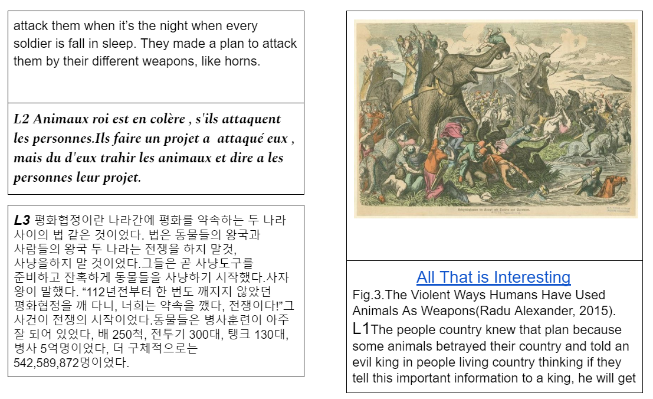
Figure 2
An Example of a Student’s Plurilingual Fairytale, Written in French, English, and Korean

In Figure 3, there are unedited translations of the text from Figure 2 (French to English and Korean to English). The reader is invited to notice how the degree of detail increases from the students’ least proficient language to their most proficient one. When students brainstorm in the L1, they are able to develop their ideas with more creativity and detail because they are not burdened by the additional cognitive demands of translation. As students translated to their additional languages in the FSL classroom, for example, students had only learned present tense conjugations of être (to be), avoir (to have), and regular ER verbs, which is reflected in the tense choice of this student’s text. The French to English is a free translation, and the Korean to English was completed using Google Translate.
French to English  Once upon a time, there is a animal country and a person country. In the person country, there is an evil king to live in the castle, he does not give to eat, but the people are angry, so they hunt the animals in the animal country. | English  Once upon a time, there was an animal living country and people living country, in people living country, there was plenty of food that can feed everybody in the castle, but the evil king doesn’t let them get what they planted. The people were starving, so they tried to hunt the animals. | Korean to English  A very long time ago, there was the kingdom of animals and the kingdom of man; the kingdom of animals was very peaceful, unlike other kingdoms; no social or economic problems arose; whereas the kingdom of men was a different thing; their king was very selfish and irresponsible. The daily walking tax and all the food was eaten only by kings and nobles...

Figure 3
Translations of the Text From the Student’s Work in Figure 2

At the end of this summative task, I collected packages which were used to assess the student’s work. These packages included the brainstorming worksheet, the rough draft with teacher suggestions, a second draft with student corrections, a published copy or final version, as well as a post-unit reflection. These packages were used as authentic assignments which teacher candidates could assess, following an authentic rubric, during the cL2c workshop. In the following section, I describe the structure of the workshop and the corresponding activities.

The Workshop

Following the completion of the aforementioned unit, I had the opportunity to present it during a regional conference in Vietnam which brought together teachers at international schools across the city. Moreover, I brought the student work developed above to FSL department meetings, where the other teachers and I used it as a tool for professional learning. Building on ideas that worked with in-service teachers, I adapted them for teacher candidates in the context of a 75-minute workshop conducted during the 2022 cL2c conference. In my view, workshops which encourage collaboration between FSL and homeroom teacher candidates need to be language-focused and assessment-focused. Below, I discuss the research which supports language awareness and assessment in ITE, then describe how the activities met these foci. Finally, I reflect on the déroulement of the workshop and its implications for ITE.

Developing a Language-Focused Workshop

All teacher candidates begin their ITE with previous experiences related to language learning and teaching. Consciously or not, these experiences, which may be rooted in such fallacies like the monolingual principle or the two solitudes assumption, guide their beliefs and practices as they plan activities and assessments (Cummins & Persad, 2014; Faez, 2011). It is therefore necessary for teacher candidates to be given professional learning opportunities wherein they reflect on previous experiences with language learning and the implications that these experiences may have on their practices. Byrd Clark (2008) refers to this reflection as a time where teacher candidates come to understand their investment in language learning. What languages and associated cultures are valued in Canadian society, and how do their practices reproduce these values in education? For teacher candidates to critically reflect on their investments, a language-focused workshop creates the conditions for them to make explicit their deeply held beliefs. To attain this goal, the first two activities in this workshop are based on plurilingual approaches, inspired by such projects as Élodil at the University of Montreal (Université de Montréal, n.d.).

Plurilingual approaches are a type of pedagogy which supports language alternance and curricular transversality in language teaching. In the framework of these approaches, linguistic diversity is treated as an asset and a tool for learning. In the Élodil project, for example, Lory and Armand (2016) list three ways that languages and representations of languages can be used as an object of study. Students may:

- observe, manipulate, listen to, pronounce, or write words and phrases in different languages;
- discover facts (geographic, historic, and linguistic) about different languages;
- reflect on the roles and uses of language in different environments and in their everyday life.

Although these tenets are originally conceived for student learning in the classroom, and indeed, underpin the theory driving cross-curricular plurilingual pedagogy, I believe they are just as valuable for the professional learning of teacher candidates.

Activity 1: Les Bonjours

This activity is taken directly from the Élodil website. For this activity, students are presented with a list of words in different languages which each translate to “hello”, as well as a box with the names of the corresponding languages. Students must identify in which language each “hello” is written. In my workshop, I placed a similar list of greetings on the Mural application, an online collaboration tool. The participating teacher candidates worked together to identify the languages of each word (see Figure 4). At the end, volunteers offered to read the greeting aloud and provide the answer. I reminded the teacher candidates that their pronunciation of each greeting may not be entirely correct, and that this is acceptable.

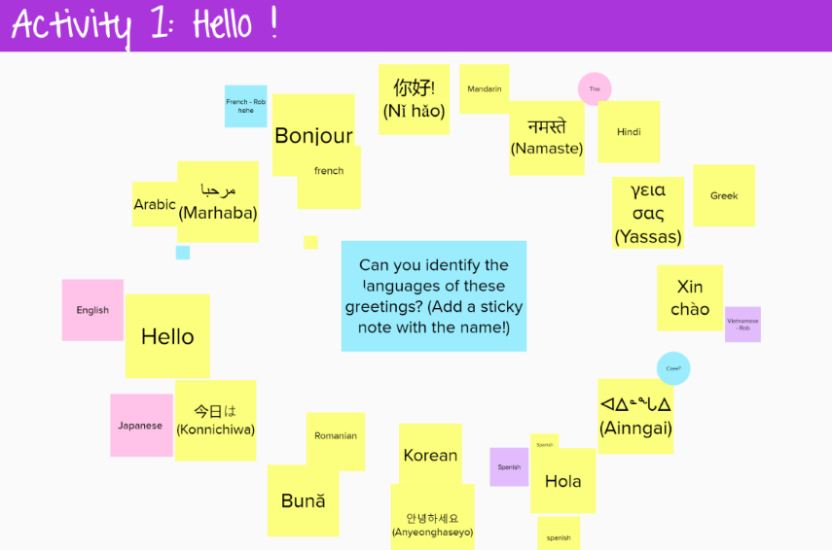

Figure 4
A Screenshot of the Activity 1 Setup in the Mural Online Application

This activity serves as an excellent introduction to any lesson because it signals to learners that all languages are valued in that context. If there are learners who speak one of the languages in which a greeting is presented, they may take a leading role by teaching the proper pronunciation of that greeting. In this way, the activity provides an opportunity for learners to present themselves and reveal their language assets, if they choose to do so.

The hello game is a simple way for educators to promote the active use of non-official languages in their classroom. I explore the difference between active and passive use of languages in Activity 2.

Activity 2: Active or Passive?

When a language is used explicitly as the medium of instruction, it facilitates the legitimation process of that language into a student’s repertoire, helping them overcome feelings of linguistic insecurity (Lory & Armand, 2016). As teachers consider official languages the only viable medium of instruction (i.e., the monolingual principle), attempts to incorporate non-official languages into their pedagogy may be done implicitly or passively. For example, a teacher may hang posters in different languages around the classroom, but not refer to them during their lessons. In order to challenge passive uses of plurilingualism, the second activity is meant for teacher candidates to exercise their professional judgment as they evaluate the degree to which common attempts at language alternance in the classroom are explicit. Following the prompt “active or passive?”, teacher candidates judge the following activities:

- the “hello” game;
- a culture festival;
- a bilingual word wall;
- the creation of plurilingual texts.

Generally speaking, I found that workshop participants were able to recognize that a culture festival and a bilingual word wall did not necessarily involve an active use of languages, and were able to propose ways in which these activities could be altered to achieve the active mode. Once participants understand the value of their professional judgment and are ‘calibrated’ to plurilingual thinking, they are better positioned to understand how to assess plurilingual student work.

Developing an Assessment-Focused Workshop

In the same way that language learning experiences influence one’s teaching practice, teacher candidates arrive in ITE with experiences related to assessment which impact their practice. Beliefs about assessment develop during K-12 schooling, where many mainstream teachers continue to implement product-oriented forms of assessment, which means that assessment is based solely on tests or summative tasks that occur towards the end of the unit. In addition to these concerns, FSL teacher candidates may have developed preconceived notions about assessment which place an emphasis on grammatical accuracy and orthographic control instead of on the student’s ability to communicate ideas (Rehner et al., 2021). To confront these obsolete notions, researchers call for explicit assessment instruction during ITE programs, with the goal of encouraging candidates to embrace alternative ideas of the purposes and practices of assessment (DeLuca & Bellara, 2013). Explicit assessment instruction can and should occur at moments outside of formal assessment courses.

Activity 3: Collaborative Assessment

With this in mind, Activity 3 is an assessment experience for teacher candidates which is based on collaborative assessment. Collaborative assessment is a practice where multiple teachers candidates negotiate the assessment of student work in order to “develop shared interpretations of assessment tasks and the requisite standards… and to develop a common language for describing and assessing students’ work” (Wyatt-Smith et al., 2010, p. 72). Drawing from Adie et al. (2012), I implemented the ‘calibration’ model of collaborative assessment, where participants mark previously selected samples of student work. In preparation for this activity, I created PDF copies of four examples from the student work packages which had been written in at least English and French (see Appendix A for student work example). I tried to select examples which represented different achievement levels based on my assessment scheme. I also prepared a copy of the rubric I used for assessment (see Appendix B). This rubric followed the Ontario assessment standards, meaning it was divided into the four categories: Knowledge and Understanding, Thinking, Communication, and Application, and had descriptions for each of these categories ranging from level 1 to level 4. The FSL curriculum overall expectations for writing were listed at the top. In addition, the learning goal and the final task were written as “I can” statements (respectively, “I can use the writing process to write a story/I can create a fairy tale in two or more languages). After presenting the cross-curricular plurilingual unit and the assessment criteria, I asked participants to look through the first package as well as a rubric and tell me what they noticed. Then, we consulted the rubric together and participants discussed what level they would give the student. I invited the teacher candidates to critique my rubric as their assessment practice may be different from mine. Afterwards, I divided the participants into breakout groups and they continued the collaborative assessment activity for the other three examples. The activity lasted about 40 minutes.

There were a few salient takeaways from this activity. First, when the teacher candidates were analyzing the rubrics, they began discussing assessment practices in a way that mirrors the professional judgment decision-making of experienced teachers. For example, the teacher candidates disagreed on which category the assessment of visualizations should be placed: while one suggested that this element should be assessed in Thinking, another argued that it should be in Application. During this discussion, the teacher candidates agreed that there should be an equal distribution of elements across the four categories and were hesitant to overload one category. In another line of thought, the teacher candidates recognized that they had difficulty assessing student work on my rubric because the rubric had context-dependent descriptors such as “student has a clear understanding of the vocabulary”. They debated whether my approach was appropriate or whether specific vocabulary should be included in the descriptors.

With regard to the category of Communication, the teacher candidates assessed the student work based on their known languages. In one of the breakout rooms, all of the candidates were in the FSL stream and decided to assess the French part of the assignment. In contrast, candidates in another breakout room had little knowledge of French and therefore assessed the English part of the assignment. Once again, the candidates had difficulty mapping the communication skills of the student work onto my rubric due to context-dependent descriptors. Nevertheless, each candidate offered their interpretation of what the language skills of a Grade 7 student should be in order to negotiate during the assessment process. Surprisingly, the candidates did not immediately recognize that the French language proficiency of a student in core French is probably lower than their proficiency in English, and as a result, assessed the French and English texts as if the proficiencies should be equal.

Lastly, the analysis of authentic student work also led to a discussion about student well-being. In one of the fairy tales, the student had written about a girl who escaped her abusive father thanks to a fairy godmother. As Cummins and Persad (2014) suggest, plurilingual texts are avenues for students to write about their lives and experiences in a way which represents and affirms their identity. One of the teacher candidates asked whether the text was a reflection of the student’s personal life and whether they were receiving support. This question sparked a discussion about teachers’ ethical responsibility when confronted with this type of content, as well as the procedure for responding in an appropriate way.

Discussion

FSL teachers often feel that their knowledge is devalued during professional learning opportunities, and are relegated to support functions (Knouzi & Mady, 2014; Mason, 2017). Not only is there a need to help language teachers recognize that they can be leaders of change in their schools, this change will only be possible when ELA teachers also recognize the knowledge and skills which FSL teachers can contribute to professional learning goals. Fostering dialogue and mutual understanding between these two groups of teachers is challenging, but starting this process during ITE may lead to the proliferation of cross-curricular and plurilingual approaches in Canadian classrooms. In this section, I offer reflections on the development of cross-curricular plurilingual pedagogy during my time as an FSL teacher, and on the advantages and limitations of using this pedagogy for professional learning in ITE.

Challenges of Cross-Curricular Plurilingual Pedagogy

As I had stated above, there were challenges in creating the cross-curricular unit with the homeroom teacher. As the FSL teacher, I did not share a common planning time with the other Grade 7 teachers, nor was I invited to participate in the Grade 7 team meetings (as I was expected to be at the FSL team meetings). Moreover, my classroom was located far away from the Grade 7 corridor. Combining these factors, it was difficult for me to find time to discuss with the Grade 7 teachers about their long-range plans. If I wanted to do cross-curricular planning, it was my responsibility and my burden to reach out to these teachers and propose ideas. I was grateful to work with someone like Daniella who had years of experience with second language learning pedagogy as well as a disposition for trying new ideas in her classroom. In spite of her willingness, poor planning on my part limited the degree to which the unit could be implemented simultaneously between the two classrooms.

During the second year of my tenure, Daniella moved to another school, which meant that I would have to establish new connections with the Grade 7 team if I wanted to do this unit again. Before the school year started, I attended the grade team meetings and asked if they would be willing to implement this unit which had been successful the previous year. The new cohort of Grade 7 teachers had much less language-pedagogy experience than Daniella, and they looked at me like I was speaking another language (I was speaking in English, I promise!). My proposal did not fit within the framework of their two solitudes assumption. They were hesitant to develop this unit with me but reluctantly agreed. I attended their team meetings before the unit started and tried to further our discussions. As the school year progressed, these teachers became quickly overwhelmed with managing their own curricular expectations and abandoned the cross-curricular unit. After the unit finished in my classroom, one teacher apologized to me and tried to extend the unit in their classroom by asking students to produce English versions of the fairytales they started in mine. I appreciated the effort, but report cards had already been submitted for the year and my students had already forgotten about the unit. As is always the case with FSL, the fairytales were an “add-on” to that teacher’s unit plans, only deserving of space once content higher up in the curricular hierarchy was completed. If cross-curricular plurilingual ventures are to be successful, homeroom classrooms need teachers like Daniella, who have a basis of understanding in second language pedagogy, an inclination for risk-taking, as well as flexibility in their unit planning skills. Moreover, this type of pedagogy is best supported by an administrative team that organizes common planning time between the FSL and ELA teachers.

Fostering Collaboration Between FSL and Mainstream Teacher Candidates

There is a growing recognition that the type of professional learning in which Canadian teacher candidates engage during ITE should reflect the type of learning that occurs in the profession (Cammarata & Haley, 2018; Gambhir et al., 2008; Kane & Francis, 2013). When teacher candidates enact collaborative assessment, they develop a professional practice of collaborative inquiry, which is a prerequisite skill for participation in teacher induction programs. As I have demonstrated through this workshop, the assessment of authentic student work allows teacher candidates to explicitly state their interpretations of assessment procedures and curriculum standards, so that they can negotiate these understandings with other candidates and develop a common language which ultimately allows them to complete the activity. At several moments during collaborative assessment, teacher candidates must confront the uncertainty of assessment practice as they attempt to exercise and justify their professional judgement of student work.

Using cross-curricular plurilingual pedagogy as a basis for collaborative assessment affords many opportunities to the professional learning of both FSL and ELA candidates. During the workshop, teacher candidates were able to develop both common and differentiated understandings of their professional practice. With regard to common understandings, first of all, the package of student work is a tool to help all teacher candidates overcome preconceived notions of product-oriented understandings of assessments. The package which teacher candidates analyze contains traces of the entire writing process, including brainstorming, drafting, revising, publishing, and reflecting. By asking candidates to consider all of these elements instead of just the published product, they gain experience with process-oriented approaches to assessment. Although the student work package represents a process, it is nevertheless limited in contributing to a reorientation away from product because it is presented as a summative task. It would be useful to find ways to include assessments that occur outside the summative task to promote a process-oriented understanding. Second, the plurilingual nature of the student work helps all teacher candidates, but especially FSL candidates, move beyond assessment beliefs tied exclusively to grammatical accuracy and orthographic control. When teacher candidates are asked to assess work in a language that they do not understand, they can no longer base their assessment on the students’ linguistic proficiency as demonstrated in the text. Instead, they are forced to consider metalinguistic skills that the student demonstrates if they wish to negotiate a mark for brainstorming, publishing, and reflecting (see Growing Success for more details [Ontario Ministry of Education, 2010, p. 28]). In this way, linguistic alternance reinforces the process-oriented nature of assessment.

The analysis of plurilingual student work also allows for differentiation in the professional learning of teacher candidates. While the FSL teacher candidates were able to work together to assess the French text in relation to the FSL curriculum standards, the ELA teachers were able to do the same with the English text. Admittedly, I did not have Daniella’s rubric for the unit at the time of the workshop, which would have been more useful for the learning of the mainstream teacher candidates. Another limitation to this workshop derived from the type of student work I had available. The examples I offered to the participants were taken from year 2 of the project, when no cross-curricular collaboration had occurred. As a result, the English version of the fairytales were not written or assessed under the guidance of an ELA teacher and may not reflect the English writing ability or expectations of a Grade 7 student. It would be useful to procure more student work from cross-curricular plurilingual units in order to provide authentic learning material to all teacher candidates.

It would also be remiss of me not to comment on the structure of this professional learning experience. I have no illusions that a 75-minute workshop had any meaningful impact on the pedagogical and professional practices of the participating teacher candidates. Compared to learning that occurs in courses over a longer period of time, teacher candidates often develop superficial understandings of concepts through workshop-style sessions (Cochran-Smith & Lytle, 2009; Dunn, 2011). Cross-curricular plurilingual pedagogy and its theoretical underpinnings require sustained learning over an extended duration so that teacher candidates have the time to make explicit their beliefs and attitudes, put new understandings into practice, and then critically reflect on the process. Activity 3 is only the first step in the collaborative inquiry practice development of teacher candidates. If the goal is for professional learning in ITE to reflect what occurs in the profession, the next step is to build the professional autonomy of teacher candidates by transitioning to the ‘conferencing’ model, where candidates guide their colleagues in the collaborative assessment process by using student work developed during their practicum (Adie et al., 2012). The conferencing model requires a significant amount of skill, autonomy, trust, and timing beyond what can be accomplished in the framework of a workshop. More research into different models of collaborative assessment will fulfill a need to understand how multiple pre-service structures contribute to the assessment competence of teacher candidates (DeLuca & Bellara, 2013).

Conclusion

In this paper, I present a cross-curricular unit which was conducted between an FSL and ELA teacher, and was informed by plurilingual approaches. The student work produced from this unit was subsequently used as a professional learning tool during a workshop to develop the collaborative inquiry practice of teacher candidates. If we aim to overcome the devaluation of FSL teachers’ knowledge and practice during professional learning, it is essential to find ways to foster mutual understanding between FSL and ELA teacher candidates during ITE. In my view, centering professional learning in ITE around cross-curricular plurilingual pedagogy creates conditions in which both FSL and ELA candidates can develop a common understanding of the implementation of plurilingual approaches, and simultaneously, a mutual respect for the unique professional learning practice of each of these groups. The collaborative assessment of student work deriving from this pedagogy provides a common professional learning framework for teacher candidates in FSL and other streams, and bolsters their confidence to reach across the language aisle once they transition to the profession.

References

Adie, L. E., Klenowski, V., & Wyatt-Smith, C. (2012). Towards an understanding of
teacher judgement in the context of social moderation. Educational Review,
64(2), 223–240. https://doi.org/10.1080/00131911.2011.598919

Byrd Clark, J. (2008). So why do you want to teach French? Representations of
multilingualism and language investment through a reflexive critical
sociolinguistic ethnography. Ethnography and Education, 3(1), 1–16.
https://doi.org/10.1080/17457820801899017

Cammarata, L., & Haley, C. (2018). Integrated content, language, and literacy
instruction in a Canadian French immersion context: A professional
development journey. International Journal of Bilingual Education and
Bilingualism, 21(3), 332–348. https://doi.org/10.1080/13670050.2017.1386617

Cochran-Smith, M. & Lytle, S. L. (2009). Teacher researcher as stance. In S. E. Noffke
& B. Somekh (Eds.), The SAGE handbook of educational action research (pp.
39–49). SAGE Publications. http://dx.doi.org/10.4135/9780857021021.n5

Cummins, J. (1979). Linguistic interdependence and the educational development of
bilingual children. Review of Educational Research, 49(2), 222–251.
https://doi.org/10.3102/00346543049002222

Cummins, J. (2007). Rethinking monolingual instructional strategies in multilingual
classrooms. Canadian Journal of Applied Linguistics, 10(2), 221–240.
Cummins, J. (2014). To what extent are Canadian second language policies evidence
based? Reflections on the intersections of research and policy. Frontiers in
Psychology, 5, 358. https://doi.org/10.3389/fpsyg.2014.00358

Cummins, J., & Persad, R. (2014). Teaching through a multilingual lens: The evolution
of EAL policy and practice in Canada. Education Matters, 2(1), 3–40.

DeLuca, C. & Bellara, A. (2013). The current state of assessment education: Aligning
policy, standards, and teacher education curriculum. Journal of Teacher
Education, 64(4), 356–372. https://doi.org/10.1177/0022487113488144

Dewey, J. (1938). Experience & education. Simon and Shuster.
https://doi.org/10.1103/PhysRevB.33.3530

Dunn, W. (2011). Working toward social inclusion through concept development in
second language teacher education. In K. E. Johnson & P. R. Golombek (Eds.),
Research on second language teacher education: A sociocultural perspective on
professional development (pp. 50–64). Routledge.
https://doi.org/10.4324/9780203844991

Faez, F. (2011). Developing the knowledge base of ESL and FSL teachers for K-12
programs in Canada. Canadian Journal of Applied Linguistics, 14(1), 29–49.

Gambhir, M., Broad, K., Evans, M., & Gaskell, J. (2008). Characterizing initial teacher
education in Canada: Themes and issues. International Alliance of Leading Education Institutes, September, 30.

Grosjean, F. (2010). Bilingual: Life and reality. Harvard University Press.

Kane, R. G., & Francis, A. (2013). Preparing teachers for professional learning: Is there
a future for teacher education in new teacher induction? Teacher Development,
17(3), 362–379. https://doi.org/10.1080/13664530.2013.813763

Knouzi, I., & Mady, C. (2014). Voices of resilience from the bottom rungs: The stories
of three elementary core French teachers in Ontario. Alberta Journal of
Educational Research, 60(1), 62–80.

Lory, M.-P., & Armand, F. (2016). Éveil aux langues et évolution des représentations
d’élèves plurilingues sur leur répertoire linguistique. Alterstice, 6(1), 27–38.
https://doi-org.proxy.bib.uottawa.ca/10.7202/1038276ar

Lyster, R., Collins, L., & Ballinger, S. (2009). Linking languages through a bilingual
read-aloud project. Language Awareness, 18(3–4), 366–383.
https://doi.org/10.1080/09658410903197322

Mady, C., Arnett, K., & Muilenburg, L. Y. (2017). French second-language teacher
candidates’ positions towards allophone students and implications for inclusion.
International Journal of Inclusive Education, 21(1), 103–116.
https://doi.org/10.1080/13603116.2016.1184330

Mason, S. (2017). Foreign language teacher attrition and retention research: A meta
analysis. NECTFL Review, 80(80), 47–68.

Moore, D. (2001). Une didactique de l’alternance pour mieux apprendre ? Éla. Études
De Linguistique Appliquées, 121(1), 71. https://doi.org/10.3917/ela.121.0071

Nguyên, N., & Quang, D. (2006). Le mat du têt (Cây nêu ngay têt). L’Harmattan.
Ontario Ministry of Education. (2010). Growing success: Assessment,
evaluation and reporting in Ontario schools (1st ed.).
http://www.edu.gov.on.ca/eng/policyfunding/growsuccess.pdf

Palmer, D. K., Martínez, R. A., Mateus, S. G., & Henderson, K. (2014). Reframing the
debate on language separation: Toward a vision for translanguaging pedagogies
in the dual language classroom. The Modern Language Journal, 98(3), 757–772.
https://doi.org/10.1111/j.1540-4781.2014.12121.x

Piccardo, E. (2016). La diversité culturelle et linguistique comme ressource à la
créativité. Voix Plurielles, 13(1), 57–75.

Prasad, G., & Lory, M.-P. (2020). Linguistic and cultural collaboration in schools:
Reconciling majority and minoritized language esers. TESOL Quarterly, 54(4),
797–822. https://doi.org/10.1002/tesq.560

Rehner, K., Lasan, I., Popovich, A., & Palta, Z. (2021). The impact of CEFR-related
professional learning on second-language teachers’ classroom practice: The case
of French in Canada. Canadian Journal of Applied Linguistics, 24(1), 26–53.
https://doi.org/10.37213/cjal.2021.28992

Université de Montréal (n.d.). Élodil: Enseigner en milieu pluriethnique et plurilingue.
https://www.elodil.umontreal.ca/

Wyatt-Smith, C., Klenowski, V., & Gunn, S. (2010). The centrality of teachers’
judgement practice in assessment: A study of standards in moderation.
Assessment in Education: Principles, Policy and Practice, 17(1), 59–75.
https://doi.org/10.1080/09695940903565610

Appendix A: Example of Student Work

Below is an example of a student work package taken from the culminating assessment of the cross-curricular plurilingual unit. In order, the reader will find a brainstorming worksheet, a rough draft, a differentiated support tool for the rough draft, the good copy, and the reflection.
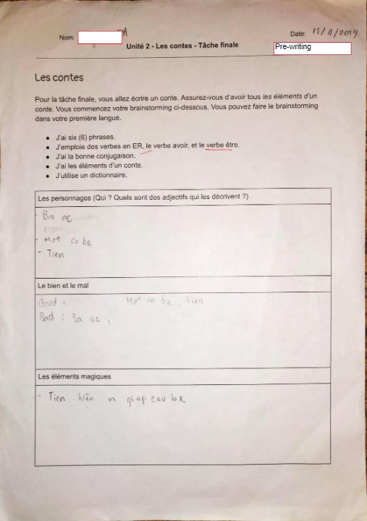

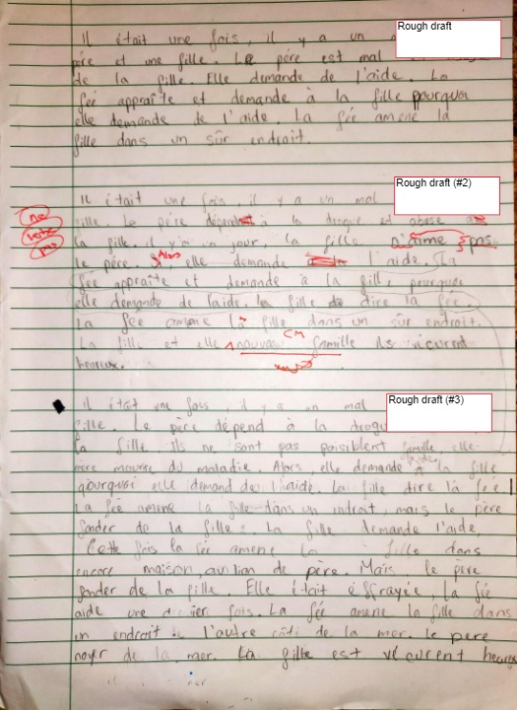
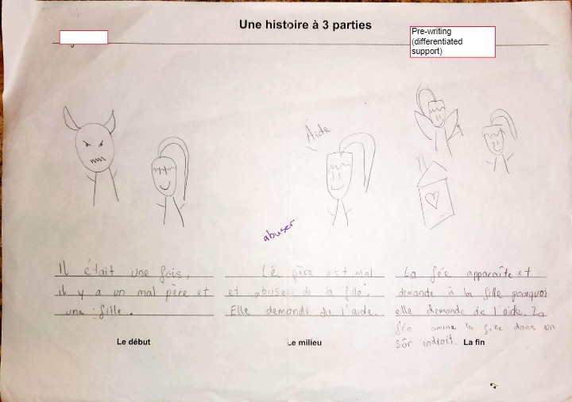
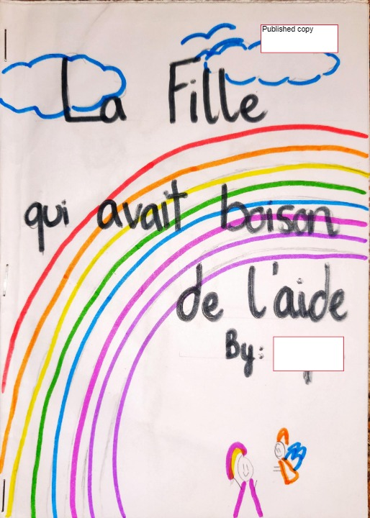

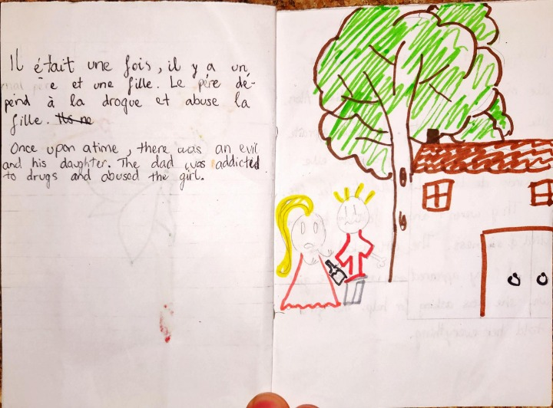
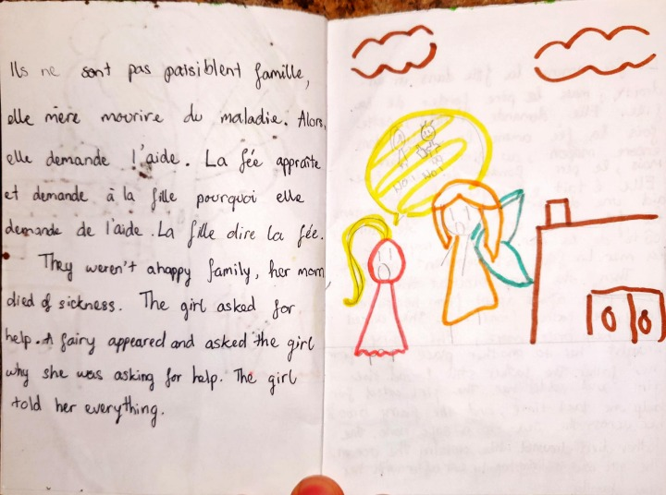
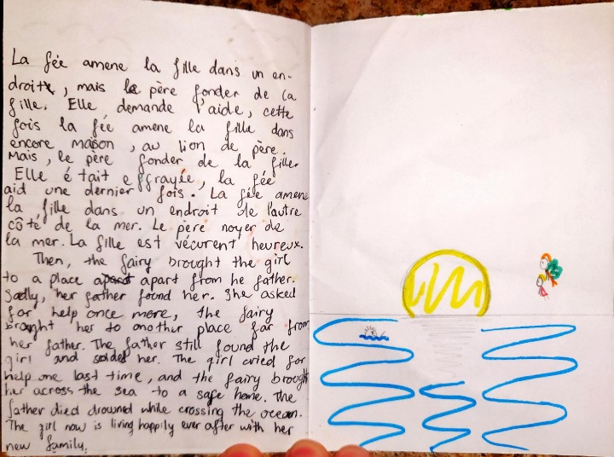

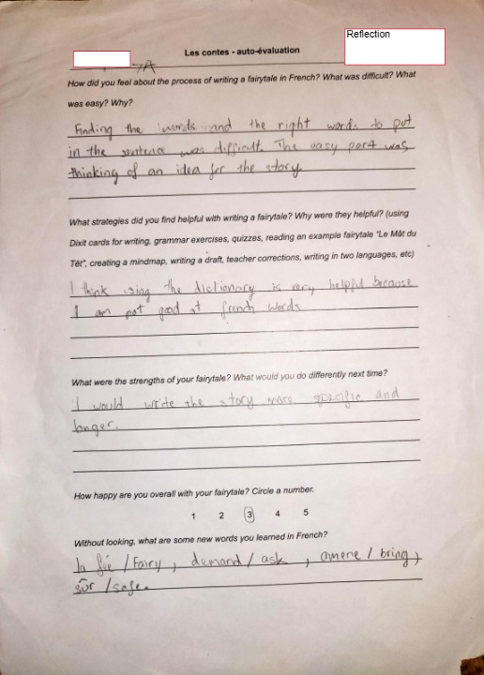

Appendix B: Assessment Rubric

Below is the rubric used to assess the student work, which was subsequently presented to teacher candidates for the collaborative assessment activity.

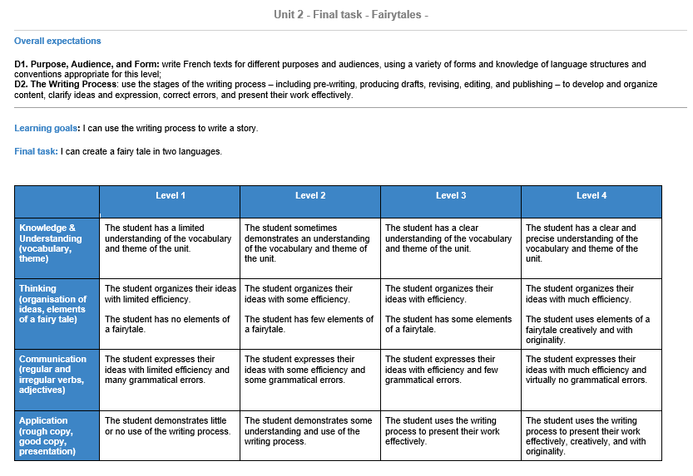
CHAPTER
3

An Extensive Reading Approach:

Teaching and Learning Within and Beyond the Language Classroom

Chuan Liu
University of Western Ontario

Abstract
Ontario schools recognize the need for English language learners (ELLs) to develop their academic competencies. Specifically, ELLs face challenges in content learning due to limited exposure to academic language. Furthermore, teachers’ negative beliefs and lack of knowledge of ELLs can also impede ELLs’ learning outcomes. To tackle these problems, this chapter will introduce an Extensive Reading (ER) approach. This chapter is based on the workshop initiated by the Second Language Education Cohort of the Bachelor of Education program at the Faculty of Education at the University of Ottawa for teacher candidates (TCs). In this workshop, I introduced ER to the TCs, who co-constructed the concepts of ELLs and ER through sharing their perspectives in the online community. Based on TCs’ perspectives, previous literature offered them an explicit picture of ER, underpinning the activities that teachers collaboratively experienced as to how ER benefitted students and could be implemented in various ways. To help TCs visualize the practice of ER, I shared a case from my class to showcase one possible way of implementing ER. Finally, TCs reflected on their learning in the wrap-up session by contributing to the word cloud.

Keywords: vocabulary, English language learners, art-based practices, drawing

Introduction

This chapter stems from a workshop that was presented during the professional development day initiated by the Second Language Education Cohort of the Bachelor of Education program at the Faculty of Education at the University of Ottawa. Participants were first-year students in a two-year program, many of whom had no specialization in teaching English as a second language. This online workshop aimed for teacher candidates (TC) of varied disciplines to build awareness around the idea that “Every teacher is a language teacher”.

According to Statistics Canada (2021), 2,040,399 students in grades K-12 are enrolled in second language programs, which includes students who have enrolled in an English as a second language (ESL) program and French as a second language (FSL) program. In diverse cities in Canada, such as Vancouver and Toronto, more than 20% of the students are English language learners (ELLs) in K-12 public schools (Roessingh, 2016). Given the large number of ELLs, Ontario schools recognize the need for ELLs to develop their academic competencies (Stille et al., 2015). In this chapter, I will follow the definition of ELL by the Ontario Ministry of Education (2007), namely, students whose first language is a language other than English.

It is critical for ELLs to engage in linguistic practices in different subject matters. Many ELLs encounter additional challenges in public schools in comparison to their peers (Hoffman et al., 2021). Specifically, ELLs have limited exposure to the academic language as opposed to first language learners (Renandya, 2007). Academic language in this chapter refers to languages used in different content areas, such as language arts, math, science, and social studies. As a result, ELLs may face more challenges in content learning (Leseman et al., 2019) and need a longer time to catch up with their native-speaking peers regarding academic language (Cummins, 1981). For example, the implementation of inquiry-based learning (i.e., students learn and build connections with the world through exploring and questioning) is not adequate to support ELLs in science classes (August et al., 2010). In the same vein, ELLs face vocabulary problems in both math (Moschkovich & Scott, 2021) and social studies (Zhang, 2017). Consequently, the linguistic barriers that ELLs encounter disrupt their comprehension and, even worse, their overall performance (Jozwik et al., 2021). To resolve this problem, it is suggested that students should be more exposed to academic language (Snow & Uccelli, 2009).

In addition to the challenges ELLs face in the classrooms, teacher beliefs and knowledge of ELLs can also in part influence ELLs’ learning. Kim (2021) reviewed studies published from 1985 to 2015 and concluded that when teachers' attitudes were negative, it could impede ELLs’ learning outcomes due to the devaluation of linguistic diversity and teachers’ limited knowledge of ELLs. Since teacher beliefs can influence their teaching practice (Kagan, 1992; Pajares, 1992), it is essential to address teacher beliefs through professional development (Wu, 2021).

To tackle the challenges of academic language exposure and teachers’ awareness of ELLs in classrooms of varied disciplines, the Extensive Reading (ER) approach can be a possible solution (Renandya, 2007). According to Carrel and Carson (1997), extensive reading “generally involves rapid reading of large quantities of material or longer readings (e.g., whole books) for general understanding, with the focus generally on the meaning of what is being read than on the language” (pp. 49-50). The following chart (see Figure 1) demonstrates the difference between extensive reading and teaching with a textbook.

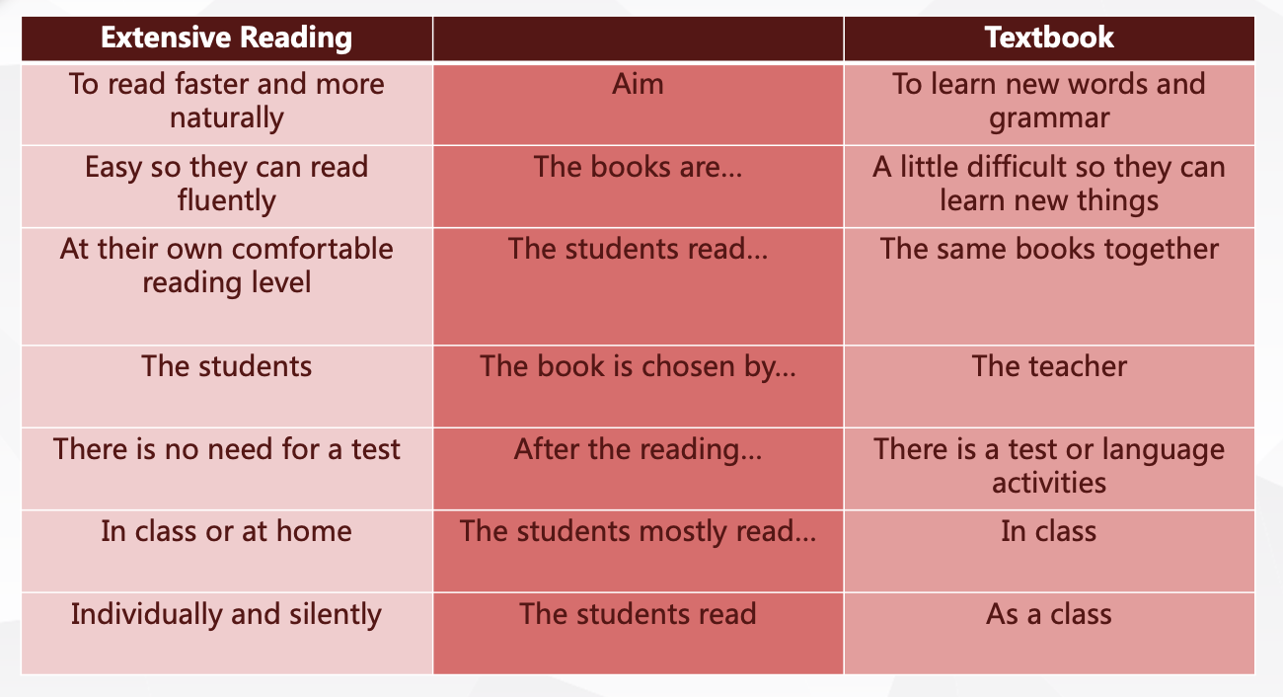

Figure 1
Key Ideas of ER

Previous research has demonstrated numerous benefits of ER, including promoting reading proficiency (e.g., Beglar & Hunt, 2014; Beglar et al., 2012; Huffman, 2014; Nation, 2007; Robb & Kano, 2013), enhancing reading motivation and attitude (e.g., Ro, 2016), improving general language proficiency (e.g., Jeon & Day, 2016), and expanding learners’ vocabulary (e.g., Krashen, 2004) and grammatical knowledge (e.g., Song & Sardegna, 2014). Therefore, the implementation of ER is ideal in different subject matters to expose ELLs to academic language.

This chapter aims to address teachers’ awareness of ELLs' challenges and knowledge of the ER approach to enhance ELLs’ exposure to academic vocabulary. By emphasizing academic language exposure, however, I do not mean to marginalize minoritized communities. According to Flores and Rosa (2015), the notion of academic language is considered a racialized ideology, where ELLs are molded to practice the white language, which is deemed the only appropriate language in the school context. Recognizing the limitations of academic language (Rosa & Flores, 2015), this chapter acknowledges the need for ELLs to be adequately exposed to academic language rather than solely advocating practice or prioritizing academic language in school contexts. Below, I will present theory, explain my rationale, and describe my experiences as well as the steps I took when implementing this workshop for TCs, thereby helping readers to visualize the workshop.

The Workshop Experiences

Overview

I am a veteran teacher with more than 10 years of teaching experience with Chinese ELLs. I have worked in English private language schools with mainly Chinese ELLs. I introduce ER in this workshop because it helps my students improve the mastery of their academic language and further develop their learning autonomy. At present, as an international student in an English dominant context, I find my experience very useful for TCs to recognize the needs of ELLs and resolve the limited exposure through implementing ER.

In this workshop, TCs learned about the research-based ER approach to support multilingual classrooms across disciplines. The workshop offered various interactive activities, including discussions, hands-on activities, and games. TCs were able to reflect on the concept of ELLs, ER, and critically examine the implementation of the ER approach through a case study. This workshop was presented in two consecutive sessions. Each session was 60 minutes.

Consciousness-Raising Activity: Find Someone Who…

As discussed in the introduction section, teachers’ belief and knowledge may influence their practice. As such, this consciousness-raising activity was developed to situate the teachers in the context to understand their beliefs and knowledge about ER.

To learn about TCs’ demographics, I asked them to add different tags to their zoom names. These tags included their teaching area, student age, and teaching experience, such as Chuan-English-KG-3yr. The TCs could find someone who had a similar background and send them a greeting message. Meanwhile, I could access the information and adjust the workshop objectives and pace.

The tags demonstrated that most TCs were specializing in K-6. Many of them were content teachers. Meanwhile, they had little experience with ELLs and little knowledge of the ER approach.

Given the fact that most TCs were unfamiliar with the ER approach, it was important to address teacher beliefs and knowledge about ER at the beginning of this workshop. Therefore, I adjusted my workshop to a focus on motivating the TCs through a number of activities demonstrated below, including conceptualizing ELLs and ER in the classrooms, and the necessity of implementing ER. Following this, I engaged them to discuss who ELLs were.

Consciousness-Raising Activity: The ELLs

Teachers’ understanding of ELLs may influence their teaching practice in their classrooms. It is critical to understand who ELLs are so that teachers can consciously adjust their teaching to address ELLs’ learning needs.

During the workshop, I prompted TCs to reflect on “who are English language learners?” and “why should we support them with language learning?”. TCs expressed their beliefs towards ELLs (see Figure 2).

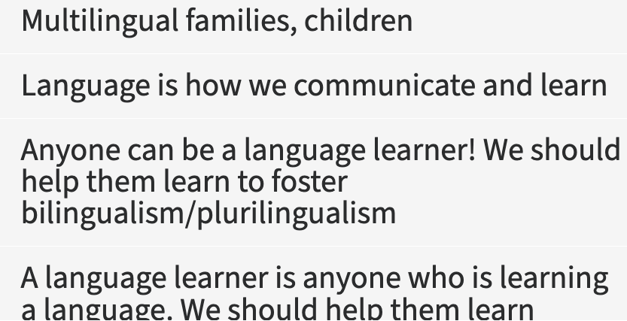

Figure 2
TCs’ Responses to the Identity of ELLs

The presentation of individual answers offered the TCs a collective understanding of ELLs. Originally, some TCs thought ELLs only referred to students who were in language programs or whose first language was not English. After reading each other’s answers, TCs realized that anyone could be an ELL, in that it referred to an individual who needed support in understanding and applying content vocabulary. As such, teachers, regardless of their content area, should posit themselves as language teachers. They could thus build awareness of and be more sensitive to ELLs so as to be more proactive in accommodating their needs in content classes.

Based on TCs’ responses, I shared reflections on my learning experiences. Specifically, I encountered difficulties in understanding the content in some of my undergraduate university courses even if the classes were delivered in my native language due to myriads of unknown academic words. Moreover, as an international student in Canada, I also came across misunderstandings of core concepts in my courses, such as ‘language learning’ and ‘language acquisition’, due to the similarity of meaning between ‘learning’ and ‘acquisition’ in my native language.

In a nutshell, this activity helped TCs to co-construct an understanding of ELLs through reflecting, reconstructing, and modifying their conceptions of ELLs. As such, TCs could build awareness of ELLs' learning needs. Next, I introduced the concept of ER.

Knowledge of ER Activity: The Concept of ER

In light of the understanding of teachers’ demographics and the concept of ELLs, I presented ER as a solution to address ELLs’ learning needs regarding academic language in their classrooms.

In line with an inquiry-based approach which solicits participants’ funds of knowledge, I developed multiple-choice questions (see Appendix A) regarding the concept of the ER approach based on the literature. TCs saw the questions on the slides and were given time to share their answers. When their time was up, I asked them to send out their answers simultaneously in the chat box. As such, they did not interrupt each other's ideas and had equal opportunities to express their opinions.

Then, I engaged TCs in discussion regarding questions based on related literature (Day & Bamford, 2002; Day et al., 1998). Day et al. (1998) define ER as an approach to reading where students read as much as possible and select what they want to read. The reading materials are of low-level difficulty, and the purpose of reading is for general understanding and pleasure so as to get more exposure to target academic language.

With a better understanding of ER, the TCs then discussed some of the misunderstandings about ER, including the choice of reading material, after-reading activities, and the teacher’s role. In line with ER, teachers should guide students in selecting their own book. After all, it is not necessary to have a quiz after ER. Rather, teachers may observe students’ behavior and intervene when necessary.

The multiple-choice activity promoted the TCs’ understanding of ER by predicting what ER is and affirming the concept of ER through reading literature. In K-12 classrooms, the focus of ER should be academic language exposure for ELLs through an easy and enjoyable reading process.

Knowledge of ER Activity: A Need for ER

After TCs built a better understanding of ER, we moved on to the significance of ER for ELLs. Understanding the value of ER or holding a positive value belief would contribute to the practice of ER (Wigfield & Eccles, 2000).

I asked the TCs to read sentences on an image (see Figure 3), which was purposefully flipped vertically. A volunteer teacher could still read the text but not very fluently. Others shared a similar experience. Then, I reminded TCs what it could be like to not be able to easily access a text and its content. Through this activity, TCs could perceive the challenges of ELLs in their reading experience.

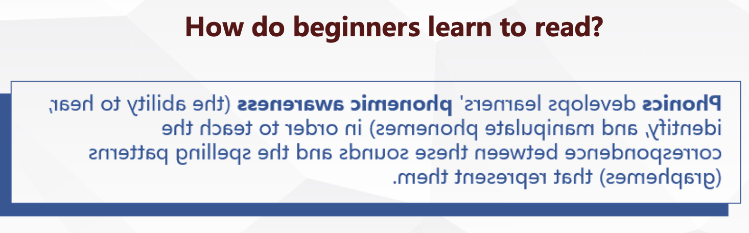

Figure 3
Flipped Reading Material

Next, I showed the TCs an article with different proportions of missing words (see Figure 4). I asked them to read the text and see if they could make sense of the text. All TCs agreed that they could comprehend the text with 5% missing words, but they were more comfortable with the presence of all the words. This experiential learning activity led us to conclude that students would enjoy reading easy text with knowing more than 95% of the words, which is congruent with Hu and Nation’s (2000) finding. In contrast, too many unknown academic words would impede their reading motivation (Day et al., 1998).

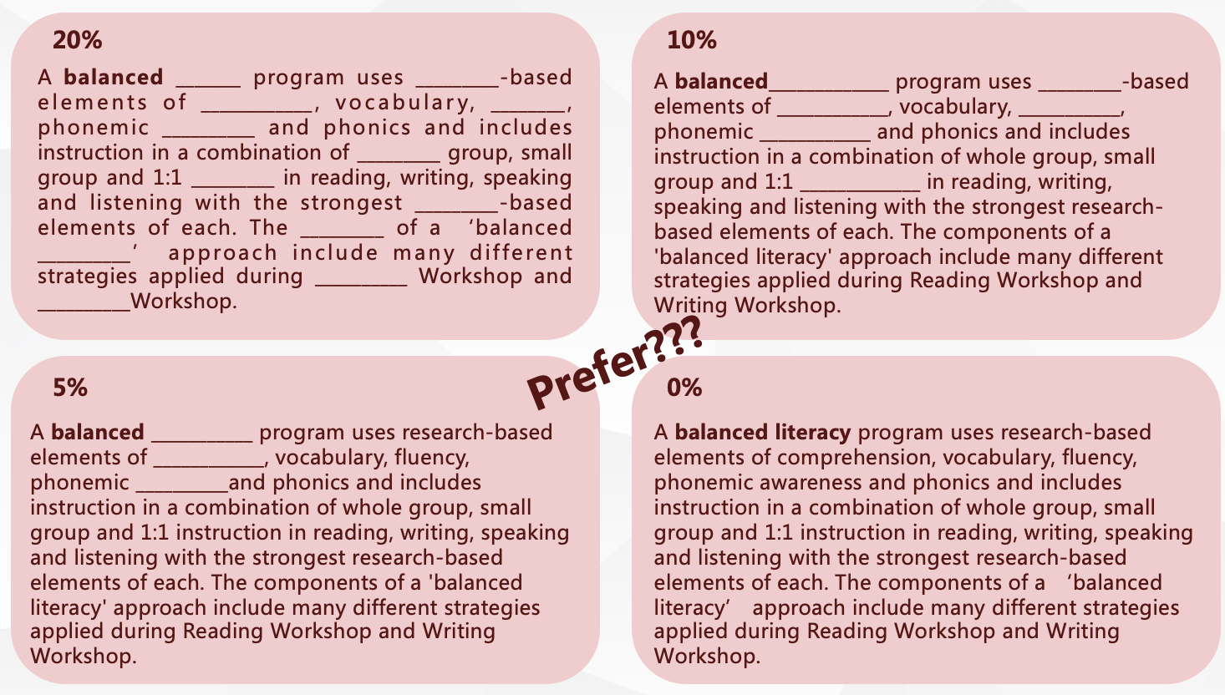

Figure 4
Different Ratios of Missing Words in the Same Text

These activities help TCs understand the challenges that ELLs face in reading different content books and how unknown academic vocabulary could disrupt students’ understanding of the content. To fill in the gap, ER can increase the frequency of academic vocabulary and contextualize word use in content areas so as to enhance vocabulary learning and use (Pigada & Schmitt, 2006). Next, I discussed the implementation of ER.

Knowledge of ER Activity: The Implementation of ER Approach

Building upon the rationale of ER, we then discussed the implementation of ER. Given that pedagogical knowledge, namely the knowledge of teaching methodology, is the key to effective teaching (Shulman, 1987), teachers can transform their content knowledge into practice and create various forms of representations to deliver content (Shulman, 1986).

I engaged TCs with a discussion regarding ten principles of ER proposed by Day and Bamford (2002):

- The reading material is easy.
- A variety of reading material on a wide range of topics must be available.
- Learners choose what they want to read.
- Learners read as much as possible.
- The purpose of reading is usually related to pleasure, information, and general understanding.
- Reading is its own reward.
- Reading speed is usually faster than slower.
- Reading is individual and silent.
- Teachers orient and guide their students.
- The teacher is a role model of a reader. (pp. 137–141)

After browsing the principles, TCs were asked to share which principles they would most likely follow if they practiced ER. TCs gave divergent opinions towards the principles, which resonated with the idea that the classroom practice is bounded to the teaching context (Macalister, 2008).

Following this, I shared a result of Day’s (2015) research about the top three practiced principles:

- A variety of reading material on a wide range of topics must be available.
- Learners choose what they want to read.
- Learners read as much as possible.

To respond to teachers’ different choices, I presented what Day (2015) concluded:

while there is no widespread agreement on exactly what an ER program is, based on the results of the survey, it can be claimed that an ER program uses some of the 10 principles. If none are used, then a so-called ER program is most likely a fringe ER program. (p. 298)

In summary, the implementation of ER may differ due to disparate classroom settings. ER can be a stand-alone activity (Day & Bamford, 2002) or embedded in a task-based approach (Green, 2005). ER can also act as a supplementary activity (Nakanishi, 2015), including but not limited to book reports and small-group discussion (e.g., Beglar et al., 2012), worksheets, filling in vocabulary notebooks based on the books the learners read, etc. (e.g., Horst, 2005). ER can be accompanied by both pre-reading activities, such as choosing an appropriate title for the book, and post-reading activities, such as teacher-led instruction on vocabulary-learning strategies (e.g., Al-Homoud & Schmitt, 2009). After independent reading, for example, students can design a poster, role play the story, and have a debate on controversial issues raised by a book. More activities can be found in Appendix B.

To help TCs implement ER, I offered them a revised checklist of a successful ER program based on Renandya’s (2007) work. Teachers who implement ER do not need to follow every item listed in the checklist. In contrast, teachers can check if they have included any ER elements in their teaching practice. Teachers may find the checklist below:

- Do students read large amounts of books that contain the academic vocabulary?
- Do students choose what they want to read?
- Do books that contain the academic vocabulary vary in terms of topic and genre?
- Are books students read within their level of comprehension?
- Are students engaged in post-reading activities that target the content vocabulary?
- Do teachers model read to the students?
- Do teachers and students keep track of student progress regarding the content vocabulary?

Afterwards, I shared a case study from my previous teaching to help TCs visualize the implementation of the ER approach.

Case Study

I shared my experience of implementing an activity called The Author's Chair to engage students with ER. In the case study, I was the teacher of a group of 24 ELLs whose ages ranged from 6 to 12. I employed the content-based approach, teaching language arts, math, social studies, and science, in English. The focus of my teaching is multifaceted: (1) students are able to build interests in reading; (2) students are able to get more exposure to academic vocabulary at their appropriate level; (3) students are able to build confidence in communicating their thoughts and opinions with target academic language. Since the students’ needs were highly different, ER allowed me to address their needs through facilitating their selection of books at appropriate levels.

Lesson procedures are as follows:

Step 1: Understand the Task
I shared the objectives of the activity with the students. They should find a book in the library and read independently. I asked them to finish a worksheet, which assisted them with the book report.

Step 2: Find a Book
They were given three minutes to find a book of their own level. I demonstrated how they could use “Five Finger Rules” to find the right book. In other words, if the book had more than two unknown words on a single page, the students should find another book (Day et al., 1998).

Step 3: Finish the Worksheet (see Appendix C)
I designed worksheets for students of different levels. The worksheet contained more lower-order thinking questions for beginners, such as who the story was about and what problem the characters had. Meanwhile, I asked more advanced students critical or creative thinking questions, such as what their favourite part of the book was or what they would change about the story. At the same time, students were able to get familiar with the content vocabulary, such as character, setting, and plot.

In math and science classes, I asked students to recognize the content words in the stories or nonfiction books and take note of what they learned from the books. For beginners, I asked them to introduce one page of the book and the words they found. For more advanced students, I asked them to use thinking maps or visual arts, such as drawing a food chain or bubble map of a community to demonstrate what they read from the books.

Step 4: Share the Book
Students acted as the book’s promoter to share the books they read. Specifically, I invited the students to sit on a swivel chair. They presented their books and shared one thing or one page that they loved about the book and/or the content words they had identified from the book. The use of a swivel chair motivated the students to share in front of the class instead of sitting on a regular classroom chair.

Step 5: The Class Popularity Vote
I asked the students to vote for the book they liked with stickers. Each student had two stickers, which they stuck on the presenter’s clothes. The books that received the most stickers were designated the popular books of the month.

As a teacher, I made the following observations and noticed numerous changes. First, I circulated throughout the classroom during ER time to take anecdotal notes about who was on task and found that more students were engaged in this activity at the end of the term. Second, more students enjoyed reading, as demonstrated by their eagerness to rush into the school library and pick up their books. As the teacher and researcher, I perceived that the act of reading made the students more engaged in academic language. That said, we could not expect a student to become fluent in academic language without adequate exposure.

Next, I will present the reflections of TCs and share my interpretations of their reflections.

Reflection

At the end of the workshop, TCs were asked to share three takeaways, including new knowledge, methods, and ideas. Then, we produced a word cloud to illustrate their collective understandings (see Figure 5).

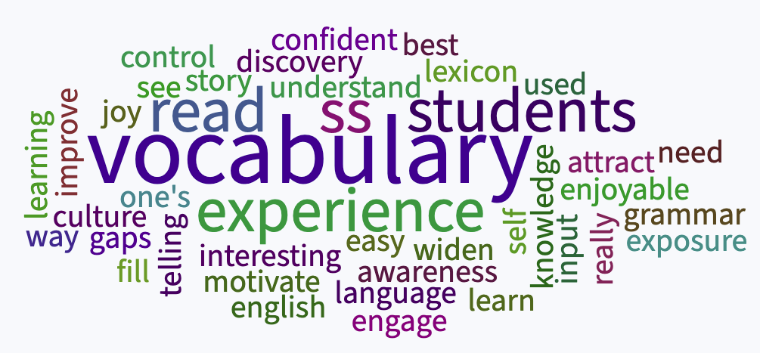

Figure 5
Word Cloud

The top four keywords that emerged in the word cloud were vocabulary, students, read, and experience.

In terms of vocabulary, most TCs agreed that ER could address academic vocabulary in different contents. The results correspond to the purpose of this workshop, namely, drawing TCs’ attention to ELLs’ learning challenges regarding academic vocabulary. Given the disruptiveness brought by academic words, the incorporation of ER would help ELLs recap academic words with adequate context-bounded exposure. As such, ELLs could gain familiarity with target vocabulary.

With regards to students, the consciousness-raising activities helped TCs recognize ELLs’ identity. TCs could relate to ER as a student-centered approach which would allow students to choose their own books at their appropriate level, as teachers are not the decision-makers or leaders of the class. In contrast, teachers would facilitate the process of students’ book selection and independent reading.

Concerning read, teachers of different subjects acknowledge the role of reading across disciplines. To strengthen students’ reading capability, teachers should encourage and motivate students to read extensively. As such, students can clear the barriers of academic vocabulary and improve their performance in their subject content.
TCs also highlighted experience in their reflection. Learning is not the filling of a pail but offering students an experiential learning process. ER thus reinforces students’ learning agency by cultivating active learners. This workshop follows the ER style by engaging TCs through activities in order to experience the reading process of ELLs.

In a nutshell, the aim of ER is not just to learn new words but to consolidate the content vocabulary learned in classes. To achieve this aim, students should read easy books at their own comfort levels rather than challenging books. To address their needs, teachers should offer large amounts of books that contain the target vocabulary so that students can choose their favourite books. Students should regard the reading as its own reward. That said, teachers do not need to test students' knowledge after their reading. Instead, teachers are encouraged to plan post-reading activities to facilitate authentic learning of academic vocabulary, such as accomplishing tasks, engaging in discussions, and creating artifacts.

Finally, I will conclude this chapter with key ideas of this workshop.

Concluding Thoughts

In this workshop, I introduced ER to the TCs, who co-constructed the concepts of ELLs and ER by sharing their perspectives in the online community. Based on TCs’ perspectives, prior literature offered them a clear picture of ER, underpinning the activities that teachers collaboratively explored and through which they experienced how ER benefitted students. To help TCs visualize the practice of ER, I shared a case from my class to showcase one possible way of implementing ER. At the same time, the case did not aim to generalize the practice of ER. Instead, the introduction to the class demographics contextualized the ER activities design and helped teachers to make sense of my practice. Teachers reflected on their learning in the wrap-up session by contributing to the word cloud.

ER is not a panacea but one possible remedy for addressing ELLs’ needs in content classrooms. Teachers who employ the ER approach need to be attentive to students’ emotions and motivations rather than knowledge and grammar. Simply put, ER offers students a chance to get adequate exposure to academic vocabulary and gain confidence and comprehension in classes of varied disciplines. The underlying ER principles (Day & Bamford, 2002) presented above will stimulate more approaches and methods in different contexts and classrooms.

In addition to the benefits of ER, teachers should also be aware of its limitations. First, content teachers may not have enough time or resources for students to read during the class. In response to this problem, content teachers may collaborate with language arts and language teachers to design an extensive reading program for language learners. I have also shared some e-learning resources in Appendix D. Second, teachers who are unfamiliar with ER may find it less efficient than teacher-led activities. Teachers need to carefully observe their students' behavior and reflect on how different teaching methods will influence students' learning outcomes. Since ER is a research-based approach, teachers should learn more about ER, such as the articles in the references list, and dedicate more time to student-centered learning. As such, students can become independent and confident learners.

To sum up, one workshop is merely the beginning of a potential change in teachers' behaviours. Teachers should continuously participate in such workshops and reflect on their teaching practices to keep themselves updated with evolving pedagogies.

References

Al-Homoud, F., & Schmitt, N. (2009). Extensive reading in a challenging environment:
A comparison of extensive and intensive reading approaches in Saudi
Arabia. Language Teaching Research, 13(4), 383–401.
https://doi.org/10.1177/1362168809341508

August, D., Artzi, L., & Mazrum, J. (2010). Improving science and vocabulary learning
of English language learners. CREATE brief. Center For Research on the
Educational Achievement and Teaching of English Language Learners.

Beglar, D., & Hunt, A. (2014). Pleasure reading and reading rate gains. Reading in a
Foreign Language, 26(1), 29–48.

Beglar, D., Hunt, A., & Kite, Y. (2012). The effect of pleasure reading on Japanese
university EFL learners’ reading rates. Language Learning, 62(3), 665–703.
https://doi.org/10.1111/j.1467-9922.2011.00651.x

Carrell, P. L., & Carson, J. G. (1997). Extensive and intensive reading in an EAP
setting. English for Specific Purposes, 16(1), 47–60.
https://doi.org/10.1016/S0889-4906(96)00031-2

Cummins, J. (1981). Age on arrival and immigrant second language learning in Canada:
A reassessment. Applied Linguistics, 2(2), 132–149.
https://doi.org/10.1093/applin/II.2.132

Day, R. R. (2015). Extending extensive reading. Reading in a Foreign Language, 27,
294–301.

Day, R. R., & Bamford, J. (2002). Top ten principles for teaching extensive reading.
Reading in a Foreign Language, 14(2), 136–141.

Day, R. R., Bamford, J., Renandya, W. A., Jacobs, G. M., & Yu, V. W.-S. (1998).
Extensive reading in the second language classroom. RELC Journal, 29(2), 187–
191. https://doi.org/10.1177/003368829802900211

Flores, N., & Rosa, J. (2015). Undoing appropriateness: Raciolinguistic ideologies and
language diversity in education. Harvard Educational Review, 85(2), 149–171.
https://doi.org/10.17763/0017-8055.85.2.149

Green, C. (2005). Integrating extensive reading in the task-based curriculum. ELT
Journal, 59(4), 306–311. https://doi.org/10.1093/elt/cci059

Hoffman, L., Suh, E., & Zollman, A. (2021). What STEM teachers need to know and do
to engage families of emergent multilingual students (English language
learners). Journal of STEM Teacher Education, 56(1), 1–15.

Horst, M. (2005). Learning L2 vocabulary through extensive reading: A measurement
study. Canadian Modern Language Review, 61(3), 355–382.
https://doi.org/10.1353/cml.2005.0018

Hu, M., & Nation, I. S. P. (2000). Vocabulary density and reading comprehension.
Reading in a Foreign Language, 13, 403–430.

Huffman, J. (2014). Reading rate gains during a one-semester extensive reading course.
Reading in a Foreign Language, 26(2), 17–33.

Jeon, E.-Y., & Day, R. R. (2016). The effectiveness of ER on reading proficiency: A
meta-analysis. Reading in a Foreign Language, 28(2), 246–265.

Jozwik, S. L., Freeman-Green, S., Kaczorowski, T. L., & Douglas, K. H. (2021). Effects
of peer-assisted multimedia vocabulary instruction for high school English
language learners. Reading & Writing Quarterly, 37(1), 82–100.
https://doi.org/10.1080/10573569.2020.1723153

Kagan, D. M. (1992). Implication of research on teacher belief. Educational
Psychologist, 27(1), 65–90.

Kim, S. L. (2021). A review of the literature on teachers’ beliefs about English language
learners. International Journal of Educational Research Open, 2, 100040.
https://doi.org/10.1016/j.ijedro.2021.100040

Krashen, S. (2004). The power of reading: Insights from the research. Libraries
Unlimited.

Leseman, P. P., Henrichs, L. F., Blom, E., & Verhagen, J. (2019). 15 young
monolingual and bilingual children’s exposure to academic language as related
to language development and school achievement. Learning through Language:
Towards an Educationally Informed Theory of Language Learning, 205.

Macalister, J. (2008). Implementing extensive reading in an EAP programme. ELT
Journal, 62(3), 248–256. https://doi.org/10.1093/elt/ccm021

Moschkovich, J., & Scott, J. (2021). Language issues in mathematics word problems for
English learners. In A. Fritz, E. Gursoy, & M. Herzog (Eds.), Diversity
dimensions in mathematics and language learning (pp. 331–349). Walter de
Gruyter GmbH.

Nakanishi, T. (2015). A meta‐analysis of extensive reading research. TESOL
Quarterly, 49(1), 6–37. https://doi.org/10.1002/tesq.157

Nation, P. (1996). The four strands of a language course. TESOL in Context, 6(1), 7–12.

Nation, P. (2007). The four strands. International Journal of Innovation in Language
Learning and Teaching, 1(1), 2–13.

Nation, P., & Chung, T. (2009). Teaching and testing vocabulary. In The handbook of
language teaching (pp. 543–559). Wiley‐Blackwell.
https://doi.org/10.1002/9781444315783.ch28

Ontario Ministry of Education. (2007). English language learners: ESL and ELD
programs and services: Policies and procedures for Ontario elementary and
secondary schools, kindergarten to Grade 12.
http://www.edu.gov.on.ca/eng/document/esleldprograms/ esleldprograms.pdf

Pigada, M., & Schmitt, N. (2006). Vocabulary acquisition from extensive reading: A
case study. Reading in a Foreign Language, 18(1), 1–28.

Pajares, M. F. (1992). Teachers’ beliefs and educational research: Cleaning up a messy
construct. Review of Educational Research, 62(3), 307–332.
https://doi.org/10.3102/00346543062003307

Renandya, W. A. (2007). The power of extensive reading. RELC Journal, 38(2),
133–149. https://doi.org/10.1177/0033688207079578

Ro, E. (2016). Exploring teachers' practices and students' perceptions of the extensive
reading approach in EAP reading classes. Journal of English for Academic
Purposes, 22, 32–41.

Robb, T., & Kano, M. (2013). Effective extensive reading outside the classroom: A
large-scale experiment. Reading in a Foreign Language, 25(2), 234–247.
Roessingh, H. (2016). Academic language in K-12: What is it, how is it learned, and
how can we measure it? BC TEAL Journal, 1(1), 67–81.

Shulman, L. S. (1986). Those who understand: Knowledge growth in teaching.
Educational Researcher, 15(2), 4–14.

Shulman, L. S. (1987). Knowledge and teaching: Foundations of the new reform.
Harvard Educational Review, 57(1), 1–22.
https://doi.org/10.17763/haer.57.1.j463w79r56455411

Snow, C. E., & Uccelli, P. (2009). The challenge of academic language. In D. R. Olson
& N. Torrance (Eds.), The Cambridge handbook of literacy (pp. 112–133).
Cambridge University Press. doi:10.1017/CBO9780511609664.008

Song, J., & Sardegna, V. G. (2014). EFL learners’ incidental acquisition of English
prepositions through enhanced extensive reading instruction. RELC
Journal, 45(1), 67–84. https://doi.org/10.1177/0033688214522623

Statistics Canada. (2021). Number of students in official languages programs, public
elementary and secondary schools, by program type, grade and sex.
https://www150.statcan.gc.ca/t1/tbl1/en/tv.action?pid=3710000901

Stille, S. V. V., Jang, E., & Wagner, M. (2015). Building teachers’ assessment capacity
for supporting English language learners through the implementation of the
STEP language assessment in Ontario K-12 schools. TESL Canada Journal,
1–23.

Vygotsky, L.S. (1978). Mind in society. Harvard University Press.

Wigfield, A., & Eccles, J. S. (2000). Expectancy-value theory of achievement
motivation. Contemporary Educational Psychology, 25(1), 68–81.
https://doi.org/10.1006/ceps.1999.1015

Wu, K. (2021). Professional development and change in teachers' beliefs and practice
for teaching English language learners [Doctoral dissertation, Brigham Young
University]. ProQuest Dissertations Publishing.

Zhang, Y. (2017). Supporting English language learners in social studies: Language
focused strategies. The Social Studies, 108(5), 204–209.
https://doi.org/10.1080/00377996.2017.1354808

Appendix A: Multiple Choice Questions about ER

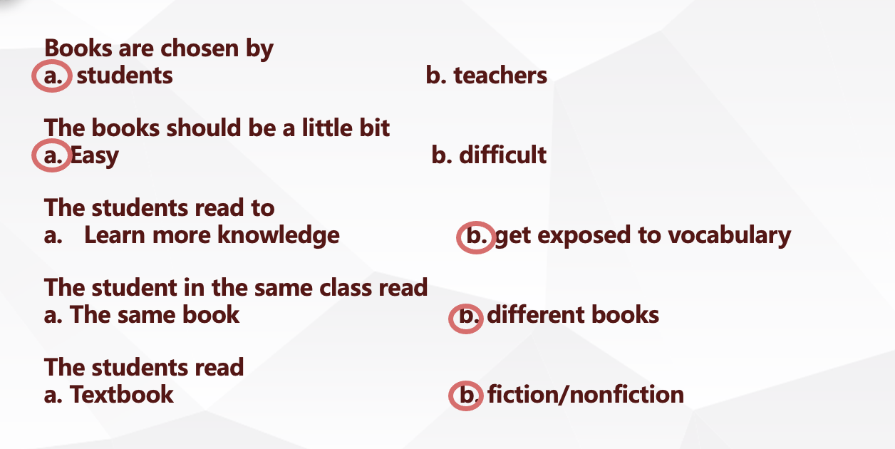

Appendix B: Activities

101 Ideas for Extensive Reading and Listening
https://www.er-central.com/contributors/learn-about-extensive-reading-and-listening/how-to-do-extensive-reading/101-ideas-for-erel/

103 Things to Do Before, During, or After Reading
https://www.readingrockets.org/article/103-things-do-during-or-after-reading

20 Meaningful Vocabulary Activities for Every grade
https://www.weareteachers.com/vocabulary-activities/

Appendix C: Worksheet Sample

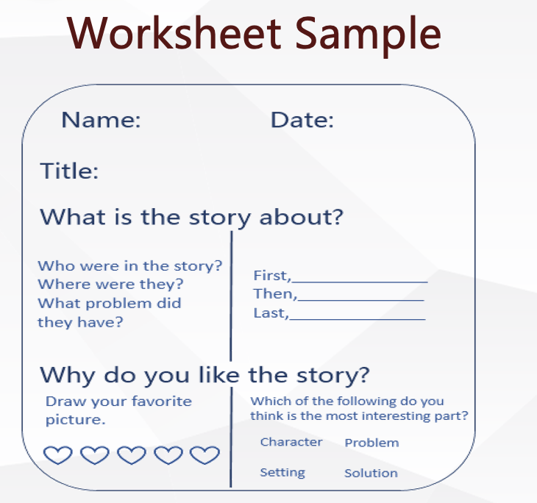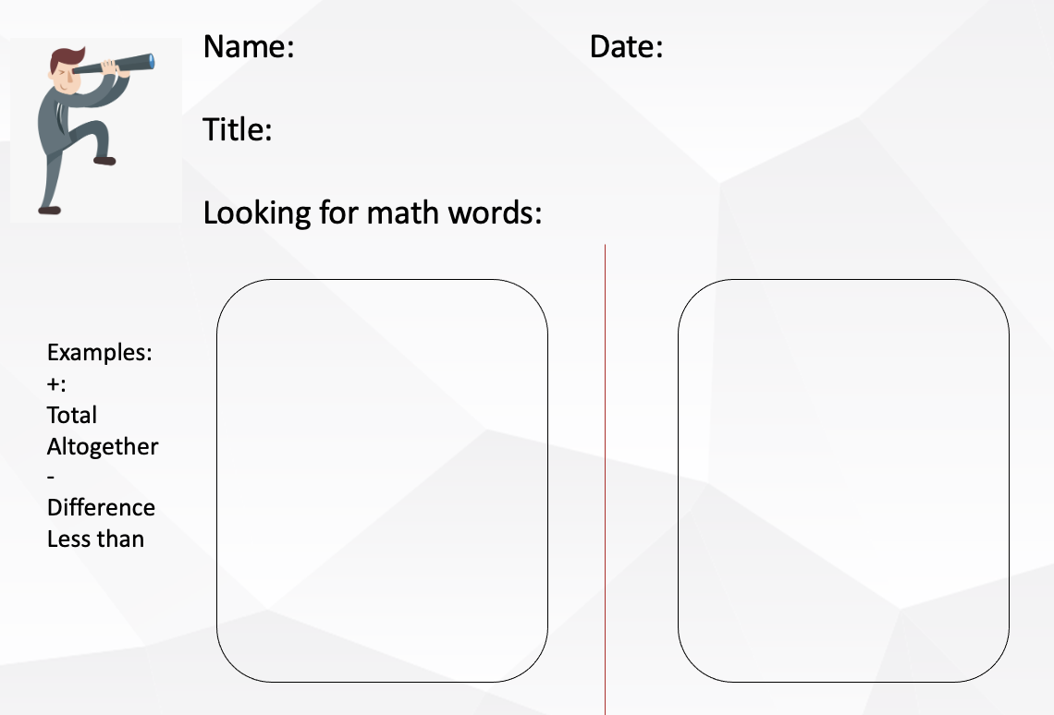

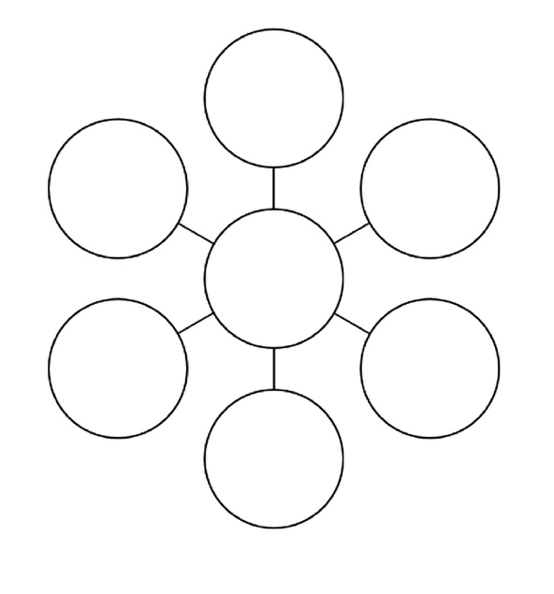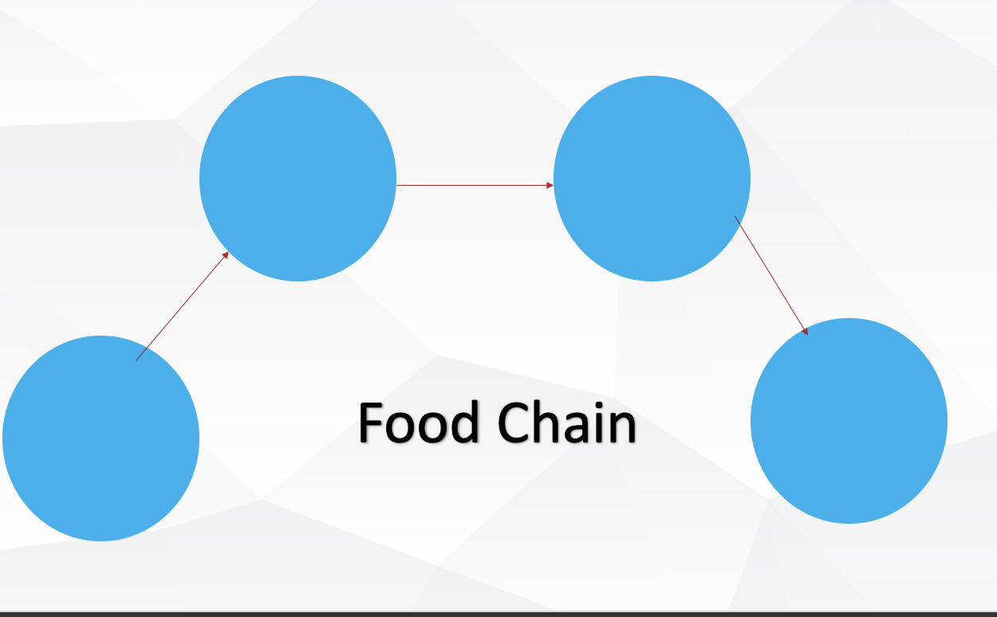

Appendix D: Useful Resources for ER

Funbrain
https://www.funbrain.com/

International Children's Digitial Library
http://en.childrenslibrary.org/

Literactive
http://literactive.com/home/index.asp

Recueil De Textes
http://www.hello-world.com/languages.php/?language=french

CHAPTER
4

Best Practices for Language Teaching and Learning:
In-Person and Online

Krystina Raymond, Zein Abuosbeh,
Michelle Chin, Diana Burchell, and Xi Chen
University of Toronto / Ontario Institute for Studies in Education

Abstract
Best practices for teaching and learning online are now critical for successful literacy education in many classrooms due to the COVID-19 pandemic and school closures. It was evident during the pandemic that pre-existing opportunity and achievement gaps widened significantly for students from diverse backgrounds. It is thus critical for teachers to recognize and assist diverse students who are struggling to read. Here are a few key questions that will be addressed in this workshop: How to scaffold online spoken interaction so that students are comfortable communicating in all oral language contexts? How to plan an effective intervention for students who lag behind their peers in their language abilities? How to plan for differences in children’s language abilities depending on their level of second language exposure during the pandemic? How to develop and assess writing activities that are equivalent both in-person and online?
Keywords: L2 education, oral language, reading, teaching online, learning online, writing

Best Practices for Language Teaching and Learning:

In-Person and Online

Language learning is a critical foundation for all areas of academic success (García-Vázquez et al., 1997; Graham, 1987). The development of language is a complex process which includes multiple developmental milestones. First, pre-school age children develop oral language skills (Dickinson et al., 2010). Once they enter the school system, they begin to explicitly work on oral language skills such as phonological awareness (Evans et al., 2006). Subsequently, children begin to apply their oral language skills to their reading ability (Roth et al., 2002). By the third grade, children transition from ’learning to read’ to ’reading to learn’ (Allington & Johnston, 2002). Finally, around Grade 3, students begin to produce substantive written language (Dockrell et al., 2009). During the COVID-19 pandemic, students were forced to learn online and develop these skills via screens and with the use of the Internet instead of with a traditional in-person teacher (Morgan, 2020). This chapter is designed to walk you through four specific milestones of language development (Shanahan et al., 2006): Part 1: Oral Language (written by Diana), Part 2: Phonological Awareness (written by Krystina), Part 3: Vocabulary and Literacy (written by Zein), and Part 4: Writing (written by Michelle).

Early research conducted throughout the COVID-19 pandemic has revealed the negative impact of online learning on the acquisition of children’s language skills (Engzell et al., 2021; Toronto District School Board, 2021). Furthermore, recent studies have revealed that the negative impact of the pandemic on children’s learning worsened throughout the repeated lockdowns (Kuhfeld et al., 2022). As a result of this alarming decline in child language abilities, research has now turned towards investigating online teaching practices as a tool that may help children to learn more effectively. This chapter pulls together multiple recent studies in order to cover a range of ages and language milestones. More specifically, we will describe these milestones by exploring the key differences in online and in-person learning, as well as provide the best practices for teaching and learning. These milestones are important for teachers from all disciplines since they provide a framework which educators could use to teach and evaluate content knowledge (e.g., students in first grade might discuss science orally, whereas students in fourth grade can express themselves through written language).

Review of Related Literature and Research

Part 1: Oral Language

We know from research that oral language competence is one of the strongest predictors of later reading ability in both monolingual and bilingual children (e.g., Miller et al., 2006; Roth et al., 2002). For example, a study by Kendeou and colleagues (2009) in the upper Midwest examined the influence of decoding and oral language skills, tested at ages four and six, on longitudinal literacy outcomes two years later. This study shows the significant and long-term impact of early oral language skills. Therefore, it is critical that children have a strong oral language foundation to succeed academically in all subjects: math (Fuchs et al., 2018; Pazeto et al., 2019), literacy (Kieffer, 2012; Spira et al., 2005), science (Graf et al., 2016) and general academic performance (Prevoo et al., 2016). Within the realm of oral language competence, children develop increasingly complex oral language abilities throughout their childhood and into adolescence.

In the context of this section, Diana presented three developmental milestones: conversational language (informal oral language), narrative language (oral or written narration of a sequence of events), and expository language (oral or written instructions). Conversational language begins to develop during the first year and continues into the pre-school years (Donnelly & Kidd, 2021). The next skill to develop is narrative competence, which starts before school and continues into the primary years (Stadler & Ward, 2005). Expository language, often called ‘procedural language’ or ‘descriptive language’ in the classroom, begins to develop in the primary years and continues to develop well into high school (Lundine & McCauley, 2016).

Part 2: Phonological Awareness

Extensive research has highlighted the significant role of phonological awareness in reading development for monolingual (Adam, 1990; Ehri, 1991; Nicholson, 1997; Snow et al., 1998; Stanovich, 2000; Wagner & Torgesen, 1987) and bilingual children (Comeau et al, 1999; Genesee et al., 2006; MacCoubrey; 2003; Wise & Chen, 2010; Wise & Chen, 2015; Wise et al., 2016). Phonological awareness is defined as the ability to attend to, isolate, and manipulate the individual sounds in words (Wagner et al., 1999) and is a strong predictor of reading success (Cipielewski, & Stanovich, 1992; Ehri, 1992). Children naturally focus on the meaning of a word instead of the phonological structure of a word. To familiarize children with the sounds in a word teachers can ask them to identify the phonemes. Phonemes are the smallest units of sound in a spoken language. For example, pronouncing the word cat involves three phonemes /k/ /ae/ /t/.

In this part of the workshop, Krystina shared evidenced-based strategies to teach phonological awareness in-person or online to young children. As reported in the National Reading Panel (2000), students need high-quality language input as well as systematic and explicit instruction. This can be done by providing explicit instruction on one or two phonological awareness skills at a time, which has been found to be more effective than when taught in combination. Teacher candidates were introduced to the response-to-intervention (RTI) model. This model is composed of three tiers and is designed to enhance early identification of students who are at-risk. ​By screening children as early as Kindergarten, teachers can help support them sooner and avoid further delays in their reading development. Once students have been identified as at-risk for reading difficulties, they must receive intervention immediately. ​Furthermore, Krystina introduced different approaches teachers can use to help students with their pre-literacy skills, including instruction focused on syllable segmentation with phonemes and letters (see Appendix A). ​Additionally, the research shows that children who are taught phonological awareness skills in small groups have greater learning growth than when they are taught individually or as a whole class. The approaches above support in-person and online schooling for teachers and can be adapted. Teachers can incorporate various scaffolds, such as audios, movements, and visuals, which in turn will provide more equitable access for students of all learning abilities.

Part 3: Vocabulary and Literacy

In this section, Zein presented key findings related to vocabulary and literacy. Language exposure has been shown to significantly impact vocabulary, language, and literacy development in both monolingual and bilingual children (Place & Hoff, 2011; Thordardottir, 2011). Throughout the pandemic, children's language development has become a bigger concern because of setbacks due to online learning. A recent reading assessment administered by the Toronto District School Board (2021) anticipated that 30% of Grade 1 students would fall behind in their reading achievement by June 2021. Indeed, with the shift to remote learning, teachers of French Immersion (FI) programs struggled to provide high-quality French input, such as vocabulary (Khan, 2021; Timmons et al., 2021).

Part 4: Writing

According to the simple view of writing (Berninger et al., 2002), transcription is a component of the writing process that is expected to influence the quality of children’s texts. The act of writing is a complex and non-linear learning process. Teachers’ written corrective feedback (WCF), also known as their “essay marking” practices are a very tedious and exhausting task (Lee, 2019). WCF is commonly done manually by many educators providing students with direct and comprehensive comments. Educators often correct everything they see and unfortunately cannot reuse their annotations, comments, nor gain statistical information about major types of errors or frequently used words by their students. When educators provide selective WCF rather than correcting every error they see, they save time and can focus on providing individualized feedback which in turn creates autonomous writers. With the help of these tools, students can also focus their cognitive load on meaning making rather than spelling and grammar. They are also more engaged with the writing task at hand when they receive WCF (Lee, 2019).

In this section of the workshop, Michelle shared solutions to make teachers’ WCF more productive based on her most recent research project. Educators can integrate computer-mediated tools in their practice to promote students’ digital literacy skills, collaborative learner-teacher interactions, and improvement in the number of error rates long-term (Bitchener et al., 2005; Lee, 2017; Sheen, 2010). With the implementation of these tools and by providing selective written corrective feedback, students become better at self-correcting their errors and increase their metacognitive awareness. In addition, students can be given access to technological and pedagogical scaffolding around autocorrect, how to use French accents, and how to avoid plagiarism. For educators, using this form of assessment for both in-person and online learning will inform your knowledge of students as writers and allow you to focus on the meaning they are conveying in their writing (Lee, 2019).

Workshop Activities

Part 1: Oral Language

For the first part of this workshop, we walked teacher candidates through the differences we found in a research study (ages 7-12) when administering oral language measures in-person (pre-pandemic) and virtually (during the pandemic) (Burchell et al., 2022). Overall, we found that children tend to have shorter conversations online compared to in-person. This could be attributed to multiple factors, including technology issues, anxiety about the online learning format, or the lack of gestural language. We found that narrative language was completely the same in-person and online, indicating that narrative assessments are reliable across contexts. Finally, we found that children produce fewer complex sentences during expository speech online. While we are unsure why this happens, it may be due to the transactional nature of online interactions.

Given that narrative assessments were the most reliable across both in-person and online contexts, we then walked teacher candidates through a brainstorming activity to see if narrative language could be incorporated into multiple subject areas, including math, science, and social studies. We provide an overview of these suggestions and resources to help teachers implement these concepts in the classroom. For example, we show how students might use narrative language to describe their life as a water droplet in the water cycle for science (for further examples, see Appendix B).

Part 2: Phonological Awareness Interventions

For the second part of this workshop, we went over the steps to implement an effective early phonological awareness intervention. Teachers will benefit from seeking support from other school personnel. To begin the process of developing an early intervention, teachers can turn to their professional learning community (PLC). The PLC spend time reflecting and collaborating to support instructional change through innovative ideas with the goal to promote student learning, improve learning outcomes, and facilitate systemic change (Brownell et al., 2002; Lavié, 2006; Little, 1990; Talbert & McLaughlin, 1994). We recommend following the six steps below to implement a successful intervention:

- Develop research questions based on the needs and demands of the students in their classroom,
- Examine any underlying assumptions about their research questions,
- Systematically collect data from and with their students​,
- Share and discuss their data with the administration​,
- Analyze and interpret their data with the support of the clinicians,
- Present their findings to students, colleagues, and members of the community.

For higher success rates, the PLC can follow a response-to-intervention (RTI), focusing primarily on Tier 2 if resources are limited. Krystina walked the teacher candidates through the tiers of RTI. In Tier 1 intervention, teachers will use differentiated instruction to meet students at their level, focusing on phonological awareness skills, such as blending, segmenting, etc. Teachers can assign different questions or set up learning stations based on the students' needs. For more intensive intervention, teachers can follow a Tier 2 model. The teacher can focus on a specific skill in small groups of three to four students for optimal learning. Additionally, if there are extra-support staff, Tier 2 can be done on a pull-out basis where children can work in another usually quieter room with extra multisensory materials to complement their learning. Children should receive daily interventions for at least 15 minutes. Lastly, students can receive Tier 3 intervention, where they are receiving one-on-one help. This level of intervention is reserved for students who are not making any progress in Tier 2. Teacher candidates had a chance to review the different activities meant to help at-risk students improve their phonological awareness skills, namely, rhyming, syllable segmentation and initial sound (see Appendix A).

Part 3: Vocabulary and Literacy

During the third part of this workshop, we walked teacher candidates through an evidence-based method to increase French vocabulary input. In a recent analysis conducted in our lab, results showed that FI students who received virtual instruction during the pandemic are performing lower in French vocabulary knowledge than their peers who attended school in-person before the pandemic.

As a first step, teachers could create a monthly list of target words addressing different themes in order to introduce students to diverse contexts that will enrich their first and second language lexicon (see Appendix C). As a second step, teachers could utilize word walls to organize target words and provide a classroom resource for vocabulary learning. Word walls can be adapted as an interactive activity by assigning each student a target word for the classroom word wall. Students can write out their assigned word on a piece of paper and draw pictures as visual aids. In an FI context, teachers could also encourage students to write the word in French on one side and English on the other to facilitate transfer and the acquisition of the word's meaning. As a third step, teachers could implement explicit instruction to help students acquire and comprehend the target words. This includes providing definitions of target words in addition to presenting the words in context. As a fourth and final step, teachers could allow students to apply their knowledge and use target words in context. This can be done by providing students with stories containing the target words accompanied by questions or by creating discussion questions about the vocabulary theme. As a bonus step, teachers could use visual and auditory supports (such as pictures, gestures, and music) to bolster vocabulary learning through online platforms.

Part 4: Writing

For the final part of this workshop, we looked at the affordances that computer-mediated tools provide when supporting online and in-person writing production with second language (L2) learners. The activities presented in the workshop were two writing activities that examined different points of view. “Deux drôles de bêtes dans la forêt” (primary) (see Appendix D) and “Une histoire à quatre voix” (Late Primary/Junior) (see Appendix D) are both available in English and French. The educator can begin with an in-person or online read-aloud. If there is an online read-aloud available, a suggestion would be to mute the video and read it aloud. This is so that students can hear your intonation and to allow you to pause and model teacher think-aloud strategies. For example, you can discuss how the illustrator’s drawings influence how the characters feel and differ depending on whose perspective we are hearing. By providing teacher think-aloud models to students, they can use their detective skills to read between the lines and infer how characters may be feeling. Following the read-aloud, introduce students to the writing activity. Using Google docs, paper, or another platform of your choice, create a table with the number of perspectives being told. In “Deux drôles de bêtes” we hear about the little girl and the little monster’s point of view (see Appendix D). Ask students to choose a specific scene from the story and then answer how each character felt. Point out how characters can have different points of views on the same event. Students can work in pairs or individually to fill out the rest of the table. As an extension, you can encourage students to make text to self-connections of when they had differing point of views with someone on the same event. If you are using the students’ work as a form of assessment, the implementation of written corrective feedback, specifically, annotated codes, would be helpful to monitor student progress and for the students themselves to see how they are progressing in their writing.

Teacher Candidates’ Responses to the Workshop

The feedback we received from participants was one of the most rewarding parts of this workshop. Below is what they learned in their own words.

What were some take-aways from this workshop?
- Online learning had a negative impact on language learning and moving forward teachers need to better assist students’ learning online. This can be done using several strategies such as phonological awareness activities to support English Language Learners.
- It was immensely helpful to learn about the importance of oral language and to be introduced to research-based strategies surrounding the benefits of narrative dialogue in online learning and how it can be adapted to various subjects.
- An important take away from the presentation was the role that motivation plays in online learning. If students are extrinsically motivated to learn they will not respond well to online learning. However, if they are intrinsically motivated to be learning online their learning experience will be positive.
- I learned that when teaching we should always have explicit examples of the topic we are teaching on display.
- When teaching words, we should provide examples of the words and allow students to discuss the word. We should always use audio and visual aids in the classroom and to use CVC words when teaching reading, writing, and rhyming.

What did you enjoy most about this workshop?
- What I enjoyed most about the workshop were the supplementary teaching resources provided through the document and the one drive and the strategies that can support students’ language learning development online.
- I was impressed by the presenters’ use of academic research to support the practical strategies they presented for teaching in online.
- What I enjoyed most about this workshop is that it gave practical examples on how to be successful in our teaching profession as well as the opportunity to discuss the subject with our colleagues in breakout rooms.
- What I found most beneficial about this workshop was being introduced to specific activities that can be used in the classroom and learning about how to include audio visual aids in our lessons.

Authors’ Reflections

It was clear from the feedback received by participants in our workshop that teachers are always searching for the best strategies to maximize their students’ learning. When preparing for the conference beforehand, our objective as researchers and educators was to present teaching strategies that are rooted in education research in a practical way that can easily be adapted to everyday teaching. Due to the ongoing COVID-19 pandemic, we insisted on bringing to light the challenges students faced adapting to online learning and cited research that provided possible solutions to aid children with these setbacks. Much of our preparation consisted of creating activities based on language teaching concepts that have been supported by peer-reviewed literature. We shared concrete evidence-based practices for educators to support students with different learning abilities and/or culturally diverse students online and in person. As researchers in the domain of language and literacy, our goal was to make sure that the importance of language learning can be appreciated by teachers in all subject areas. For this reason, we underscored the importance of creating activities for teaching language online that can be applicable to academic subjects other than English, French, or languages. We mentioned the importance of maintaining consistent communication with at-risk students, especially when teaching online. We suggested strategies and interventions that were accessible to all students to reduce the inequities that were exacerbated during the pandemic. Moreover, we provided examples of how these language learning strategies can be used in subjects such as science and math:

Math: In each math unit, teachers can provide word definitions of target concepts and use equations or symbols as visual aids and provide vocabulary quizzes or flashcards for each novel word in the unit. Also, teachers can use word problems to allow students to apply their knowledge of target concepts in context and to also understand how these terms are applied in the real world. This can be done in a think, pair, share format.

Science: When introducing scientific concepts with complex words, using syllable segmentation will allow students to better understand, remember, and produce the word.

Post hoc discussions and reflections allowed us to examine the social justice and equity elements of our workshop as a group. An awareness of the social and political history that we work in is essential for educators. We sought to convey this through territorial and land acknowledgments in order to recognize the injustices committed against the Indigenous population whose consequences are felt in our present day. However, after further reflection, we recognized that a land acknowledgment can be a passive form of activism and may not have been enough to show solidarity. We encouraged teacher candidates to share after the territorial and land acknowledgement was stated; however, there were no volunteers. Learning from this experience, we plan to do tangible work in order to help marginalized communities and to share these actions with our audience.

One of the main goals of our presentation was tacit knowledge dissemination. Therefore, a main concern was the accessibility of the content and resources we are sharing. To address this, we made sure to discuss access checks to welcome all our attendees and to acknowledge their unique needs. We also made sure to ask the teachers about any access needs they may have and provided them with the opportunity to communicate with us privately via chat. In hindsight, discussing accessibility at the beginning of the workshop may not give us the time to effectively accommodate students should the need arise. In the future, we will aim for a greater focus on accessibility by conducting access checks in advance of the workshop date in order to ensure equitable participation for all teacher candidates and presenters.

While conducting the workshop, we also realized that engaging students online was more difficult than in person. This is no different for elementary and high school teachers who are working with children and teens online. We acknowledge that the COVID-19 pandemic was forced upon everyone and understand the importance of our role in providing different practices and adapting our teaching styles when working with students. We voiced to our teacher candidates that although one strategy may work for one student, another best practice could work better for another. For instance, during our workshop, we proposed that students could either voice their questions and comments using the microphone option or write them in the chat, as having the option could increase classroom engagement and allow everyone to participate.

Conclusion

This chapter highlights important research studies related to the four developmental milestones of language learning: oral language, phonological awareness, vocabulary, and writing. Whether you’re teaching and learning in-person or online, the participants in this workshop found the activities most helpful. We kicked off the workshop by explaining the research on oral language and the importance to scaffold online spoken interactions so students feel comfortable communicating in all oral language contexts. This was followed by a section on effective interventions to help students who are struggling and lag behind their peers in their language abilities. Next, we discussed planning and activities for teaching children online whose language abilities differ in terms of their level of second language exposure. Lastly, the teacher candidates learned about writing activities that are equivalent both in-person and online. The workshop also provided teacher candidates with teaching tips to effectively teach oral language and written language skills. Implementing these activities can lead to student improvement and better understanding in all academic subjects. Educators may use the information in this chapter to build on their current knowledge in order to continually adapt their teaching strategies and approaches to support student needs. For further details on best practices for teaching and learning languages, we invite you to contact the authors of this workshop and to visit our lab’s website: https://xichenmll.wixsite.com/website.

References

Adams, M. J. (1990). Beginning to read: Thinking & learning about print.
MIT Press.

Allington, R. L., & Johnston, P. H. (2002). Reading to learn: Lessons from exemplary
fourth-grade classrooms. Guilford Press.

Berninger, V., Vaughan, K., Abbott, R. D., Begay, K., Coleman, K. B., Curtin, G.,
Hawkins, J. M., & Graham, S. (2002). Teaching spelling and composition alone and together: Implications for the simple view of writing. Journal of Educational Psychology, 94(2), 291–304. https://doi.org/10.1037/0022-0663.94.2.291

Bitchener, J., Young, S., & Cameron, D. (2005). The effect of different types of
corrective feedback on ESL student writing. Journal of Second Language Writing, 14(3), 191–205. https://doi.org/10.1016/j.jslw.2005.08.001

Brownell, M. T., Walther-Thomas, C., & Casareno, A. (2002). Ed Ellis: Working to
improve education for adolescents with learning disabilities. Intervention in School and Clinic, 37(5), 292–297. https://doi.org/10.1177/105345120203700505

Burchell, D., Bourassa Bedard, V., Boyce, K., McLaren, J., Brandeker, M., Squires, B.,
Kay-Raining Bird, E., MacLeod, A. A. N., Rezzonico, S., Chen, X, & Cleave, P. (2022). Exploring the validity and reliability of online assessment for conversational, narrative, and expository discourse measures in school-aged children. Frontiers in Communication, 7. https://doi.org/10.3389/fcomm.2022.798196

Cipielewski, J., & Stanovich, K. E. (1992). Predicting growth in reading ability from
children's exposure to print. Journal of Experimental Child Psychology, 54(1), 74–89. https://doi.org/10.1016/0022-0965(92)90018-2

Comeau, L., Cormier, P., Grandmaison, E., & Lacroix, D. (1999). A longitudinal study
of phonological processing skills in children learning to read in a second language. Journal of Educational Psychology, 91, 29–43.
https://doi.org/10.1037/0022-0663.91.1.29

de Jong, P. F., & van der Leij, A. (2002). Effects of phonological abilities and
linguistic comprehension on the development of reading. Scientific Studies of Reading, 6(1), 51–77. https://doi.org/10.1207/S1532799XSSR0601_03

Dickinson, D. K., Golinkoff, R. M., & Hirsh-Pasek, K. (2010). Speaking out for
language: Why language is central to reading development. Educational Researcher, 39(4), 305–310. https://doi.org/10.3102/0013189X10370204

Dockrell, J. E., Lindsay, G., & Connelly, V. (2009). The impact of specific language
impairment on adolescents’ written text. Exceptional Children, 75(4),
427–446. https://doi.org/10.1177/001440290907500403

Donnelly, S., & Kidd, E. (2021). The longitudinal relationship between conversational
turn‐taking and vocabulary growth in early language development. Child Development, 92(2), 609–625. https://doi.org/10.1111/cdev.13511

Ehri, L. (1991). Development of the ability to read words. In R. Barr, M. L. Kamil, P.
Mosenthal, & P. D. Pearson (Eds.), Handbook of reading research (2nd ed., pp. 383–417). Longman.

Ehri, L. (1992). Reconceptualizing the development of sight word reading and its
relationship to recoding. In P. Gough, L. Ehri, & R. Treiman (Eds.), Reading acquisition (pp. 107–143). Lawrence Erlbaum Associates.

Engzell, P., Frey, A., & Verhagen, M. D. (2021). Learning loss due to school closures
during the COVID-19 pandemic. Proceedings of the National Academy of Sciences, 118(17). https://doi.org/10.1073/pnas.2022376118

Evans, M. A., Bell, M., Shaw, D., Moretti, S., & Page, J. (2006). Letter names, letter
sounds and phonological awareness: An examination of kindergarten children across letters and of letters across children. Reading and Writing, 19(9), 959–989. https://doi.org/10.1007/s11145-006-9026-x

Fuchs, L. S., Gilbert, J. K., Fuchs, D., Seethaler, P. M., & Martin, B. N. (2018). Text
comprehension and oral language as predictors of word-problem solving: Insights into word-problem solving as a form of text comprehension. Scientific Studies of Reading, 22(2), 152–166. https://doi.org/10.1080/10888438.2017.1398259

García-Vázquez, E., Vázquez, L. A., López, I. C., & Ward, W. (1997). Language
proficiency and academic success: Relationships between proficiency in two languages and achievement among Mexican American students. Bilingual Research Journal, 21(4), 395–408. https://doi.org/10.1080/15235882.1997.10162712

Genesee, F. (2007). French immersion and at-risk students: A review of research
evidence. The Canadian Modern Language Review, 63(5), 655–726. https://doi.org/10.3138/cmlr.63.5.655

Genesee, F., Geva, E., Dressler, C., & Kamil, M. (2006). Synthesis: Cross-linguistic
relationships. In D. August & T. Shahnahan (Eds.), Developing literacy in second-language learners: Report of the national literacy panel on language-minority children and youth (pp. 153–174).

Graf, E., Hernandez, M. W., & Bingham, R. S. (2016). Preschool predictors of
academic achievement in five kindergarten readiness domains: Oral language & literacy, math, science, social-emotional development & approaches to learning. https://krfoundation.org/krf/site-content/uploads/2017/05/Kindergarten-Readiness-Predictors-Final-Report-120916.pdf

Graham, J. G. (1987). English language proficiency and the prediction of academic
success. TESOL Quarterly, 21(3), 505–521. https://doi.org/10.2307/3586500

Hoover, A., & Gough, P. B. (1990). The simple view of reading. Reading and Writing:
An Interdisciplinary Journal, 2, 127–160. https://doi.org/10.1007/BF00401799

Huo, M. R. Y., Koh, P., Cheng, Y., Marinova-Todd, S. H., & Chen, X. (2021). The
simple view of reading in French second language learners. Learning and Individual Differences, 92. https://doi.org/10.1016/j.lindif.2021.102082

Jean, M., & Geva, E. (2009). The development of vocabulary in English as a second
language children and its role in predicting word recognition ability. Applied Psycholinguistics, 30(1), 153–185. https://doi.org/10.1017/S0142716408090073

Kendeou, P., van den Broek, P., White, M. J., & Lynch, J. S. (2009). Predicting reading
comprehension in early elementary school: The independent contributions of oral language and decoding skills. Journal of Educational Psychology, 101(4), 765–778. https://doi.org/10.1037/a0015956

Khan, A. (2021, May 23). Virtual classes proving très difficile for French immersion
teachers. CBC News. https://www.cbc.ca/news/canada/ottawa/french-immersion-language-1.6031763

Kieffer, M. J. (2012). Early oral language and later reading development in Spanish-
speaking English language learners: Evidence from a nine-year longitudinal study. Journal of Applied Developmental Psychology, 33(3), 146–157. https://doi.org/10.1016/j.appdev.2012.02.003

Kuhfeld, M., Soland, J., & Lewis, K. (2022). Test score patterns across three
COVID-19-impacted school years. Educational Researcher. https://doi.org/10.3102/0013189X221109178
Lavié, J. M. (2006). Academic discourses on school–based teacher collaboration:
Revisiting the arguments. Educational Administration Quarterly, 42(5), 773–805.
https://doi.org/10.1177/0013161X06290647
Lee, I. (2017). Classroom writing assessment and feedback in L2 school contexts.
Springer. https://doi.org/10.1007/978-981-10-3924-9

Lee, I. (2019). Teacher written corrective feedback: Less is more. Language Teaching,
52(4), 524–536. https://doi.org/10.1017/S0261444819000247

Leu, D. J., Kinzer, C. K., Coiro, J., Castek, J., & Henry, L. A. (2017). New literacies: A
dual-level theory of the changing nature of literacy, instruction, and assessment. Journal of Education, 197(2), 1–18. https://doi.org/10.1177/002205741719700202

Little, J. W. (1990). Chapter 6: The mentor phenomenon and the social organization of
teaching. Review of Research in Education, 16(1), 297–351. https://doi.org/10.3102/0091732X016001297

Lundine, J. P., & McCauley, R. J. (2016). A tutorial on expository discourse: Structure,
development, and disorders in children and adolescents. American Journal of Speech-Language Pathology, 25(3), 306–320.
https://doi.org/10.1044/2016_AJSLP-14-0130

MacCoubrey, S. (2003). A phonemic awareness intervention for at-risk second language
readers [Unpublished Master's thesis]. Queen's University.

Miller, J. F., Heilmann, J., Nockerts, A., Iglesias, A., Fabiano, L., & Francis, D. J.
(2006). Oral language and reading in bilingual children. Learning Disabilities Research & Practice, 21(1), 30–43.
https://doi.org/10.1111/j.1540-5826.2006.00205.x

Morgan, H. (2020). Best practices for implementing remote learning during a pandemic.
The Clearing House: A Journal of Educational Strategies, Issues and Ideas, 93(3),
135–141.

National Reading Panel (US), National Institute of Child Health, Human Development
(US), National Reading Excellence Initiative, National Institute for Literacy (US), & United States Department of Health. (2000). Report of the National Reading Panel: Teaching children to read: An evidence-based assessment of the scientific research literature on reading and its implications for reading instruction: Reports of the subgroups. National Institute of Child Health and Human Development, National Institutes of Health.

Nicholson, T. (1997). Closing the gap on reading failure: Social background, phonemic
awareness, and learning to read. In B. Blachman (Ed.), Foundations of reading acquisition and dyslexia: Implications for early intervention (pp. 381–408). Lawrence Erlbaum.

Pazeto, T. D. C. B., Dias, N. M., Gomes, C. M. A., & Seabra, A. G. (2019). Prediction
of arithmetic competence: Role of cognitive abilities, socioeconomic variables and the perception of the teacher in early childhood education. Estudos de Psicologia (Natal), 24(3), 225–236.

Pearson, B., Fernandez, S., Lewedeg, V., & Oller, D. (1997). The relation of input
factors to lexical learning by bilingual infants. Applied Psycholinguistics, 18(1),
41–58. https://doi.org/10.1017/S0142716400009863

Place, S., & Hoff, E. (2011). Properties of dual language exposure that inflence 2-year-
olds’ bilingual proficiency. Child Development, 82(6), 1834–1849. https://doi.org/10.1111/j.1467-8624.2011.01660.x

Prevoo, M. J., Malda, M., Mesman, J., & van IJzendoorn, M. H. (2016). Within-and
cross-language relations between oral language proficiency and school outcomes in bilingual children with an immigrant background: A meta-analytical study. Review of Educational Research, 86(1), 237–276. https://doi.org/10.3102/0034654315584685

Roth, F. P., Speece, D. L., & Cooper, D. H. (2002). A longitudinal analysis of the
connection between oral language and early reading. The Journal of Educational Research, 95(5), 259–272. https://doi.org/10.1080/00220670209596600

Shanahan, T., MacArthur, C. A., Graham, S., & Fitzgerald, J. (2006). Relations among
oral language, reading, and writing development. Handbook of Writing Research,
171–183.

Sheen, Y. (2010). Introduction: The role of oral and written corrective feedback in
SLA. Studies in Second Language Acquisition, 32(2), 169–179. https://doi.org/10.1017/S0272263109990489

Snow, C., Burns, M. S., & Griffin, P. (1998). Preventing reading difficulties in young
children. National Academy Press.

Spira, E. G., Bracken, S. S., & Fischel, J. E. (2005). Predicting improvement after first-
grade reading difficulties: the effects of oral language, emergent literacy, and behavior skills. Developmental Psychology, 41(1), 225–234.
https://doi.org/10.1037/0012-1649.41.1.225

Stadler, M. A., & Ward, G. C. (2005). Supporting the narrative development of young
children. Early Childhood Education Journal, 33(2), 73–80. https://doi.org/10.1007/s10643-005-0024-4

Stanovich, K. E. (2000). Progress in understanding reading: Scientific foundations and
new frontiers. Guilford Press.

Talbert, J. E., & McLaughlin, M. W. (1994). Teacher professionalism in local school
contexts. American Journal of Education, 102(2), 123–153. https://doi.org/10.1086/444062

Thordardottir, E. (2011). The relationship between bilingual exposure and vocabulary
development. International Journal of Bilingualism, 15(4), 426–445. https://doi.org/10.1177/1367006911403202

Timmons, K., Cooper, A., Bozek, E., & Braund, H. (2021). The impacts of COVID-19
on early childhood education: Capturing the unique challenges associated with remote teaching and learning in K-2. Early Childhood Education Journal, 49(5), 887–901. https://doi.org/10.1007/s10643-021-01207-z

Torgesen, J. K., Wagner, R. K., Rashotte, C. A., Burgess, S., & Hecht, S. (1997).
Contributions of phonological awareness and rapid automatic naming ability to the growth of word-reading skills in second-to fifth-grade children. Scientific Studies of Reading, 1(2), 161–185. https://doi.org/10.1207/s1532799xssr0102_4

Toronto District School Board. (2021). Covid-19 pandemic recovery plan.
https://www.tdsb.on.ca/Portals/0/docs/Pandemic-Recovery-Plan-June-23.pdf

Wagner, R. K., & Torgesen, J. K. (1987). The nature of phonological processing and its
causal role in the acquisition of reading skills. Psychological Bulletin, 101(2), 192–212. https://doi.org/10.1037/0033-2909.101.2.192

Wagner, R. K., Torgesen, J. K., Rashotte, C. A., & Pearson, N. A.
(1999). Comprehensive test of phonological processing: CTOPP. Pro-ed.

Wise, N., & Chen, X. (2010). At-risk readers in French immersion: Early identification
and early intervention. Canadian Journal of Applied Linguistics, 13(2), 128–149.

Wise, N., & Chen, X. (2015). Early intervention for struggling readers in grade one
French immersion. Canadian Modern Language Review, 71(3), 288–306.

Wise, N., D’Angelo, N., & Chen, X. (2016). A school-based phonological awareness
intervention for struggling readers in early French immersion. Reading and Writing, 29(2), 183–205. https://doi.org/10.1007/s11145-015-9585-9

Appendix A: Phonological Awareness Activity



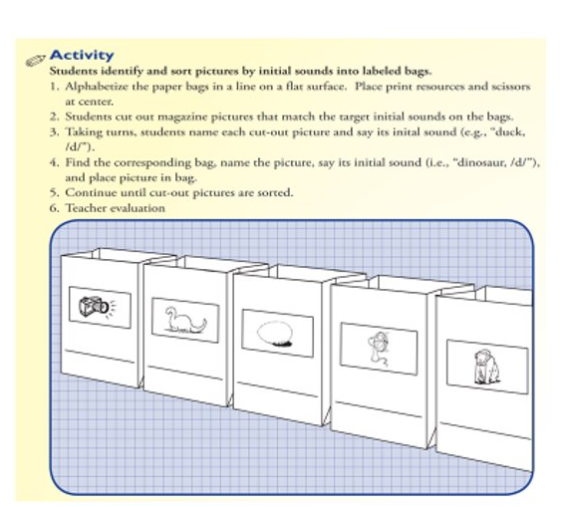
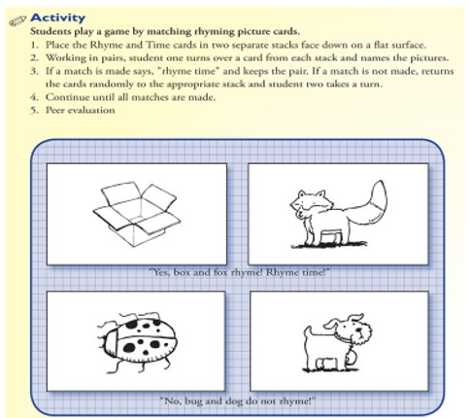

Appendix B: Oral Language Resources

Subject | Idea | Resources
Science | Have students create stories which include physical and chemical changes | http://www.westerville.k12.oh.us/userfiles/4148/Classes/5342/A%20Chemical%20and%20Physical%20Change%20Story.pdf
Math | Have students tell a story about baking a cake and relate it to coding | https://medium.com/@emily.f.delapena/coding-is-just-like-baking-a-cake-2feceb07cbc1
Social Studies | Have students create stories where the write about different family compositions | https://www.cbc.ca/parents/learning/view/five-amazing-books-about-all-different-types-of-families
Science | Have students create a story where they imagine themselves as a water droplet | https://www.youtube.com/watch?v=Ov8II2y7rmE
Math | Have students tell a story based on the question ‘Does McDonald’s Serve Cheese Burgers’ to learn long division | https://www.youtube.com/watch?v=1Wrp0Qc_gDM
Social Studies | Have students create stories about holiday traditions from diverse cultures | https://www.huffpost.com/entry/diverse-holiday-books-for-kids_l_5df93997e4b0969b618bfbb1

Appendix C: Vocabulary Activity

L'école
Des personnes | Des lieux | Des actions | Des matériaux | Des matières
Le professeur/  La professeure | La salle de classe | Lire | Un cahier | Les mathématiques
Le directeur/  La directrice | Le gymnase | Écrire | Un crayon | La science
Le/ la bibliothécaire | Le bureau | Découper | Une gomme | La musique
Les étudiant.e.s | Les toilettes | Effacer | Un livre | L'art
Le/la secrétaire | La cafétéria | Travailler | Un stylo | L'éducation physique

Appendix D: Writing Activities

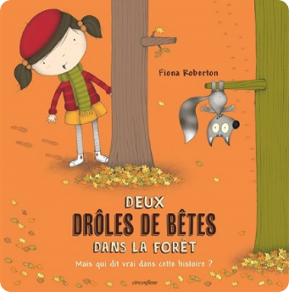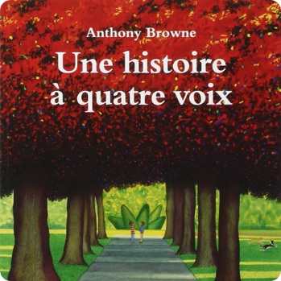

Sample questions you can use with the books (each question can have its own column):
Deux drôles de bêtes dans la forêt | Une histoire à quatre voix
-Demande aux élèves de choisir un  évènement dans l’histoire.  -Comment penses-tu la petite fille s’est  sentie?  -Comment penses-tu que la petite bête  s’est sentie? | -Comment décrirais-tu chaque  personnage?  -Quelle était leur perspective de la journée?

CHAPTER
5
Communicating in Mathematics While Learning an Additional Language:
Challenging Deficit Perspectives of Multilingual Students’ Learning of Mathematics

Fatima Assaf
University of Ottawa

Abstract
This chapter is based on a workshop given at the University of Ottawa in the Faculty of Education for teacher candidates. The focus of the workshop was to challenge some deficit perspectives on multilingual learners' participation and communication in the mathematics classroom. Students’ communication is regarded as an essential process in learning mathematics, as it is used to share their mathematical thinking and understanding. Such an emphasis on communication highlights the important role of language in relation to learning mathematics in an additional language. Participants engaged in various hands-on activities, including an introductory activity, an animated video with reflection questions, an exploration of key words in a word cloud, a review of the research literature, a mathematical problem activity, and an opportunity to explore students’ mathematical thinking through examples of students’ work. Since the focus of this workshop is on how language and mathematics intersect, information from it could support educators as they plan mathematics learning for all.
Keywords: multilingualism, mathematics, language, communication, problem solving

Introduction

Since 2019, I have conducted yearly workshops for teacher candidates in the Faculty of Education at the University of Ottawa to challenge some deficit perspectives on multilingual learners' participation and communication in the mathematics classroom. In this chapter, I begin with a review of the research literature on teachers’ views as shaping and influencing students’ learning of mathematics. Next, I outline the workshop objectives, followed by a step-by-step description of the activities included in the workshop. Finally, I share some concluding remarks and some of the participants’ reflections.

Teachers’ Views as Shaping and Influencing Students’ Learning of Mathematics

Mathematics teachers living and working in multilingual and multicultural societies are often teaching immigrant, refugee, migrant, and Indigenous students–all with varying languages and cultures (de Abreu, 2005, 2008; Gates, 2006). These students may have alternate ways of doing mathematics and may have experienced different pedagogical practices, or developed out-of-school mathematical practices (Civil, 2018). This wealth of diversity presents a challenge for teachers who are often trained to teach homogenous groups of students. Traditionally, teachers, when confronted with a more pluralistic classroom, tend to minimize the cultural differences among their students, a practice which they understand as a means of treating everyone the same (de Abreu, 2005; Sari & Yüce, 2020). The idea of treating everyone equally is further supported by teachers’ conceptualization that mathematics knowledge is culture-free and universal (César & Favilli, 2005; de Abreu & Gorgorió, 2007). This view has been shown to cause additional problems for students learning mathematics. In their 2006 study (as cited in de Abreu & Gorgorió, 2007), Gorgorió and her colleagues describe an instance where an international student’s use of a division algorithm was not recognized by their teacher because it was different from that to which the teacher was accustomed. In such situations, teachers’ understanding of mathematics as universal prevents them from inviting and accepting alternate ways of solving problems, which can create difficulties for students learning mathematics.

Moreover, teachers who view mathematics as a universal subject tend to view students’ limited language proficiency as the main obstacle faced by these learners in a mathematics classroom (de Abreu & Gorgorió, 2007), suggesting that fluency in the language of instruction is necessary for the development of mathematical competency (Clarkson, 2006). There are an increasing number of researchers who are suggesting that exclusive emphasis on learning the language of instruction may hinder students’ learning of mathematics (Barwell, 2005; Civil, 2008). These researchers demonstrate that knowledge of the language of instruction is only one aspect of becoming competent in mathematics and lead us to consider the multiple resources multilingual learners use to construct knowledge, negotiate meanings, and communicate mathematically (Moschkovich, 2007). Hence, teachers’ attitudes regarding the universality of mathematics and their perspectives regarding the need to learn the language of instruction prior to attending mathematics classes might prevent students from engaging in mathematics effectively.

Even when teachers are aware of alternate ways of solving mathematics problems and understand that exclusive knowledge of the language of instruction will not lead to mathematical competency, they may not be equipped with the proper background knowledge or training to cultivate learning experiences that reveal and shape alternate ways of doing mathematics (Civil, 2016, 2018). According to Hoffert (2009), “it is our job as teachers to…take whatever mathematics ability [students] possess, build on it, and make them successful, confident students of mathematics” (p. 133). Teachers not only need to “acknowledge a student’s first language and culture, teachers must also acknowledge [students’] “first mathematics”, the mathematics they bring with them to their new […] classroom” (Whiteford, 2009, p. 277). In so doing, teachers acknowledge students' previous mathematics experiences as contributing to their present learning.

Workshop Objectives

My main goal in the workshop was 1) to disrupt deficit perspectives regarding multilingual students’ mathematics learning, and 2) to support educators as they plan mathematics learning for all learners—despite students’ expertise in the language of instruction or previous schooling experiences. A central argument I have emphasized in all of the workshops is that we, as educators, need to shift our focus from what multilingual learners cannot do, and to consider the multiple resources students use to communicate mathematically (Moschkovich, 2007). According to Moschkovich (2007),

If all we see are students who...mispronounce English words, or don’t know vocabulary, instruction will focus on these deficiencies. If, instead, we learn to recognize the mathematical ideas these students express in spite of their accents, code-switching, or missing vocabulary, then instruction can build on students’ competencies and resources. (p. 3)

There are several communicative resources that students make use of to negotiate or express their mathematical ideas and understandings, including various objects; drawings; pictures; gestures; their bodies; facial expressions; their experiences of the world; their mathematical knowledge and mathematical language; other students’ ideas and interpretations; and the languages they know (Assaf, 2021). Ideally, students could utilize any resource they perceive as useful to negotiate mathematical meaning in relation to a mathematical task.

Workshop Description

The participants engaged in four hands-on activities: 1) In Three Words or Phrases; 2) An Animated Video; 3) Polling Task; and 4) A Mathematical Problem-Solving Activity. For each activity, I provide a general description of the activity, followed by a summary of how the participants engaged in the activity, including how the activities unfolded in-person or online. Some reflections are also provided.
In Three Words or Phrases

To gain some understanding of participants’ thoughts towards teaching mathematics to language learners, I asked them to write 3-5 words or phrases that immediately came to mind when I said, “Teaching mathematics to English or French language learners with little to no prior schooling experiences”.

During in-person workshops, a handout was distributed to each participant to write out their words or phrases (see Appendix A). Participants were then asked to share one word or phrase with the person next to them and to explain their choice. In the most recent workshop, I used an online interactive software called Mentimeter. This software allows participants to answer a question then see their responses in a word cloud in real-time (see Figure 1).

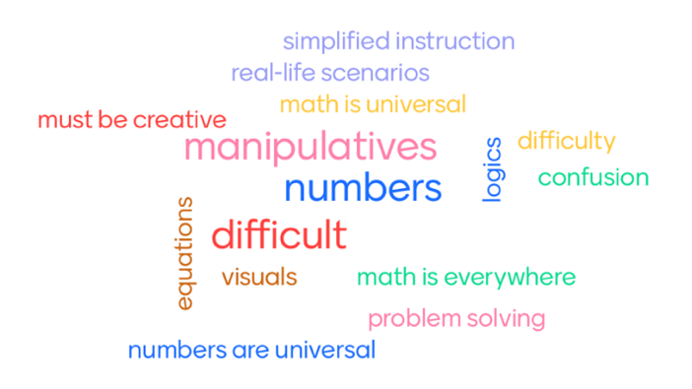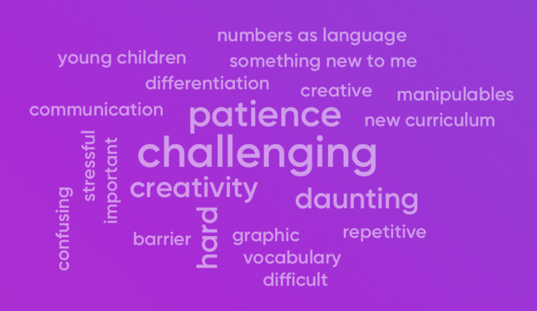

Figure 1
Word Cloud Examples

I shared the word cloud with the participants and asked them to reflect on their responses. Participants’ responses appeared diverse, with some believing that teaching mathematics to English or French language learners is a challenge, or that language may act as a barrier to learning mathematics effectively. Others talked about the importance of using manipulatives, students’ home languages, and establishing students’ background knowledge to enhance their learning experiences. Such responses provided me with some understanding of the participants thoughts towards teaching mathematics to language learners and helped me discern what to focus on in response to their uncertainties.

An Animated Video – “Words are not enough”

The next activity included an animated video created by my colleague (Dr. Alison Goss) and I (see Appendix B for a full script of the video). We created this video as an illustration of the experiences faced by some newly arrived students in mathematics classrooms, especially when teachers focus on the challenges students face rather than considering what students bring with them, such as languages, alternate ways of doing mathematics, or the multiple resources they use to communicate mathematically.

The video portrays, a teacher, Mrs. Goss speaking in Afrikaans, a language not familiar to the new student, Fatima, an Arabic speaker. Fatima feels uncomfortable and begins to cry. Mrs. Goss walks out of the classroom and has a heated discussion with the ESL teacher, Mrs. Assaf. Mrs. Goss suggests that Fatima should not be in a regular class until she has mastered her second language. Mrs. Assaf tries to reason with Mrs. Goss. However, Mrs. Goss is not ready to accept what Mrs. Assaf is saying.

For the follow-up activity, I asked the participants to work in groups of three or four to discuss the video. Some questions prompted them to reflect on their thoughts, the message, and their feelings toward the video. In-person participants were provided with chart paper and markers to write out their responses (see Appendix C). Online participants worked in breakout rooms in Zoom and used Jamboards (see Appendix D).

Following that, participants shared some key takeaways with the rest of the group. Participants’ reflections revealed their feelings of sympathy towards Fatima’s experience and their displeasure with how the teacher treated her. For instance, they were shocked by how the teacher created an isolating environment and was unwilling to adapt her lesson to be inclusive of all learners in her classroom. The participants also agreed that the teacher caused Fatima great discomfort and made her feel overwhelmed and unwelcomed. There were also several suggestions and messages that the participants directed towards the teacher. The participants’ responses suggest awareness of the need for teachers with newly arrived students to do the following: 1) differentiate instruction, 2) work with a language specialist (e.g., ELD or ESL teachers), 3) use various resources (e.g., visuals, manipulatives, etc.), 4) have flexibility, and 5) be open to compromise. The participants appeared quite aware of the fundamental role a teacher plays in students’ successful integration and access to mathematics learning, paired with maintaining an inclusive classroom environment.

Polling Task

After the participants were given a chance to reflect on the video, I shared a word cloud that was generated from an accumulation of responses I had gathered from participants over the past few years. These responses highlighted participants’ thoughts towards teaching mathematics to English or French language learners with little to no prior schooling experiences (see Figure 2).

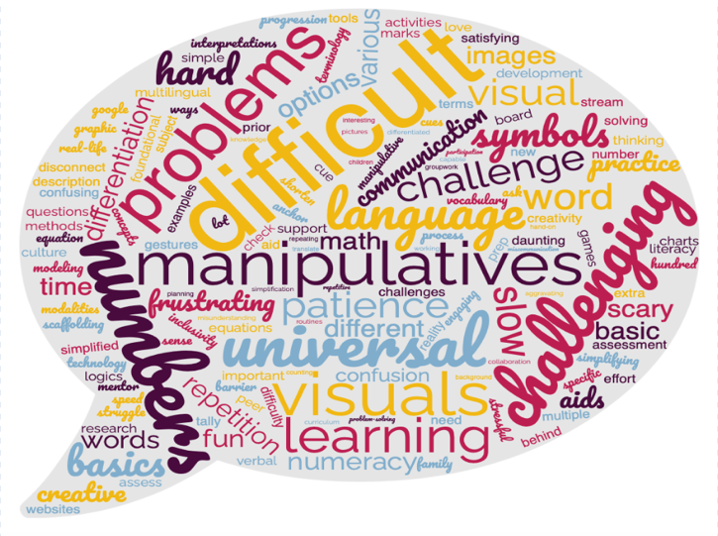
Figure 2
Word Cloud of Participants’ Responses

The top 10 recurring words in participants’ responses were 1) manipulatives, 2) challenging, 3) difficult, 4) numbers, 5) patience, 6) problems, 7) universal, 8) visuals, 9) language, and 10) learning. I addressed some of those words with the participants by relying on the research literature to challenge deficit views of multilingual learners’ learning of mathematics.

In terms of the word manipulatives, I explained that although teachers recognize the need for manipulatives when working with multilingual learners, we must be mindful of the following:

manipulatives on their own have no meaning. It is through students’ previous experiences, the questions we pose, and the contexts we create that manipulatives can represent specific mathematical concepts. Change the context/ questioning/ experiences and you change what they represent. (Krpan, 2019)

That said, with teacher guidance, there should be a connection between what the students are learning and the manipulatives they are using because a manipulative on its own does not hold the meaning of a mathematical idea (Clements, 1999).

Concerning the words challenging, difficult, and problems, I talked about the importance of not being stuck on those words without trying to make a change. So, instead of contemplating how challenging it is to teach mathematics to multilingual learners, we must consider effective pedagogical practices that are “necessary to promote deep learning of mathematics” (National Council of Teachers of Mathematics, 2014, p. 9). Assaf (2021) suggests a variety of pedagogical practices to support and influence multilingual students’ mathematics learning experiences:

- The physical set up of the classroom of students sitting in groups with easy access to materials.
- The design of the mathematics block that provides students with an opportunity to engage in activities that encourages students to be active participants in the classroom through hands-on and engaging problem-solving activities.
- Using interactive mathematical tasks that allow for different solutions.
- Using mathematical discourse practices that promote students to share mathematical thinking through discussions and through using visual, oral, and written communication.
- Using multiple strategies by modelling their use for students to reason their way to a solution.
- Using concrete learning tools by engaging students in tasks that invite them to explore a mathematical idea or a concept in a hands-on way.
- Making mathematics connections between mathematical ideas to broaden students’ mathematical understanding of concepts and procedures.
- Differentiating instruction and work by being aware of student’s diverse levels of expertise and learning experiences.

These pedagogical practices can create a learning environment that is inclusive of the needs and success of all students in the mathematics classroom despite their expertise in the language of instruction.

Another word evident in participants’ responses was universal in the sense that mathematics knowledge is the same all over the world and among people of different cultures. During in-person workshops, I asked for a show of hands about whether the participants thought mathematics knowledge is culture-free and universal. However, the participants were reluctant to share. During online workshop sessions, participants were more open to share as they used an interactive polling feature in Mentimeter. Once participants cast their votes, a bar chart appeared that presented the participants’ responses (see Figure 3).

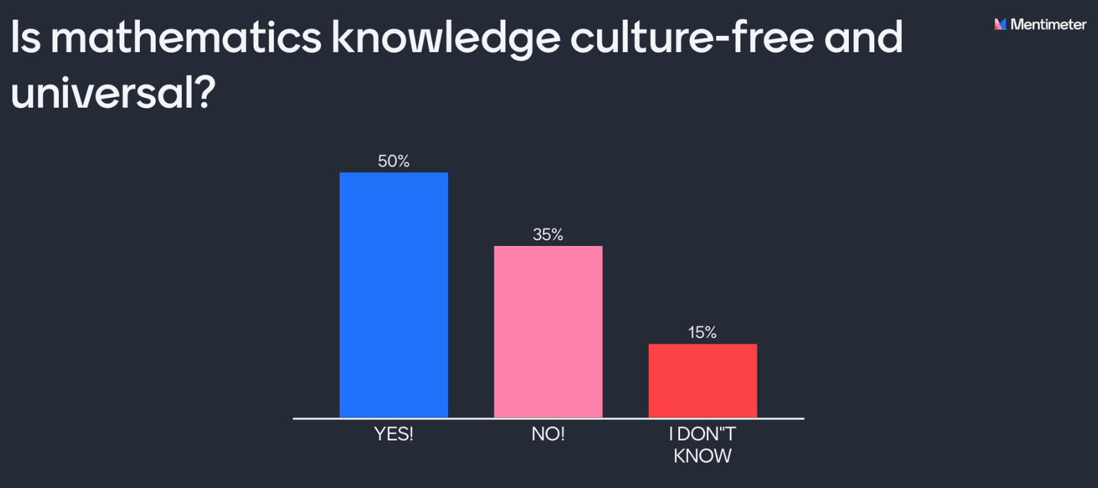

Figure 3
Participant Responses

In general, 50% of the participants believed that mathematics knowledge is culture-free and universal, 35% believed that mathematics knowledge is not culture-free and universal, and 15% did not know if mathematics knowledge is culture-free and universal. Unlike in-person workshops, more people participated in the online poll, presumably because it was anonymous.

To disrupt notions that speak to mathematics as a universal subject. I talked about the risk of assuming that all students, regardless of where they have come from, learn and do the same mathematics. Such an assumption results in:

- an attempt to assimilate the […] student into the social representation of a monocultural learner,
- a neglect of cultural differences in mathematical practices in favour of what they [teachers] perceive to be universal,
- an interpretation of the process of learning from a psychological perspective that focuses on the individual, ignoring the fact that learning is also a cultural and social process. (de Abreu & Gorgorió, 2007, p. 1565)

Consider, for instance, the example I shared earlier about an international student’s use of a division algorithm that was correct but not recognized by the teacher because it was not traditional to the target country—this led the teacher to reject an alternate way of using a division algorithm. As such, it is critical to be open to the different ways students approach mathematics especially when they rely on procedures that appear different than what are assumed traditional.

Participants also wrote language quite frequently. I shared that ‘language’ plays an essential role in the teaching, learning, and doing of mathematics: an idea that has become widely acknowledged by mathematics education researchers (e.g., Barwell, 2014; Morgan et al., 2014). The crucial role of language is even more important to consider in multilingual classrooms, as found in many Canadian schools. However, in some classrooms, we might see an exclusive emphasis on learning the language of instruction (i.e., English or French) in isolation from learning mathematics, which separates language and content (Barwell, 2005). Pimm (1987) argues that learning mathematics is linked to learning language because mathematics is not only a written language but also a spoken (or communicative) one that is extensively used within the mathematics classroom. In her work, Moschkovich (2018) states that ‘communicating to learn mathematics’ is pivotal because it supports students’ conceptual understanding which involves explanations, arguments, and justifications that students construct as they engage in their own or other students’ reasoning. For multilingual learners, central to this idea of communicating to learn mathematics is a movement between mathematical (formal) language and everyday (informal) language to orchestrate and promote meaningful mathematics learning and discussion (Setati & Adler, 2000; Webb & Webb, 2008). Mathematical language refers to the standard terminologies used to describe and discuss mathematics. Everyday language refers to words or terms used in our day-to-day encounters or conversations to express mathematical understanding and ideas. It has also been argued that a movement between students’ everyday language to mathematics language is very beneficial for students because everyday language may connect to students’ everyday lives, which could help them identify, or make sense of, the mathematics they are working on (Barwell, 2016; Tshabalala & Clarkson, 2016).

By drawing on the research literature to challenge deficit perspectives concerning such words as manipulatives, challenging/ difficult/ problems, universal, and language, it was evident that we, as educators, need to be better equipped at understanding multilingual students’ learning experiences, as well as focusing on pedagogical practices that support students’ learning of mathematics, regardless of their expertise in the language of instruction. This is intended to enhance and develop multilingual students’ mathematics experiences.

A Mathematical Problem-Solving Activity

I shared a collaborative mathematical problem-solving activity that was done in a Grade 2/3 classroom with the teacher, Mrs. Holland. The activity focused on a 3-Act task entitled “The Cookie Monster” that was adapted from Graham Fletcher’s (2019) website. Visit the following link (https://gfletchy.com/the-cookie-monster/) to view the video and/or download the task. Such tasks take the form of a story and consist of three acts. In Act One, the teacher introduces the central conflict of the task or story by sharing a video or an image and discussing it. In Act Two, students reason their way to a solution by relying on the information they have or need to solve. In Act Three, the students and their teacher discuss or share the strategies used, and then conclude with a solution to the task.

The general objective of “The Cookie Monster” task was to work on addition and subtraction (within 50) by figuring out the number of cookies the monster ate. I provided a detailed account of this task for the workshop participants, as it reflected the types of open-ended tasks in which all students, despite their language or mathematics skills, can actively and collaboratively engage. Similar questions directed to Grade 2/3 students by their teacher were asked to participants at the workshop.

Act One
The Grade 2/3 teacher, Mrs. Holland, showed a video to her students. In the video, the students saw the hand of a cookie monster grabbing a box of cookies from a grocery bag, opening it, and then eating several cookies. To encourage and generate discussion, the teacher asked students what they noticed, and then what they wondered. The same questions were asked to participants at the workshop, and their responses to what they noticed resembled those shared by Grade 2/3 students, like “Eating lots of cookies; A furry hand; Oreos/ cookies; An open bag; and Crunching sounds”. In terms of what they wondered about, the participants shared things like “Who was the monster? How many cookies were eaten? How many cookies were left? and How many cookies were in the tray?”

Mrs. Holland confirmed to her students that they were to try and figure out, 1) how many cookies the monster ate and 2) how many cookies were in the tray. The teacher then drew a diagram on the board that prompted students to see what they had in terms of parts and whole, and what they were still missing (see Figure 4). I shared the diagram with the participants who said that they were not familiar with it, but felt it was an interesting strategy to help students solve the task.

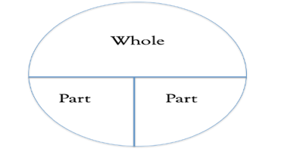
Figure 4
A Part/ Part/ Whole Diagram

Act Two

Mrs. Holland showed the students an image of a full tray of Oreo cookies (see Figure 5), and she asked, “What should we figure out?” Several students immediately got up on the board and counted the cookies. Then, one of the students counting said, “there’s 16 in this row.” A few students made the connection that there must be 16 cookies in each row. The teacher asked, “So if there’s 16 cookies in each row. How many are there in total? Grab the whiteboards, markers, hundreds’ chart. Whatever you need. And show me your work.” Some students worked together, others worked on their own, and some worked with their teacher or other volunteers in the classroom.



Figure 5
A Full Tray of Oreo Cookies

Prior to sharing with the workshop participants samples of Grade 2/3 students’ solutions to the number of cookies in the tray, I provided them with a chance to consider how they thought Grade 2/3 students solved the task. The participants shared things like “Students could use counters to create a visual representation of the Oreo tray and then count how many there are in total”; “Students might count on from 16”; and “Students might count the Oreos one-by-one”.

Following that, I shared with the participants some examples of students’ solutions. Working in groups of four or five, the participants were asked to discuss how Grade 2/3 students calculated the number of cookies in a tray and to consider the types of strategies and manipulatives the students used.

For in-person workshops, participants gathered in small groups, and were provided with printed images of students’ solutions. During online workshops, participants worked in breakout rooms in Zoom, and were asked to review the students’ solutions by referring to Google slides. Once we reconvened, the participants shared their chosen solution and explained how they thought the students calculated the number of cookies in the tray. According to some participants, “while some students’ solutions were easy to follow, others were a little more complicated.” This stresses the importance of understanding students’ solutions by creating spaces for them to share their solution using various communicative resources, and not to guess or try to predict how students solved a task.

In what follows, I provide some examples of Grade 2/3 students’ solutions and a step-by-step explanation of how the students determined the number of Oreo cookies in the tray in Figures 6, 7, 8, 9 and 10 (see Appendix E for more examples of students’ solutions). Students relied on various communicative resources (e.g., oral, visual, and written) to share their solutions and thinking.

In Figure 6, the student (Samartha) knows that she needs to add 16 plus 16 plus 16. First, she decomposes two of the number 16s into tens and ones (i.e., 10+6 and 10+6). She then adds the digits in the ones’ place—that is, 6 plus 6 equals 12. She decomposes the 12 into tens and ones (i.e., 10+2). Samartha then uses the hundreds’ chart to add the digits in the tens’ place and to find her solution. She starts at 16, adds 10 equals 26, adds 10 equals 36, adds 10 equals 46, adds 2 equals 48.

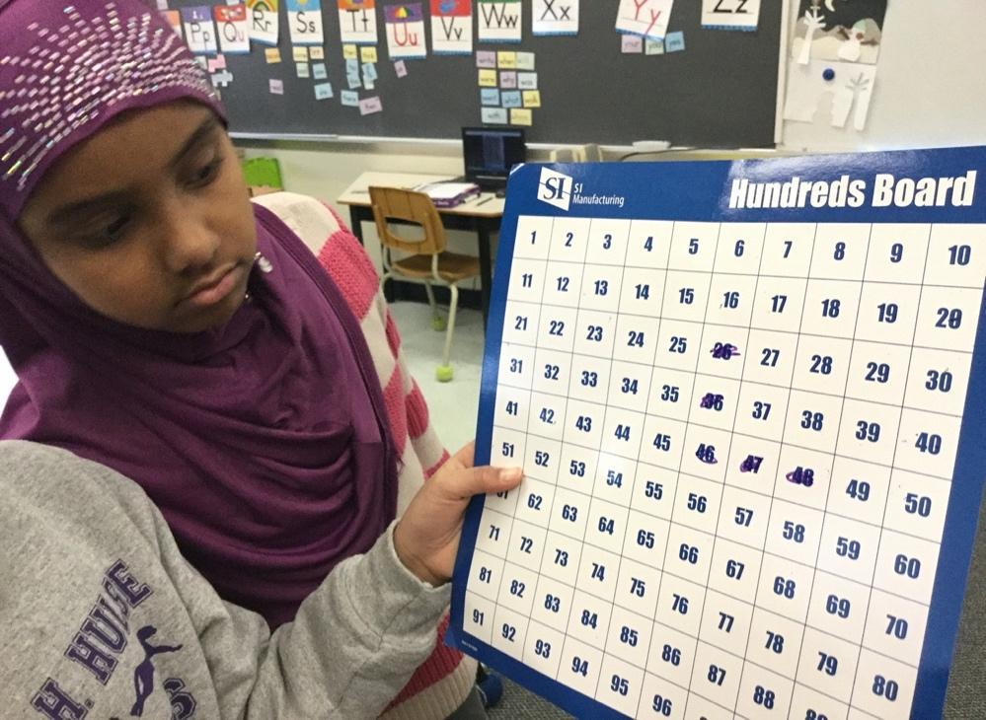

+2
+10
+10
+10

She starts with:
16 + 16 + 16
(10 + 6) (10 + 6)

6 + 6
12
(10 + 2)

Using the hundreds’ chart she adds:
16 + 10 = 26
26 + 10 = 36
36 + 10 = 46
46 + 2 = 48

Figure 6
Samartha’s Solution

In Figure 7, Sabina adds 16 each time by counting up by ones. That is, the student starts at 16, counts 16 more to 32, and then counts another 16 to 48. Notice how on the hundreds’ chart, the student made a pencil mark on 49—that is because the student counted 17 rather than 16 more. However, the student recounted to double-check their solution, giving them 48.

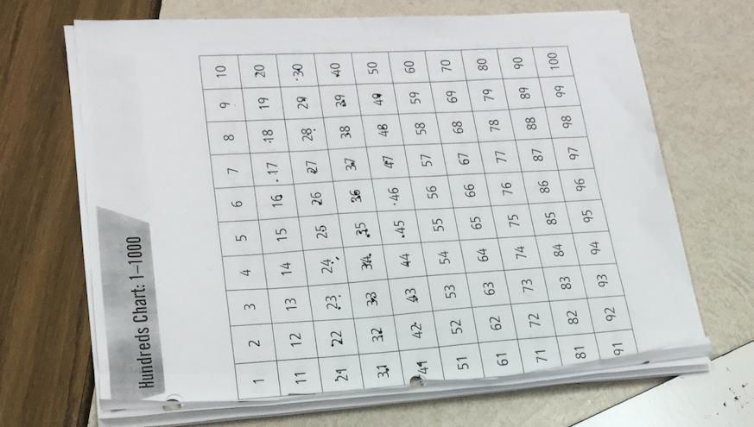

Figure 7
Sabina’s Solution

In Figure 8, Tamam also uses the hundreds’ chart but starts adding the digits in the ones’ place followed by the digits in the tens’ place. She starts at 6, counts 6 equals 12, then counts 6 more equals 18. Tamam then adds the digits in the tens’ place. She starts at 18, adds 10 equals 28, adds 10 more equals 38, then adds another 10 equals 48.

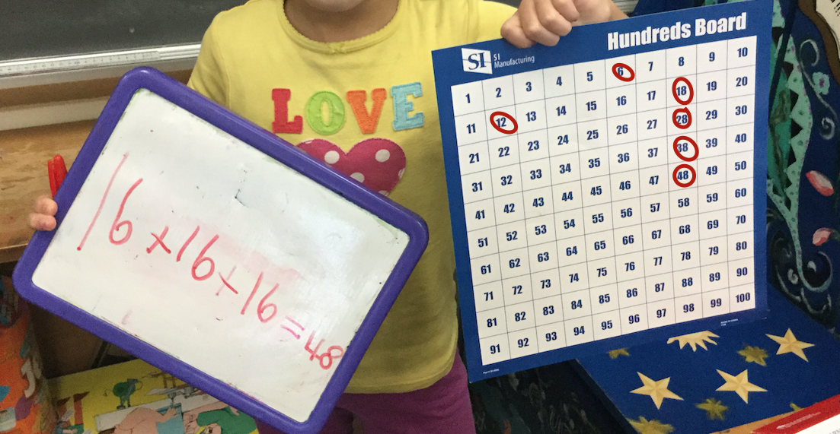

She starts with:
16 + 16 + 16
(10+6) (10+6) (10+6)

Using hundreds’ chart she adds:

6 + 6 = 12
12 + 6 = 18
18 + 10 = 28
28 + 10 = 38
38 + 10 = 48

Figure 8
Tamam’s Solution

In Figure 9, Hayat used tally marks to count by ones. Interestingly, as she counted, she grouped them by fives. Once she was done counting, she calculated the total by counting by fives (i.e., 5, 10, 15, 20, 25, 30, 35, 40, 45), then she counted three more (i.e., 46, 47, 48).

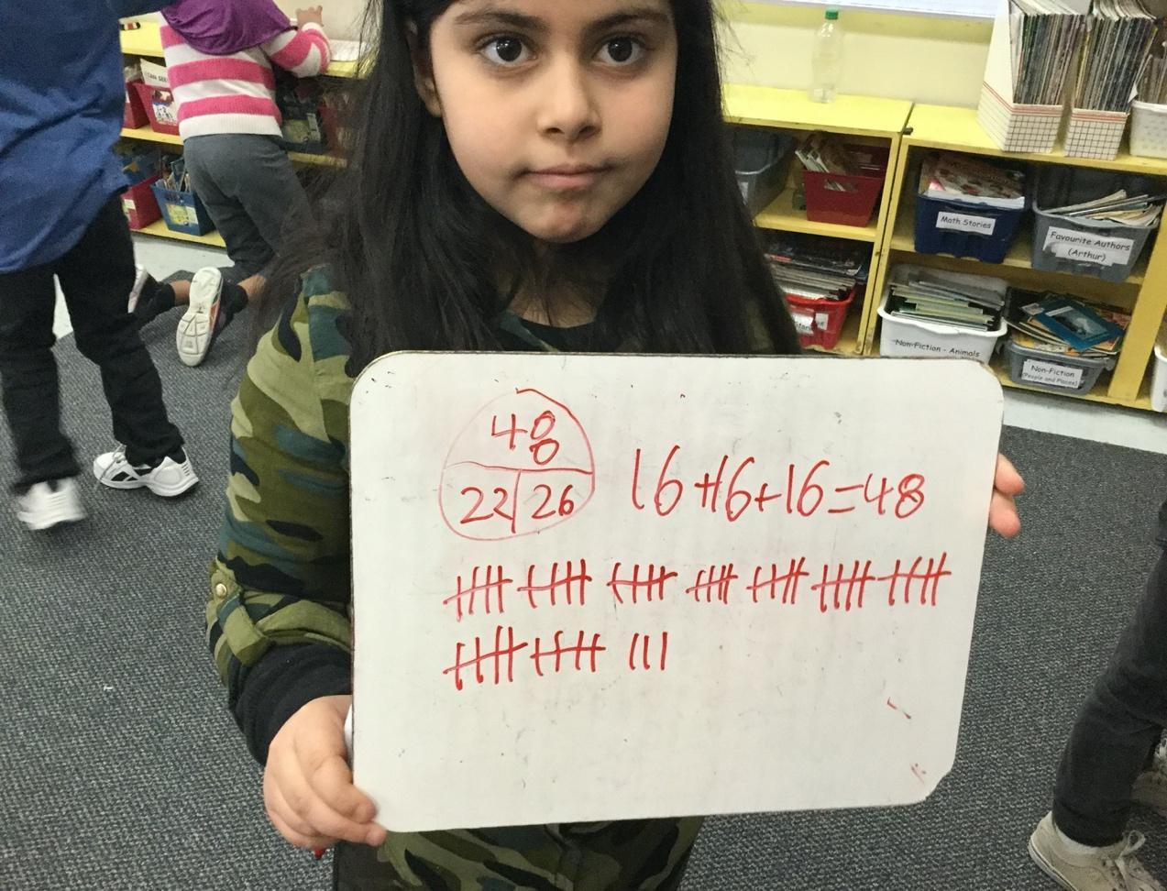

Figure 9
Hayat’s Solution

In Figure 10, Ahmed added the numbers mentally. First, he added all the digits in the tens’ place (i.e., 10+10+10=30), then he added the digit in the ones’ place (i.e., 6+6+6=18). Finally, he added 30 plus 18 equals 48. The student indicated, “I can see the numbers in my head, and I put them together.”

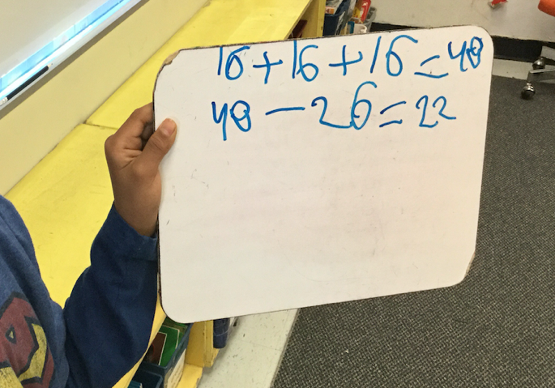

Figure 10
Ahmed’s Solution

My intention in sharing with the workshop participants some of the students’ solutions was to help them see the multiple ways in which students solve a mathematical problem, and to familiarize them with various strategies and manipulatives students use to find a solution. It was evident from Grade 2/3 students’ solutions that their thinking was complex and sophisticated, and this was understood only by communicating with the students about their solutions as I was in the classroom at the time.

Act Three

The students and their teacher reconvened at the carpet and shared their solutions and some of the strategies they used. The students agreed that there were 48 cookies in total, and the teacher wrote the number 48 (i.e., the whole) in the diagram. She then shared a picture of the tray with the missing cookies (see Figure 11).



Figure 11
An Oreo Tray with Missing Cookies
Two students went up to the board and counted the cookies in each row one-by-one, and the teacher wrote the number of cookies in each row (see Figure 12). One student then shared the total number of cookies left in the tray, and the teacher asked the student to explain how they got the answer. The workshop participants were asked to think of the strategy the student used to get the answer. Some participants shared, “The student might start at 11, count up 9, then count up 6 more.” Another participant suggested, “The student could decompose the 11 into 10 and 1, add 1 to 9 which is 10, add 10 plus 10 that’s 20, and add 6 more so that’s 26.” Here, the participant appeared to have relied on the examples shared earlier of students decomposing numbers to suggest the strategy the student might have used, which was like the strategy the student used.



Figure 12
A Written Representation of the Number of Cookies in Each Row

The teacher then prompted the students to tell her what they were still missing. The students agreed that they still needed to know “How many cookies the monster ate?” Again, the participants were provided with space to share some strategies students might use. For example, one participant shared, “Students could use the hundreds chart. They start at 48 and count backwards 26.” Another participant shared, “They could start at 48. Minus 10 which is 38. Then minus another 10 that’s 28, then take away 6 more equals 22.” The participants’ strategies were like those used by Grade 2/3 students. Finally, the teacher provided the students with a quick recap of what they solved and reflected on some of the strategies that students used to solve the activity.

This 3-Act task provided the workshop participants with space to explore mathematical problem-solving skills and various strategies Grade 2/3 students used to reason their way to a solution, which illustrated the influence of various skills and strategies on multilingual students’ mathematics learning experiences.

Conclusion

In this workshop, participants engaged in various hands-on activities, including an introductory activity, an animated video with reflection questions, an exploration of key words in a word cloud, a review of the research literature, and a mathematical problem activity that reflected the various strategies students used. Through these activities, I set out to disrupt and challenge deficit perspectives of multilingual students’ learning of mathematics. I encouraged teacher candidates to shift their focus from what multilingual learners cannot do and to consider the multiple resources multilingual students use to communicate mathematically. As evident from the solutions of Grade 2/3 students, the students drew on a variety of resources to make mathematical meaning, and their meaning making was not strongly dependent on proficiency in the language of instruction, rather it was dependent on the opportunities the teacher provided for the students to develop their mathematics learning experiences. Hence, teachers should provide opportunities for students to experience mathematics through exploring problem-solving skills, communicating with others to share and engage in their own and other students’ thinking, developing an understanding of mathematical terminology and associated concepts, and applying and using various strategies and learning tools to find a solution. To this end, I argue that all students can engage in rich mathematics learning when teachers create a learning environment that expands their mathematical thinking and understanding.

As revealed from the participants’ feedback towards the workshop, the activities disrupted deficient perspectives towards multilingual learners’ learning of mathematics. Some takeaways shared by the participants confirm that to be the case:

- Students have different backgrounds and ways of thinking. Focus on the CAN DO, not the CANNOT.
- Mathematic knowledge is not the same all around the world, it is not cultural free and universal.
- I learned that for ESL learners we as teachers must create, implement, ADAPT strategies, and differentiate instructional lessons to ensure they [students] are successful in the classroom and have equal opportunity to excel.

To this end, I conclude by leaving the reader with the following questions: What aspects still exist in the educational system in Ontario, Canada that could represent an obstacle to learning mathematics for multilingual learners? If any exist, what are some ways that we, as educators, could try to address those obstacles?

References

Assaf, F. (2021). Understanding multilingual learners’ mathematical experiences and
meaning making in a Canadian educational setting [Doctoral dissertation,
University of Ottawa]. uOResearch.
https://ruor.uottawa.ca/bitstream/10393/42797/4/Assaf_Fatima_2021_Thesis.pdf

Barwell, R. (2005). Working on arithmetic word problems when English is an additional
language. British Educational Research Journal, 31(3), 329–348.
https://doi.org/10.1080/01411920500082177

Barwell, R. (2014). Mathematics and language. In P. Andrews, T. Rowland, & S.
Brindley (Eds.), Masterclass in mathematics education: International perspectives
on teaching and learning (pp. 75–86). Bloomsbury Publishing.

Barwell, R. (2016). Mathematics education, language, and super diversity. In A. Halai &
P. Clarkson (Eds.), Teaching and learning mathematics in multilingual
classrooms: Issues for policy, practice and teacher education (pp. 25–39).
Sense Publishers.

César, M., & Favilli, F. (2005). Diversity seen through teachers’ eyes: Discourse about
Multicultural classes. In M. Bosch (Ed.), Proceedings of the fourth Congress of the European Society for Research in Mathematics Education (pp. 1153–1164).
Universitat Ramon Llull.

Civil, M. (2008). Mathematics teaching and learning of immigrant students: An overview
of the research field across multiple settings. In O. Skovsmose & B. Greer (Eds.),
Opening the cage: Critique and politics of mathematics education (pp. 127–142).
Sense Publishers.

Civil, M. (2016). “This is nice but they need to learn to do things the U.S. way”: Reaction
to different algorithms. In D. Y. White, S. Crespo, & M. Civil (Eds.), Cases for
mathematics teacher educators: Facilitating conversations about inequities in
mathematics classrooms (pp. 219–225). Information Age Publishing.

Civil, M. (2018). Intersections of culture, language, and mathematics education: Looking
back and looking ahead. In G. Kaiser, H. Forgasz, M. Graven, A. Kuzniak, E.
Simmt, & B. Xu (Eds.), Invited lectures from the 13th International Congress on
Mathematical Education (pp. 31–47). Springer.
https://research.monash.edu/files/243003698/243003598_oa.pdf

Clarkson, P. C. (2006). Australian Vietnamese students learning mathematics: High
ability bilinguals and their use of their languages. Educational Studies in
Mathematics, 64, 191–215. https://doi.org/10.1007/s10649-006-4696-5

Clements, D. H. (1999). Concrete manipulatives, concrete ideas. Contemporary Issues in
Early Childhood, 1(1), 45–60.

de Abreu, G. (2005). Cultural identities in the multiethnic mathematical classroom. In M.
Bosch (Ed.), Proceedings of the fourth Congress of the European Society for
Research in Mathematics Education (pp. 1131–1140). Universitat Ramon Llull.

de Abreu, G., & Gorgorió, N. (2007). Social representations and multicultural
mathematics teaching and learning. In D. Pitta-Pantazi & G. Philippou (Eds.), Proceedings of the fifth Congress of the European Society for Research in Mathematics Education (pp. 1559–1566). University of Cyprus.

de Abreu, G. (2008). From mathematics learning out-of- school to multicultural
classrooms: A cultural psychology perspective. In L. English (Ed.), Handbook of
international research in mathematics education (2nd ed., pp. 352–384).
Routledge.

Fletcher, G. (2019, September 15). 3-Act Tasks. https://gfletchy.com/3-act-lessons

Gates, P. (2006). The place of equity and social justice in the history of PME. In A.
Gutiérrez & P. Boero (Eds.), Handbook of research on the psychology of
mathematics education: Past, present and future (pp. 367–402). Sense Publishers.

Hoffert, B. S. (2009). Mathematics: The universal language? The Mathematics Teacher,
103(2), 130–139.

Krpan, M. C [@CathyMarksKrpan]. (2019, Sept 22). Manipulatives on their own have no
meaning. It is through Ss previous experiences, the questions we pose, & the
contexts we create that manipulatives can represent specific mathematical
concepts. Change the context/questioning/experiences and you change what they
represent [Tweet]. Twitter.
https://twitter.com/cathymarkskrpan/status/1175804152250867712

Morgan, C., Craig, T., Schuette, M., & Wagner, D. (2014). Language and communication
in mathematics education: An overview of the research in the field. ZDM
Mathematics Education, 46, 843–853. https://doi.org/10.1007/s11858-014-0624-9

Moschkovich, J. (2007). Bilingual mathematics learners: How views of language,
bilingual learners, and mathematical communication impact instruction. In N.
Nasir & P. Cobb (Eds.), Improving access to mathematics: Diversity and equity in
the classroom (pp. 89–104). Teachers College Press.

Moschkovich, J. (2008). “I went by twos, he went by one”: Multiple interpretations of
inscriptions as resources for mathematical discussions. The Journal of the
Learning Sciences, 17, 551–587. https://doi.org/10.1080/10508400802395077

Moschkovich, J. (2018). Talking to learn mathematics with understanding: Supporting
academic literacy in mathematics for English learners. In L. A. Bailey, A. C.
Maher, & C. L. Wilkinson (Eds.), Language, literacy, and learning in the STEM
disciplines: How language counts for English learners (pp. 14–34). Routledge.

National Council of Teachers of Mathematics. (2014). Principles to actions: Ensuring
mathematical success for all. National Council of Teachers of Mathematics.

Pimm, D. (1987). Speaking mathematically: Communication in mathematics classrooms.
Routledge Kegan & Paul.

Sari, M. H., & Yüce, E. (2020). Problems experienced in classrooms with students from
different cultures. Journal on Efficiency and Responsibility in Education and
Science, 13(2), 90–100. http://doi.org/10.7160/eriesj.2020.130204

Setati, M., & Adler, J. (2000). Between languages and discourses: Language practices in
primary multilingual mathematics classrooms in South Africa. Educational
Studies in Mathematics, 43, 243–269.

Tshabalala, L., & Clarkson, P. (2016). Mathematics teacher’s language practices in a
Grade 4 multilingual class. In A. Halai & P. Clarkson (Eds.), Teaching and learning mathematics in multilingual classrooms: Issues for policy, practice and teacher education (pp. 211–225). Brill Sense.

Webb, L., & Webb, P. (2008) Introducing discussion into multilingual mathematics
classrooms: An issue of code switching? Pythagoras, 67, 26–32.
https://doi.org/10.4102/pythagoras.v0i67.71

Whiteford, T. (2009). Is mathematics a universal language? Teaching Children
Mathematics, 16(5), 276–283.

Appendix A: In 5 Words or Phrases Handout
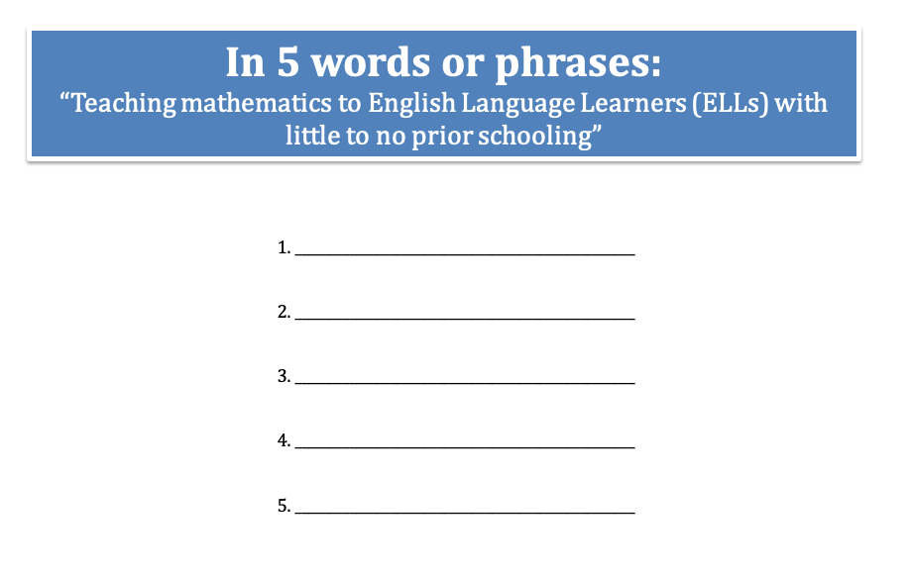

Appendix B: Script for Animated Video

Words Are Not Enough!
Script

Scene I- Classroom setting with teacher, Mrs. Goss, and students, including new student, Fatima.
Dialogue in this scene is in Afrikaans and Arabic
Mrs. Goss: Goeie more almal! Fatima, hoe gaan dit met jou vandag? Is jy goed? What het jy gister doen?
Translation: Good morning everyone! Fatima, how are things with you today? Are you well? What did you do yesterday?
Fatima: (smiles)
Mrs. Goss: Vandag ek wil jou a klein wiskunde probleem gee. Alright?
Translation: Today I will give you a small math problem. Okay?
Fatima: (confused)
Mrs. Goss: Dit sal n toevoeging probleem wees. Kyk! Ek het n nommer.
Luister!
Translation: It will be an addition problem. Look! I have a number. Listen!
Mrs. Goss: Drie honnerd drie en viertig. Ek sal dit skryf.
Translation: Three hundred and forty-three. I shall write it.
(Writes number on board)
Fatima. (Uncomfortable)
Mrs. Goss: Fatima, se dit! Drie honnerd drie en viertig
Translation: Say it! Three hundred and forty-three
(Repeats this request couple of times)
Fatima: Se dit. Drie honderd …
Mrs. Goss: Nie! Nie! Nie!
Translation: No! No! No!
Mrs. Goss: Verstaan jy my, Fatima?
Translation: Do you understand me Fatima?
Mrs. Goss: Wat is die probleem?
Translation: What is the problem?
Fatima: (crying)
Translation: I swear I don’t understand anything. I don’t know why we came here. I want to go back to Lebanon now.

Scene II In the hallway outside the classroom, Mrs. Assaf and Mrs. Goss have a heated discussion.
Mrs. Goss Oh here is the ESL teacher! Mrs. Assaf! Wait, I need to talk to you!
Mrs. Assaf: Oh hi, Mrs. Goss. How are you? Anything I can help you with?
Mrs. Goss: I am desperate about Fatima. She doesn’t understand a word I say. She should not be in my class!
Mrs. Assaf: Ohhh!
Mrs. Goss: She should not be in a regular class for at least two years, until she is has mastered her second language.
Mrs. Assaf: Umm, hmmm! I don’t know about that, quite frankly.
Mrs. Goss: She really does not have enough of the vocabulary she needs to be in my classroom.
Mrs. Assaf: Excuse me there now. Knowing the mathematics vocabulary isn’t everything!
Mrs. Goss: Mrs. Assaf, what are you talking about? I am telling you she doesn’t have the vocabulary that she needs!
Mrs. Assaf: You should be aware, however, that students who are learning an additional language are facing new challenges when learning mathematics.
Mrs. Goss: What do you mean “face new challenges”? It’s been about vocabulary all along.
Mrs. Assaf: Well, well, Mrs. Goss. If you were to take into account the emphasis that was initiated by the mathematics curriculum and teaching standards which, for your information, spoke to the importance of students participating in more verbal and social activities, their focus isn’t then always focused towards the vocabulary. They are encouraged to draw upon other resources.
Mrs. Goss: I don’t understand what you are talking about, Mrs. Assaf!
Mrs. Assaf: My point here is to say that you should not treat the difficulties Fatima encounters with these words as mere problems with vocabulary, Mrs. Goss.
Mrs. Goss: But aren’t they just problems of vocabulary?
Mrs. Assaf: No! Vocabulary is part of the process of mathematical exploration, which can influence the use of various tools that help her clarify her understanding. And by the way, Mrs. Goss, these tools should be encouraged and readily available in your class at all times.
Mrs. Goss: I wonder whether these various tools can in fact be referred to as manipulatives?
Mrs. Assaf: Ah ha! Yet it is important to first situate what you take manipulatives to mean.
Mrs. Goss: Huh? Situate? What do you mean?
Mrs. Assaf: Well, you know, let me tell you something. The definition of a manipulative is often open for interpretation, quite frankly. I personally refer to manipulatives as concrete tools, which are used to create an external representation, which is something outside of the mind that stands for a mathematical idea.
Mrs. Goss: Oh?
Mrs. Assaf: Look! These include but are not limited to base ten blocks, linking cubes, fraction circles, and even gestures, drawings, and also verbal expressions can be considered manipulatives as well.
Mrs. Goss: I am not sure you even know what you are talking about! I think it is your responsibility Mrs. Assaf to teach her proper Afrikaans before she is permitted back into my classroom. She is holding the other students back and she is taking up too much of my time.

Appendix C: Video Reflections from In-Person Workshops

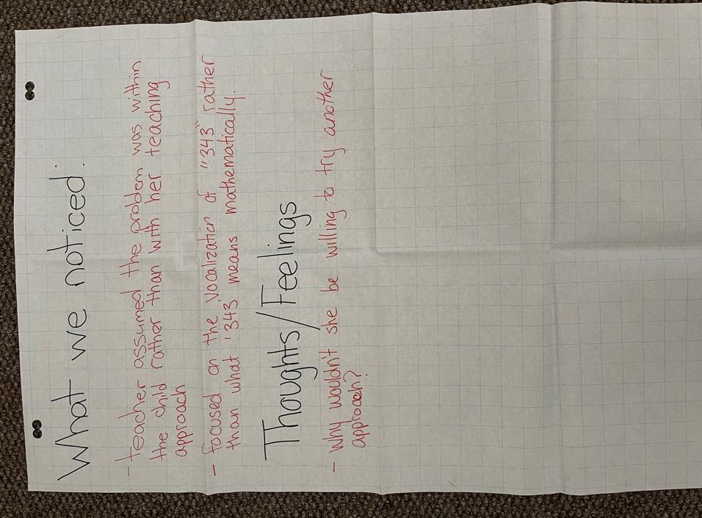
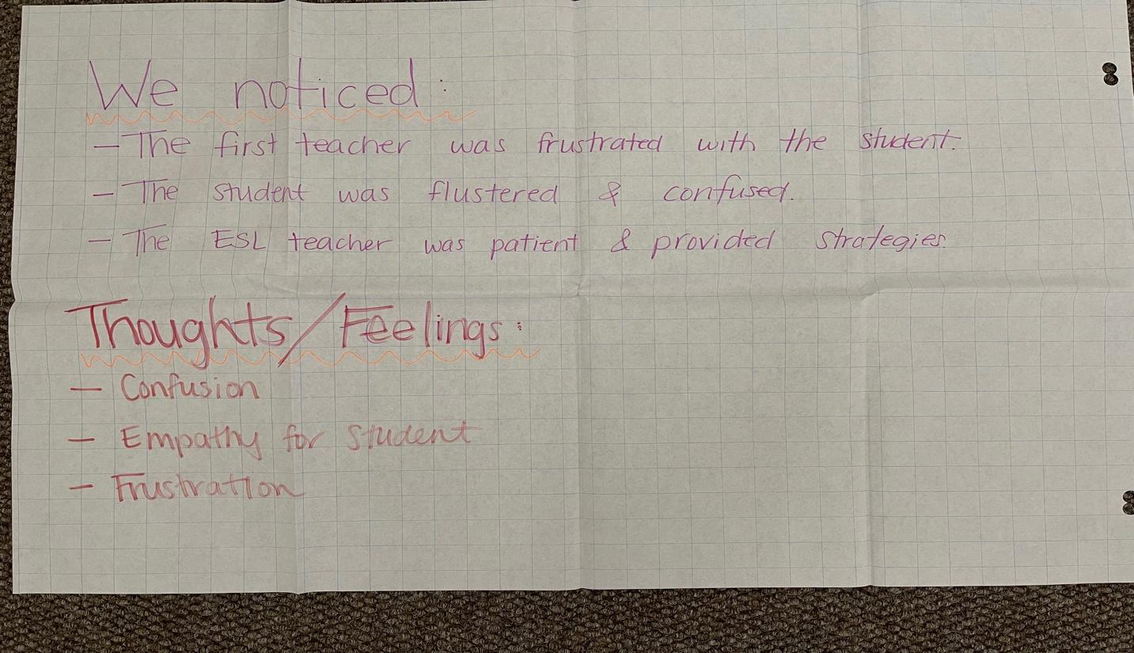

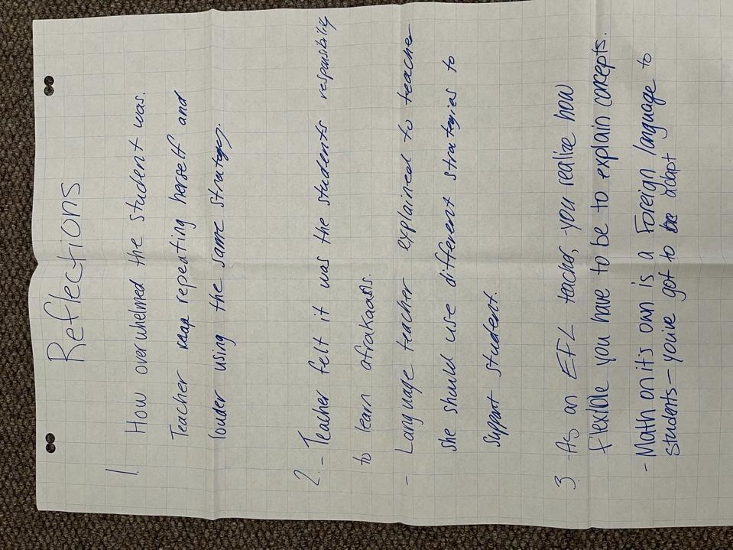
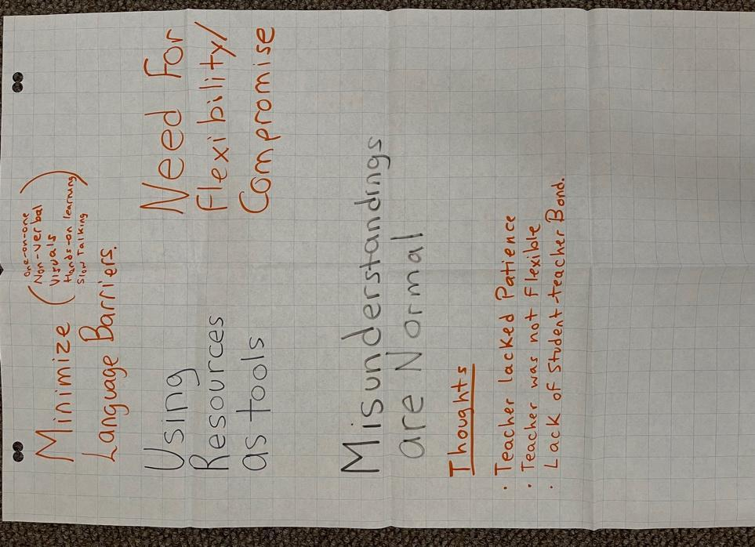
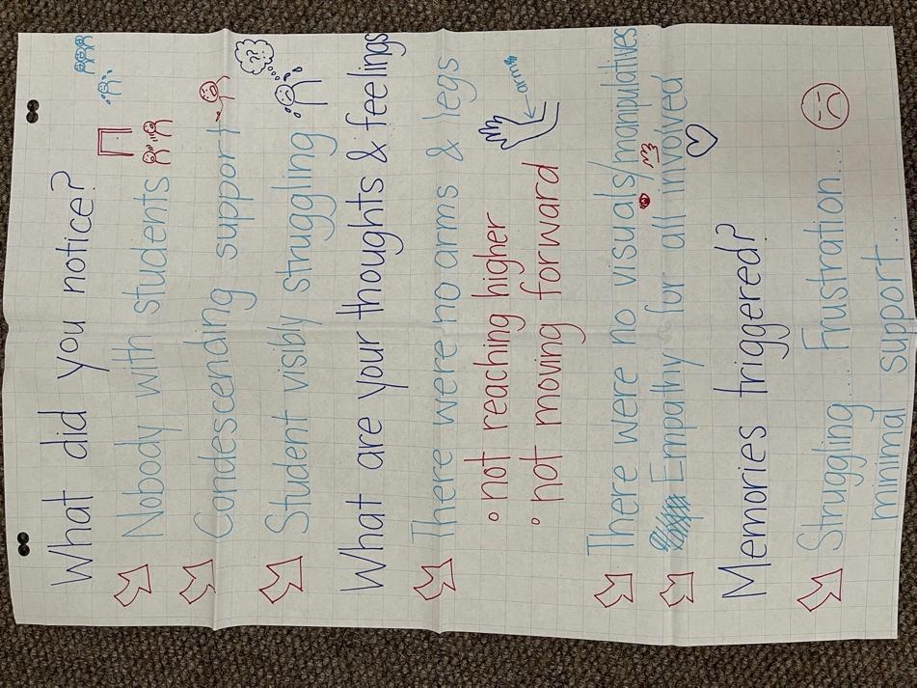
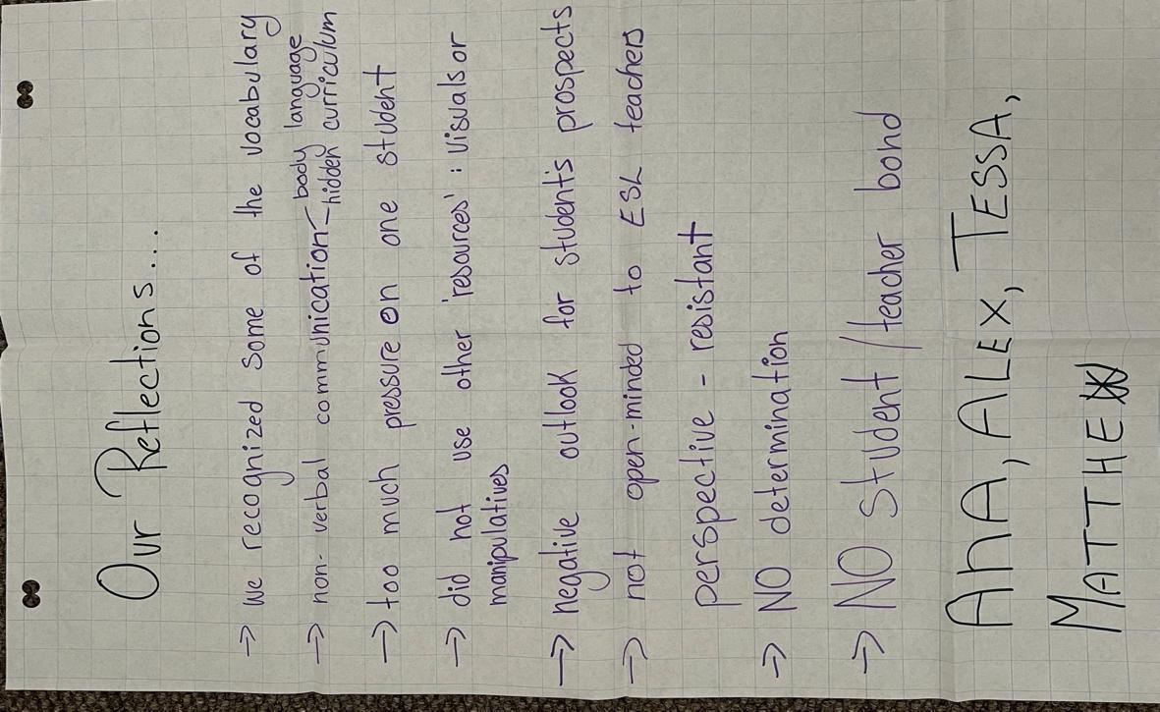

Appendix D: Video Reflections from Online Workshops

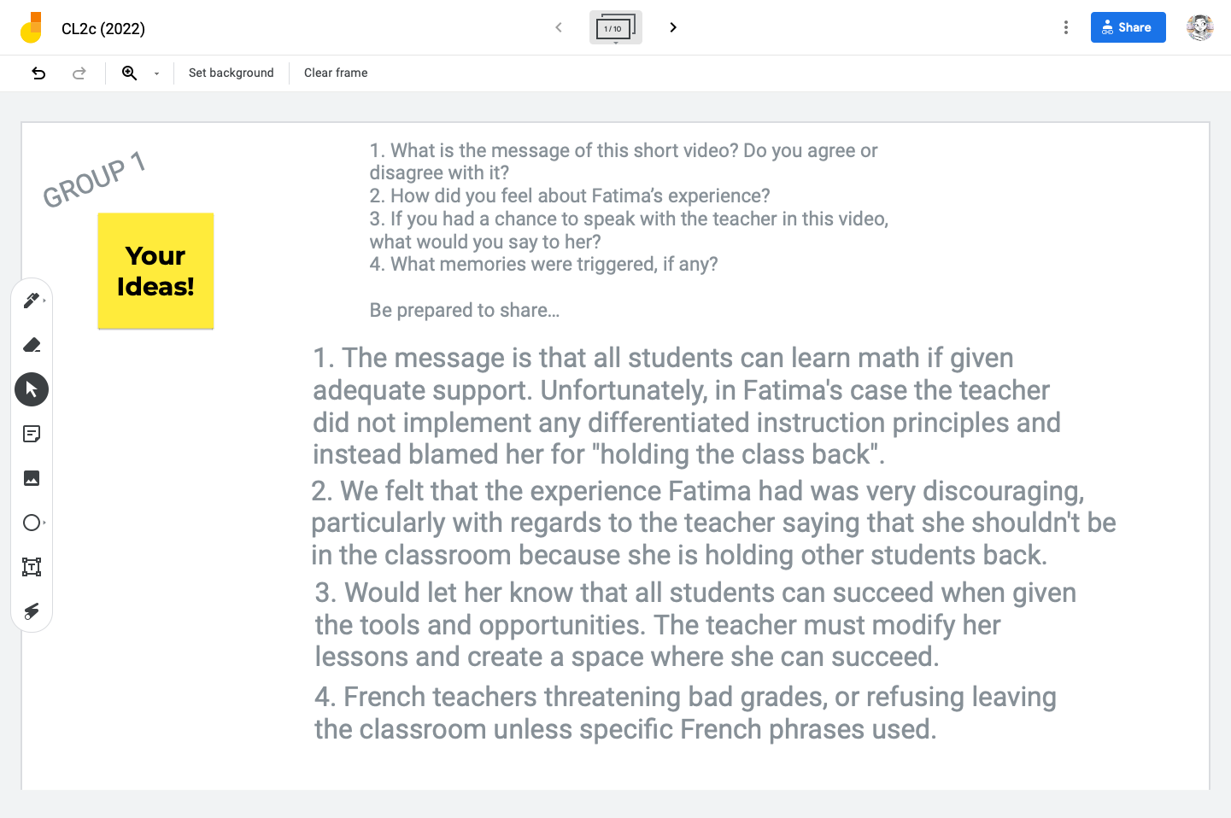
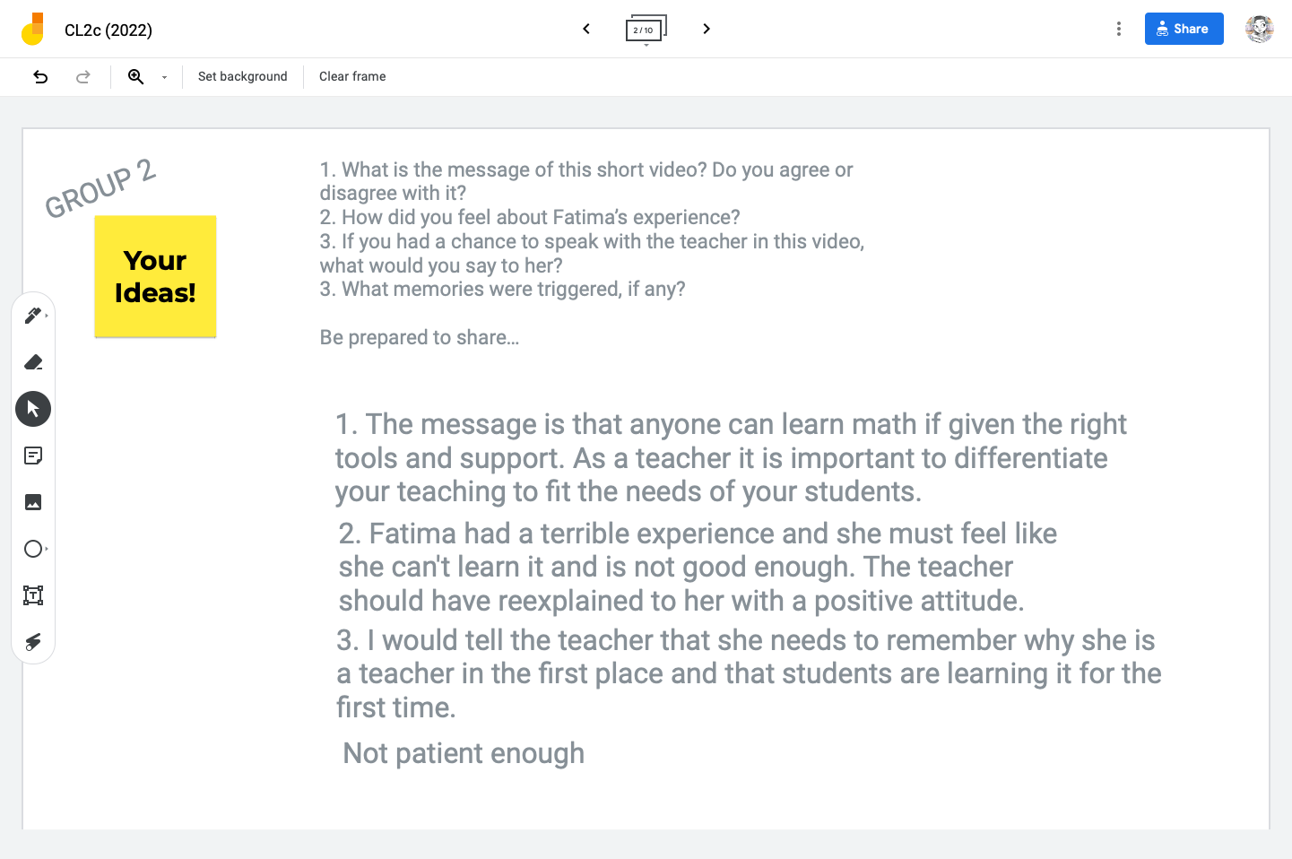
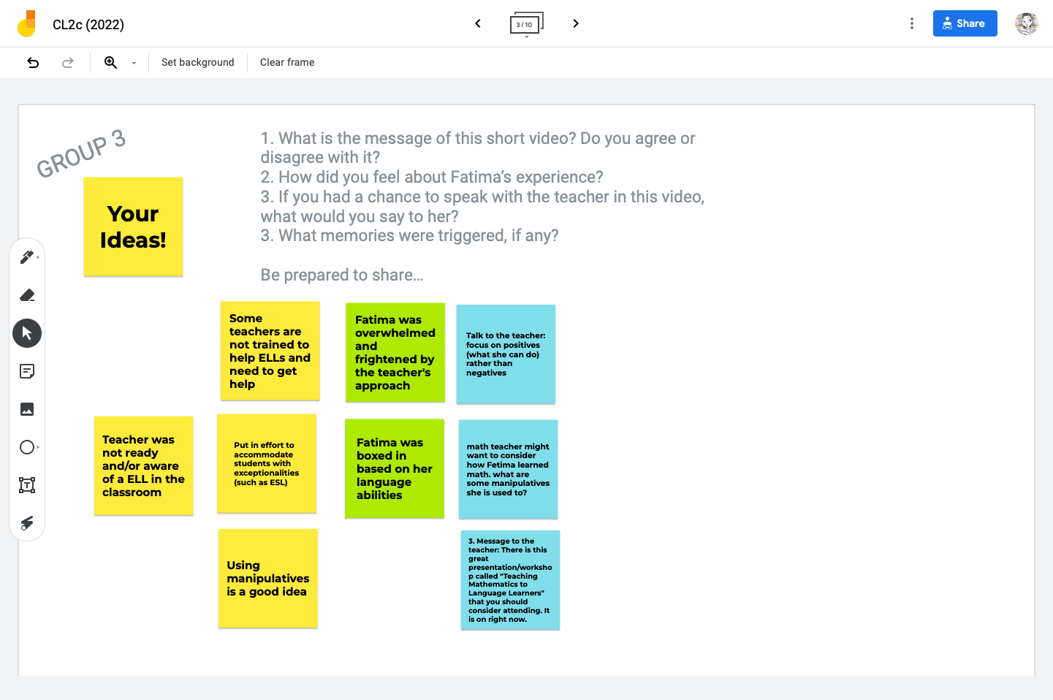
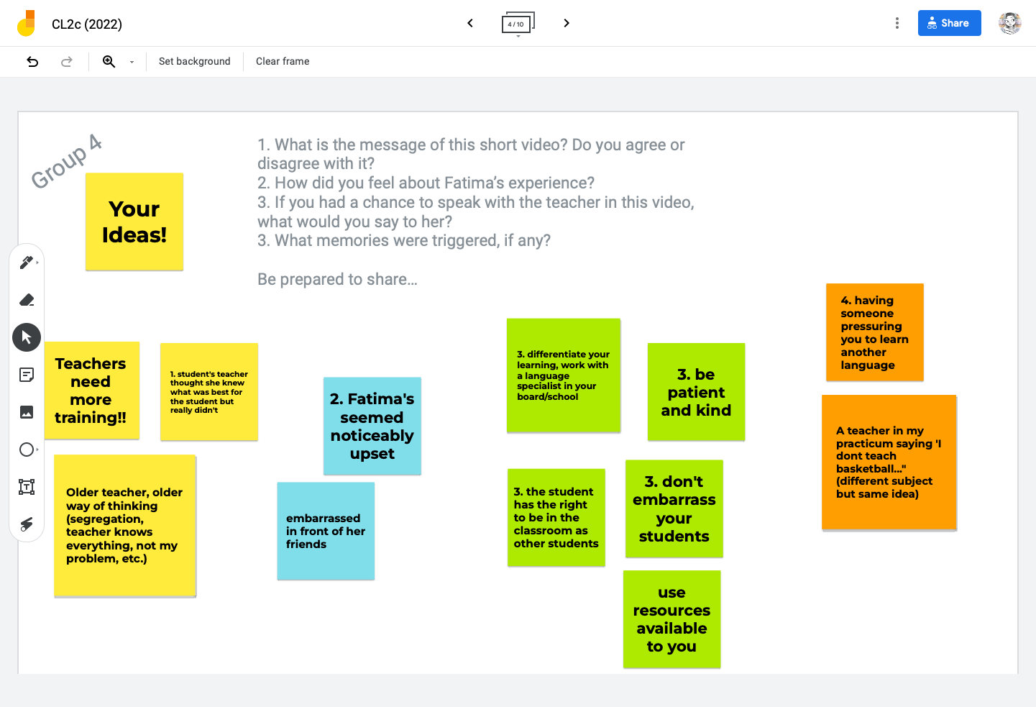
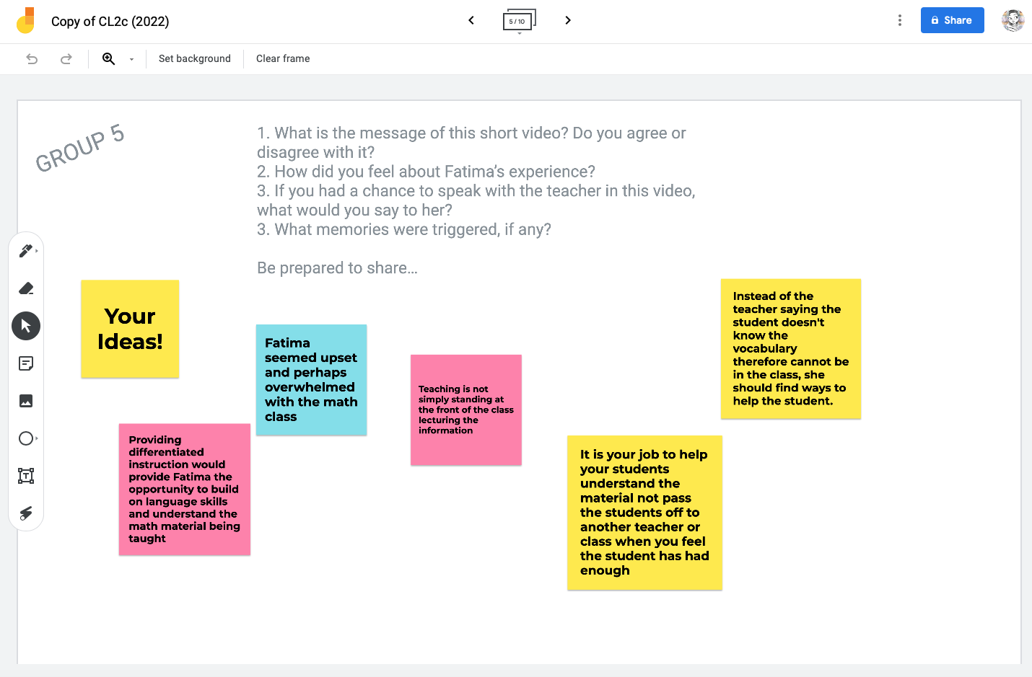
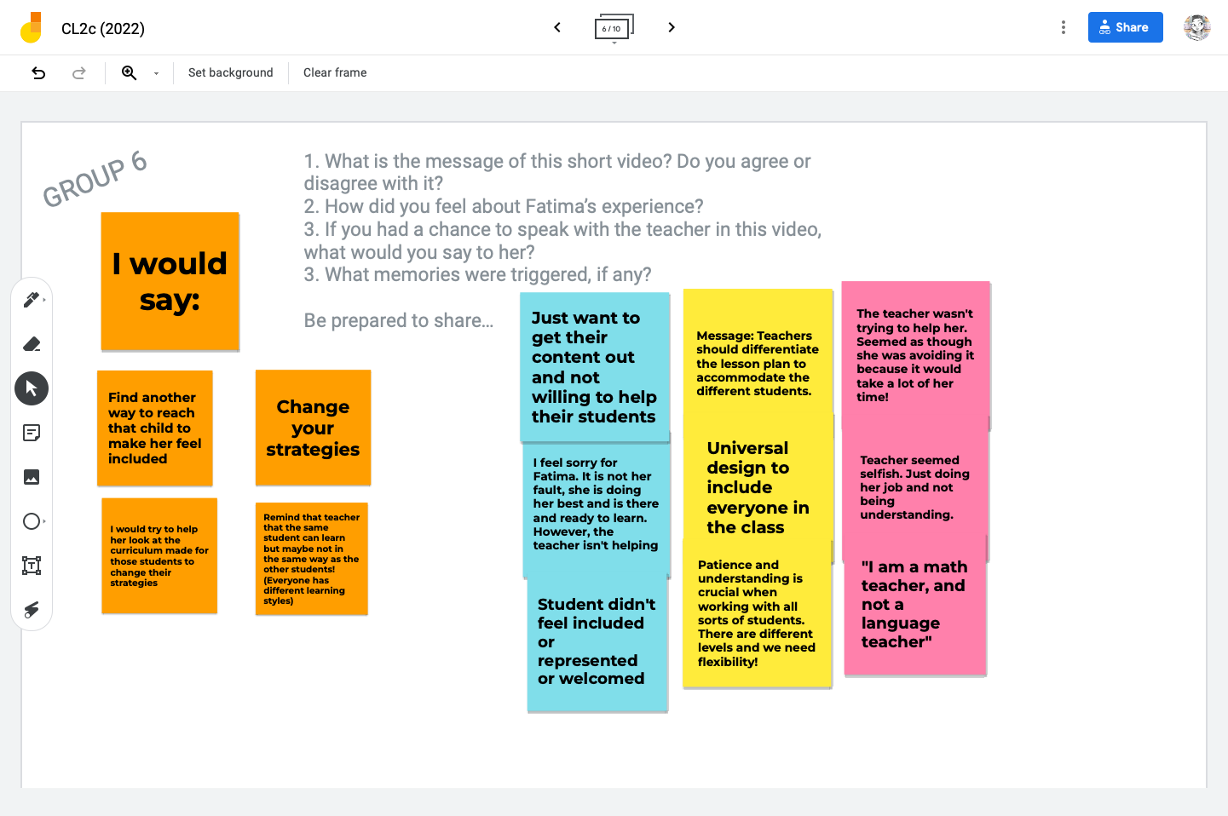
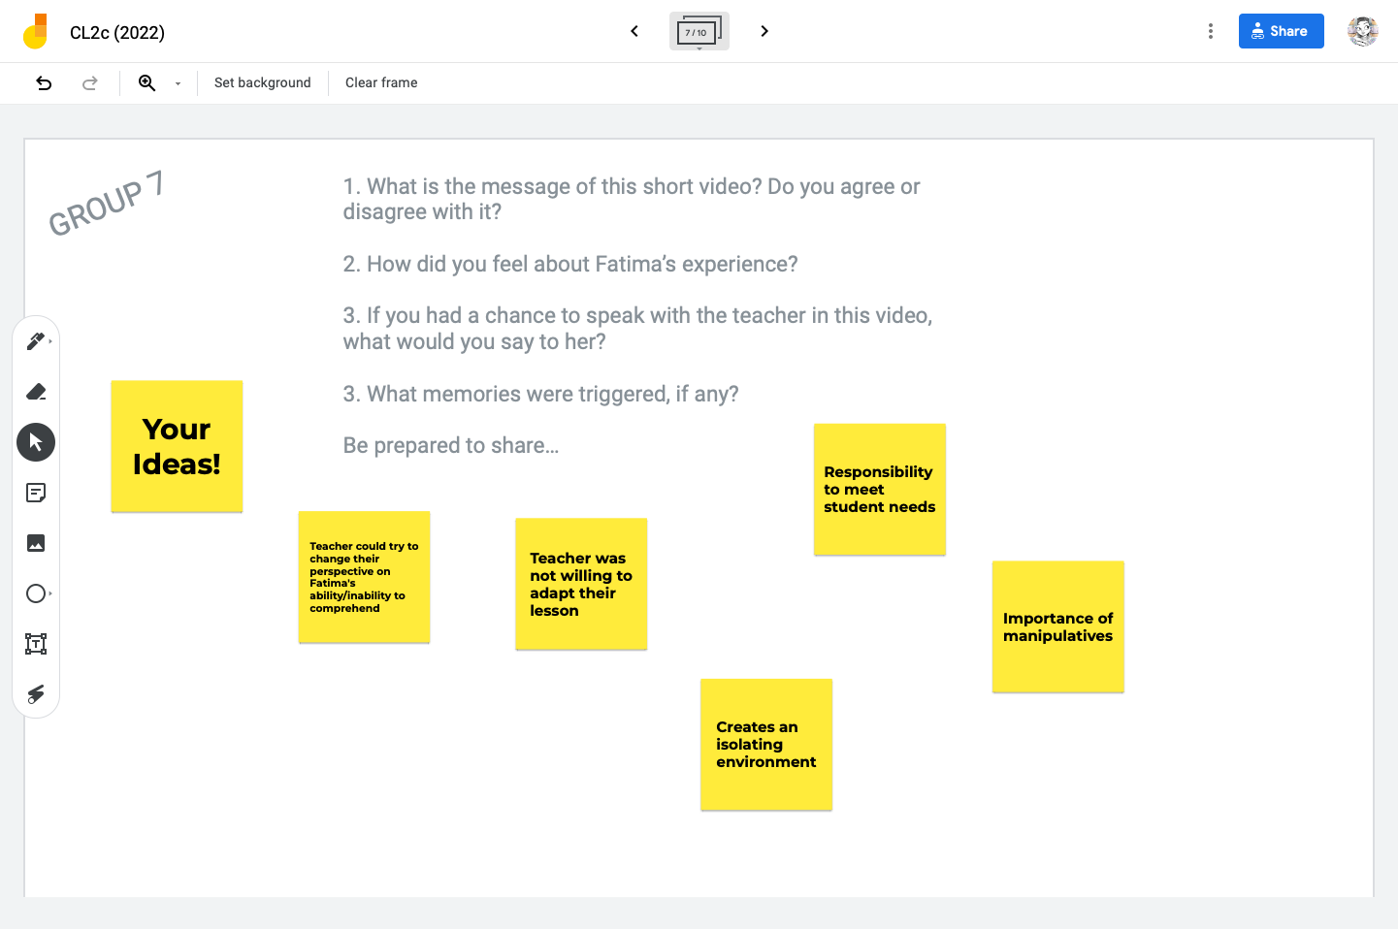
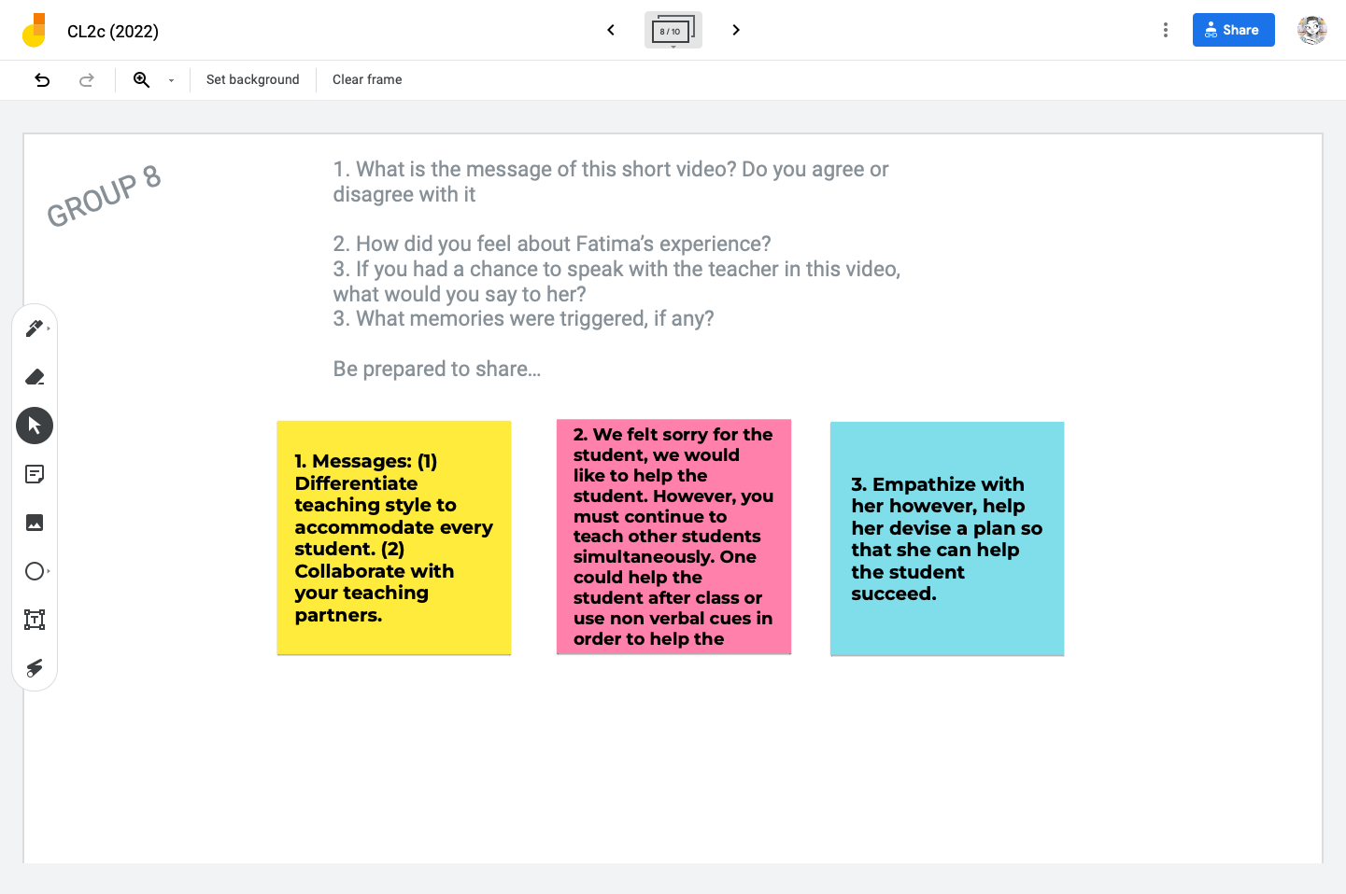

Appendix E: Samples of Students’ Solutions to the 3-Act Tasks

Sahar's Solution
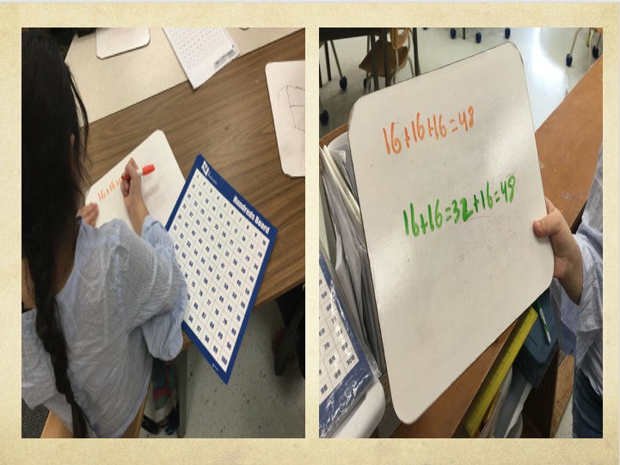
She starts with:
16 + 16
(10+6)

Using the hundreds’ chart she adds:
16 + 10 = 26
26 + 6 = 32

She then works with:
32 + 16
(10+6)

Using the hundreds’ chart she adds:
32 + 10 = 42
42 + 6 = 48
Sahar uses the hundreds’ chart to find her solution. She first works with 16 plus 16, and she decomposes one of the 16s into tens and ones (i.e., 10+6). She then refers to the hundreds’ chart, she starts at 16, adds 10 equals 26, then adds 6 more equals 32. Then, Sahar adds 32 plus 16, but first, she decomposes the 16 into tens and ones. She starts at 32 on the hundreds’ chart, adds 10 equals 42, then adds 6 more equals 48.

Abed and Mousa's Solution
They start with:
16 + 16 + 16
(10+ 6) (10+6)

6 + 6
12
(10 + 2)

They add:
10 + 10 + 10 = 30 + 2 = 32

Then, they work with:
32 + 16
(30+2) (10+6)

30 + 10 2 + 6
40 + 8
=48

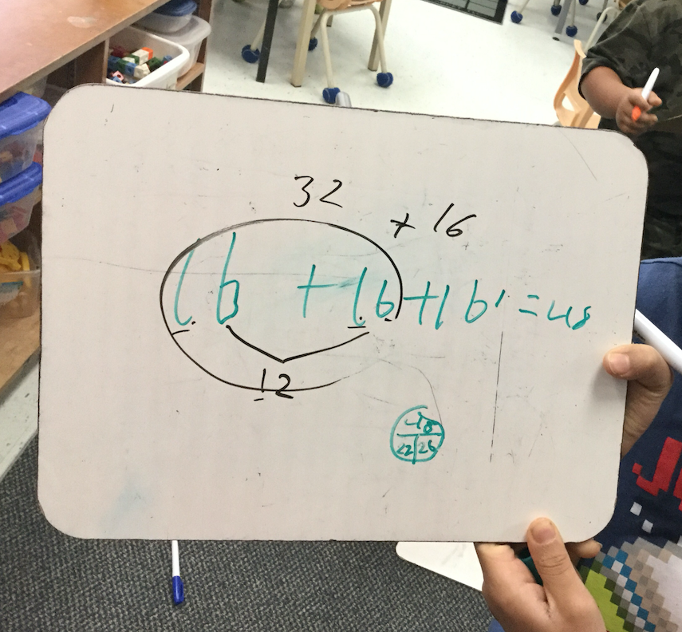

Abed and Mustapha worked together to find a solution. First, they decomposed two of the number 16s into tens and ones (i.e., 10+6 and 10+6). Then, they added the digits in the ones’ place (i.e., 6+6=12). The number 12 was then decomposed into tens and ones (i.e., 10+2). After that, the students added the digits in the tens’ place (i.e., 10+10+10=30), plus the remaining 2 equals 32. The number 32 was decomposed into tens and ones, and so was the remaining 16. The students added the digits in the tens’ place (i.e., 30+10=40), then added the digits in the ones’ place (i.e., 2+6=8). Finally, they added 40 plus 8 equals 48.

Joud's Solution
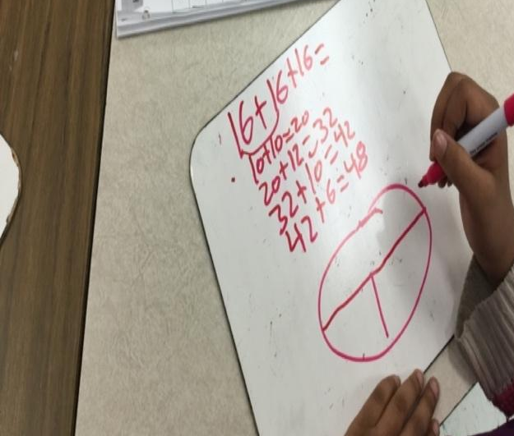

Joud’s solution is like those shared earlier but without using a hundreds’ chart. First, Joud focused on the digits in the tens’ place and added them together (i.e., 10+10=20), then she added the digits in the ones’ place (i.e., 6+6=12). She then added 20 plus 12 equals 32. Working with the remaining 16, Joud added 32 to the tens’ digit in 16 (i.e., 10) equals 42. Finally, she added 42 to the ones’ digit in 16 (i.e., 6) equals 48.

CHAPITRE
6

Équité, diversité et inclusion : La pédagogie sensible et adaptée à la
culture pour les futur(e)s enseignant(e)s
de FLS en Ontario

Eric Keunne
Université York (Toronto)

Résumé
Ce travail est une réflexion sur la nécessité pour les futur(e)s enseignant(e)s de français langue seconde (FLS) de se familiariser avec la pédagogie sensible et adaptée à la culture (PSAC) dans le contexte de leur formation des enseignant(e)s de FLS en Ontario. Cette réflexion s’adosse sur l’atelier que nous avons offert aux futur(e)s enseignant(e)s de FLS en cours de formation à la faculté d'éducation de l'Université d’Ottawa et sur les difficultés que rencontrent les enseignant(e)s à aborder les questions multiculturelles, d’anti-oppression et de décolonisation sur le terrain. Qu’est-ce la PSAC ? En quoi cette pédagogie est-elle pertinente dans le contexte d’enseignement du FLS en Ontario ? Comment se traduit concrètement l’usage de la PSAC en cours de FLS ? L’objectif est d’analyser et d'établir la pertinence de la PSAC dans la promotion d’un cadre d’enseignement du FLS inclusif. À travers un survol des trois axes identifiés (dimension institutionnelle, la dimension personnelle et la dimension pédagogique), les participants ont retenu que : Les enseignant(e)s culturellement réactifs (a) sont socio-culturellement conscients, (b) ont une vision positive des élèves d'origines diverses, (c) se considèrent comme responsables et capables d'apporter des changements pour rendre les écoles plus équitables, (d) comprennent comment les apprenants construisent leurs
connaissances et sont capables de promouvoir la construction de connaissances, (e) connaissent la vie de leurs élèves, et (f) conçoivent un enseignement qui s'appuie sur ce que leurs élèves savent déjà tout en les poussant au-delà du familier (Villegas & Lucas, 2002).

Mots clés : pédagogie sensible et adaptée à la culture (PSAC), questions
multiculturelles, anti-oppression et décolonisation

Introduction

Le monde de l'éducation est constamment en mutation au 21e siècle et plusieurs facteurs expliquent ceci, entre autres les inégalités observées dans les différents curriculums scolaires. Historiquement, l'éducation a été utilisée comme un outil par les colonisateurs pour exercer une domination linguistique. Compte tenu de l'histoire complexe de la colonisation et des contextes multiculturels croissants d'aujourd'hui dans le monde, comment les futur(e)s enseignant(e)s de langues peuvent-ils/elles :

- Être plus inclusifs dans le soutien aux communautés raciales diverses ?
- Utiliser des pratiques et des stratégies d'enseignement pour créer un sentiment d'appartenance dans les écoles ?
- Créer des plans de cours qui reflètent une plus grande diversité parmi les élèves et la communauté scolaire ?
- Utiliser des textes contemporains déconstruisant les stéréotypes des apprenants indigènes et racialisés ?

Une analyse du cadre d’apprentissage et de l’enseignement du français langue seconde (FLS) en Ontario permet de constater qu’il est multiculturel particulièrement dans les régions de Toronto et d’Ottawa où les apprenants et leurs familles viennent d’horizons divers notamment de l’Afrique, de l’Asie, d’Amérique du Sud et de l’Europe, et ils emportent avec eux dans leur processus d’immigration et d’installation au Canada, les différentes facettes de leurs identités culturelles. Les cours de langue vus comme des lieux extraordinaires où se tiennent des interactions complexes (Cicurel, 2002), ce cadre projette l’enseignant(e) dans un rôle de médiateur où il est très régulièrement invité à répondre à des questions posées par les élèves sur les questions de racisme, d’anti-oppression, et d’inclusion.

Notre expérience sur le terrain de l’enseignement du FLS en Ontario depuis près d’une décennie nous a amené à faire le constat selon lequel plusieurs enseignant(e)s éprouvent de sérieuses difficultés à aborder les questions en rapport avec les inégalités au sein de notre société en perpétuelle mutation.

Afin d’atténuer ces inégalités, plusieurs approches pédagogiques ont été élaborées et proposées aux éducateurs et éducatrices dans la perspective de décoloniser l’apprentissage et particulièrement le FLS en Ontario. C'est dans ce sillage que la pédagogie sensible et adaptée à la culture (PSAC) a émergé et a beaucoup été implémentée dans les écoles et facultés d'éducation aux États-Unis, au Canada et en Europe. Au cours de notre atelier avec les étudiants du programme de formation à l'enseignement de l'Université d’Ottawa en février 2022, nous nous sommes donnés comme objectif d'examiner et de faire une analyse critique des ressources que les futur(e)s enseignant(e)s de FLS (et d’autres concentrations) doivent considérer pour intégrer et mettre en application la PSAC.

Ce travail est organisé en trois grandes parties reflétant les discussions que nous avons eues tout au long de notre atelier. Dans un premier temps, nous passons en revue quelques travaux sur la PSAC. Dans un deuxième temps, nous proposons un examen sur les trois axes d'intérêt de tous les futurs(e)s enseignant(e)s de FLS en Ontario à se familiariser avec et à intégrer la PSAC. La troisième partie quant à elle, se penche sur quelques réflexions sur notre atelier et met en lumière quelques rétroactions des différents participants.

Aperçu historique : Qu’est-ce que c’est la pédagogie sensible et adaptée à la culture ?

Introduite par Gloria Ladson-Billings (1995), la notion de PSAC a beaucoup évolué au fil du temps et a nourri une littérature abondante dans le domaine de la formation des enseignant(e)s et la didactique des langues. La pédagogie sensible et adaptée à la culture est une approche d’enseignement centrée sur l'étudiant, dans laquelle les forces culturelles uniques de l'étudiant sont identifiées et entretenues pour promouvoir la réussite de l'étudiant et un sentiment de bien-être quant à sa place culturelle dans le monde. La PSAC se divise en trois dimensions fonctionnelles : la dimension institutionnelle, la dimension personnelle et la dimension pédagogique.

La dimension institutionnelle met l'accent sur la nécessité de réformer les facteurs culturels qui affectent l'organisation des écoles, les politiques et procédures scolaires (y compris l'allocation des fonds et des ressources), et la participation de la communauté. La dimension personnelle fait référence au processus par lequel les enseignant(e)s apprennent à devenir culturellement sensibles. La dimension pédagogique fait référence aux pratiques et aux défis associés à la mise en œuvre de la sensibilité culturelle dans la salle de classe (Gay, 2000; Ladson-Billings, 1995; Lynch, 2017).

Le Ministère de l’Éducation de l’Ontario (MEO), dans l’élaboration de son document stratégique portant sur les considérations concernant la planification du programme des écoles élémentaires et secondaires de l’Ontario, consacre une bonne section sur la PSAC. Dans ce document, on y lit ce qui suit :

Dans un système d’éducation inclusif, les élèves doivent se reconnaître dans le curriculum et dans leur milieu immédiat, de même que dans leur milieu scolaire en général, pour se sentir motivés et pour renforcer leur sentiment d’autonomie à l’égard de leurs expériences d’apprentissage. En somme, l’enseignement offert aux élèves et les apprentissages doivent correspondre à ce dont les élèves ont besoin et à qui ils sont. À cette fin, le personnel enseignant de la province adopte une pédagogie sensible et adaptée à la culture (PSAC), qui reconnaît que l’apprentissage des élèves est lié aux antécédents, à la langue, à la structure familiale et à l’identité sociale ou culturelle. (MEO, 2020, para. 5)

Gay (2000) et Villegas et Lucas (2002) utilisent les termes enseignement sensible à la culture ou pédagogie sensible à la culture pour désigner un enseignement qui reconnaît que les modes d’apprentissage des élèves sont différents et parfois associés au milieu d’origine, à la langue, à la structure familiale et à l’identité sociale ou culturelle. Cette approche pédagogique a connu une grande évolution grâce à des contributions de plusieurs scientifiques des différents courants et des différentes dimensions ou domaines de recherche pour décrire et expliquer la plus-value ou les limites de la PSAC. De par son nom même, la PSAC encourage à mettre l'accent sur l'autre, elle ne traite pas de la
" cécité épistémique " (Stein & Andreotti, 2018) de la blancheur et des visions eurocentriques du monde ; et enfin, elle se concentre sur le changement des pratiques individuelles des enseignant(e)s et ne traite pas d’inégalités systémiques et structurelles inhérentes aux systèmes éducatifs qui sont un produit direct du système mondial colonial (Grosfoguel, 2011).

Un autre courant intellectuel en éducation qui intègre plusieurs autres analyses qui vont au-delà de l’aspect multiculturel en éducation et de la PSAC est celui de la décolonisation. Parmi ces spécialistes de l’approche de décolonisation, Martin et al. (2017) proposent dans le cadre de ce qu’ils nomment un projet de criticité, de jeter un regard critique sur la formation initiale des enseignant(e)s qui selon ces derniers a besoin d'être décolonisé. Qu’il s’agisse d’une perspective post-coloniale ou d’une perspective autochtone en contexte canadien, il s’agirait donc de confronter et de contester les pratiques colonisatrices qui ont influencé l’éducation dans le passé et qui sont toujours présentes aujourd'hui (Kermoal, 2018). Ce processus de décolonisation dans la formation serait donc une bien meilleure approche car la PSAC, telle que mise en application par les enseignant(e)s et les membres de la communauté éducative, n’a pas jusqu’ici produit l’effet désiré. Martin et al. (2017) essaient de relier la PSAC à la question plus fondamentale du privilège blanc (incarné dans les systèmes éducatifs, les programmes, les structures scolaires et la profession d'enseignant(e)) comme moyen de décoloniser ce que les auteurs perçoivent comme les principaux obstacles à une mise en œuvre réussie de la PSAC. Au Canada plus particulièrement, le processus de décolonisation nécessite une quête et une connaissance profonde de l’histoire des peuples autochtones, afin de mieux saisir l’impact des violations de droits qui leur ont été infligées.

Du point de vue de Martin et al. (2017), la notion de compétence interculturelle en éducation est diversement interprétée et ces différentes interprétations ont révélé plusieurs préoccupations. Selon Gorski (2008) et Martin et al. (2017), cette approche ne permettrait pas de panser les blessures causées par la domination du pouvoir monoculturel et eurocentrique en éducation car l'interculturalisme en tant que dimension de la compréhension internationale vise à garantir une nouvelle forme d'impérialisme dans le monde, pour des avantages économiques (Kabir, 2011).

Selon le MEO (2014), la pédagogie adaptée à la culture ne consiste pas en des célébrations culturelles et ne correspond pas aux idées traditionnelles du multiculturalisme. Elle suppose une reconnaissance attentive, un respect et une compréhension de la différence et de ses complexités. À travers cette revue, il en ressort que la question de la PSAC est d’un intérêt en éducation qui a fait l’objet de plusieurs études.

Le présent chapitre vient donc s’ajouter et enrichir la formation des futur(e)s enseignant(e)s tout en se consacrant spécifiquement à l’analyse et l’examen des trois aspects fondamentaux de la pratique enseignante : l'apprenant, l'apprentissage, et l'environnement d'apprentissage qui sous-tendent la mise en application de la PSAC dans la salle de classe et que tout futur(e) enseignant(e) de FLS en Ontario devrait considérer dans la sélection des ressources. La prochaine partie de notre travail est consacrée à la présentation d’un aperçu que nous avons utilisé pour illustrer ces trois axes d'intérêt au cours de notre atelier.

La pédagogie sensible et adaptée à la culture en classe de FLS

Pour ce travail, nous avons abordé ces trois dimensions (institutionnelle, personnelle et pédagogique) en réfléchissant à trois aspects fondamentaux de la pratique enseignante : l'apprenant, l'apprentissage, et l'environnement d'apprentissage en classe de FLS en posant les questions suivantes :

L'apprenant : Qui sont les apprenants ? En quoi les ressources correspondent-elles à leurs intérêts, perspectives, identités, niveau de maturité et/ou expériences ? Offrent-elles à chaque élève la possibilité de penser, de s'exprimer et de réfléchir ?

L'apprentissage : Comment les ressources peuvent-elles affirmer et responsabiliser les élèves dans l'exploration de leurs identités ? Comment les ressources peuvent-elles favoriser la compréhension entre les groupes et/ou la prise de conscience de l'inégalité ou de l'oppression ? Ces ressources contribuent-elles à affirmer les points de vue des groupes ou communautés historiquement et actuellement marginalisés ?

L'environnement : Certaines personnes ou certains groupes sont-ils laissés de côté ou se voient-ils attribuer des rôles qui ne leur permettent pas d'être entendus ? Qui a créé la ressource et quelles sont les voix présentes ou absentes ? Considérez ceci en relation avec la collection dans son ensemble : comment pouvons-nous inviter plus de voix à la table (personnel, étudiants, membres de la communauté) pour fournir une analyse de texte plus complète ?

Une PSAC au niveau de la salle de classe nécessite donc l’analyse et l’examen des trois dimensions que les futur(e)s enseignant(e)s doivent mettre en avant dans la planification de leurs leçons et dans l’identification des ressources pédagogiques. Pour cette section, nous avons identifié et parlé d’un aspect en particulier (non exhaustif) pour chaque dimension :

La dimension personnelle : Les apprenants

La PSAC repose essentiellement sur la création des cours et de milieux scolaires inclusifs et équitables au sein desquels l’enseignant(e) a des attentes académiques élevées pour tous les élèves. Les enseignant(e)s peuvent par exemple planifier une activité portant sur la réalisation de la cartographie des origines de vos élèves au début de l'année scolaire ou semestre. L’ultime objectif à travers cette activité sera de développer un outil ou d’utiliser des stratégies qui vous permettront de mieux connaître vos élèves, de comprendre leurs défis dans le processus d'intégration pour eux et leurs familles au Canada et de sélectionner progressivement vos ressources en tenant compte de la cartographie que vous aurez réalisé ensemble avec vos élèves. Cette cartographie offrira une opportunité de développer vos compétences interculturelles. Le tableau 1 et la carte présentée dans le tableau 1, ci-dessous, suivante, peuvent servir d’exemple dans cette activité.

Tableau 1
Réaliser une cartographie de la salle de classe
Type d’activité | Réalisation de la cartographie d’identité de ma salle de classe
Quelles stratégies pour mener à bien l’activité? | - Écoute active  - Communication interpersonnelle  - Questions ciblées (orientées) par exemple l’origine et la signification du nom de famille.  - Respect de l’autre  - Valorisation de l'expérience des autres  - Recherches sur internet
Quels éléments de culture l'activité permet-elle d’identifier? | - Le plat traditionnel du pays d’origine  - La mode, la musique et les arts  - L’impact de la colonisation sur le pays d'origine  - Les identités culturelles et plurielles du pays
Comment procéder? | - Créer une liste de mots et expressions à utiliser (vocabulaire)  - Partager un exemple de phrases pour stimuler la motivation des élèves  - Partager un exemple de cartographie de la classe avec les élèves  - Interaction avec les élèves dans de petits groupes  - Encourager les élèves à prendre la parole  - Rétractions en petits groupes et avec la classe  - Mener une réflexion de groupe sur l'activité
Quels résultats espérer obtenir? | - Mieux comprendre le vécu de mes élèves (description, enjeux et défis) afin d’aider dans la sélection des ressources pédagogiques
Produit final (modèle ou l’exemple) | - Carte interactive/Mini Site Web

Le tableau ci-dessus est un exemple de procédé que les futur(e)s enseignant(e)s de FLS pourront utiliser afin de réaliser une cartographie de leur salle de classe avec leurs élèves. Il leur permet dans un premier temps d’identifier une activité, et ensuite de se servir des questions proposées pour favoriser une cadre d’apprentissage interculturel mutuel. Les informations recueillies à travers ce tableau pourraient par la suite être utilisées pour déterminer d’où viennent les apprenants et quel vécu culturel ils/elles pourraient apporter pour enrichir l’apprentissage du FLS en classe.

Dans l’optique de remettre en question délibérément la pensée qui a mené à la montée des obstacles systémiques et des résultats disproportionnés pour certains groupes d’élèves, un travail réfléchi, fondé sur des données, donne naissance à des approches axées sur l’action, et permet de reconnaître les expériences vécues par nos élèves. Il devient donc important pour tout enseignant(e) de FLS et praticien de la PSAC de :

- co-créer des normes de classe et des attentes pour l’apprentissage qui sont maintenues par la communauté de la classe ;
- montrer aux élèves comment leur réussite est liée à la vôtre, en tant qu’éducateur, par le biais d’une communication transparente. Modeler pour les élèves que vous êtes aussi dans une posture d’apprentissage pour qu’ainsi les expériences qu’ils partagent en classe contribuent à enrichir votre compréhension du monde et à les aider à réussir ;
- assurer, par une réflexion quotidienne, la réussite scolaire et comportementale des élèves qui ont des identités sociales diverses et multiples (discussions de classe, en petits groupes ou individuellement) ;
- présenter le travail en utilisant des points d’entrée, des solutions et des formes d’évaluation multiples, et ce, en vous appuyant sur les points forts, les connaissances antérieures et les compréhensions partielles des élèves.

La dimension pédagogique : L'apprentissage

Le développement des compétences culturelles chez les enseignant(e)s de FLS et praticiens de la PSAC doit être mis en avant dans l’optique de les préparer et mieux les outiller à aborder des questions multiculturelles, d’anti-oppression et de décolonisation lors des interactions avec les élèves, les familles et la communauté. Ce développement de compétences peut se faire en équipe avec la classe de façon quotidienne ou hebdomadaire au cours d’une activité de lecture suivie et expliquée par exemple ou un mini projet de recherche. De ce fait, une exploitation des thèmes importants peut aussi être envisagée en fonction du degré de compréhension des uns et des autres. La boite à outils (voir Figure 1) suivante que nous proposons pourrait accompagner les enseignant(e)s dans ce développement de compétences culturelles.

- Co-construire avec les élèves des critères de sélection de littérature inclusive.
- Utiliser des leçons/évaluations qui font appel aux expériences vécues par les élèves de FLS et aux événements actuels.
- Fournir aux élèves de FLS des occasions de partager leurs apprentissages culturels et leurs propres besoins permanents au sein de la classe en tant que communauté.
- Soutenir et valoriser les élèves de FLS dont la première langue ou la culture diffère de la langue d'enseignement de manière intentionnelle et cohérente.

Figure 1
Boîte à outil : Dimension pédagogique (apprentissage)

Pour ce qui est du premier point en rapport avec la sélection de la littérature inclusive, le/la futur(e) enseignant(e) de FLS est encouragé à se poser les questions suivantes lors de la préparation du matériel (lectures, Powerpoint, supports visuels): Qui est représenté dans ces manuels? Comment ces personnes sont-elles représentées (de manière positive, négative, stéréotypée, selon un ou plusieurs points de vue) ? Est-ce que les élèves se reconnaîtront dans la classe et grâce à l’utilisation de ces ressources ? Si oui, comment ? Pour répondre à ce besoin de littérature inclusive, les sites Mistikrak (pour le niveau élémentaire) et FSL Disrupt (pour le niveau secondaire) offrent une abondance de ressources que les enseignant(e)s de FLS peuvent exploiter à suffisance en tenant compte du niveau de compréhension de leurs élèves.

Pour parvenir à la réalisation de ces trois dimensions, il est important de noter que chaque ressource que nous utilisons a un impact sur la réussite scolaire et sur l’engagement des élèves. Ces ressources peuvent aussi avoir un impact sur la santé mentale, le bien-être et la sécurité des élèves. La PSAC au niveau de la classe permet donc aux enseignant(e)s de choisir les ressources et les stratégies pédagogiques les plus pertinentes et les plus accessibles. Les questions contenues dans la boite à outils (voir Figure 2) suivante peuvent aider dans la sélection et l’utilisation d’une ressource :

- Ai-je examiné le langage utilisé dans le texte (ton, choix de mots, stéréotypes etc…)?
- Comment l'histoire interrompt-elle les récits dominants d'oppression, de racisme, d'homophobie, de transphobie et d'hétéronormativité?
- Cette sélection de ressources nous aide-t-elle à recadrer notre pensée? A désapprendre les stéréotypes, les mythes?
- Les personnages de cette ressource affirment-ils positivement et élargissent-ils la connaissance des identités des élèves?

Figure 2
Boîte à outil : La sélection des ressources en classe de FLS

La dimension institutionnelle : L'environnement

Compte tenu de l’importance de leur rôle dans le processus d’enseignement et d’apprentissage, il est important pour les enseignant(e)s de FLS de développer une conscience critique en considérant les ressources, en incorporant des stratégies pédagogiques et dans leurs différentes interactions avec les apprenants, les familles et les collègues. De ce point de vue, les considérations contenues dans la boite à outils (voir Figure 3) suivante pourront nous être utiles dans l’établissement d’un cadre d’apprentissage inclusif.

- Favoriser la prise de parole des élèves pour qu’ils partagent divers avis/diverses expériences afin d’élargir leur compréhension d’eux-mêmes et du monde. Par exemple, inviter les élèves à raconter à travers une activité à l'écrit puis à l'oral, une expérience culturelle vécue dans un autre pays ou ville.
- Développer une connaissance et une conscience plus profondes de ce qui doit être enseigné, comment et à qui. Par exemple parler de la colonisation et l’incidence sur la langue et la culture aiderait les élèves à mieux cerner les enjeux liés au racisme ou toute autre forme de discrimination.
- Présenter en classe des visuels réalisés par les élèves qui reflètent les valeurs de justice sociale par le biais de témoignages d’élèves, d’événements actuels et de visuels.
- Utiliser diverses ressources dynamiques (personnes ressources, technologie, articles, supports audiovisuels, blogues etc..) pour s’assurer que le travail est intellectuellement sophistiqué, qu’il offre des perceptions globales et qu’il n’est pas uniquement basé sur l’enseignement des manuels scolaires.
- Créer des occasions d’en apprendre davantage sur les contributions, les réussites et les défis permanents des groupes marginalisés afin de promouvoir la citoyenneté mondiale et les valeurs de justice sociale. Par exemple, parler des personnes d’origines diverses qui contribue à façonner et renforcer l’identité canadienne à travers leurs inventions et idées.
- Explorer et développer le langage de l’inclusion et de l’acceptation avec les élèves. Les histoires authentiques sont essentielles pour montrer aux élèves que leurs origines sont valorisées et qu'ils se trouvent dans un espace qui accueille toutes les parties d'eux-mêmes.

Figure 3
Boîte à outil : L’environnement d’apprentissage du FLS

Quelques réflexions sur notre atelier, et les rétroactions des participants

La réussite scolaire est liée à l'engagement des élèves, à la santé mentale, au bien-être et à la sécurité des élèves. Ces éléments sont interconnectés et les ressources utilisées jouent un rôle clé dans le travail de création d'espaces inclusifs pour tous les élèves. Les écoles et le système éducatif ne sont pas des espaces neutres. Chaque ressource dans les classes, les bibliothèques et les écoles est une occasion de perturber le statu quo et de promouvoir des résultats équitables pour les élèves. Notre atelier qui portait sur la PSAC a eu un écho favorable auprès des futur(e)s enseignant(e)s de FLS et quelques leçons importantes ont jailli à la fin de notre réflexion commune en rapport avec les dimensions de l’apprentissage du FLS.

L’importance d’apprendre un peu plus sur la notion, et en fait la réalité de la francophonie plurielle

Cette observation vient en effet rejoindre l’un des objectifs visés dans cet atelier à travers la PSAC notamment emmener les futur(e)s enseignant(e)s de FLS à :

- enrichir leurs connaissances factuelles sur la francophonie d'ici et d'ailleurs, dans sa dimension linguistique, historique, géographique, institutionnelle, culturelle, sociale ou politique ;
- mieux connaître et comprendre la francophonie comme institution, de même que ses rôles et places par rapport aux autres grandes organisations internationales ;
- comprendre les grands enjeux du monde francophone ;
- connaître les penseurs et acteurs de la francophonie ;
- penser à identifier et utiliser des ressources de FLS qui parlent d’autres cultures de la francophonie et qui vont au-delà de la France et du Québec.

Notre obligation comme enseignant(e) à aider les élèves à désapprendre des stéréotypes

Ceci est d’autant plus pertinent que nous savons que le Canada étant connu et célébré pour sa riche diversité et son multiculturalisme. Désapprendre des stéréotypes (l’Afrique et la pauvreté, le mode de vie dégradant des populations en Asie et en Afrique, etc.) en intégrant la PSAC en classe de FLS peut donc avoir un impact positif sur les expériences d'apprentissage des élèves issus de différentes cultures et milieux.

Intégrer des stratégies pour s'assurer que les élèves se sentent représentés dans la classe

En effet, la création d'environnements scolaires et de classes inclusifs et équitables est l'objectif même de la pédagogie pertinente et adaptée à la culture. Pour remettre en question de manière intentionnelle la pensée qui a conduit à des obstacles systémiques et à des résultats disproportionnés pour certains groupes d'élèves, les approches pédagogiques des futur(e)s enseignant(e)s doivent être intentionnelles et basées sur l'action qui affirment les expériences vécues de nos étudiants.

L'importance d’offrir à ses élèves une occasion de voyager et d’appendre des autres cultures du monde sans quitter le cadre de la salle de classe

Comme nous le savons, 88 états et gouvernements font partie de l'organisation de la francophonie et il serait pertinent pour l'enseignant(e) et bénéfique pour les élèves, d’explorer et d’aller à la rencontre de ces peuples et ces cultures dans nos classes de langues à travers une sélection de ressources appropriées.

Cet atelier nous a permis de remarquer avec les participants que l’enseignement du FLS en Ontario offre des perspectives nouvelles compte tenu des différentes cultures qui se côtoient dans la salle de classe. Ces cultures sont le reflet des identités des apprenants de FLS et nécessitent de ce fait que les futur(e)s enseignant(e)s soient suffisamment outillés à la PSAC afin de les valoriser et offrir des opportunités d’apprentissage authentiques a leurs élèves. L’aspect de l’identification des ressources en rapport avec la littérature inclusive en classe de FLS s’est illustré comme étant d’un intérêt particulier pour les participants. Malheureusement, ce travail n’a pas donné l’occasion d’illustrer quelques suggestions/recommandations par des exemples pratiques. Toutefois, les sites de références partagées avec les participants (Mistikrak et FSL Disrupt) pourront les guider dans ce sens.

Conclusion

L’objectif de cet atelier et de ce travail était d’aborder une exploration des trois dimensions (institutionnelle, personnelle et pédagogique) de la PSAC en réfléchissant à trois aspects fondamentaux de la pratique enseignante : l'apprenant, l'apprentissage, et l'environnement d'apprentissage en classe de FLS. Depuis quelques années, le Canada est résolument engagé sur le chemin de la réconciliation et le dialogue avec les peuples autochtones dans le cadre de la commission vérité et réconciliation, ainsi que les 94 appels à l’action sont loin d’avoir contribué à la transformation de la société canadienne dans son ensemble. La multiplication des injustices sociales des deux dernières années avec le meurtre de Georges Floyd aux États-Unis, le mouvement de revendications Black Lives Matter ici au Canada et bien d’autres a donné matière à réflexion aux acteurs du monde de l’éducation sur la façon de combattre ces injustices sociales. Le plus grand défi que nous devons relever en tant qu'enseignant(e)s c’est de contribuer à briser les barrières qui constituent un frein à l'établissement de la justice sociale et à l'épanouissement des personnes et peuples historiquement marginalisés. Notre démarche dans ce chapitre a permis de faire comprendre aux futur(e)s enseignant(e)s de FLS l’importance d’adopter une posture de pédagogue sensible à la culture dans l’ultime but de contribuer à la consolidation de la justice sociale dans nos salles de classes et dans nos écoles.

Nous espérons que ces trois dimensions pourront inspirer les enseignant(e)s dans leurs pratiques pédagogiques. Ceci conduira sans doute à une amélioration du cadre d’apprentissage des élèves et à une meilleure inclusion des élèves venant d’horizons divers. Les enseignant(e)s de FLS peuvent également s’inspirer des informations contenues dans ce chapitre pour renforcer leur compréhension au sujet de la PSAC en vue de leur enrichissement professionnel et aussi dans l’optique d'améliorer le cadre d’apprentissage de leurs élèves.

Bibliographie

Centre national pour la vérité et la réconciliation. (2022). Commission de vérité
et réconciliation du Canada.
https://nctr.ca/a-propos/histoire-de-la-cvr/commission-de-verite-et-reconciliation-du-canada/?lang=fr

Cicurel, F. (2002). La classe de langue un lieu ordinaire, une interaction complexe.
L’Acquisition en classe de langue, 16, 145–164. https://doi.org/10.4000/aile.801

FSL Disrupt. (2020). https://www.fsldisrupt.org/

Gay, G. (2000). Culturally responsive teaching: Theory, research, and practice.
Teachers College Press.

Gorski, P (2008). Good intentions are not enough: A decolonizing intercultural education.
Intercultural Education, 19(6), 515–525.
https://doi.org/10.1080/14675980802568319

Grosfoguel, R. (2011). Decolonizing post-colonial studies and paradigms of
political-economy: Transmodernity, decolonial thinking, and global coloniality. Transmodernity, 1(1), 1–36. https://doi.org/10.5070/T411000004

Kabir, A. H. (2011). A new discourse of “international understanding”: Nothing but
“Americanism.” Critical Literacy: Theories and practices, 5(1), 38–50.

Kermoal, N. (2018). Le rôle des universités canadiennes dans la décolonisation des
savoirs: le cas de l’Alberta. ACME: An International Journal for Critical Geographies, 17(3), 651–670.

Ladson-Billings, G. (1995). Toward a theory of culturally relevant pedagogy. American
Educational Research Journal, 32(3), 465–491.
https://doi.org/10.3102/00028312032003465

Lynch, B. (2017). The gate in the wall: Beyond happiness-making in museums. In B.
Onciul, M. L. Stefano, & S. Hawke (Eds.), Engaging heritage, Engaging communities (pp. 11–29). Boydell & Brewer. https://doi.org/10.7722/j.ctt1kgqvrc.6

Martin, F., Pirbhai-Illich, F., & Pete, S. (2017). Beyond culturally responsive pedagogy:
Decolonizing teacher education. In F. Pirbhai-Illich, S. Pete, & F. Martin (Eds.), Culturally responsive pedagogy: Working towards decolonization, indigeneity and interculturalism (pp. 235–255). Springer International Publishing. https://doi.org/10.1007/978-3-319-46328-5_11

Ministère de l’Éducation de l’Ontario. (2014). Équité et éducation inclusive dans les
écoles de l’Ontario : Lignes directives pour l’élaboration et la mise en oeuvre de politiques. https://files.ontario.ca/edu-equity-inclusive-education-guidelines-policy-2014-fr-2022-01-13.pdf

Ministère de l’Éducation de l’Ontario. (2020). Considérations concernant la planification
du programme : Droits de la personne, équité et éducation inclusive. https://www.dcp.edu.gov.on.ca/fr/planification/considerations-concernant-la-planification-du-programme/droits-de-la-personne-equite-et-education-inclusive

Mistikrak. (2015). Mistikrak ! Littérature jeunesse. https://mistikrak.ca/

Stein, S., & Andreotti, V. de O. (2018). Decolonization and higher education. In M.
Peters (Ed.), Encyclopedia of educational philosophy and theory (pp. 370–375). Springer Singapore. https://doi.org/10.1007/978-981-287-588-4_479

Villegas A. M., & Lucas, T. (2002). Educating culturally responsive teachers: A coherent
approach. SUNY Press.

CHAPTER
7

Recognize Resilience:
Challenge Your Perceptions of Refugee
and Newcomer Students

Alaa Azan
University of Ottawa

Abstract
How do we better support refugee families to overcome challenges in the host country? is one of the many questions asked by policymakers, administrators, and teachers. Refugees face many obstacles upon arrival, which are amplified by the dominant deficit discourse that positions them as victims of war and vulnerable beings. These views are particularly problematic for refugee students as they could create barriers to achievement and success in school, particularly as they combine with language barriers. In response to this issue and informed by earlier research on the topic, I designed a workshop for teacher candidates to showcase how deficit approaches appear in the classroom and how to better support refugee students in overcoming language barriers through the counter-narrative of a strength-based approach to teaching.
Keywords: refugee students, strength-based approaches, deficit-based
approaches, resilience

Introduction

What comes to mind when you think of refugee students? Guided by this question, I designed a workshop for teacher candidates at the University of Ottawa. The goal of the workshop was to allow teacher candidates to reflect on their beliefs about refugee students and recognize how much they influence classroom practices. I situated the workshop in light of my previous research on refugee students’ lived experiences in schools and the two discourses guiding the study, which were deficit and strength-based approaches to refugee education. After introducing the study background and purpose, I will further discuss and compare the two opposing discourses in relation to refugee education. I will then discuss the workshop rationale, activities, and final takeaways.

Research Study

In 2019, I conducted a research study documenting refugee students’ perspectives on their schooling in Ottawa. My research question was “How do Arabic-speaking elementary school refugee students depict their school-based experience through drawings and accompanied narratives?” I decided to focus on this topic because I identified a gap in Canadian research on the lived experiences of refugee students. As I investigated the literature on refugee students, I realized that many narratives and approaches stem from a deficit-based lens, where refugee students were categorized as victims and subjects of trauma. Guided by strength-based approaches, I wanted to shed light on refugee students’ resilience and counteract stories of struggle and hardships which are presented as the dominant and single story of refugee students.

Study Sample and Findings

The study took place at two community centers in Ottawa from December 2018 until January 2019. I used drawing analysis and narratives from participants. Following a strength-based approach, I used the drawing prompt “draw a typical day at school” and avoided deficit-based prompts that are often used in drawing methodologies with refugee students. I also asked the participants to describe the drawings to me to avoid biased interpretations of the drawings. A total of 18 students from ages 6 to 12 took part in the study. Findings showed that students had a positive outlook toward school. The findings paint a different image (than the dominant discourse) of refugee students, one of resilience, hope, and optimism.

Through analysis of the participants' drawings, I revealed the positive outlook that students had towards their education (see Figure 1). Hope and resilience were dominant themes in their drawings. These themes were evident in the colour choices and what they chose to display in their drawings. It appeared that overall, the drawings were dominated by many positive colours, such as yellow, blue, and green, all of which are associated with happiness (Burkitt et al., 2009). Sports was also a dominant aspect of the refugee students’ school day that they enjoyed. Therefore, I argued that sports represented an important aspect of students' typical day at school and a positive element of their day.

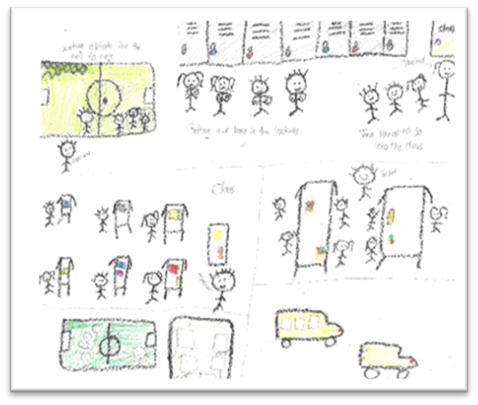
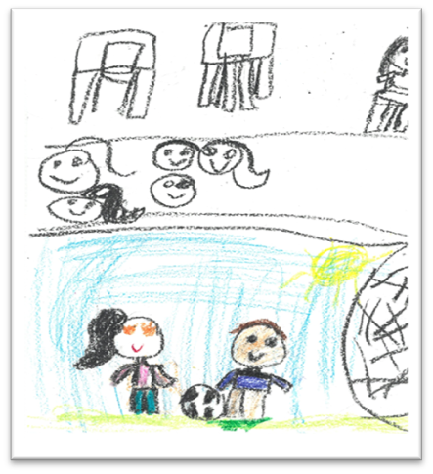
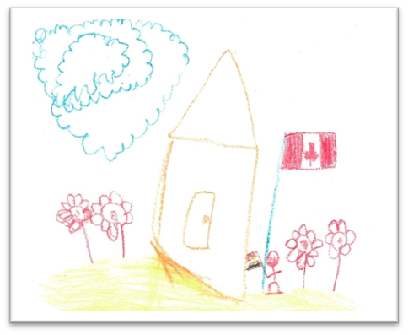

Figure 1
Refugee Students’ Drawings of a Typical Day at School

Research has also shown that “when a child has confidence in their abilities it builds resilience [and] physical activity is a way to do this.” (Best Star, 2012, p. 37, as cited in Savazzi, 2018).

I started the workshop by talking about the study and sharing these findings to show teacher candidates how they should regard refugee students and families as experts by working with them to better support language development and overall academic success. A first step could be to ask them about their experiences in school, their goals, and the resources they need.

Literature Review

For the purpose of the workshop, my goal was to draw attention to the key discourses on refugee students that I examined in the study and show how they materialize in the classroom. Therefore, after summarizing my research findings, I introduced the two key discourses guiding my work, which were deficit and strength-based approaches. In this section, after reviewing key findings on both concepts and comparing opposing arguments, I will conclude with a discussion on overcoming language barriers from a strength-based approach.

Deficit Approaches

The deficit approach is often seen when describing the perceived reality of groups on the margins of society, consequently, generating part of that reality because it “is a term of comparative disadvantage. It functions as a collective reference for the excluded and as a barrier of exclusion, it demarcates the limit between the ‘good society’ and the invidious ‘others’” (Aikman et al., 2016, p. 331). The issue with deficit discourses in the context of refugee education is that students' differences (e.g., being ELL, from a different culture, or a refugee) are viewed “as a problem rather than a resource” (Shapiro, 2014, p. 390). Further, deficit perspectives utilize negative labels to describe the groups deemed different in society. In the case of refugee students, deficit perspectives often group all refugee students into one category and assume certain labels to represent them, such as being “subjects of trauma” and “vulnerable victims” (Pacini-Ketchabaw & Bernhard, 2012; Taylor & Sidhu, 2012).

Deficit perspectives are most problematic when they are perpetuated in school settings. Once this problem-driven way of thinking is present in the classroom, it limits students in many ways. Negative labels affect refugees’ capacity and motivation for learning and their levels of self-esteem, leading refugee students to resent the school environment and feel a lack of belonging and connection with their peers. Further to labelling, deficit assumes they all have had similar life experiences which are othered (i.e., viewed as different) (Shapiro, 2014). Faulty assumptions are also made with regard to their experiences. For example, refugee students’ experiences of interrupted schooling are viewed as their lack of emphasis on education, which is often false: “the narrative of educational deficit is doubly hurtful as it not only makes inaccurate assumptions about students' schooling histories but also denies their identities as active seekers of educational opportunity” (Shapiro, 2014, p. 395). Deficit approaches impact students’ ability to join mainstream classes as “students who are presumed to be educationally deficient is not predicted to reach high levels of achievement, and therefore may not be encouraged to challenge themselves academically” (Shapiro, 2014, p. 397), consequently impacting their decisions to pursue post-secondary education (Shapiro, 2014) and their life chances in the host country (i.e., employment opportunities, etc.). Adopting a deficit perspective impacts teachers' behaviours and views of refugee students and families in the classroom. Instead of focusing on the “uniqueness of learners,” their learning and progress are linked to the dominant labels around refugees (Shrestha, 2015, p. 319, as cited in Aikman et al., 2016). Ultimately, focusing on the deficit creates “a cycle of focusing only on what needs to be repaired” which leads to “prescribed resources or assumed solutions” (Hammond & Zimmerman, 2008, p. 2), as opposed to building on students' existing resources, as is the case with strength-based approaches.

Strength-Based Approaches

Recognizing the consequences of deficit approaches in research with refugee students, I searched for a counter-narrative to ground my research study. Strength-based approaches presented the conceptual framework that allowed me to acknowledge the dominance of a deficit discourse and present a counter-argument in response. Unlike deficit approaches, strength-based approaches argue against using negative labels to describe a group in society; rather, the emphasis is on the resilience and strength of a given group. Everyone is viewed individually and a grouping of characteristics is seen as unjust, as it reduces the diversity of experiences into a single one (e.g., by referring to all refugee students as vulnerable) (Aikman et al., 2016). The aim of the strength-based approach is to work with the targeted group collaboratively, as opposed to a predetermined perspective on what works and what is a correct intervention. Hammond and Zimmerman (2008) further explain the consequences of a deficit versus a strength-based approach in influencing the type of message educators can send:

If external resources and supports are not offered in the context of what is meaningful and building upon the person’s existing strengths and resources, it can undermine the person’s ability to learn and be self-determining. It can send messages such as: “You have no strengths that are relevant” or “You cannot cope or change your life” or “You need our expertise”. As opposed to “what is wrong” and this is what we think you need in order to be healthy or so called-normal, it means asking questions about “what is right” and how can we support people in ways that will lead to sustainable success. (p. 8)

The language we use to describe someone from a group significantly impacts our mindsight, and ultimately, our behaviours toward members of that group, both intentionally and unintentionally. Hammond and Zimmerman (2008) show us the stark contrast between the terms used in each approach (see Table 1).

Table 1
Strength-based and deficit-based concepts comparison
Strength-Based Concepts | Deficit-Based Concepts
At-Potential | At-Risk
Strengths | Problems
Engage | Intervene
Persistent | Resistant
Understand | Diagnose
Opportunity | Crisis
Celebrate (i.e., successes) | Punish (i.e., non-compliance)
Time-in | Time-out
Adapt to | Reform
Empower | Control
Process-focused | Behaviour-focused
Dynamic | Static
Movement | Epidemic

It is important to note that adopting a strength-based approach to refugee education does not mean ignoring hardships and challenges that are faced by refugee students, but rather “identify the positive basis of the person’s resources (or what may need to be added) and strengths that will lay the basis to address the challenges resulting from the problems. The strengths of a person give one a sense of how things might be and ideas about how to bring about the desired changes” (Hammond & Zimmerman, 2008, p. 5). Further, instead of seeing refugees as the problem, they are viewed as “robbed of opportunities by the problem” (Hammond & Zimmerman, 2008, p. 3), such as regarding interrupted schooling as external and not representative of the person’s whole being. This mindset shift empowers refugees to take ownership of the issue and not be limited by predetermined labels.

The teachers’ role involves recognizing that refugee students and their families have the resources and resilience to overcome challenges. A strength-based mindset allows both teachers and students to see hope, potential, and capacities, and search for solutions, rather than focusing on deficits and vulnerabilities (Hammond & Zimmerman, 2008). Shapiro’s (2014) study revealed that refugee students valued teachers that were both caring and demanding. In other words, teachers who believe in their students' abilities despite any language barriers, yet recognize their unique challenges. Similar to previous arguments (see Hammond & Zimmerman, 2008), I positioned strength-based and deficit-based approaches as opposite ends on a spectrum of support (see Figure 2).

Deficit-based Perspectives
Strength-based Perspectives

Focus on shortcomings
Negative view of difference
Starts from a place of deficit
Othering
Projects a single story for a group
Creates negative labels

Focus on resilience
Positive view of difference
Starts from a place of hope
Welcoming
Projects multiple stories for a group
Rejects labels

Marginalization
Empowerment
Figure 2
Deficit- vs. Strength-Based Approaches

I presented this figure during the workshop to help the teacher candidates see the impact of adopting a deficit approach and why they should follow a strength-based approach.

Overcoming Language Barriers

Language differences could present a barrier to teachers’ efforts to support refugee students. Therefore, after presenting both approaches, I offered a few classroom practices to help the teacher candidates navigate this challenge following a strength-based approach. Creating a welcoming classroom can be achieved by following many strategies that do not involve knowledge of refugee students’ home language. For example, teachers could make an effort to learn their students’ names and important words from the refugee students' L1 as this will help them better connect with the students (Savazzi, 2018). Further, teachers could include elements from the students' culture and language into their daily classroom routine; in this way, the students will feel valued and welcomed. Grouping refugee students with classmates who speak their L1 will also help in creating meaningful class time (Robertson & Breiseth, n.d.).

When it comes to lesson planning, teachers have the autonomy to be creative with their lesson design and delivery. Simplifying speech and avoiding information overload are both important strategies to incorporate during lesson planning. This could be done by using fewer words and more props (Robertson & Breiseth, n.d.). For older students, seeking resources that are age-appropriate is key (Robertson & Breiseth, n.d.) because even if they have experienced interrupted schooling, students likely have literacy skills in their L1 and might be frustrated and lose motivation to learn if given materials intended for younger students. An example of these resources would be reading material that uses easy language but is on a topic relevant to an older age group.

Teachers might aim to start with what the student already knows, as opposed to rejecting their pre-existing knowledge. Even if refugee students were unable to access formal education, they have funds of knowledge that should be recognized and utilized to support them. Collaborating with community members could help in identifying ways to keep students engaged even if their language levels are low. Although it is important to emphasize the importance of learning the English language, this should not result in the marginalization or denial of students’ home languages (Shapiro, 2014). Efforts to develop the English language should be made in conjunction with supporting their home language, as it is a critical part of refugee students’ identity (Savazzi, 2018). The school can also support teachers’ efforts by posting simple English phrases and pictures around the classroom and throughout the school (Robertson & Breiseth, n.d.).

Workshop

Although I had presented the above-mentioned study at academic conferences, my original aim was to share the findings with teachers, as I believe they are the main audience for the study. Teachers work directly with refugee students and have the ability to improve their experiences in the classroom. With this workshop, I was finally able to reach the targeted audience by organizing the study in the format of a workshop for teacher candidates at the Faculty of Education. In contrast to my previous presentations of the study, I tailored my presentation to teachers by offering more practical resources as opposed to sticking with theoretical considerations. I organized the workshop with the goal of having teachers:

- recognize they can support refugee students regardless of the subject and grade they are teaching,
- explore important differences between key discourses and how they materialize in the classroom,
- approach, work with, and build relationships with refugee students from a (potentially) new light, and
- feel empowered and confident in their abilities to support refugee students despite the existing language barriers.

Workshop Activity: What Comes to Mind When You Think of Refugee Students?

The goal was not only to explain the two approaches in the context of refugee education but to show what adopting either approach looks like in the classroom. Before introducing the concepts, I wanted to explore the attendees' own perspectives of refugee students. This was done by asking the attendees early on in the workshop to reflect on their currently held perspectives (i.e., guiding discourses) on refugee students. Using Menti.com, I asked the attendees to answer the question, “what comes to mind when you think of refugee students?” (see Table 2). The goal was to document their perspectives early on in the workshop and revisit them at the end in light of the newly introduced concepts.

Table 2
Answers to the question “What comes to mind when you think of refugee students?”
Deficit-Based | Strength-Based | Neutral | Mixed
War | Brave | ELL | Resilient, tough past, uncertain future, support, love and acceptance.
Difficult to work with | Resilience, support | ELL | Resilience, struggle victim, challenges, language barriers, need support, trauma
Anxiety | Lots of potential | Language | Students who have been through difficult experiences, PTSD, resilience, opportunity, chance for other students to learn about the world outside their own
Potential Trauma | Courage | Diverse | Language barriers, trauma, change, lack of comfortability, growth
Middle Eastern | Resilience | ELL | Culture differences, diverse, Canadian
I think of students who might require extra resources | Unique | Trust
Hardship | Newcomers seeking to learn | Diverse
War-torn | They have their own prior experiences and culturally practices, so it may be difficult to adapt to a new environment | English as a second language
Trauma, stress, need help, extra care, stories to tell, listening to them, patience | Determination | Worldly
quit/shy | Important | New experience
Stuck between two unrecognizable worlds | Resilience | Culture
ESL, ELD students may not have the same educational foundation as other students in the school | Brave | Diversity
War, ESL, third world countries, different schooling | Want to thrive not just survive | Adjustment
Language barriers, culture shock, curiosity, making friends | Resilience | Non-English speaking
They are scared/nervous | Normal students | Culture
Culture shock | Resilient | Immigrants
Struggle | I feel sympathy and compassion for the students both inside and outside of the classroom | Language
Trauma | Determination
Families, war, victims | Hopeful, self-conscious
I think the current narrative is that refugee students are poor, non-English speakers, are victims of war | Eager to learn
Trauma, uncertainty | Gentle
shy, scared, timid

A total of 65 teacher candidates participated in the Menti activity. I reviewed the responses along with the attendees at the end of the workshop. I wanted to show how the language they used to describe refugee students offers a lens into their beliefs and could impact actions and behaviours towards the refugee students they teach. For the purpose of this chapter, I filtered the responses into four categories: deficit and strength-based approaches guided by the conceptual framework introduced earlier in the chapter, a neutral category for answers that did not fit either category, and a mixed category which included answers that combined perspectives from both deficit and strength-based approaches (see Table 2). In preparing the activity, I assumed that the answers would lean towards the deficit approach because it has been normalized and widely accepted by media platforms and research. However, I was intrigued by the mixed column and the idea that one could hold both perspectives at the same time. The table shows how the deficit discourse is dominating the narrative around refugee students, which speaks to the importance of spreading awareness about the impact of the deficit discourse on attitudes towards these students. I emphasized that teacher candidates should not feel discouraged by their responses if they now realize that their responses stem from a deficit approach, as that does not necessarily represent them as teachers. Rather, I encouraged them to reflect on their perspectives in light of what they had learned from the workshop and throughout their careers. I also reminded them that they are lifelong learners and are in a constant state of development and learning. More importantly, I urged them to trust in their role and ability to make a difference in the students’ lives and to seek support and collaboration, as it takes everyone involved to support refugee students and their families.

Reflections

After the workshop, attendees shared their takeaways. This allowed me to evaluate the workshop and whether I had met the objectives outlined earlier in this chapter. I was pleased to see that many teacher candidates had reflected on their beliefs and recognized the importance of avoiding a deficit approach when working with refugee students. When asked about their takeaways from the workshop, the following statements by three teacher candidates perfectly summarize the key message:

- That the stories we tell ourselves about our newcomer students, direct our actions in teaching them; let our stories be about what they do know, what they already contribute and not all about hardship, vulnerability, war etc. That sports are commonly a great way for newcomer students to build confidence and resilience.

- Recognize students’ prior knowledge as newcomers, just because they are from somewhere else or speak another language does not mean they aren't knowledgeable.

- Reflect on my assumptions and focus on what the students can do rather than what they can't do! Collaborate with my peers and colleagues. It is an ongoing process.

Although I offer some practical resources, the goal of the workshop was for the teacher candidates to become reflective, critical and ultimately transform (if needed) their views and perceptions of refugee students and families into a strength-based approach. A shift in perspectives and beliefs could then lead to a change in actions and attitudes because teacher candidates would have the key tools and language to search for and identify effective resources when they see them and to avoid ineffective and deficit-based resources.

The key takeaway from this workshop was to empower the teacher candidates into believing that they are able to make a difference in refugee students' lives. Although language barriers present a real challenge, they do not determine the level of support teachers can offer students. By making minor changes to lesson plans and the language used in relation to refugee students, the classroom environment can transform in ways that can profoundly impact refugee students' school journey and overall wellbeing. I hope reading this chapter offered you (the reader) a glimpse into the workshop and encouraged you to revisit your own views on refugee students and to reflect on whether these need to change.

References

Aikman, S., Robinson-Pant, A., McGrath, S., Jere, C. M., Cheffy, I., Themelis, S., &
Rogers, A. (2016). Challenging deficit discourses in international education and
development. Compare, 46(2), 314–334.
https://doi.org/10.1080/03057925.2016.1134954

Burkitt, E., Barrett, M., & Davis, A. (2009). Effects of different emotion terms on the size
and colour of children’s drawings. International Journal of Art Therapy, 14(2),
74–84. https://doi.org/10.1080/17454830701529567

Hammond, W., & Zimmerman, R. (2008). A strength-based perspective. Resiliency
Initiative.
https://www.esd.ca/Programs/Resiliency/Documents/RSL_STRENGTH_BASED
_PERSPECTIVE.pdf

Robertson, K., & Breiseth, L. (n.d.). How to support refugee students in your school
community.
https://www.colorincolorado.org/article/how-support-refugee-students-ell-
classroom

Savazzi, H. (2018). The resilience guide: Strategies for responding to trauma in refugee
children. https://cmascanada.ca/wpcontent/uploads/2018/02/resilienceguide.pdf

Shapiro, S. (2014). “Words That You Said Got Bigger”: English language learners’ lived
experiences of deficit discourse. Research in the Teaching of English, 48(4),
386–406.

Taylor, S., & Sidhu, R. K. (2012). Supporting refugee students in schools: What
constitutes inclusive education? International Journal of Inclusive Education,
16(1), 39–56. https://doi.org/10.1080/13603110903560085

Pacini-Ketchabaw, V., & Bernhard, J. K. (2012). Revisioning multiculturalism in
early childhood education. In N. Howe & L. Prochner (Eds.), Recent perspectives
on early childhood education in Canada (pp. 159–181). University of Toronto
Press. https://doi.org/10.3138/9781442662032-008

Contributors

 | Biographies
 | Zein Abuosbeh is a first-year PhD student in Developmental Psychology and Education at the University of Toronto. Zein’s doctoral research focuses on English and French language and literacy development in French Immersion students. As a native Arabic speaker, Zein also studies the Arabic language development of immigrants to Canada. Zein is especially interested in using her research to help create interventions and provide resources for diverse learners to succeed in multilingual learning environments.
 | Fatima Assaf is currently a post-doctoral scholar at the University of Ottawa. She completed her Ph.D. in Teaching, Learning, and Evaluation in 2021. Her research revolves around understanding newly arrived immigrant and refugee children’s mathematics experiences in a Canadian educational context. Fatima coordinated the mathematics education research unit (MERU) at the University of Ottawa for 4 years, and recently worked as a sessional instructor at the University of Manitoba. She is very passionate about working with teacher candidates and graduate students, and believes that there is never an endpoint to learning as we continuously learn from those with whom we interact.
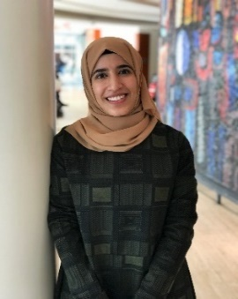 | Alaa Azan holds an MA in Education from the University of Ottawa where she completed her thesis on the lived experiences of high school students and their parents with online math services in Ottawa. She also investigated refugee students’ experiences in Canadian schools as part of her Honours BA in Child Studies at Carleton University. Alaa currently works as the Curriculum Developer/Instructional Designer for a not-for-profit organization in Ottawa, where she is creating a person-centred e-learning training platform.
 | Diana Burchell is a 4th year doctoral candidate in the Developmental Psychology and Education program at the Ontario Institute for Studies in Education (OISE). As a project coordinator for The International Bilingual Education (IBE) project (Canada, China & the Netherlands), Diana’s research focuses on the accessibility of language immersion programs for exceptional and multilingual students in Canada.
 | Becky (Xi) Chen is a professor in the Department of Applied Psychology and Human Development at OISE. Her research focuses on language and literacy development among bilingual and multilingual children. She studies how bilingual children develop language and literacy skills in the first and second language, and how skills transfer between the two languages. She also examines how to identify at-risk reading status in bilingual children and provide identified children with effective interventions.
 | Michelle Chin is a French Immersion teacher with the Toronto District School Board and a recent graduate from the Master of Arts in Child Study and Education from OISE. She is a graduate research assistant in Dr. Chen’s Multilingualism and Literacy Lab and is currently a supervisor on the International Bilingual Education Project in partnership with the Netherlands and China. Michelle’s research focuses on how transcription mode (handwriting/typing) influences French as a second language learners writing performance. With more than six years of teaching experience and a passion for research, Michelle aims to use educational research in inquiry-based learning to continually inform her own practice and inspire other educators.
   | Robert Grant is currently a PhD student at the University of Ottawa. His research interests include investing queer inclusivity in the second language classroom and studying language teachers' beliefs and attitudes around this inclusion. Rob is a certified Ontario teacher and has taught within and outside of Canada. He has experience teaching a wide range of learners (e.g., Kindergarten to Grade 12), with varying levels of exposure to the language.  Adam Kaszuba is a doctoral student in the Faculty of Education at the University of Ottawa. After becoming an Ontario Certified Teacher in 2018, he worked as a French second language (FSL) teacher in Vietnam, where he enjoyed developing a practice based on plurilingual approaches. For his doctoral research, he is exploring innovative approaches to professional learning in the context of FSL teacher education.
 | Eric Keunne est doctorant (PhD) en études françaises et assistant de recherche à l’Université de York. Ses domaines de recherche sont la didactique du Français Langue Seconde (FLS), l’équité et l’inclusion, le bilinguisme et l’analyse des politiques éducatives. Eric travaille au Conseil Scolaire du District de Halton en Ontario (HDSB). Il est diplômé des universités de York au Canada, de Newcastle au Royaume-Uni, de Yaoundé 1 et de l’École Normale Supérieure Annexe de Bambili au Cameroun.

     | Chuan Liu is a PhD student in the Curriculum Studies program at the University of Western Ontario. His research interests include language and literacy curriculum, early childhood education, and technology integration. Chuan has 12 years of experience in language teaching, curriculum development and teacher training.  Daniella M. Raposo began her elementary teaching career after graduating from the Ontario Institute for Studies in Education of the University of Toronto in 2010. Her career has spanned three continents, having worked in Canada, England and Vietnam. Daniella is a passionate educator who believes "working in collaboration with others has the potential to change the world." She is an avid reader, researcher and lifelong learner. Daniella currently lives in Vietnam with her three rescue dogs and is the International Baccalaureate Primary Years Programme Coordinator at her school in Ho Chi Minh City.  Krystina Raymond is a 4th year PhD candidate in Developmental Psychology and Education at OISE. Her present research focuses on the role of school-based professional learning communities in improving equity and inclusion for diverse learners in French immersion programs. More specifically, she collaborates with teachers and administrators to implement phonological awareness interventions for emergent readers. As a multiracial researcher, Krystina continues to be devoted to issues supporting bi/multilingual education, culturally responsive anti-bias practices and disseminating knowledge to support diverse students.
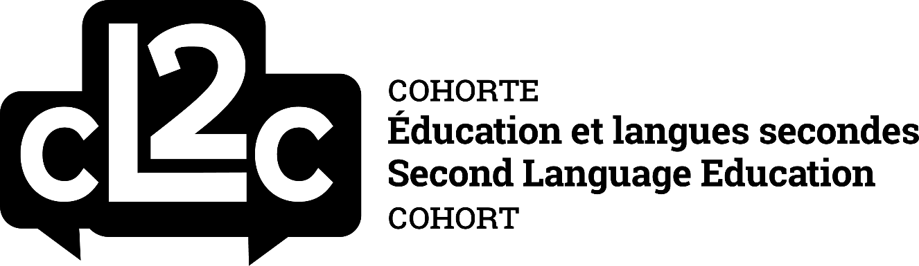



In this paper, any use of the word we refers to joint work produced by both authors, while any use of the word I refers to personal reflections made by the first author.
I use the term ELA to contrast the work that this group of teachers does relative to FSL teachers. However, when I refer to ELA teachers and teacher candidates in this paper, I generally also consider them mainstream or homeroom, meaning they teach most subjects in addition to ELA.
I do not intend here to conflate the terms code-switching, plurilingualism, and translanguaging, as each are underpinned by their own philosophical understandings.
John Dewey, an educational philosopher, suggests that education, at its core, involves the sequencing (coherence) of learning experiences (1938).
Veuillez noter que désormais, les renvois à la Pédagogie sensible et adaptée à la culture seront signalés par la mention PSAC.
https://mistikrak.ca/
https://www.fsldisrupt.org/
https://nctr.ca/a-propos/histoire-de-la-cvr/commission-de-verite-et- reconciliation-du-canada/?lang=fr
Menti.com is interactive software that is used to create polls and quizzes for presentations.

