Reliable developmental research: Not only for infancy

Patricia Brosseau-Liard (Corresponding author)
School of Psychology, University of Ottawa
136 Jean Jacques Lussier
Ottawa, ON
K1N 6N5
Canada
pbrossea@uottawa.ca

This is the accepted version of the following article: Brosseau-Liard, P. (2022). Reliable developmental research: Not only for infancy. Infant and Child Development, e2320. https://doi.org/10.1002/icd.2320

Abstract
Reliability in developmental research is important to consider not only for infant research, but also for researchers who wish to study individual differences at all ages. Forced-choice behavioural tasks are popular in cognitive developmental research with preschoolers and young school-age children because of their ease of administration and interpretation, however the fact that guessing correctly is possible introduces noise that reduces reliability. An informal simulation is presented to illustrate this issue. Researchers wishing to investigate individual differences are encouraged to consider the reliability of the tasks they choose and not reflexively rely on familiar tasks that may be poorly suited to the study of true individual differences.

Keywords: Reliability, Individual Differences, Early Cognitive Development, Selective Social Learning

Reliable developmental research: Not only for infancy
The article by Byers-Heinlein, Bergmann and Savalei (2022) raises important points about measurement issues in child development research. Developmental researchers more generally, and not just those studying infancy or using looking time as their primary dependent measure, may find the insights and recommendations from this article to be relevant to their research.
In particular, researchers using behavioural tasks to study cognitive development in preschoolers and young school-age children may not often think about measurement reliability. Traditionally, many widely-used behavioural tasks were developed for the purpose of testing whether children as a group perform above chance and/or to compare means across age groups. These research questions do not focus on the existence (or absence) of reliable individual differences. However, when researchers are interested in underlying mechanisms, relations between cognitive skills, or longitudinal stability, individual differences become relevant. Researchers may attempt to investigate these questions using existing and familiar tasks; however, tasks designed for experimental studies focusing on means are often poorly suited to the study of individual differences (Hedge et al., 2017). Although there exist published studies on the reliability of some widely-used cognitive-developmental tasks, for instance tasks measuring preschoolers’ theory of mind (e.g., Hughes et al. 2000; Mayes et al., 1996) and executive function (e.g., Beck et al., 2011; Müller et al., 2012), for most cognitive developmental tasks it is rare for measures of reliability to be published or even calculated. (This is also true in other areas of psychology, for instance in the study of adult cognition: see Parsons et al., 2019.)
I will focus on a common format of behavioural task: administering several test trials with forced-choice answers. Such a format is common in cognitive development. An example is a paradigm developed by Koenig and colleagues (Koenig et al., 2004; Koenig & Harris, 2005) with variations introduced by other research teams (e.g., Birch et al., 2008) to study selective social learning, or children’s propensity to learn from some individuals over others. In a typical study, children see two individuals who differ on one crucial attribute, for example the accuracy of their statements (e.g., one individual labels a car “a car” and the other calls it “a shoe”). On test trials, children are asked forced-choice questions: They must select between the two individuals (or between the information that each provide). In a typical task, preschoolers prefer to seek information from the previously accurate informant and to endorse their answers over those of the inaccurate informant. In the early 2000s, when this paradigm was introduced, research concentrated on demonstrating in which circumstances the effect existed: At what age? Based on which informant cues? For which types of information? Increasingly, however, researchers have become interested in correlates and mechanisms underlying performance (e.g., Jaswal & Kondrad, 2016; Sobel & Finiasz, 2020; Sobel & Kushnir, 2013).
Part of the appeal of the forced-choice format is its ease of administration and the fact that it minimizes verbal demands on young participants. However, the possibility of guessing “correctly” by chance introduces measurement error. Additionally, because of the reality of studying young children with short attention spans, the number of trials is generally kept small (i.e., it is common for cognitive developmental tasks to include 4 or fewer test trials). For these reasons, performance is likely to be unreliable at the individual level.
To illustrate, I conducted a very informal simulation using R 4.1.2 (R Core Team, 2021) of two repetitions (e.g., test-retest) of an unspecified behavioural task consisting of 4 forced-choice test trials, where there are 2 answer options on each trial, one correct and one incorrect, and where someone guessing randomly would get the correct answer on average 50% of the time. (R code available on the Open Science Framework: Brosseau-Liard, 2022) For simplicity, I assume that test trials are interchangeable (i.e., of equal difficulty) and that administering the task twice is feasible without practice effects, pragmatic weirdness, or any other practical problem. Let’s simplistically say that some children “get” the skill being evaluated and some “don’t get it”. Those who “don’t get it” would be expected to score 50% on average (2 out of 4). Those who “get it”, on the other hand, would likely score highly, but not perfectly, as young children can be inattentive on a test trial here and there. Let’s assume that the most proficient children would average 95% success (i.e., these highly proficient children are distracted and answer 50-50 on 10% of trials and succeed on the remaining 90%). Other children may “get it” while being less proficient, so average between 50% and 95%. Performance across 4 trials follows a binomial distribution: see Figure 1 for an illustration of the predicted distributions for children who succeed on average 50%, 70% and 95% of the time. I created five scenarios with different proportions of participants who “get” the skill to various degrees (see Table 1), simulated one single very large dataset (4.6 million “participants”) for each scenario, and calculated to which extent scores on the first administration (hereafter Time 1) predict corresponding scores on the subsequent administration (hereafter Time 2).
For each scenario, I present in Table 1 the Pearson correlation between total scores at Times 1 and 2. Pearson correlations are not strictly appropriate given that the variables are not truly continuous in nature (i.e., scores can only be of 0, 1, 2, 3 or 4), however in practice researchers frequently compute correlations with these scores. The Time 1 – Time 2 correlation varies across scenarios; it is highest when there is an even breakdown between highly-proficient and non-proficient participants without any intermediate-proficiency participants, and appears worse in scenarios where there is a greater proportion of poor and intermediate performers (and therefore more guessing). Even in the best scenario, however, the correlation does not look very impressive when one remembers that this is a correlation between two completely identical tasks. If a task correlates only moderately with itself, it will not easily uncover true correlations between the underlying skill and other attributes unless these true correlations are extremely large. As noted by Byers-Heinlein et al. (2022), one way to increase reliability is to increase the number of trials, and indeed repeating the simulation with 6 trials per task rather than 4 leads to higher correlations (see Table 1). However, as mentioned above, researchers working with young children often face practical constraints that limit the number of trials they can present.
Using other statistical methods (e.g., multilevel logistic regression) instead of Pearson correlations has several advantages but may not solve the underlying problem, which is the noise inherent to any variable where it is possible to guess the “correct” answer by chance. To illustrate how guessing affects predictive value at the trial level, I simulated scores on individual trials (rather than the total score) and matched performance across corresponding Time 1 and Time 2 trials. As seen in Table 1, success at Time 1 does predict a greater probability of success at Time 2 in all scenarios, but the odds ratios are small to moderate; and, because guessing leads to a 50% chance of success, predicted success at Time 2 is always above 50% even after failing the corresponding Time 1 trial.
This informal simulation illustrates a problem that researchers may encounter when using forced-choice tasks to study individual differences in cognitive development. Returning to the selective social learning example, our research team (Brosseau-Liard et al., 2018) found that selective learning tasks based on different informant reliability cues were uncorrelated, a somewhat surprising finding given the plausibility that similar mechanisms would be involved across tasks. In follow-up work (Cossette et al., 2020; Juteau et al., 2019), we systematically examined the test-retest and alternate-form reliability of two selective learning tasks. Both studies, using different analytical strategies, found fairly low reliability, similar in size to the results from the informal simulation. These results should give pause to researchers interested in individual differences: If a task barely predicts itself or a near-identical version of itself, then it has low power to predict other constructs and any relations that are uncovered may not replicate.
In summary, researchers wishing to examine individual differences should think twice before relying on the familiar forced-choice behavioural tasks typically used in the cognitive development literature. Researchers may instead need to first focus on task creation or adaptation. More generally, the recommendations by Byers et al. (2022) also apply those who study children beyond infancy. It is encouraging that some of these recommendations are already being heeded by many researchers: For example, researchers increasingly attempt to maximize data quantity both by recruiting larger sample sizes and, when possible, increasing the number and type of test trials. In addition, cognitive development researchers increasingly adopt more sophisticated analytical strategies than the traditional t tests and ANOVAs, for instance multilevel binary or multinomial logistic regression (e.g., Reifen Tagar et al., 2014; Stephens & Koenig, 2015). These are encouraging developments, and more attention to the measurement properties of existing tasks will only improve researchers’ ability to study young children’s developing skills.

Table 1
Results of informal simulation across 5 scenarios
Scenario | Time 1–Time 2 Correlation  (4 trials) | Time 1–Time 2 Correlation  (6 trials) | Success probability at Time 2 following failure vs. success at Time 1 |  | Odds ratio
1: 50% at .50 USP, 50% at .95 USP | .577 | .671 | .541 | .795 | 3.29
2: 10% at .50 USP, 90% at .95 USP | .519 | .618 | .713 | .925 | 4.96
3: 90% at .50 USP, 10% at .95 USP | .241 | .322 | .505 | .578 | 1.35
4: 25% at .50 USP, 50% at .70 USP, 25% at .95 USP | .363 | .460 | .624 | .748 | 1.79
5: All USPs between .50 and .95 equally represented | .280 | .368 | .661 | .749 | 1.53

Note. USP: underlying success probability.
Figure 1
Illustration of a binomial distribution of scores when underlying success probability is 50% (left), 70% (middle) and 95% (right), on a task with 4 trials (top) or 6 trials (bottom)
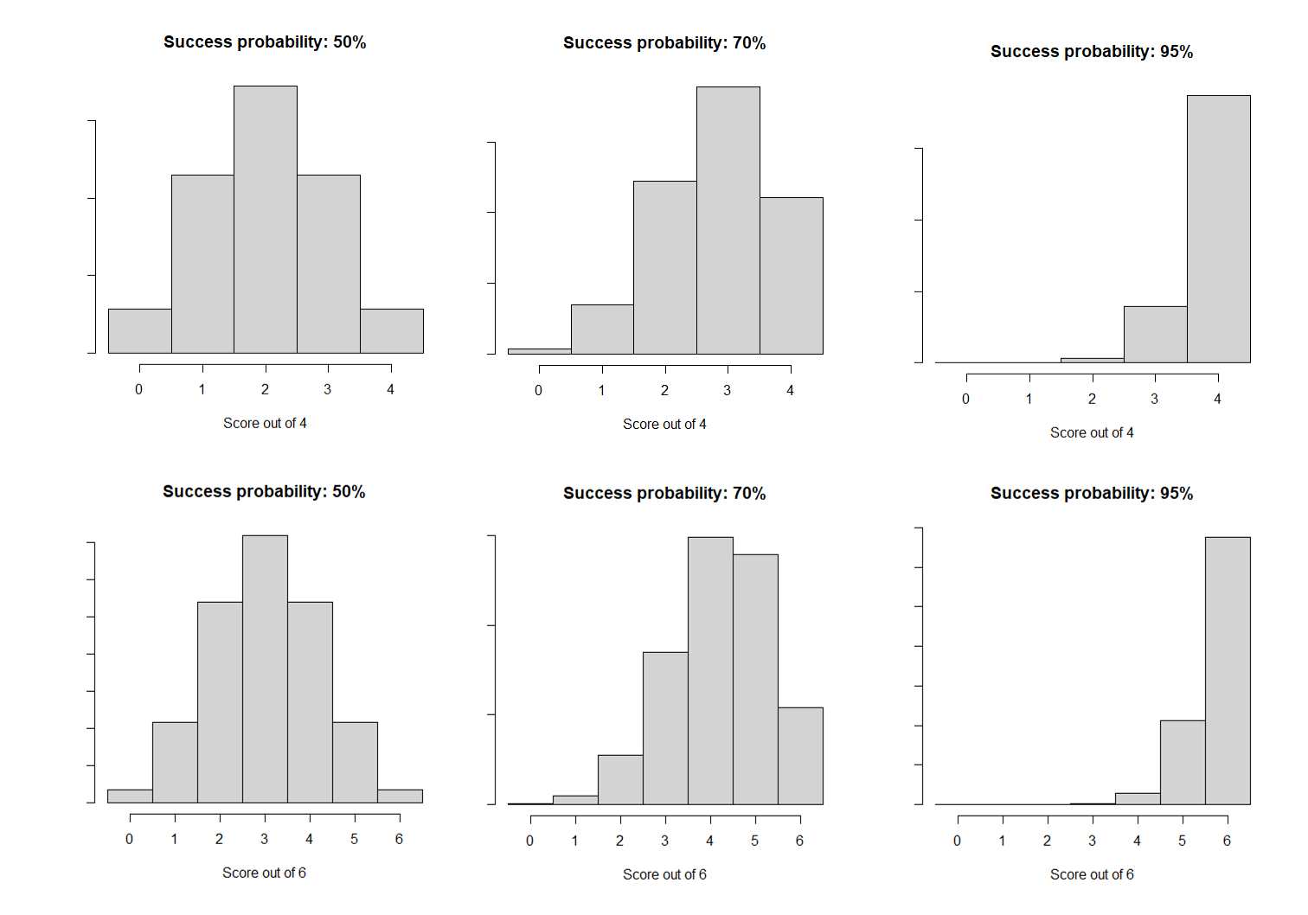

References
Beck, D. M., Schaefer, C., Pang, K., & Carlson, S. M. (2011). Executive Function in Preschool Children: Test–Retest Reliability. Journal of Cognition and Development, 12(2), 169–193. https://doi.org/10.1080/15248372.2011.563485
Birch, S. A. J., Vauthier, S. A., & Bloom, P. (2008). Three- and four-year-olds spontaneously use others’ past performance to guide their learning. Cognition, 107(3), 1018–1034. https://doi.org/10.1016/j.cognition.2007.12.008
Brosseau-Liard, P. (2022, March 10). Reliable developmental research: Not only for infancy. Retrieved from osf.io/49au3
Brosseau-Liard, P. E., Iannuzziello, A., & Varin, J. (2018). Savvy or Haphazard? Comparing Preschoolers’ Performance Across Selective Learning Tasks Based on Different Epistemic Indicators. Journal of Cognition and Development, 19(4), 367–388. https://doi.org/10.1080/15248372.2018.1495219
Byers-Heinlein, K., Bergmann, C., & Savalei, V. (2022) Six solutions for more reliable infant research. Infant and Child Development.
Cossette, I., Fobert, S. F., Slinger, M., & Brosseau-Liard, P. E. (2020). Individual Differences in Children’s Preferential Learning from Accurate Speakers: Stable but Fragile. Journal of Cognition and Development, 21(3), 348–367. https://doi.org/10.1080/15248372.2020.1727479
Hedge, C., Powell, G., & Sumner, P. (2018). The reliability paradox: Why robust cognitive tasks do not produce reliable individual differences. Behavior Research Methods, 50(3), 1166–1186. https://doi.org/10.3758/s13428-017-0935-1
Hughes, C., Adlam, A., Happé, F., Jackson, J., Taylor, A., & Caspi, A. (2000). Good Test‐Retest Reliability for Standard and Advanced False‐Belief Tasks across a Wide Range of Abilities. Journal of Child Psychology and Psychiatry, 41(4), 483–490. https://doi.org/10.1111/1469-7610.00633
Jaswal, V. K., & Kondrad, R. L. (2016). Why Children Are Not Always Epistemically Vigilant: Cognitive Limits and Social Considerations. Child Development Perspectives, 10(4), 240–244. https://doi.org/10.1111/cdep.12187
Juteau, A.-L., Cossette, I., Millette, M.-P., & Brosseau-Liard, P. (2019). Individual Differences in Children’s Preference to Learn From a Confident Informant. Frontiers in Psychology, 10, 2006. https://doi.org/10.3389/fpsyg.2019.02006
Koenig, M. A., Clement, F., & Harris, P. L. (2004). Trust in Testimony: Children’s Use of True and False Statements. Psychological Science, 15(10), 694–698. https://doi.org/10.1111/j.0956-7976.2004.00742.x
Koenig, M. A., & Harris, P. L. (2005). Preschoolers Mistrust Ignorant and Inaccurate Speakers. Child Development, 76(6), 1261–1277. https://doi.org/10.1111/j.1467-8624.2005.00849.x
Mayes, L. C., Klin, A., Tercyak, K. P., Cicchetti, D. V., & Cohen, D. J. (1996). Test-Retest Reliability for False-Belief Tasks. Journal of Child Psychology and Psychiatry, 37(3), 313–319. https://doi.org/10.1111/j.1469-7610.1996.tb01408.x
Müller, U., Kerns, K. A., & Konkin, K. (2012). Test–Retest Reliability and Practice Effects of Executive Function Tasks in Preschool Children. The Clinical Neuropsychologist, 26(2), 271–287. https://doi.org/10.1080/13854046.2011.645558
Parsons, S., Kruijt, A.-W., & Fox, E. (2019). Psychological Science Needs a Standard Practice of Reporting the Reliability of Cognitive-Behavioral Measurements. Advances in Methods and Practices in Psychological Science, 2(4), 378–395. https://doi.org/10.1177/2515245919879695
Reifen Tagar, M., Federico, C. M., Lyons, K. E., Ludeke, S., & Koenig, M. A. (2014). Heralding the Authoritarian? Orientation Toward Authority in Early Childhood. Psychological Science, 25(4), 883–892. https://doi.org/10.1177/0956797613516470
Sobel, D. M., & Finiasz, Z. (2020). How Children Learn From Others: An Analysis of Selective Word Learning. Child Development, 91(6). https://doi.org/10.1111/cdev.13415
Sobel, D. M., & Kushnir, T. (2013). Knowledge matters: How children evaluate the reliability of testimony as a process of rational inference. Psychological Review, 120(4), 779–797. https://doi.org/10.1037/a0034191
Stephens, E. C., & Koenig, M. A. (2015). Varieties of testimony: Children’s selective learning in semantic versus episodic domains. Cognition, 137, 182–188. https://doi.org/10.1016/j.cognition.2015.01.004

