Migration of Rivertown: The impact of the Three Gorges Dam project on local economic activity

by Yeyuxing Chen

(7845861)

Major Paper presented to the
Department of Economics of the University of Ottawa
in partial fulfillment of the requirements of the M.A. Degree
Supervisor: Professor Jason Garred

ECO 6999

Ottawa, Ontario
April 2020

I. Introduction
Involuntary population relocation can potentially bring profound socio-economic consequences to local communities. My study investigates the effect of the Three Gorges Dam project on the economic activity of local communities close to the Yangtze River. Approximately 1.3 million people in these regions were displaced from their homes during the period of the project’s construction from 1994 to 2009, and a massive land area has been submerged due to the rising water level of the Yangtze River. The economic activity of local communities might be affected because of three potential theoretical channels. Firstly, the direct effect of population relocation by command of local governments; secondly, the direct effect of flooding by the river; finally, local spillover effects to neighbouring areas.
In order to investigate the local economic implications of the project, I first compare the light intensity of areas close to the river in the regions where there was population relocation and regions without relocations before and after the project period. Then I compare the light intensity of these areas to areas farther to the river, which gives me a triple difference strategy. Moreover, I use various definitions of “areas very close and very far to the river”, and alternately consider the shape of river before and after neighbouring land was submerged, to see if the results are consistent across specifications. I choose a triple difference approach as my identification strategy because trends between regions with and without relocation of residents are different, which makes the estimation of simple difference-in-differences potentially biased for identification of the effect of the project. This is due to the different economic trends among different Chinese provinces from the 1990s onwards.
I provide empirical evidence that in the reservoir areas, the economic activity of local communities very close to the flooded river experienced a sharp decrease after the building of the project as compared to communities farther away to the river, while for communities at an intermediate distance from the river (close but not adjacent), economic activity increases significantly after the project. The results suggest the project might have a critical influence on the distribution of local communities’ economic activity, not only for residents living adjacent to the river, but also for those living nearby but relatively farther from the river. However, my results are not necessarily inferring a casual relation between the project and the change of local economic activity because I do not control for some potential omitted variables, such as the building of roads and highways during the period of project.
The literature that is most relevant to this study is Redding and Sturm's (2008) research of the economic outcome of the division and reunification of Germany. They empirically investigated the effect of the building and collapse of the Berlin Wall on the market access of West German cities close to the wall relative to cities far from the wall and found a sharp decline in the population of West German cities close to the wall relative to other West German cities, which suggests a causal relationship between market access and spatial distribution of economic activity of local communities. Their study inspires me that the river after the establishment of the Three Gorges Dam project could be regarded as a "wall" that would affect market access of local communities, thereby leading to a change in economic activity.
There are some other studies of the economic consequences of forced migration. For example, Bauer, Braun and Kvasnika (2013) have investigated the effect of forced migration of Germans from Eastern Europe after World War II on economic outcomes in the long run. Their results suggest displaced Germans on average have experienced a persistent disadvantage from the economic perspective due to their displacement 25 years ago. Sarvimäki, Uusitalo and Jäntti’s study about resettlement in Finland after World War II indicates that forced migration negatively affected the economic conditions of the resettled population who lived in urban regions, while it increased income in the long run for farmers by making them more likely to leave agricultural sectors. (Sarvimäki, Uusitalo & Jäntti, 2019)
With respect to eliminating barriers to migration, Bryan and Morten (2019)’s study in Indonesia indicates the reduction of barriers to internal migration results in positive aggregate effects on labor productivity. Moreover, Alix-Garcia et al. (2017) estimate the implication of Kakuma refugee camps on the local economic activity of the host population using nighttime lights, official statistics and household survey data from northern Kenya. They found that economic activity increases in areas close to the camp, which implies refugee inflows positively affected the local community from the economic perspective.
The rest of the paper is structured as follows: section II is the background; section III describes the data I use; section IV is my identification strategy; section V is the econometric model; section VI is the results; section VII is the discussion of results; VIII is the conclusion.

II. Background
2.1 Brief history of Three Gorges Dam project
The origin of the idea of building a dam across the Yangtze River comes from Sun Yat-sen, who intended to improve the condition of water transportation on the Yangtze River and take advantage of the altitude differences along the river to generate electricity. In his The International Development of China, he proposed, “The Yangtze River above Ichang (Yichang) enters the Gorges …to improve the Upper Yangtze, the rapids should be dammed up to form locks to enable crafts to ascend the river as well as to generate water power” (1922, Sun). In the 1940s, the project stopped as an idea on paper due to the outbreak of World War II.
After the war’s end, the plan of building the Three Gorges Dam was presented again in 1950s by the government at that time because of increasing flooding problems along the downstream part of the Yangtze River. Mao Tse-tung was in favour of that idea of building a giant dam across Yangtze River, writing “To hold back Wushan's clouds and rain, and the narrow gorges will rise to a level lake” (1970, Tay) to express the dream of the local geographic features being dramatically changed by the construction of a dam. However, the project was once again delayed in an internal discussion process because of disagreement among senior officials in government and following political events of the 1960s and 1970s. In the 1980s, the proposal of the Three Gorges Dam project was noted again and led to a massive argument among hydroelectric experts in the government. The disagreement mainly focused on the necessity of building a large dam to prevent the flooding of the Yangtze River and to generate electricity. Opponents of the project thought that for either of these goals that the project might achieve, there were many alternative plans that could achieve the same result with much lower costs, and they thought the leaders of the government were just obsessed with the concept of building a large dam in the location of the Three Gorges (1999, Li).
In 1990s, the Three Gorges Dam Project (TGD) eventually launched under massive controversy. In 1993, the State Council of the People's Republic of China (PRC) founded the Three Gorges Project Construction Committee, which established China Three Gorges Corporation (CTG) to take responsibility for the construction of the TGD project. The vice minister of China’s Department of Energy was named as the first general manager.

2.2 Development of the project
The project was mainly structured in three stages. The first stage of the dam started in December 1994 and ended in November 1997 when the Yangtze River was dammed in Yichang. The main river closure caused the water level of the river to rise from 68 meters to 88 meters. The second stage of the project began when the first stage was completed. In June 2003, the Three Gorges reservoir started to store the water in preparation for generating power, and the water level in the dam area rose from 90 meters to 135 meters. In July, the second stage of the project was completed as the hydroelectric gravity dam began to generate power, and a first batch of electric generators were put into action by the end of the year. The third stage of the project started in 2003. The dam attempted to store water again in September 2006, which increased the water level to 156 meters. In 2009, the building of the dam itself was completed, and the water level in the reservoir areas eventually reached 175 meters by the end of 2010.

2.3 Submerged land and the relocation of residents
The building of the project has brought a tremendous and permanent change to the landform of the riverside along the Yangtze River from Chongqing to Yichang, due to the water that was dammed and flowed back to the upstream, leading to a rise in the water level along the riverside. The mainstream and tributaries of the Yangtze River have become wider after impounding, and dammed water forms an artificial lake in the upstream of the dam. (figures 1 & 2) The striking consequences of the project include not only changes in landform, but also the artificial creation of an enormous reservoir across two provincial-level administrative regions, Chongqing and Hubei. The reservoir is approximately 660 kilometers long and about 1.12 kilometers wide in average, and the widest part of the reservoir exceeds 2 kilometers (figure 2).
Up to the end of 2010, when the project was completed, the water that was dammed submerged over 632 square kilometres of land. Approximately 129 cities and towns were submerged directly due to the flood of reservoir, including many ancient towns and historical sites that had existed over several centuries. Over 1.3 million people were involuntarily displaced from their home due to government relocation. These people came from 20 counties and districts among the regions close to the Yangtze River from Chongqing municipality to Hubei province. This includes most areas of Chongqing and four counties and districts located in the west of Hubei province. These areas are collectively named as the Three Gorges reservoir area (figure 3), and local county or district level governments in this area have been given the “political task” to take responsibility for the relocation of the population.
The primary means that local governments adopted to carry out the task of relocating residents was gradually clearing and moving residents who lived below the “red line”, which was drawn according to the expected submerged area at a specific water height at different stages of the project. The red line was classified into four categories, which are below 90 meters, 90-135 meters, 135-156 meters and 156-175 meters, and the relocation happened depending on the timing of the stages of the project. Most residents were relocated within the county where they lived, a few groups of them were moved to another county nearby, and some of them were moved out of the province. The destination of relocation within the county could be a few to dozens of kilometers away from their previous residences, for the majority of population relocated, while relocation outside the province could be more than a thousand kilometers away (2019, Li).
In the early stages of the project, the governments of local counties who took charge of the relocation task claimed to follow the guidance of “impounding land by stages and relocation continuously.” However, there is some evidence that indicates experimental relocation on a micro scale had already happened a few years before the project was officially launched in 1994. For example, a government report in 1993 suggests circumstances of land acquisition and an investigation of removing residents in Zigui and Yichang, which are two counties of Hubei province where the dam itself would be located. The 2002 statistical table on the progress of relocation in the Three Gorges dam area shows that the earliest migration due to the project happened in 1985.
In the first stage of the project (1994-1997), the reports in Three Gorges Construction Yearbook suggest that the progress of removing residents was relatively slow due to the resistance of local residents and the passive attitude of local governments. For example, the 1995 report suggests that only 2,439 residents in Yichang were moved to new settlements in the whole year; while the report in 1996 suggests “the completed situation of the plan is better than previous year, while the condition of lags is still serious”. In 1997, however, the pressure of the approaching deadline of damming the mainstream made the relocation progress accelerate. Records of local governments demonstrate that 30,717 people who lived in the countryside were relocated, and for cities and towns, this number was 30,386. Up to the end of 1997, there were in total 103,499 residents who had completed relocation, which implies that the migrating population in 1997 was about 20 thousand more than the sum of the past three years since the project started.
A similar situation also occurred in other stages of the project. In the second stage of the project (1997-2003), the relocation accelerated. For instance, except in 1998 and 1999 the relocated population was similar in each year (about 69 thousand on average). But in 2001, the population relocated was 145,017, and became 263,712 in 2002, an increase of almost twofold. In the third stage of the project (2003-2010), the land in the reservoir area below 135 meters had all theoretically been submerged, and the number of people relocated was relatively stable from year to year and fell gradually. For instance, the number of relocated people was about 130 thousand in both 2004 and 2005, and the number decreased to 54,619 in 2007.
The statistical reports of government on actual relocation can be classified into two categories: the extent of population relocation completed in the current year and the cumulative relocated population up to the current year. However, there are some serious differences between these government records across different years. For example, in the second stage, the number of relocated people reported by government in 1998 and 1999 was much larger than the difference between the cumulative relocated population of these two years comparing to the records from reports in the last year, while these data were similar for years other than 1998 and 1999. There are many potential reasons that could lead to this result, other than unavoidable errors in statistics and the possibility that local government officials made deliberately false reports. For one thing, residents who were involuntarily relocated might tend to return to their homes; this phenomenon was reported occasionally during the project’s second and third stage. For another, residents who used to live in reservoir areas might tend to move out to other economically advanced areas to seek for employment opportunities because of the relocation. The latter potential mechanism is often referred by government in their propaganda as “relocation for development” because the reservoir area is surrounded by mountains and used to be the most under-developed region in China. Finally, 1994’s report suggests that some of the population was moved more than once in the early stage of the project because the initial destination of some residents was still below the red line. However, no evidence has shown the last situation was very common in the later years, while there are some clues that support the first two effects. For example, for relocated people who lived within the 135-156 meters and 156-175 meters submerged lines, during the period from 1998 to 2002, the recorded number of relocated people by government is much smaller than the difference of the cumulative relocated population of these years and the last year. In contrary, for areas within the 90-135 meters submerged line, the government’s estimates in each year are sometimes more and sometimes fewer than the difference between the cumulative relocated population of each year, which implies that there might have been some local spillover effects affecting the movement of the population other than political commands.

2.4 The change of administrative regions during the project
One thing that is worth noting is the change in the administrative division of Chongqing at this time. Before 1997, Chongqing area, where most of the Three Gorges reservoir is located, was part of the Sichuan province. It was separated from Sichuan in 1997. Wanxian city, Fuling City and Qinjiang District were also separated from Sichuan province at the same time and combined with Chongqing City. The new administrative region is called Chongqing municipality.

III. Data
3.1 The nighttime light data
Nighttime lights are often used by economists to investigate regional changes in economic activity. In order to estimate the local economic impact of the project, I use nighttime light data collected by Defense Meteorological Satellite Program (DMSP) satellites for the calendar years 1992-2013. Image and data processing are by NOAA's National Geophysical Data Center, and DMSP data are collected by the US Air Force Weather Agency.
The dataset provides the average stable nighttime light of cities, towns, locations with persistent lighting and gas flares for these years and has already removed light caused by transient events like fires (figure 4). The nighttime lights are stored as raster data, which consists of a matrix of pixels that contains a value for each of the pixels. Data values of the nighttime lights range from 0 to 63, representing different light intensity. It’s noteworthy that for calendar years 1994 and 1997-2007, there are two sets of data for the same year because they are collected by two different satellites, so I take the average of pixel values of these two sets and make that represent the nighttime light for the year.
I use a 1: 1 million scale map of China with administrative region divisions at the province, county and district level, which comes from the National Geomatics Center of China in 2015. I exclude the lights that are far from the relocation by limiting the nighttime light data to 20 counties located in the Three Gorges reservoir area. They are close to the Yangtze River and were most likely to be treated by relocation. I also include the nighttime light data of 9 counties located upstream of the reservoir area because they are also close to the mainstream of the Yangtze River, while they are far from the potential submerged areas and have no record of relocation due to the project, which makes them a natural control group for the relocation areas (figure 3A). The reason I did not use the counties and districts downstream of the dam as controls is because the water flow downstream is much more complex than upstream, consisting of a large number of lakes and tributaries that are complicated to identify as a single river.
In order to extract the nighttime light data for analysis, I create fishnet points for each pixel of the raster data and assign the values of each pixel to the point. As the result, I get 79,341 points that represent the light value of every year in three gorges reservoir areas. The number of points is identical every year, which suggests the consistency of the data. Meanwhile, for the control group, I have 14,840 points with light value that are also consistently present in every year (figure 5). Finally, I assign each point to the county to which it belongs.

3.2 Distance to the River and submerged lands data
I extract the shape of “old” Yangtze River at the scale 1: 1 million from the Digital Chart of China in 1993, which comes from the database of the Digital Chart of the World (DCW). I choose the shape of river in 1993 because at this time, the land by the riverside should not had been submerged by the rise of the water. Then I use the data of Yangtze River in 2017 at a scale of 250 thousand from National Geomatics Center of China as the “current river” to show the land by the riverside that has been submerged by the rise of the water level (figure 6). Then I remove the water bodies like lakes and small reservoirs that are far from the mainstream of Yangtze River because they are inconsistent between the river data of these two years. Also, they were not likely affected by the expansion of the river due to their distance from it. In the end, I calculate the distance of each grid of pixels to the “old river” and “current river” separately. The unit of distance is meters and for the grid of pixels in the river or intersecting with the shape of the river, the distance is set to zero. Consequently, I have a panel of the nighttime light intensity of different pixels for the calendar years 1992-2013, as well as information on distance to the old and current river by pixel.

3.3 Summary statistics
Table 1 shows the summary statistics of the light intensity data for each pixel of both treated and control areas from 1992 to 2013. The value of the light varies from 0 to 63 in the Three Gorges reservoir areas, while it varies from 0 to 52 in the control areas. It’s noteworthy that approximately 80-90 percent of observations have the value of zero. Also, the mean of the light intensity of the control group in 1992 is 0.630, which is about 0.05 units lower than in the Three Gorges reservoir areas in 1992. This suggests the light intensity in the control areas are not significantly different from the treated areas before the project. In order to solve the problems of outliers and many raster values of the light being equal to zero, Michalopoulos and Papaioannoui (2003)’s study suggests setting up the dependent variable as log of light intensity adding a very small number 0.01, which could deal with these issues.
Table 1 also shows the distance of these pixel-level points to the Yangtze River based on its shape in 1993 and 2017. The median of the distance from a pixel to river in 1993 is 17, 816 meters, and 13, 325 meters to the river in 2017. Also, the maximum distance of a pixel to the river in 1993 is 87 kilometers, and 82 kilometers to the river in 2017. The median of the distance of each pixel to the river falls dramatically when I change the river from its 1993 shape to its 2017 shape because the river in 2017 extends further inland.

IV. Identification strategy
In order to investigate the implication of relocation for economic activities in the local communities located close to the riverside, I want to compare areas with relocation and ones without relocation before and after the establishment of the project. Therefore, I select the 9 counties in Sichuan province that were located just upstream of the Three Gorges reservoir areas and that the Yangtze River passes by.
The geographic situation of these areas makes them a natural control group for the Three Gorges reservoir areas. However, the problem of this comparison is that Chongqing has experienced an economic boom ever since it became a municipality directly under the central government in 1997, so my estimates could be biased if I used a simple difference-in-differences strategy without additional controls. As a result, I additionally compare areas close to the river and areas that are far from the river among the counties with and without relocation before and after the establishment of the project (i.e. a triple difference strategy). This division should rule out the internal factors that occurred in the province that would affect the economic activity in the local community instead of the project. One potential concern is that the economic boom might be more critical for counties close to the river because the Yangtze River is also an essential means of transportation between Chongqing and Hubei. This may not be a major issue because the waterways used for transportation in the Three Gorges Reservoir area and the control group are related to one another, and the control group is geographically closer to Chongqing city, which is the most economically advanced area of Chongqing, relative to elsewhere along the waterway to Hubei province (figure 3).
The assumption here is that communities who live sufficiently far from the river should not be affected by the relocation and flooding that happened in submerged regions that are nearer the river. I use two ways to divide up areas along the riverside and areas that are far away: one is whether the distance to the river is less or more than 20 kilometers, and another is whether the distance is less or more than 25 kilometers to the river. The reason I divide treatment into two parts and choose areas that are 20 or 25 kilometres to the Yangtze River as the riverside region because I think places that close to the river might experience a disproportionate effect of population relocation relative to places far away from the river. To be specific, areas far away might be less affected by the resettlement that happened close to the river. Besides, the population relocation progress was operated by moving residents close to the river into the inland areas. It would be fair to assume the effect of residents' relocation would be minimized in areas over 20 or 25 km away because they are approximately 5-10 kilometres more than the average distance to the river in the region in 2017. Moreover, I also use the shape of the river in different years to see if the result is robust across these various definitions.
However, it would be problematic if places over 20 or 25 km away from the river are also affected by the population relocation, which would underestimate the effect of population relocation close to the river. Similarly, it is hard to know how much of the population was relocated in these “riverside” areas, thereby the estimation of the “effect” for 10-20 km or 10-25 km may not necessarily represent the causal impact of population relocation close to the river, but a potential spillover effect related to it.

V. Empirical Model
In order to identify the effect of relocation on economic activity in the Three Gorges reservoir area, I adopt a triple difference approach to compare the regions close to and far from the river between the Three Gorges reservoir area and the control area before and after the project. The specification is the following:

$y_{i},_{p},_{t}=β_{0}+β_{1}treat_{p}+β_{2}post_{t}+β_{3}riverside_{i}+β_{4}treat_{p} post_{t}+β_{5}treat_{p} riverside_{i}+β_{6}post_{t} riverside_{i}+β_{7}treat_{p} post_{t} riverside_{i}+ϵ_{i},_{p},_{t}$ （1）

Where $y_{i},_{p},_{t}$ represents economic activity in pixel i of province p in the year t; $treat_{p}$ is a binary variable that equals 1 if the pixel is located in the treated provinces and zero otherwise; $post_{t}$ represents the time binary variable that equals 1 if in year 2013, and zero if in 1992; $riverside_{i}$ is the regional binary variable that denotes whether the pixel is located in areas that are close to the river, which equals 1 if the pixel i is close to the river, and zero otherwise; $treat_{p} post_{t}$ is the interaction term of $treat_{p}$ and $post_{t}$; $treat_{p} riverside_{i}$ is the interaction term of $treat_{p}$ and $riverside_{i}; treat_{p} post_{t} riverside_{i}$ is the interaction term of $treat_{p}$, $post_{t}$ and $riverside_{i}$, which is also the coefficient of interest of my study. I only use the year 1992 and 2013 from my panel data instead of using all years, because the project had not started in 1992 and had been completed for three years as of 2013, which allows me to investigate the full effect of the project by comparing these two years.
The variable $riverside_{i}$ is defined in two steps. Firstly, I restricted $riverside_{i}$ to be equal to one only if the distance of pixel is smaller than 20 kilometers to the Yangtze River in 2017, and zero otherwise. In an alternative version, I instead change the definition of riverside by setting $riverside_{i}$ equal to 1 if the distance is smaller than 25 kilometers to the river in 2017. Also, I used the distance of pixel to the Yangtze River in 1993 instead of 2017 and repeated each procedure above, generating two other alternatives.
Secondly, I classify “riverside” into four or five categories depending on my definition of areas that are potentially affected by the relocation of the population close to the Yangtze River. These categories are 0-5 km, 5-10 km, 10-15 km, 15-20 km and 20-25 km from the river respectively. The essence of my exercise (when the comparison group is > 20 km) is to compare areas in the 0-5 km range to those >20 km, and then to compare 5-10 km to >20 km, followed by 10-15 km to >20 km, and then 15-20 km to >20 km. Moreover, I checked if the results were consistent by using the river data in different years using different definitions in the first step as discussed above.
So the precise definition of $riverside_{i}$ in each regression will be changed based on the different categories of “riverside” mentioned above. Specifically, categories of $riverside_{i}$ other than the one that is estimated in each column will be dropped. For example, in the estimation of effects on locations 0-5km from the river, observations 5-20km from the river are dropped from the estimation; similarly, in the estimation of effects on locations 10-15km from the river, the observations in categories 0-10km and 15-20km are dropped from the estimation. By doing so, I investigate how economic activity is affected heterogeneously across these different areas.

There is a concern that some relocation had already occurred before 1992. According to the summary of experimental relocation by China’s government, the experimental relocation had already happened as early in 1985 and lasted for eight years, and these relocations happened among 19 counties and districts in the Three Gorges reservoir area. The problem of using a year after this treatment is that my estimation might not contain the full effect of the project since treatment areas had already been treated in 1992. However, some evidence makes me believe this would not be a critical issue. For example, the total population in the experimental relocation in these eight years would be approximately between 2000 and 4500. Specifically, 28 factories were established, and 2275 people from agricultural sectors were resettled for “development progress” during this period, and cases of factories in Wancheng district and Wushan county suggest there were approximately 140-160 people for each factory. Therefore, I think it would not be a severe problem to set 1992 as the base year because the relocated population before this year was much less than the population relocated afterward.

VI. Results
Table 2 reports the results of the estimation of my first specification. It suggests that the light intensity became 84.8 percent lower for regions located within 5 kilometers to the river in 2017 compared to the areas that are 20 kilometers and farther away from the river among the Three Gorges reservoir areas, compared to areas without relocation and flooding after the establishment of project, and this relationship is statistically significant with a p-value of 0.04. Moreover, the results also indicate the light intensity became 77.6 percent higher in the regions located between 15 to 20 kilometers to the river in 2017 as compared to areas that are 20 kilometers and farther away to the river, and the relationship is statistically significant with a p-value of 0.008. In contrast, the effects on areas in between (5-10 km and 10-15 km) are not statistically significant, although the point estimates rise monotonically as locations get more distant from the river. I also include the results of running a single regression with all of the treated areas as separate treatment categories in column (1) of Table 6, which suggests the estimated coefficient for the 0-5km category in column (1) is statistically different from the 5-10km, 10-15km and 15-20km categories in column (1) with a p-value of 0.0075, 0.005 and 0.0032 respectively.
Table 3 displays the result that when I change the definition of “riverside” to places whose distance to the river in 2017 is less than 25 kilometers, the light intensity of regions that are 0-5 kilometres to the river still becomes 72.3 percent lower as compared to regions that are 25 kilometres and more far away, among treated relative to control areas before and after the building of project, and this relationship is statistically significant with a p-value of 0.08. Also, the light intensity in areas located 10 to 15 kilometres to the river in 2017 became 64.9 percent higher and this is statistically significant at the 10 percent level. Moreover, for areas located 15 to 20 kilometres from the current river, the light intensity became 90.1 percent higher and this is statistically significant with a p-value of 0.006, while this became 45.6 percent higher (significant at 5% level) in areas that are 20 to 25 kilometres away from the river. I also include the results of running a single regression with all of the treated areas as separate treatment categories in column (2) of Table 6, which suggests the estimated coefficient for the 0-5km category in column (2) is statistically different from the 5-10km, 10-15km, 15-20km and 20-25km categories in column (2) with a p-value of 0.0075, 0.005, 0.0032 and 0.0114 respectively. Table 4 and 5 report the results when I instead use the river in 1993, which is the original river that before the rise of the water level. Table 4 suggests for areas that were 0 to 5 kilometres from the original river, the light intensity became 64.7 percent lower relative to the areas that are 20 kilometres or farther away from the river, in the treated compared to the control group before and after the building of the project, though the result is only marginally significant with a p-value of 0.11. For areas located 15 to 20 kilometres from the old river, the light density became 66.2 percent higher and this is statistically significant with a p-value of 0.027. I also include the results of running a single regression with all of the treated areas as separate treatment categories in column (3) of Table 6, which suggests the estimated coefficient for the 0-5km category in column (3) is statistically different from the 5-10km, 10-15km and 15-20km categories in column (3) with a p-value of 0.0108, 0.0174, and 0.0138 respectively.

Table 5 reports the result when I define the riverside as the areas where the distance to the river in 1992 is less than 25 kilometres. For areas located 15 to 20 kilometres from the river in 1993, the light intensity became 73.2 percent higher and this is statistically significant with a p-value of 0.025. I also include the results of running a single regression with all of the treated areas as separate treatment categories in column (4) of Table 6, which suggests the estimated coefficient for the 0-5km category in column (4) is statistically different from the 5-10km, 10-15km and 15-20km categories in column (4) with a p-value of 0.0108, 0.0174, 0.0138 and 0.0516 respectively.
It is important to note that the number of observations changes between columns of Table 2, Table 3, Table 4 and Table 5. This condition is caused by the fact that some areas 5-20km are outside the counties in the sample. For example, according to Table 1A, there are 1,883,620 observations for the whole sample in 1992 and 2013 (941,810 pixel-level points in each year). Using the distance to the river in 2017, the number of observations from 0-5 km is 44,820, and the number of observations over 20 km is 64,176, which is 108,996 in total and equals the number of observations in column (1) of table 2; similarly, the number of observations in the 5-10 km category is 31,298, and the number over 20 km is again 64,176, which is 95,474 in total and equals the number of observations in column (2) of table 2.
Therefore, the change in the number of observations is caused by the differences in the number of observations among different region categories, which is in turn caused by the missing observations in areas located 5-20 km from the river but outside the region of the Three Gorges Dam Reservoir area (figure 6). The same situation occurs in the control group because my control group only contains the nine counties that the river passes, and thereby observations are missing due to the same reason (figure 7). One might reduce the difference in the number of observations by including counties near the treatment areas in the sample for analysis, but this would be problematic because the sample would include areas that had never been treated into the treatment group.

VII. Discussion
The results of different specifications are highly consistent with each other, especially for areas whose distance to river is between 10-25 kilometres. Whether I use the previous or current Yangtze River, light intensity in these areas is estimated to have increased after the building of the project. This result suggests there is more economic activity assembling in these areas comparing to the regions that more far away from the river after the relocation of residents due to the building of the dam. This phenomenon might imply that the relocation of residents in riverside caused more population and economic activity to assemble in nearby inland areas instead of riverside areas that are very close to the river. This is supported by the finding that the change of light intensity of areas 0-5 kilometres to the river in 2017 is negative and statistically significant at the 10% level, which imply some of the population or economic activities moved away from these areas due to the relocation.
Three potential mechanism could likely explain the change of economic activity in the local community around reservoir area. First of all, the involuntary migration due to the government’s commend of relocation, which might explain the decrease in light intensity in the regions very close to the river. The flooding of land caused by the rise of water level could also lead to this phenomenon because the population who lived in the local area had to move away due to the shortage of land. Moreover, the local spillovers of the project, such as local residents moving out because their neighborhoods were moved out, might explain why economic activity is rising in the areas several kilometres away from the river. Nevertheless, from the results we cannot infer that the change in economic activity is completely caused by the building of the project because of the lack of controls for some possible omitted variables.
For one thing, the building of roads and highways during the period of the project could also affect economic activity in these areas. For another, some areas close to the river but significantly higher may be less likely to be affected by the population relocation relative to areas further but at a similar altitude to the river. If that is the case, estimates of the project’s implications would be biased because the population who used to live in the low ground close to the river were likely moving to the high ground close to the river, which means the effect for the 0-5 km and 5-10 km ranges would likely be underestimated.

VIII. Conclusion
In this study, I use annual average light intensity data at night before and after the period of the Three Gorges Dam project to investigate the impact of involuntary relocation on economic activity in the local communities. By the method of triple difference, I show that the light intensity became significantly lower for regions that were very close to the river, and significantly higher for areas that were relatively farther from the river. This implies that local economic activities might have been negatively affected by the project for places near to the river, while it made economic activity assemble in the places that are relatively farther from the river. However, it’s important to note that my study cannot conclusively suggest a causal relationship between the building of project and economic activity in the relevant areas because of the problem of omitted variables, such as building of roads and highways between 1992 and 2013 and altitude of areas close to the river relative to areas far from the river. As a consequence, my study provides an initial perspective to investigate the economic consequences of the Three Gorges Dam project on local communities, which requires further empirical evidence from future research to reveal more stories hiding behind.

References
Alix-Garcia, Jennifer., Sarah Walker, Anne Bartlett, Harun Onder and Apurva Sanghi (2018) "Do refugee camps help or hurt hosts? The case of Kakuma, Kenya." Journal of Development Economics 130: 66-83.

Bauer, Thomas K., Sebastian Braun, and Michael Kvasnicka (2013). "The economic integration of forced migrants: Evidence for post‐war Germany." The Economic Journal 123 (571): 998-1024.

Bryan, Gharad, and Melanie Morten (2019). "The aggregate productivity effects of internal migration: Evidence from Indonesia." Journal of Political Economy 127(5): 2229-2268.

Li, Rui (1999). “Responsible for history to the end: recalling the beginning and end of the Three Gorges Project.” Modern China Studies, issue 3.
李锐（1999）。《对历史负责到底：回忆三峡工程上马过程的始末》当代中国研究，第三期。

Li, Feng (2019). “Three Gorges Migration after 30 years.” The Paper. Extracted from https://www.thepaper.cn/newsDetail_forward_4282655
李风（2019）。《三十年后的百万移民》。澎拜新闻。

Michalopoulos, S., & Papaioannou, E. (2013). Pre‐colonial ethnic institutions and contemporary African development. Econometrica, 81(1): 113-152.

Redding, Stephen J., and Daniel M. Sturm (2008). "The costs of remoteness: Evidence from German division and reunification." American Economic Review 98(5): 1766-97.

Sarvimäki, Matti, Roope Uusitalo, and Markus Jäntti (2019). "Habit formation and the misallocation of labor: evidence from forced migrations." Available at SSRN 3361356.

Sun, Yat-sen. (1922). The International Development of China: With 16 Maps in the Text and a Folding Map at End. GP Putnam's sons.

Tay, C. N (1970). "Two Poems of Mao Tse-tung in the Light of Chinese Literary Tradition." The Journal of Asian Studies, 29 (3): 633-655.

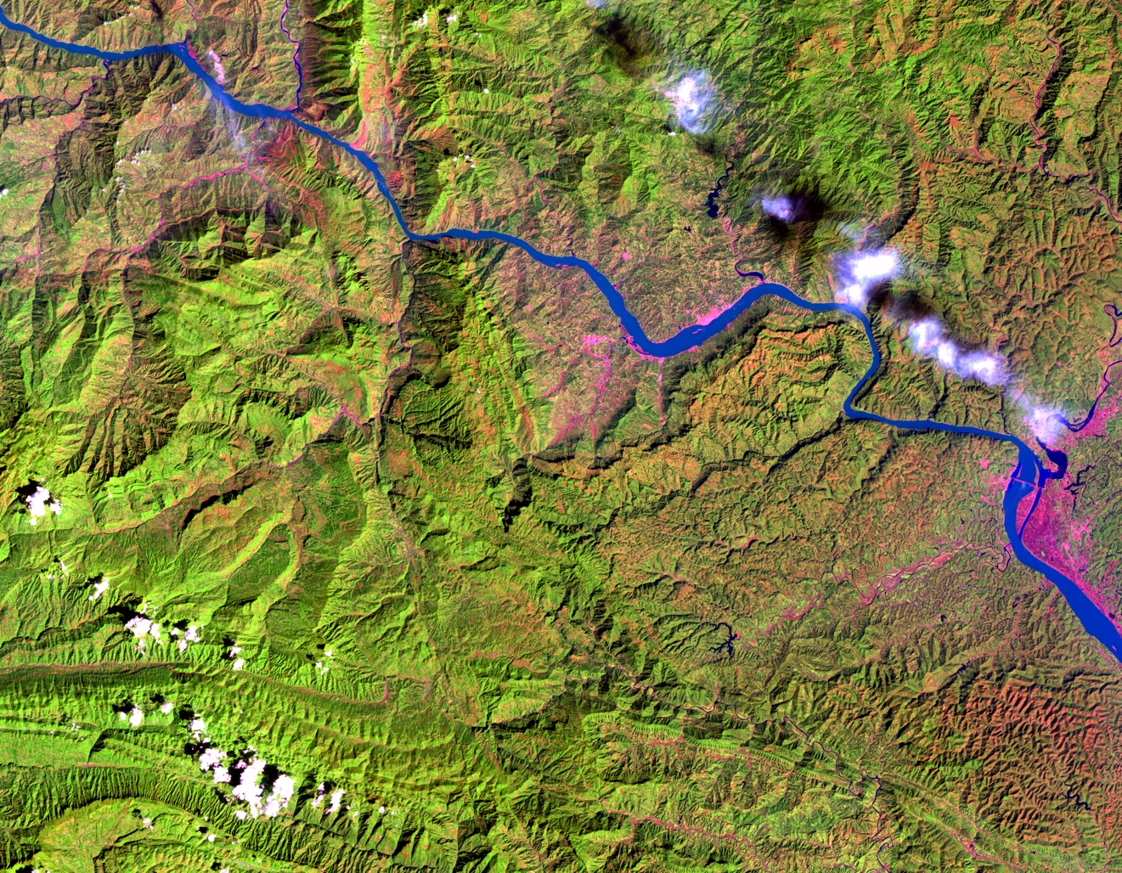
Figure 1: Landform around Three Gorges Dam before the river was submerged. Picture was taken by Landsat 5 on September 24, 1993.

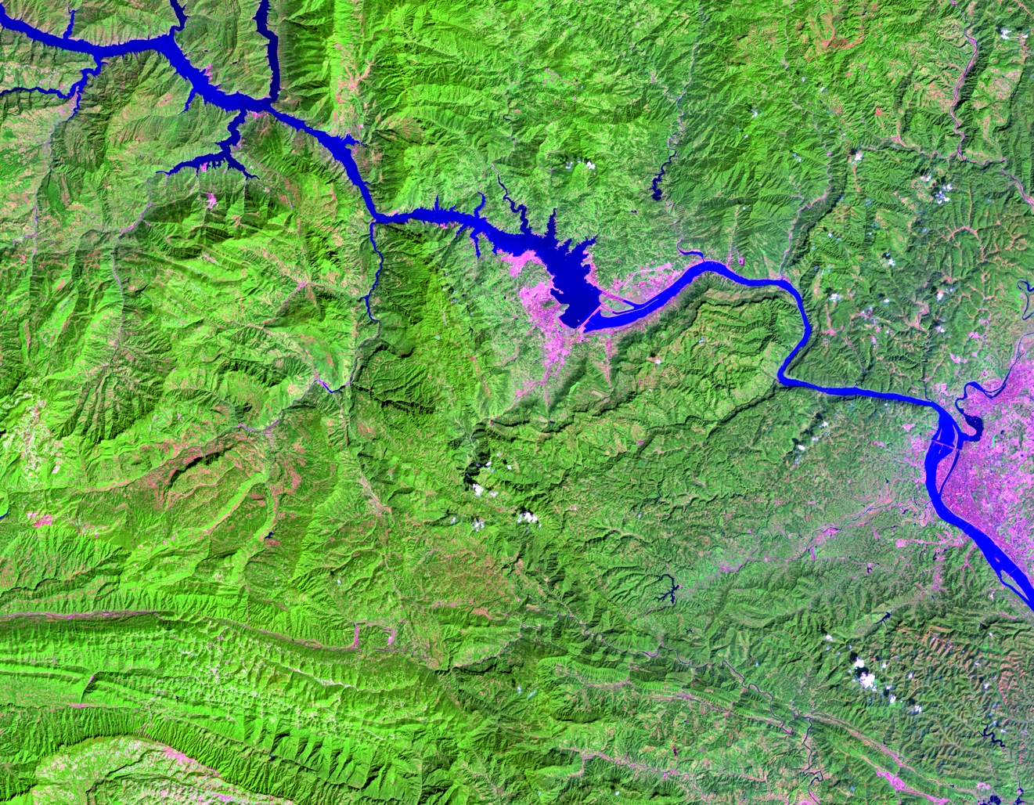
Figure 2: Landform around Three Gorges Dam after the river was submerged. Picture was taken by Landsat 8 on September 15, 2013.

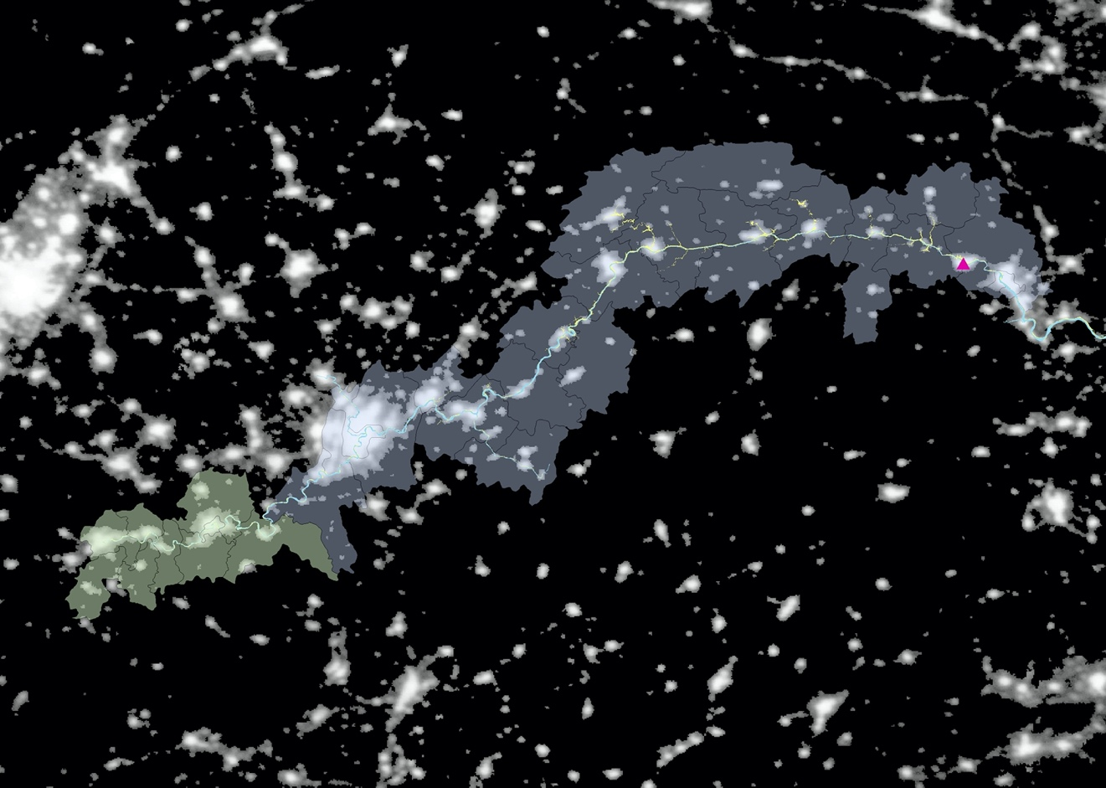
Figure 3: The blue area depicts 21 counties and districts in the Three Gorges reservoir area with relocation; the green area denotes 9 counties in Sichuan province without relocation. The red triangle represents where the dam is located.

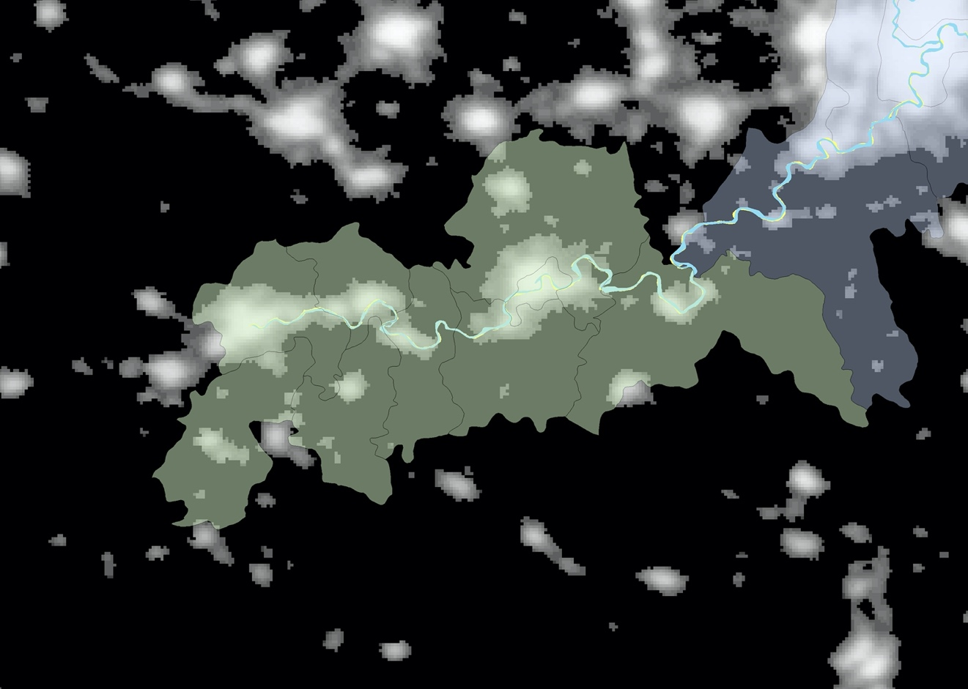
Figure 3A: The control areas consist of 9 counties located upstream without relocation and flooding. The blue polygon is the original river in 1993, and the yellow polygon is the current river in 2017, which are highly similar to each other.

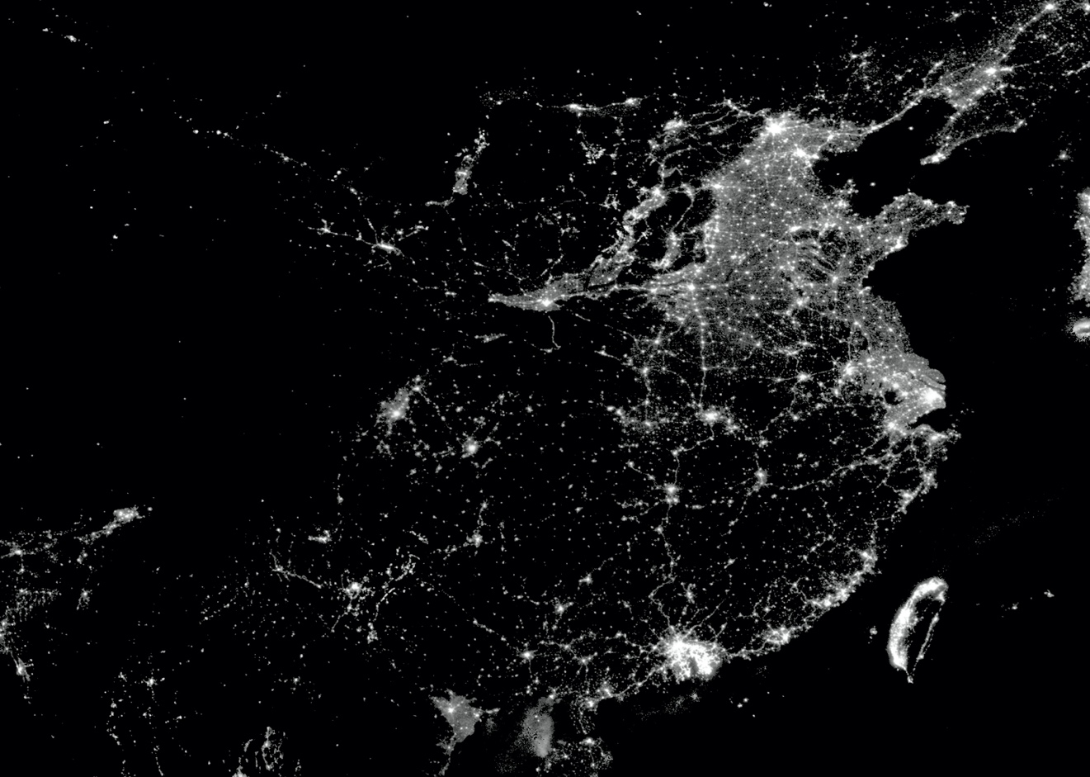
Figure 4: Nightlights of China in 2013.


Figure 5: Pixel-level points. Each point contains data on the light intensity value of the pixel and the region to which it belongs (i.e. county, province, distance to the river). For points that are in or intersect with the polygon of the river, the distance to the river equals zero.

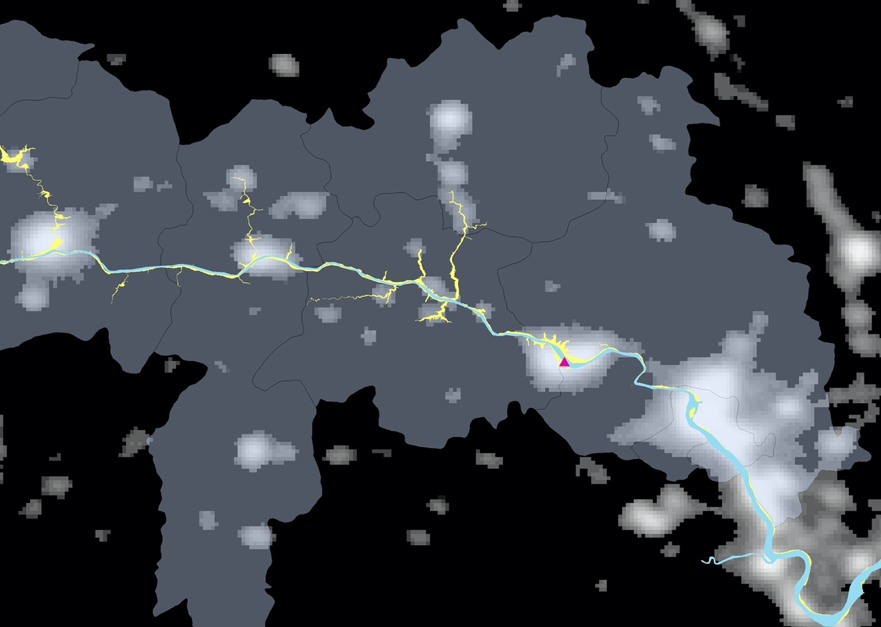
Figure 6: The Yangtze River before and after being submerged. The yellow part denotes the areas that are submerged because of the rising water level; the blue part is the original river.

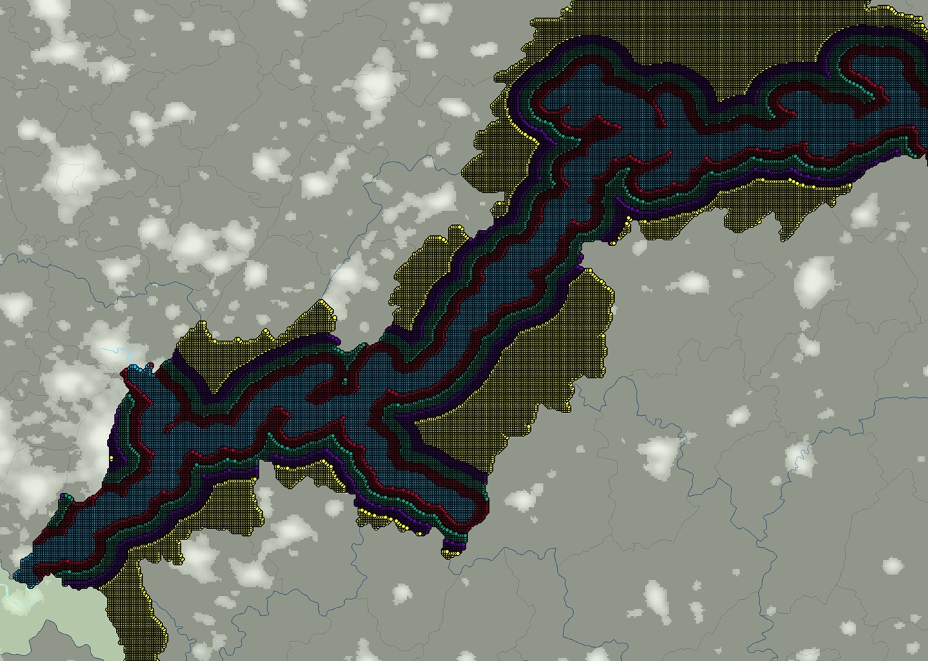
Figure 7: Treatment area. The blue area is 0-5km from the river, the red area is 5-10 km from the river, the green area is 10-15 km from the river, the purple area is 15-20 km from the river, and the yellow area is over 20 km from the river.

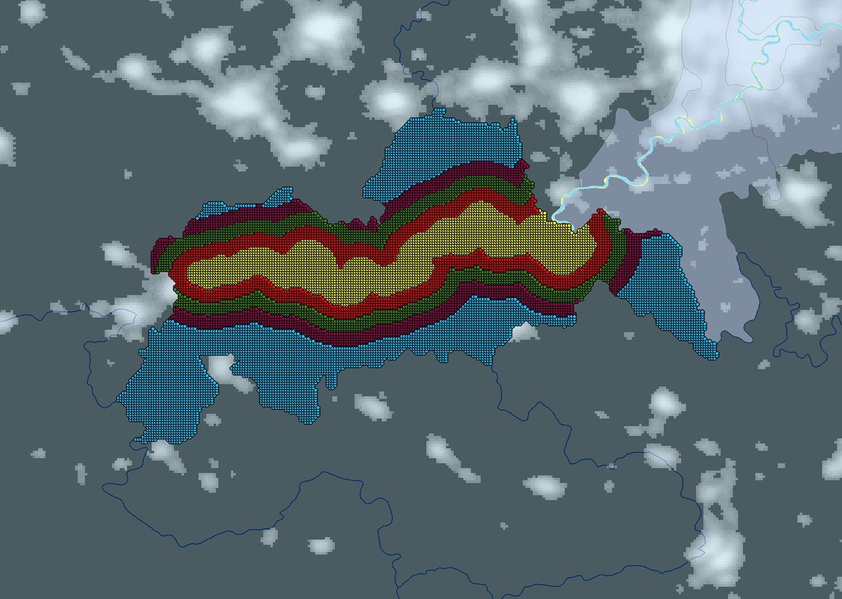
Figure 8: Control area. The yellow area is 0-5 km from the river, the red area is 5-10 km from the river, the green area is 10-15 km from the river, the purple area is 15-20 km from the river, and the blue area is over 20 km from the river.

Table 1
Summary Statistics
Variable | Obs. | Mean | St. Dev. | Median | Max | Min | Proportion of zeros
Panel A: The Full Sample
Light Intensity (1992-2013) | 2,071,982 | 1.839 | 6.165 | 0 | 63 | 0 | 80.122
Ln (0.01+light intensity) | 2,071,982 | -3.336 | 2.579 | -4.605 | 4.143 | -4.605
Light Intensity (1992) | 94,181 | 0.672 | 3.527 | 0 | 53 | 0 | 92.755
Ln (0.01+light in 1992) | 94,181 | -4.131 | 1.706 | -4.605 | 3.970 | -4.605
Light Intensity (2013) | 94,181 | 3.858 | 10.303 | 0 | 63 | 0 | 78.772
Ln (0.01+light in 2013) | 94,181 | -3.078 | 2.962 | -4.605 | 4.143 | -4.605
Panel B: Three Gorges Reservoir Areas
Light Intensity (1992-2013) | 1,745,502 | 1.908 | 6.467 | 0 | 63 | 0 | 80.525
Ln (0.01+light intensity) | 1,745,502 | -3.353 | 2.576 | -4.605 | 4.143 | -4.605
Light Intensity (1992) | 79,341 | 0.680 | 3.689 | 0 | 53 | 0 | 93.122
Ln (0.01+light in 1992) | 79,341 | -4.152 | 1.677 | -4.605 | 3.970 | -4.605
Light Intensity (2013) | 79,341 | 3.967 | 10.777 | 0 | 63 | 0 | 79.132
Ln (0.01+light in 2013) | 79,341 | -3.097 | 2.958 | -4.605 | 4.143 | -4.605
Panel C: Control Areas
Light Intensity (1992-2013) | 326,480 | 1.468 | 4.176 | 0 | 52 | 0 | 77.968
Ln (0.01+light intensity) | 326,480 | -3.241 | 2.590 | -4.605 | 3.951 | -4.605
Light Intensity (1992) | 14,840 | 0.630 | 2.492 | 0 | 36 | 0 | 90.795
Ln (0.01+light in 1992) | 14,840 | -4.018 | 1.849 | -4.605 | 3.584 | -4.605
Light Intensity (2013) | 14,840 | 3.275 | 7.926 | 0 | 52 | 0 | 76.846
Ln (0.01+light in 2013) | 14,840 | -2.977 | 2.982 | -4.605 | 3.951 | -4.605
Panel D: Yangtze River
Distance to the River in 1992 | 2,071,982 | 22,341 | 18,346 | 17,816 | 86,995 | 0
Distance to the River in 2017 | 2,071,982 | 16,901 | 14,426 | 13,325 | 82,351 | 0
Notes: The Full sample consists of years from 1992 to 2013, the number of pixel-level points for the Three Gorges reservoir areas is 79,341, and the number of pixel-level points for the control areas is 14,840. Distance to river (in meters) equals zero when the point is in the river or intersects with the polygon of the river.

Table 1A
Change in Number of Observations between Different Categories
 | Number of Pixel-level Points
 | Total | 0-5km | 5-10km | 10-15km | 15-20km | 20-25km | >20km | >25km
 | (1) | (2) | (3) | (4) | (5) | (5) | (6) | (6)
Yangtze River in 1993 | 1,883,620 | 32,548 | 43,662 | 43,994 | 42,088 | 39,042 | 85,560 | 67,852
Yangtze River in 2017 | 1,883,620 | 44,820 | 31,298 | 26,338 | 21,730 | 17,574 | 64,176 | 46,602
Notes: The sample only contains the observations of the pixel-level points in the years 1992 and 2013, in total 1,883,620 observations, which is 941,810 observations in each year.

Table 2
Light intensity and distance to the river in 2017
Ln (0.01 + Light Density)
 | 0-5 km to the river in 2017 | 5-10 km to the river in 2017 | 10-15 km to the river in 2017 | 15-20 km to the river in 2017
 | (1) | (2) | (3) | (4)
$$treat$$ | -0.220 (0.079)*** | -0.220 (0.079)*** | -0.220 (0.079)*** | -0.220 (0.079)***
$$post$$ | 0.472 (0.146)*** | 0.472 (0.146)*** | 0.473 (0.146)*** | 0.473 (0.146)***
$riverside$ (20km) | 1.391 (0.488)*** | 0.471 (0.394) | -0.136 (0.059)** | 0.049 (0.168)
$$treat post$$ | -0.122 (0.154) | -0.122 (0.154) | -0.122 (0.154) | -0.122 (0.155)
$$treat riverside$$ | -0.192 (0.624) | -0.068 (0.436) | 0.336 (0.152)** | 0.132 (0.177)
$$post riverside$$ | 2.607 (0.337)*** | 0.706 (0.252)*** | 0.057 (0.223) | -0.394 (0.215)*
$$treat post riverside$$ | -0.848 (0.397)** | 0.159 (0.353) | 0.524 (0.353) | 0.776 (0.272)***
Constant | -4.332 (0.076)*** | -4.333 (0.076)*** | -4.333 (0.076)*** | -4.333 (0.076)***
Observations | 108,996 | 95,474 | 90,514 | 86,906
Notes: Regression results. Dependent variable: Ln (0.01 + Light Density). Riverside denotes the distance to the river in 2017 being less than 20km. Riverside areas other than the category studied in each column are dropped (i.e. in 0-5km column, locations 5-20km from the river are omitted). Standard errors are in the brackets. *Significant at 10-percent level; **Significant at 5-percent level; ***Significant at 1-percent level. Standard errors are clustered by county for 30 counties in column (1) and (2), for 29 counties in column (3) and 27 counties in column (4).

Table 3
Light intensity and distance to the river in 2017
Ln (0.01 + Light Density)
 | 0-5 km to the river in 2017 | 5-10 km to the river in 2017 | 10-15 km to the river in 2017 | 15-20 km to the river in 2017 | 20-25 km to the river in 2017
 | (1) | (2) | (3) | (4) | (5)
$$treat$$ | -0.221 (0.087)** | -0.221 (0.087)** | -0.221 (0.087)** | -0.221 (0.087)** | -0.221 (0.087)**
$$post$$ | 0.510 (0.156)*** | 0.510 (0.156)*** | 0.510 (0.156)*** | 0.510 (0.156)*** | 0.510 (0.156)***
$riverside$ (25km) | 1.405 (0.485)*** | 0.485 (0.390) | -0.122 (0.064)* | -0.036 (0.174) | 0.049 (0.082)
$$treat post$$ | -0.247 (0.165) | -0.247 (0.165) | -0.247 (0.165) | -0.247 (0.165) | -0.247 (0.165)
$$treat riverside$$ | -0.191 (0.622) | -0.068 (0.421) | 0.336 (0.154)** | 0.132 (0.183) | 0.002 (0.093)
$$post riverside$$ | 2.570 (0.334)*** | 0.668 (0.243)*** | 0.019 (0.224) | -0.432 (0.235)* | -0.137 (0.109)
$$treat post riverside$$ | -0.723 (0.397)* | 0.284 (0.355) | 0.649 (0.361)* | 0.901 (0.303)*** | 0.456 (0.218)**
Constant | -4.346 (0.087)*** | -4.346 (0.084)*** | -4.346 (0.084)*** | -4.346 (0.084)*** | -4.346 (0.218)***
Observations | 91,422 | 77,990 | 72,940 | 68,332 | 64,176
Notes: Regression results. Dependent variable: Ln (0.01 + Light Density). Riverside denotes the distance to the river in 2017 being less than 25km. Riverside areas other than the category studied in each column are dropped (i.e. in 0-5km column, locations 5-25km from the river are omitted). Standard errors are in the brackets. *Significant at 10-percent level; **Significant at 5-percent level; ***Significant at 1-percent level. Standard errors are clustered by county for 30 counties in column (1) and (2), for 29 counties in column (3) and 27 counties in column (4) and column (5).

Table 4
Light intensity and distance to the river in 1993
Ln (0.01 + Light Density)
 | 0-5 km to the river in 1992 | 5-10 km to the river in 1992 | 10-15 km to the river in 1992 | 15-20 km to the river in 1992
 | (1) | (2) | (3) | (4)
$$treat$$ | -0.207 (0.079)** | -0.207 (0.079)** | -0.207 (0.079)** | -0.207 (0.079)**
$$post$$ | 0.467 (0.147)*** | 0.467 (0.147)*** | 0.467 (0.147)*** | 0.467 (0.147)***
$riverside$ (20km) | 1.383 (0.488)*** | 0.470  (0.397) | -0.106 (0.083) | -0.056 (0.164)
$$treat post$$ | 0.011 (0.163) | 0.011  (0.163) | 0.011  (0.163) | 0.011  (0.164)
$$treat riverside$$ | 0.277 (0.689) | 0.040  (0.459) | 0.320 (0.173)* | 0.158  (0.174)
$$post riverside$$ | 2.572 (0.338)*** | 0.785 (0.255)*** | 0.086  (0.237) | -0.389 (0.204)*
$$treat post riverside$$ | -0.647 (0.393) | 0.317  (0.365) | 0.503  (0.364) | 0.662 (0.282)**
Constant | -4.332 (0.076)*** | -4.332 (0.077)*** | -4.332 (0.077)*** | -4.332 (0.077)***
Observations | 118,108 | 90,170 | 87,732 | 84,402
Notes: Regression results. Dependent variable: Ln (0.01 + Light Density). Riverside denotes the distance to the river in 1992 being less than 20km. Riverside areas other than the category studied in each column are dropped. (i.e. in 0-5km column, locations 5-20km from the river are omitted). Standard errors are in the brackets. *Significant at 10-percent level; **Significant at 5-percent level; ***Significant at 1-percent level. Standard errors are clustered by county for 30 counties in column (1) and (2), for 29 counties in column (3) and 27 counties in column (4).

Table 5
Light intensity and distance to the river in 1993
Ln (0.01 + Light Density)
 | 0-5 km to the river in 1992 | 5-10 km to the river in 1992 | 10-15 km to the river in 1992 | 15-20 km to the river in 1992 | 20-25 km to the river in 1992
 | (1) | (2) | (3) | (4) | (5)
$$treat$$ | -0.205 (0.086)** | -0.205 (0.086)** | -0.205 (0.086)** | -0.205 (0.086)** | -0.205 (0.086)**
$$post$$ | 0.510 (0.156)*** | 0.510 (0.156)*** | 0.510 (0.156)*** | 0.510 (0.157)*** | 0.510 (0.157)***
$riverside$ (25km) | 1.392 (0.486)*** | 0.480  (0.395) | -0.095 (0.087) | -0.046 (0.172) | -0.046 (0.172)
$$treat post$$ | -0.058 (0.173) | -0.058 (0.173) | -0.058 (0.173) | -0.058 (0.173) | -0.058 (0.173)
$$treat riverside$$ | 0.274 (0.688) | 0.038  (0.456) | 0.318 (0.175)* | 0.156 (0.187) | 0.156  (0.181)
$$post riverside$$ | 2.529 (0.332)*** | 0.742 (0.244)*** | 0.042 (0.238) | -0.432 (0.226)* | -0.432 (0.226)*
$$treat post riverside$$ | -0.578 (0.391) | 0.386  (0.365) | 0.572 (0.371) | 0.732 (0.308)** | 0.289  (0.194)
Constant | -4.342 (0.084)*** | -4.342 (0.084)*** | -4.342 (0.084)*** | -4.342 (0.084)*** | -4.342 (0.084)***
Observations | 100,400 | 72,596 | 70,256 | 67,124 | 63,946
Notes: Regression results. Dependent variable: Ln (0.01 + Light Density). Riverside denotes the distance to the river in 1992 being less than 25km. Riverside areas other than the category studied in each column are dropped (i.e. in 0-5km column, locations 5-25km from the river are omitted). Standard errors are in the brackets. *Significant at 10-percent level; **Significant at 5-percent level; ***Significant at 1-percent level. Standard errors are clustered by county for 30 counties in column (1) and (2), for 29 counties in column (3) and 27 counties in column (4) and column (5).

Table 6
Light intensity and distance to the river, all treated areas
 | Ln (0.01 + Light Density)
 | River in 2017, Over 20km as Control | River in 2017, Over 25km as Control | River in 1993, Over 20km as Control | River in 1993, Over 25km as Control
 | (1) | (2) | (3) | (4)
(0-5km)*treat*post | -0.848 (0.397)** | -0.723  (0.397)* | -0.647  (0.393) | -0.578  (0.391)
(5-10km)*treat*post | 0.159  (0.353) | 0.284  (0.355) | 0.317  (0.365) | 0.386  (0.365)
(10-15km)*treat*post | 0.524  (0.353) | 0.649  (0.361)* | 0.503  (0.364) | 0.572  (0.371)
(15-20km)*treat*post | 0.776 (0.272)*** | 0.901  (0.303)*** | 0.662 (0.282)** | 0.732 (0.308)**
(20-25km)*treat*post |  | 0.456 (0.218)** |  | 0.289  (0.194)
Observations | 188,362 | 188,362 | 188,362 | 188,362
Notes: Regression results. Dependent variable: Ln (0.01 + Light Density). 0-5km denotes areas0-5km from the river; 5-10km denotes areas 5-10km from the river; 10-15km denotes areas 10-15km from the river; 15-20km denotes areas 15-20km from the river; 20-25km denotes areas 20-25km from the river. Standard errors are in brackets. *Significant at 10-percent level; **Significant at 5-percent level; ***Significant at 1-percent level. Standard errors are clustered by county for 30 counties.

All the information following (including local government reports, political propaganda and statistics on “planned and actual relocation”) about the project comes from editions of the Three Gorges Construction Yearbook from 1994 to 2010, published by the Three Gorges Project Construction Committee.
Three Gorges Construction Yearbook (1994)
One noteworthy detail in the annual report is that, after the project officially started, the State Council of PRC created a policy to let one province or city that was relatively more economically advanced and outside the reservoir area to support one county in the reservoir area. While this support was mainly focused on financial investment, materials supplies and personnel assistance, no evidence indicates that these provinces and cities outside the reservoir area would also take responsibility for the relocation tasks of local counties and districts in the reservoir area.
Three Gorges Construction Yearbook (1995)
U.S. Geological Survey. (https://earthshots.usgs.gov/earthshots/node/84#ad-image-0-0)
U.S. Geological Survey. (https://earthshots.usgs.gov/earthshots/node/84#ad-image-0-0)

