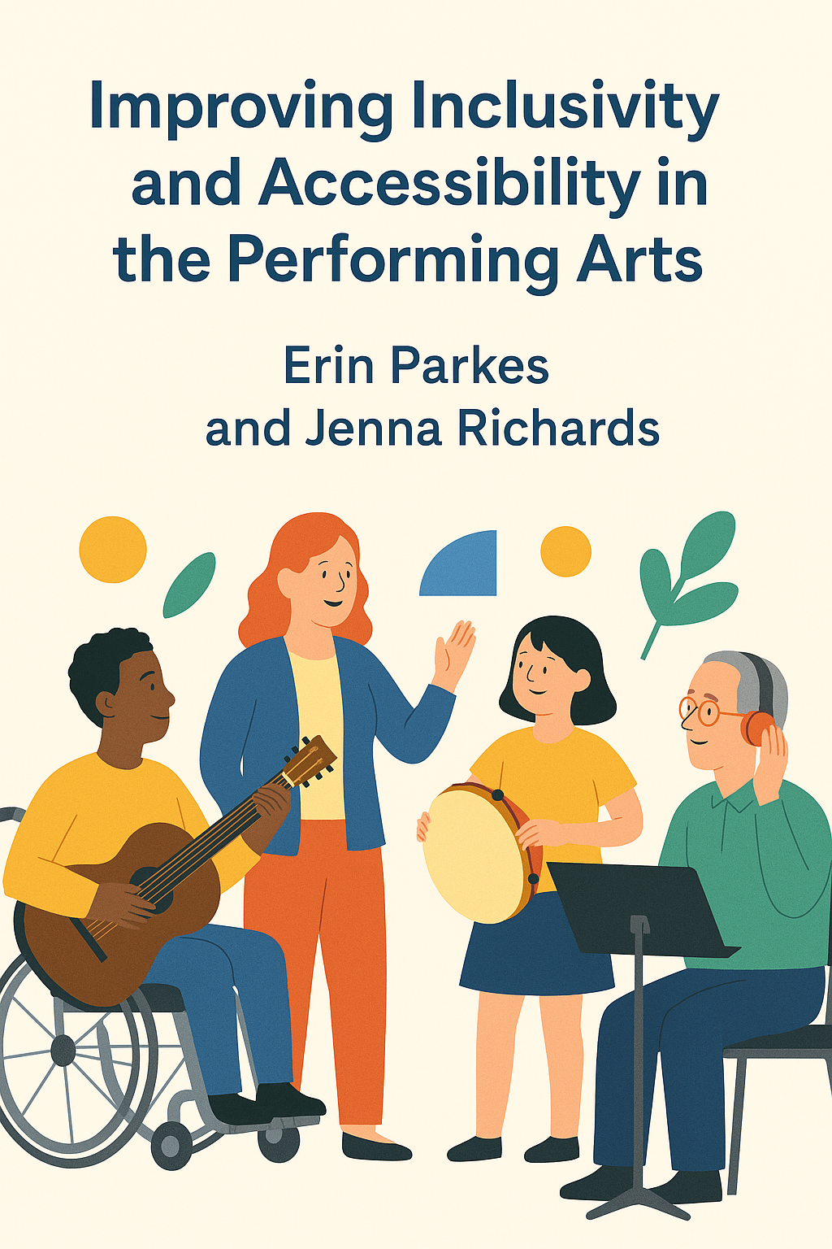
OER Resource and Reading List for all Modules
Developed for/from OER for Improving Inclusivity and Accessibility in the Performing Arts:
Adaptive Performance Resources, Practices, and Learning Materials

How to build a visual/social story:
- https://relaxedperformance.wordpress.com/2017/02/06/building-a-visual-story/
Examples of a visual/social story:
- The Children’s Theatre Company of Minnesota “Social Story” https://images.childrenstheatre.org/uploads/2019/10/SocialStoryUHG.pdf
- Chattanooga Symphony & Opera “Social Story” https://chattanoogasymphony.org/wp-content/uploads/2022/08/SF-Social-Story-Winds-Optimized.pdf
- Storybook Theater “Social Story” https://storybooktheater.org/wp-content/uploads/2018/05/Social-Story-KPC-1.16.18.pdf
- Milwaukee Ballet “The Nutcracker: A Social Story” https://milwaukeeballet.org/files/galleries/Sensory-Friendly-Nutcracker-Social-Story-Milwaukee-Ballet-0001.pdf
- Xenia Concerts “Venue Guides” https://xeniaconcerts.com/resources/venue-guides/

Examples of a programming guide:
- Kennedy Center Beauty and the Beat https://www.kennedy-center.org/education/resources-for-educators/classroom-resources/performance-guides/performance-guides/19-20-season/200117-beauty-and-the-beat-nso-music-for-young-audiences/
- Ottawa Chamberfest and the Lotus Centre for Special Music Education “Online Adaptive Concert” https://www.chamberfest.com/2021/wp-content/uploads/2023/03/Adapted-Concert-shhh-March-2023.pdf
- Trinity Rep “Fences Sensory Guide” https://www.trinityrep.com/app/uploads/2024/04/August-Wilsons-FENCES-Sensory-Guide-FINAL.pdf

Academic Sources:
Considine, Allison. 2017. “Extra Sensory.” American Theatre. https://www.americantheatre.org/2017/10/13/extra-sensory-crafting-autism-friendly-performances/
DeBoth, Kelle, Madalynn Wendland, Tyler Bilinovic, and Chelsea Sanford. 2021. “Caregiver Perceptions of Child Participation in Sensory Friendly Community Events.” Journal of Occupational Therapy, Schools, and Early Intervention 14 (3): 291–306. https://www.tandfonline.com/doi/abs/10.1080/19411243.2020.1862729
Fletcher-Watson, Ben. 2015. “Relaxed Performance: Audiences with Autism in Mainstream Theatre.” The Scottish Journal of Performance 2 (2 (June)): 61–89. https://www.sjop.org/Fletcher-Watson_relaxed-performance_SJoP0202_DOI_10.14439sjop.2015.0202.04.pdf
Fletcher, Tina, Julie Anderson-Seidens, Hope Wagner, Martha Linyard, and Elyse Nicolette. 2019. “Caregivers’ Perceptions of Barriers and Supports for Children with Sensory Processing Disorders.” Australian Occupational Therapy Journal 66 (5): 617–26.
Fletcher, Tina Sue, Emily S. Wiskera, Lynda H. Wilbur, and Natalie M. Garcia. 2021. “The Sensory Totes Programme: Sensory-Friendly Autism Program Innovations Designed to Meet COVID-19 Challenges.” World Federation of Occupational Therapists Bulletin, 1–9. https://www.tandfonline.com/doi/full/10.1080/14473828.2021.1943868
Kempe, Andrew J. 2015. “Widening Participation in Theatre through ‘Relaxed Performances.’” New Theatre Quarterly 31 (1): 59–69. https://www.cambridge.org/core/journals/new-theatre-quarterly/article/abs/widening-participation-in-theatre-through-relaxed-performances/9895F11A88A721969BD6B4A0AADB646C
———. 2018. “Beauty and the Beast: Providing Theatre Access for Children with Autism.” In The Routledge Hanbook of Disability Arts, Culture, and Media: Part II Inclusion, Well-Being, and Whole-of-Life Experience, edited by Bree Hadley and Donna McDonald, 1st ed., 89–99. London, UK. https://www.taylorfrancis.com/books/edit/10.4324/9781351254687/routledge-handbook-disability-arts-culture-media-bree-hadley-donna-mcdonald
Kim, Sunghun. 2021. “Creating Sensory-Friendly Recitals for Music Students with Autism.” American Music Teacher no. June/July: 30–33. https://www.mtna.org/downloads/DEI/Inclusive/2021_JJ_Creating.pdf
Koenig, Kristie Patten, and Sarah Rudney. 2010. “Performance Challenges for Children and Adolescents with Difficulty Processing and Integrating Sensory Information: A Systematic Review.” The American Journal of Occupational Therapy 64 (May/June (3)): 430–42. https://doi.org/10.5014/ajot.2010.09073
Lamarre, Andrea, Carla Rice, and Kayla Besse. 2021. “Letting Bodies Be Bodies: Exploring Relaxed Performance in the Canadian Performance Landscape.” Studies in Social Justice 15 (2): 184–208. https://doi.org/10.26522/ssj.v15i2.2430
Santanello, Patricia Jane. 2020. “The Experiences of Parents/Caregivers of Children with Autism Spectrum Disorder at a Sensory Friendly Theatre Performance.” University of Findlay. http://rave.ohiolink.edu/etdc/view?acc_num=findlay1595544825926404
Shakespeare, Tom. 1987. "The Social Model of Disability." Chapter 13 In The Disability Studies Reader. Lennard Davis ed. 212-220. http://thedigitalcommons.org/docs/shakespeare_social-model-of-disability.pdf
Silverman, Fern, and Andrea Carr Tyszka. 2017. “Supporting Participation for Children with Sensory Processing Needs and Their Families: Community-Based Action Research.” American Journal of Occupational Therapy 71 (4): 1–9. https://doi.org/10.5014/ajot.2017.025544
Stasell, Morgan R, and Molly M Bathje. 2021. “Hotel Experiences of People with Physical and Sensory Disabilities: A Qualitative Study.” The American Journal of Occupational Therapy 75 (4): 1–8. https://doi.org/10.5014/ajot.2021.044792
Thompson, Grace, Melissa Raine, Susan Hayward, and Hannah Kilpatrick. 2020. “Gathering Community Perspectives to Inform the Design of Autism-Friendly Music-Making Workshops for Wellbeing.” International Journal of Wellbeing 10 (5): 117–43. https://www.internationaljournalofwellbeing.org/index.php/ijow/article/view/1497
Umeda, Caroline, and Tracy Jirikowic. 2019. “Cultural Arts Access for Children with Disabilities via Sensory-Friendly Theater: Parent and Organization Experiences and Impacts.” The American Journal of Occupational Therapy 73 (4). https://doi.org/10.5014/ajot.2019.73S1-PO5033
Vize, Anne. 2014. “Sensory-Friendly Films: Catering for Children with Autism.” Screen Education, no. 73: 60–66. https://theeducationshop.com.au/downloads/metro-and-screen-education-articles/screen-education-articles/sensory-friendly-films-catering-for-children-with-autism/

Organizational sources:
Lotus Centre for Special Music Education (Ottawa, Canada):
https://lotuscentre.net

Ottawa Chamberfest’s Adaptive Concerts (Ottawa, Canada): https://www.chamberfest.com/series/2022/adaptive-concerts/

Xenia Concerts Inc. (Toronto, Canada):
https://xeniaconcerts.com

Kennedy Centre Sensory Friendly Programming Guide (New York, USA):
https://issuu.com/artsedge/docs/sensoryguidebook

National Arts Centre Orchestra Music Circle (Ottawa, Canada):
https://nac-cna.ca/en/musiccircle

Additional academic papers on disability, social justice, and DEI:
Practical Guides:
- Kennedy Centre “Sensory Friendly Programming for People with Social & Cognitive Disabilities: A Guide for Performing Arts Settings” https://www.kennedy-center.org/globalassets/education/networks-conferences--research/research--resources/lead-resources/sensoryguidebook.pdf
- Sensory Friendly Solutions “Creating a Sensory-Friendly Theatre Production” https://www.sensoryfriendly.net/creating-a-sensory-friendly-theatre-production/
Videos:
- League of American Orchestras “So you want to know about sensory-friendly programming?” https://americanorchestras.org/so-you-want-to-know-about-sensory-friendly-programming/ (includes PDF transcript)

Definitions:
Accessibility refers to the design of products, devices, services, or environments to be usable by people with disabilities. It ensures that individuals can participate in society as independently as possible (Cornell University).
Adaptive Performances are performances that consider disability and neurodiverse communities from their initial design through their execution, including an environmental audit, pre-show work, extra-musical aids, and programming adjustments. Though adaptive performances have roots in theatre and film, the most common performing arts practice of adaptive performances today is in music with adaptive concerts (Richards and Parkes).
DEI stands for Diversity, Equity, and Inclusion. Diversity involves the presence of differences; equity ensures fair treatment, access, and opportunity; and inclusion is the practice of creating environments in which any individual or group can be and feel welcomed, respected, supported, and valued (University of Michigan).
Disability is a multifaceted term with varying definitions depending on context. The World Health Organization's International Classification of Functioning, Disability and Health (ICF) defines disability as an umbrella term encompassing impairments, activity limitations, and participation restrictions (Science Direct).
Fidgets are small, handheld objects designed to be manipulated with the hands. They are often used to aid concentration and focus, particularly for individuals with attention-deficit/hyperactivity disorder (ADHD) or anxiety. Fidget toys can serve as a means to self-regulate, allowing children to discreetly reach their optimal level of arousal necessary for attention and on-task behavior (Roche, Back and Herwegen).
Hyperstimulation refers to excessive or extreme stimulation, leading to sensory overload. This can result in heightened stress or anxiety, particularly in individuals sensitive to sensory input (Merriam-Webster).
Hypostimulation denotes insufficient sensory input, which can lead to under-arousal and a lack of engagement or alertness. This state may prompt individuals to seek additional stimulation to achieve optimal arousal levels
Inclusivity involves the active, intentional, and ongoing engagement with diversity—in people, in the curriculum, in the co-curriculum, and in communities (George Washington University).
Neurodiverse describes the concept that neurological differences are to be recognized and respected as any other human variation. It acknowledges that people experience and interact with the world around them in many different ways (Harvard).
Neurotypical A neurotypical person is an individual who thinks, perceives, and behaves in ways that are considered the norm by the general population. Neurotypical does not mean “normal.” It simply means that the behaviors fall within expected boundaries, which can differ from one culture to another. (Direct eye contact, for example, is considered rude in some cultures and expected in others) (Asasumasu).
Neurodivergent “simply means that a person's brain works in a way that is not expected. It is commonly used when the behavior or response diverges from what is expected socially, physically, or verbally. Neurodivergence can be innate (e.g., ADHD, autism, depression, dyslexia, obsessive compulsive disorder, etc.) or due to a brain-altering event (e.g., PTSD, head trauma, medicines, drug use, etc.)” (Asasumasu).
Open Educational Resources (OERs) are teaching, learning, and research materials in any medium that reside in the public domain or have been released under an open license. They permit no-cost access, use, adaptation, and redistribution by others (UNESCO).
Performing Arts The performing arts encompass forms of creative expression performed in front of an audience, including music, dance, theatre, and other cultural expressions that reflect human creativity (UNESCO).
Stim: "Stimming," or self-stimulatory behavior, involves repetitive movements or sounds. It's common among individuals with autism and can serve various functions, such as self-soothing or coping with overwhelming environments.

