University of Ottawa
08
Fall

The real impacts of financial constraints. An investigation using Canadian firm financial fundamentals.

Dominique Imano (5004050)
Major Research Paper

Presented to the Department of Economics of the University of Ottawa in Partial Fulfillment of the M.A. Degree

Supervisor: Maral Kichian

ECO6999
Ottawa, Ontario
January 10th, 2014

Table of Contents
Abstract 4
1 Introduction 4
2 Literature Review 7
2.1 Alternate Definitions of Financially Constrained Firms 7
Size Index 7
KZ Index 8
Clustering Technique 9
Stochastic frontier approach 12
2.2 Impact of Macroeconomic Shocks 14
Campello and Chen (2010) 14
Gertler and Gilchrist (1994) 15
Hovakimian (2011) 16
Korajczyk and Levy (2003) 18
Lamont, Polk and Saá-Requejo (2001) 20
3 Data and Methods 22
4 Empirical Results and Discussion 25
Earnings Growth Model and Empirical Results 25
Capital Expenditure Model and Empirical Results 26
Discussion 27
5 Conclusion 30
References 31
Appendix 34
A CANSIM Acquired Variables 34
B Variable Graphs 34
B.1 Independent Variables 34
B.2 Dependent Variables 38
C Unit Root Test Outputs 39
C.1 Independent Variables 39
C.2 Dependent Variables 42
D Regression Output Tables 43
D.1 Operation Earnings Growth Model Regression 43
D.2 Capital Expenditure Growth Model Regression 43

Abstract
This research paper examines the impact of macroeconomic shocks on financially constrained firms using the size index as a financial constraint proxy. Quarterly Canadian business data is analyzed by means of OLS regressions, estimating the effects that the state of the economy, credit market conditions and monetary policy have on growth of business earnings and capital expenditures. The results suggest that state of the economy proxies (namely business production growth, the growth of the employment rate and the growth of wages) are mostly positively correlated with the aforementioned dependent variables. Similarly we find that monetary policy is a strong determinant of the aforementioned regressands. Surprisingly, the data indicates that tight credit market conditions (the growth rate of the prime corporate paper spread over the 3 month treasury bill and the growth of the chartered bank administrative rate spread over the 3 month treasury bill) are generally not statistically significant determinants of such firms’ financial performance and investment decisions.

1 Introduction
Measuring and understanding the economic burden of financially constrained firms is important since their effect impacts the overall economy. The existence of financially constrained firms obstructs economic expansion and slows growth since (due to lack of access to adequate financing) firms facing such challenges do not undertake feasible investment and business opportunities; financially constrained firms pay higher interest and rely more heavily on collateral when raising funds (Campello and Chen 2010) (Fazzari, et al. 1988). As such, these kinds of firms invest less, grow less and produce less, all the while creating fewer jobs. For example, Campello, Graham and Harvey (2010) support this statement regarding conditions in the U.S. in 2009: “the average constrained firm in the U.S. plans to dramatically reduce employment (by 11%), technology spending (by 22%), capital investment (by 9%), marketing expenditures (by 33%), and dividend payments (by 14%) in 2009.” Although these statistics are based on the U.S. economy, they paint a good picture as to the costs that the presence of financially constrained firms could also have in other developed economies such as Canada.

Financially constrained firms have been a topic of research and discussion for the past few decades, but the 2008 financial crisis has at once renewed and deepened interest in the subject matter. The crisis itself caused the failure of several major U.S. banks and numerous smaller financial institutions. “These huge losses have resulted in an increased interest in risk management on the part of financial institutions, and have lowered both their capacity and their willingness to take on risk. Evidence of tighter lending standards and withdrawn lines of credit abound” (Duchin, Ozbas and Sensoy 2010). As a result, it has been estimated that 86% of constrained firms in America chose not to undertake attractive investment opportunities due to difficulties in raising external finance (Campello, Graham and Harvey 2010). Furthermore, Smallbone, Deakins and Battisti (2012) discuss in their article that the “international economic and financial crisis in 2008–2009 presented major challenges to firms of all sizes, but particularly to smaller firms. A combination of resource-related constraints, low bargaining power in relation to a variety of stakeholders and a tendency to rely on bank credit when external finance is used, suggests that small firms may be particularly vulnerable during periods of economic downturn and financial crisis, compared with larger enterprises that control more substantial resources.” (Smallbone, et al. 2012) Moreover, Chan et al. (2010) indicate that standard corporate finance considers financially constrained firms to be “small or unprofitable…” Consequently, it is clear that the credit shortage caused by the 2008 financial crisis contributed particularly to financially constraining small firms.

Although the impacts were devastating, the 2008 crisis provides an opportunity for analyzing the effects of the performance and behavior of financially constrained firms during economic cycles. This paper will attempt to identify how macroeconomic shocks affect such constrained firm performances and their investment behavior in Canada. Specifically, we will explore the effects of the state of the economy, financial market shocks and monetary policy on constrained firm fundamentals for Canadian firms. Firms are identified as financially constrained based on the extent of their market capitalization. Regressions are then conducted in a time-series context, by means of OLS, using macroeconomic explanatory variables, in order to assess their impact on firm earnings and capital expenditures. Earnings are a proxy for firm performance while capital expenditures are a proxy for firm investment behavior.

Despite the fact that numerous studies suggest many different methods to identify financially constrained firms, the availability of research explaining such firm responses to macroeconomic shocks is limited and is one of the motives for this dissertation. In our literature review, we discuss two classical and two modern techniques used to identify constrained firms; the two classical methods being the size index and the KZ index, while the two modern methods are the clustering technique and the stochastic frontier approach. Furthermore, we discuss past findings regarding the impacts that macroeconomic shocks play on constrained firm fundamentals, including Campello and Chen (2010) who investigate the effects of the state of the economy, credit market condition and monetary policy on firm earnings and capital expenditure. Furthermore, Gertler and Gilchrist (1994) examine the effects of the prime rate on firm inventory growth, while Hovakimian (2011) analyzes the efficiency of constrained firm capital investments during recessions. Korajczyk and Levy (2003), on the other hand, study the effects of macroeconomic movements on constrained firm leverage.

Following this introduction, the paper will be organized as follow: The second section consists of a literature review about the classical and modern methods that have been used to identify financially constrained firms. We then present the results of studies that have examined the effects that macroeconomic shocks have on constrained firms. The third section introduces the theoretical model and methods. The fourth sections analyses and discusses the empirical results. The fifth section concludes.

2 Literature Review
Finding an objective and rigorous definition for financially constrained firms is an issue that remains unresolved. Numerous methods have been suggested, all with their advantages and disadvantages, but they are mostly subjective. Below we discuss two classical and two modern methods; in particular, the size index will be presented given that it was the constraint index of choice for this research. We then review past findings regarding the effects of macroeconomic shocks on financially constrained firms.

2.1 Alternate Definitions of Financially Constrained Firms

Size Index
This research paper uses firm size to identify financially constrained firms: market capitalization is the measure to be used to separate businesses into their respective constraint categories. Campello and Chen (2010) advocate that: “firm capitalization is a good proxy for constrained firms because smaller and younger firms find it more difficult to find access to credit”. It is further argued that “small firms typically do not have nearly as much collateral as large firms and will not have the same ability to raise external funds. Therefore, small firms will be more adversely affected by lower liquidity and higher short-term interest rates.” (Perez-Quiros and Timmermann 2000) Additional research demonstrated that, “constrained firms tend to be smaller, private, less profitable, less likely to pay dividends, and have lower growth prospects than firms that aren’t.” (Campello, Graham and Harvey 2010)

An immediate advantage of the size index is its simplicity and elegance: the variable (firm market capitalization) is directly measurable and datasets are easily available. Furthermore, there is empirical evidence suggesting that the firm size proxy is consistent with other financial constraint proxies. In their research, Almeida, Campello and Weisbach (2004) experiment with five different criteria to categorize firm-years into financially constrained or unconstrained pools: namely, by payout ratios, firm size, bond ratings, commercial paper ratings and by the Kaplan-Zingales index. Analyzing cross-sectional index correlations, four of the five aforementioned constrained firm classification definitions, including the size index, correlate positively amongst each other. The authors of this paper hypothesize: “the argument for size as a good observable measure of financial constraints is that small firms are typically young, less known, and thus more vulnerable to capital market imperfections.”(Almeida, Campello and Weisbach) In addition, Campello and Chen (2010) identified in their research that firm performance and behavior responses to macroeconomic shocks led to similar conclusions using four different constraint proxies, all of which always included the size index.

KZ Index
Another popular method to dichotomize U.S. sets of firms into constrained and unconstrained pools is the KZ index; named after Kaplan and Zingales (1997). Using 49 preselected firms (chosen in research conducted by Fazzari et al.), the KZ index is constructed by creating an index of classification related to firm financial and accounting variables using data from 1970 to 1984. These variables are namely cash flow to capital, market to book ratios (or the Tobin’s Q), debt to total capital, dividends to capital, and cash holdings to capital. The index parameters are calculated by using a logit regression to create a set of parameters that relate each of the aforementioned variables to the firm classification. The KZ index yields the following function:

Where “KZ” is the KZ index value parameter, “CF” is Cash Flows, “K” is capital, “Q” is the Tobin’s q parameter, “D” is Debt, “TK” is Total Capital, “Div” is Dividends & “CH” is Cash Holdings. A percentile cutoff point of definition is predetermined, where the top fraction of firms ranked by the index are defined to be constrained and the bottom fraction are unconstrained. (Kaplan and Zingales 1997)

One of the advantages of the KZ-index is the fact that it takes into account cash flow sensitivity. Cash flows has been proven, and is accepted by many researchers, to be an important factor in identifying financially constrained firms. Researchers assert that firm investments are higher if they have higher levels of internal funds; cash flows can be used as proxy to measure a firm’s level of access to internal funds. (Kaplan and Zingales 1997) However, the apparent disadvantage of this methodology is the fact that the parameters of the index were calculated based on 49 subjectively elected U.S. firms. This index, may have been more appropriate in the past when Fazzari et al. chose the companies, but varying market conditions and changing market base financial ratios are likely to bias the identification of constrained firms. Moreover, the KZ index’s parameters were identified using U.S. data, and as such, it would be more appropriate to reconstruct an index using samples of firms from the market that is being studied. In contrast, the size index is unbiased, as it is not dependent on any a priori parameter thus making it more widely applicable.

Clustering Technique
A recently proposed modern statistical method to group or identify financially constrained firms is by the use of a clustering technique. Its purpose is to endogenously create groups whose objects are similar to each other. In their research, Bassetto and Kalatzis (2011) use a hybrid clustering method, which consists of a hierarchical and a non-hierarchical method, to separate firms into pools. These clustering techniques are conducted for each time period given that this allows for group composition to vary from one period to the next; this is important since firms that were financially constrained may no longer be in later time periods.

The first technique, the Ward clustering technique (following Wang [2003]), is a hierarchical method of clustering objects. For a given cluster k, with N elements (or N firms), let ESS_{k} be the sum of squared deviations of every item in the cluster from the cluster mean; the cluster’s mean is defined to be its center. The following is the formulation of the sum of squared deviations:

Where X_{ki} is the i^{th} firm’s vector of measured variables of cluster k, and is the mean vector of measured variables of all N firms in the cluster k. The algorithm’s objective is to merge clusters such that the increase of the sum of all clusters’ squared deviations is minimized at each iteration. The sum of the squared deviations is presented by the following equation:

In their research, Bassetto and Kalatzis (2011) analyze the dendographs of the hierarchical clustering in order to determine how many clusters the dataset should be merged into. The authors then introduce a second clustering method, a non-hierarchical method, that is used in tandem with the previous to identify the optimal group cluster count.

The non-hierarchical method, implemented by the authors is called the k-means method. This algorithm seeks to identify the optimal k cluster grouping that minimizes the intra-cluster variances. First, the method uses the initial cluster centers, know as the initial “seeds” (which in this case were identified in the hierarchical grouping previously), and seeks to find alternate k cluster centers such that the total intra-cluster variance is minimized. The variance is represented by the following formula:

Where C_{k} are the K clusters centers, x_{i}’s are the objects (firms) and are the cluster centers. In other words, the algorithm seeks to minimize the intra-cluster variance (V).

The final number of clusters is determined by the k-partition that results in the lowest amount of information loss; the information criterion is the R-Square coefficient when regressing on the data partitions. For example, if the biggest decrease of the R-Square value occurs from a jump between a two-cluster to a three-cluster grouping, then the final cluster count in the sample will be two. (Bassetto and Kalatzis 2011)

The advantage of having an endogenous method to separate observations is that it reduces the subjectivity in identifying constrained firms: instead of using an a priori index or a proxy of definition, the data speaks for itself by allowing the algorithm to naturally form clusters of groups who’s elements have common characteristics. When the algorithm is successful, there is evidence of high levels of homogeneity within groups and high inter-group heterogeneity, thus making it easier to identify the differences between group characteristics; this makes it easier to compare and contrast constrained firm and unconstrained firm behavior. (Bassetto and Kalatzis 2011)
The main shortcoming of this method is the fact that the algorithm’s success is entirely dependent on its ability to create clusters whose variables have significant intergroup heterogeneity. Once the algorithm determines the optimal group composition, if intercluster variables are not significantly different from each other, it may be difficult or impossible to identify financially constrained firm clusters. In contrast, the size index has the advantage given that it is able to identify constrained firms while not being dependent on the success or functionality of any such algorithms. Furthermore, the clustering technique is a completely atheoretical method in contrast to the size index’s theoretical basis, which allows it to theoretically explain why identified sets of firms are financially constrained.

Stochastic frontier approach
The stochastic frontier approach is a constraint index construction method applied by Bhaumik, Das and Kumbhakar (2012) and by Wang (2003). The technique supposes that firm investment decisions are solely based on their respective Tobin’s q, current sales, past sales, cash flows and assets. Following this logic, Wang defines the optimal investment decision function (on the stochastic frontier) to be the following:

Where i is the firm identifier subscript; t is the time period; I is investment; K is capital; α is a regressions constant; Q is the Tobin’s q; SALE are sales; CF are cash flows; θ and μ are the time and firm fixed effects respectively; ε is the independently and identically distributed noise term.

Using the parameters {α, β_{i,t}}, a set of stochastic frontier investment to capital ratios are created for each firm (i) at each time period (t). In the presence of financing constraint, the observed optimal investment to capital ratio is observed to be less than or equal to the stochastic frontier ratio calculated above. The discrepancy between the optimal ratio, and observed ratio (which is suboptimal in the presence of financing constraints) is characterized by a non-negative term u. The equation representing this discrepancy is the following:

Hence, the left hand equation yields that given capital accumulation at t-1 (K_{i,t-1}), we have that I_{i,t} / I_{i,t}^{SF} = exp(-u_{i,t}). Where, u_{i,t} is bounded between 0 and 1 and can be identified as an efficiency score. A ratio of 0.7 would indicate the firm’s investment level is at 70% of the desired level. (Bhaumik, Das and Kumbhakar 2012)

The stochastic frontier approach’s main advantage over the stylized approaches (using pool OLS or fixed effects panel regressions) is that the method not only identifies financially constrained firms, but also measures the degree to which firms are constrained. It is also possible to approximate the marginal impact of a firm’s characteristics on its level of financial constraint. As discussed by the authors, this means that an optimal financial response or investment level can be theoretically calculated independently for each constrained firm instead of inferring financial investment decisions on group criteria averages. (Bhaumik, Das and Kumbhakar 2012)
However, the index’s model has a disadvantage. If the stochastic frontier’s constraint index parameters are derived from criteria provided by firms in a wide array of markets, it is highly likely that market segments containing firms of similar market types will have ratios that are similar. As such, the index may identify firms having lower sales to capital ratios or cash flows to capital ratios as being constraint when in reality, these ratios may simply be market characteristics. Given this, it may be more appropriate to apply the stochastic frontier method to individual markets than all firms of an economy. The size index, on the other hand, has been successfully applied to aggregates of all firm types and does not encounter this problem.

2.2 Impact of Macroeconomic Shocks
Investigating the impact of macroeconomic shocks on constrained firm fundamentals is an interesting question but studies are limited. For each of the following papers, we begin by introducing the various regression models, and then proceed with a discussion of the empirical results.

Campello and Chen (2010)
Campello and Chen (2010) attempt to find the real economic and financial implications of capital market imperfections on U.S. firms. Specifically, they study whether there are differences in responses of constrained and unconstrained firm financial characteristics to macroeconomic shocks. Using four different financial constraint indexes, one of which is the size index, they observe firm operation earnings and capital expenditure responses to changes in the state of the economy and credit market conditions; the other constraint proxy indexes are the KZ-index, and two composite indexes. The research is conducted using yearly U.S. firm data, where the authors estimate the effects of contemporaneous macroeconomic shocks on firms earnings growth and capital expenditure growth using the following regression equations:

In the above equation, π_{j,t} is the firm-year’s median real earnings growth and real capital expenditure growth, MACRO are the aforementioned macroeconomic shocks, MP (a monetary policy variable) is the growth of the overnight rate, Trend is a time effect variable and u is the regression disturbance term.

For all four constraint proxies, the authors find statistically significant evidence suggesting that constrained firm earnings growth and capital expenditure growth are both impacted positively by industrial production and the employment rate, while the aforementioned regressands are negatively impacted by the commercial paper over 30 day treasury bill spread and the bank prime loan rate of the 30 day treasury bill spread.

In the earnings growth model, for all four constraint indexes, they found that industrial production had the greatest statistically significant impact on constrained firms, while credit market variables had a slightly lesser impact, and that of the employment rate was even smaller. This suggests that both the state of the economy and credit market conditions impact constrained U.S. firm earnings. However, when firm capital expenditures were regressed on the same variables, the magnitude of both macroeconomic variable parameters were greater than those of credit market condition proxies, suggesting that U.S. constrained firms investment decisions are influenced more by macroeconomic cycles than by credit market conditions.

Note that though firm earnings is a good indicator of performance (given that firms seek to maximize profits), capital expenditures may not be the most efficient indicator of firm behaviour since it indicates how much firms invest during economic cycles but fails to identify how efficiently funds are allocated.

Gertler and Gilchrist (1994)
Gertler and Gilchrist’s research analyzes constrained and unconstrained firm manufacturing responses to changes in credit market conditions. The authors use quarterly time series for American industrial manufacturing firms and identify constrained and unconstrained firms based on their asset size. Gertler and Gilchrist argue that size is correlated with a firm’s access to credit given that “there is a strong correlation between size and the form of external finance. Smaller firms rely heavily on intermediary credit while large firms make far greater use of direct credit, including equity, public debt, and commercial paper.” (Gertler and Gilchrist 1994) Using the following model, they estimate the impact of credit market variables and other firm fundamentals on inventory growth rates.

In the above equation, I is inventory, S is sales, CR is the coverage ratio, i is the detrended value of the log of short term interest rate (prime rate), ε is a cost shock and Δ is a prefix to denote the growth rate of a variable. Inventory growth can be a proxy for firm performance, given that inventory stockpiles will generally increase when firms are producing and selling more goods and services. Furthermore, given that commercial banks set their own prime interest rates, i and Δi can both be proxies for credit market condition; banks put upward pressure on interest rates when lending becomes riskier and vice versa.

Results demonstrate that the coverage ratio was the only statistically significant parameter for small firms. However, another model estimation that dropped both coverage ratio variables yielded a statistically significant prime rate parameter estimation; there was evidence of negative correlation between the prime interest rate and inventory growth. Given this, Gertler and Gilchrist conclude that small firms’ inventory stockpile contracts substantially during bad credit conditions.

Although the prime interest rate is a simple indicator, the variable does not indicate credit market conditions as well as the spread between bank credit rates and the risky-free rate (Treasury bill rate). The spread is a better proxy for the level of uncertainty in credit markets.

Hovakimian (2011)
Hovakimian attempts to explain the efficiency of capital allocation in investment projects for financially constrained firms and conglomerates. The research seeks to identify the extent to which recessions affect constrained firm capital expenditure in high q segments (firm or firm segments having capital assets with a high Tobin’s q ratio) and low q segments (that is, firm or firm segments having capital assets with a low Tobin’s q ratio). Given that constrained firms find it especially difficult to access adequate financing during hard economic times, Hovakimian theorizes that such firms allocate scarce capital resources more efficiently during recessions. Using annual data from 1980 to 2008, she identifies constrained firms using four proxies; Namely firm dividend payout, firm size, commercial paper rating and the KZ index. She then investigates whether changes in internal capital market efficiency is induced by financial constraints. (Hovakimian 2011)

Hovakimian creates a variable that indicates the relative value added (RVA) to a firm by reallocating investment capital from one segment (or firm) to another. The variable is estimated by “weighing the firm and industry adjusted investment ratio for each segment by the difference between the segment’s q and the asset-weighted average q of all segments of the firm, and adding up this value across all segments in the firm”. (Hovakimian 2011) The following formula summarizes it:

In the above, j is the segment subscript and ind is the industry superscript. q_{j} is the estimated q for segment j, is the asset-weighted average q for all segments within the firm, capex_{j} is the segment j’s capital expenditure, assets_{j} are assets for segment j, and Assets is the sum of the firm’s assets.

Using this proxy, the author uses the following regression model on constrained firms for all four constraint proxies:

Where i is the firm subscript and t is the time subscript. RECESSION is a dummy variable identifying constrained firm years obtained from the National Bureau of Economic Rsearch Business Cycle Expansions and Contraction, firm assets are the value of firm t’s assets, Diversity of segment q is the diversity of segment growth opportunities, and the Herfindahl index is an index of the firm’s size in relation to the industry’s. α_{i} is a fixed firm effect variable.

For all constraint proxies, there is statistically significant evidence suggesting that recessions cause constrained firms to increase their RVA thus indicating that they reallocate capital to higher q segments during recessions: The results corroborate with the theory that such firms increase the efficiency of capital expenditures during weaker economic conditions. However, as the author notes, it is important to realize that financial constraint is not an overall positive factor for funding valuable investment opportunities. This theory merely indicates that investment projects that are expected to be more profitable and less risky are given priority; Hovakimian says that “despite less efficient capital allocation, valuable investment opportunities are financed more successfully under more accessible external capital markets”.

The advantage of using the RVA variable to analyze firm behaviour is its ability to measure how efficiently financially constrained firms invest during economic cycles. In contrast, capital expenditures merely indicate how much firms invest in capital investments. However, the RVA variable cannot be considered as a direct measure of firm performance. Earnings is a better indicator of performance given that firms’ main incentives are to maximize profits.

Korajczyk and Levy (2003)
In their study, Korajczyk and Levy (2003) examine the determinants of financially constrained firm leverage ratios over time. Specifically, they identify how macroeconomic conditions affect the extent to which such firms rely on debt, relative to equity, to fund their expenditures. They argue that constrained firms who are performing poorly have difficulties issuing equity and therefore have to rely more on debt to finance their operations. Consequently, leverage can be used to study how financially constrained firms behave over business cycles; firms who cannot generate sufficient funds to invest in lucrative investment opportunities must take on more debt thus increasing their leverage.

Using quarterly COMPUSTAT and monthly CRSP data ranging from 1984Q1 to 1999Q3, the authors identify constrained firms based on their dividend distribution and Tobin’s q. They then estimate the determinants of those firms’ expected leverage ratios based on the following estimation equation:

Where i is the firm and t is the month subscript. MacroT_{i,t-3} is a function of known macroeconomic variables, X_{i,t-3} are know firm-specific target variables, f_{i} is a fixed effect variable, q_{t} and fq_{t} are calendar quarter dummy and financial quarter dummy respectively, and d86_{t} is a pre-1986 Tax Act Dummy. Lev_{i,t} is defined to be the “expected optimal leverage ratio in the absence of the information asymmetries or transaction costs” (Korajczyk and Levy 2003). The authors use four different measures of leverage. The first is the ratio of short-term plus long-term debt to market value of assets, the second is the ratio of long-term debt to market value of assets, the third is the ratio of short-term plus long-term debt to book value of assets. The fourth ratio is the ratio of short-term plus long-term debt, less cash and marketable securities, to market value of assets, less cash and marketable securities.

The macroeconomic explanatory variables are the following: The two-year real aggregate domestic nonfinancial corporate profit growth (corporation profit growth), two-year return on CRSP value-weighted index of stocks traded on NYSE, AMEX and NASDAQ (two-year equity market return) and the annualized rate on the three-month commercial paper over the rate on the three-month Treasury bill (the commercial paper spread).

For all four proxies, constrained firm leverage ratios are positively correlated with corporation profit growth and equity market returns. However, there was no statistically significant evidence to suggest that leverage was negatively correlated with commercial paper spread. As such, Korajczyk and Levy conclude that higher leverage ratios, during periods of economic growth, are a consequence of financial constraint. To reiterate, constrained firm leverage ratios are generally pro-cyclical with macroeconomic conditions.

Although this method paints a good picture of the consequences of how constrained firms behave during recessions, it does not directly indicate how firms are performing. The necessity to take on debt, rather than financing through equity, is a result of financial constraint during recessions, but it does not directly measure the performance of firms over business cycles.

Lamont, Polk and Saá-Requejo (2001)
Although some research claim that macroeconomic cycles do affect firm business decisions, Lamont, Polk and Saá-Requejo found little to no evidence tying firm performance and valuation characteristics to macroeconomic metrics. Using monthly business datasets, the authors divided firms, using a size index, into low market capitalization firms, mid-cap firms and high cap firms. The three firm groups were subdivided again, by means of the KZ-index, into low, medium and highly constrained firm groupings. The following equation, similar to Campello and Chen’s model, was applied to two stock portfolios to estimate the impact of six macroeconomic variables (MACRO) on stock returns:

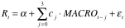

Where R_{t} is the difference in stock returns between constrained and unconstrained firms in the first portfolio (and the difference between small firms and large firms in the second portfolio); the variable was constructed using a stratified portfolio that is long on constrained firms and short on unconstrained firms in the first regression (and long on small firms and short on large firms in the second regression). MACRO variables included two state of the economy proxies and four monetary policy measures as well as lag summation variables: The proxies for the state of the economy were the change in a leading economic activity index (calculated by the department of commerce and conference board) and the change in the experimental leading index (developed by Stock and Watson in 1989) while the monetary policy measures were the change in real M2 (a standard measure of money supply), the change in the federal funds rate, the change in the discount rate charged by the federal funds rate and finally the change in the spread between the commercial paper rate and the six-month treasury bill rate.

Out of the twelve estimators for the size stratification, only one was statistically significant at the 5% level, and none were statistically significant for the financial constraint stratification. Thus, the results for both the size index stratification and KZ index stratification suggest that macroeconomic metrics are not good indicators of differences in constrained firms responses relative to unconstrained ones, or small firms responses relative to large ones.

3 Data and Methods
Information for Canadian non-financial firms was collected using Capital IQ’s Compustat Research Insight. Macroeconomic data and credit market variables were acquired using Stats Canada’s CANSIM (Canada’s Socioeconomic database). Quarterly frequency data was gathered, when available, and all other data frequencies were transformed into calendar quarterly three-month averages. The data sample extends from 2002Q1 to 2011Q4. Financially constrained firms were identified by using the size index: specifically, for each calendar quarter, a portfolio of firms having market capitalization values in the lowest 30 percent were defined to be financially constrained.

Before conducting a regression analysis, all variables were transformed by means of first difference given that they were not stationary. Furthermore, the earnings growth rate and capital expenditure growth rate variables were seasonally adjusted given their cyclical characteristics. A Dickey-Fuller test for all adjusted variables demonstrated that there was no significant evidence of the presence of unit-roots at the 5% significance level. Graphs for all variable datasets used in the regressions can be found in section B of the appendix while their respective unit root tests are located in section C of the appendix.

We use a version of the model proposed in Campello and Chen (2010). Regressions are performed by means of OLS to estimate the effects of macroeconomic shocks on the evolution of financially constrained firm investment decisions and earnings. We propose the following model:

In the above, π_{t} is the constrained portfolio’s median firm quarter real operations earnings growth or capital expenditure growth at time period t. η is a regression constant; MACRO_{t} is a vector of the state of the economy proxy variables and credit market condition variables at quarter t; MP_{t} is the monetary policy variable; and ε_{t} is the residual. Real earnings from operations were obtained by taking the quarterly earnings before interest and taxes (EBIT) and then discounting them by the consumer price index (CPI) while capital expenditures were acquired directly.

Variables representing macro conditions include: business production growth (BPG), the employment growth rate for Canadians of both genders aged 15 years or older (employ_growth), and real average wages growth rate (wages_growth). Credit market proxies are given by the growth of the spread between the 30-day prime corporate paper rate over the 3-month treasury bill (PCP_SRPREAD), and the growth of the spread between chartered bank administrative rate over the 3-month treasury bill (CBAD_SPREAD). The proxy for monetary policy (MP) was the target for the overnight rate growth. Given that the rates were acquired in percentages, the overnight rate growth was calculated by simple difference with one-quarter time lag. The following equation represents the transformation:

Here, Overnight_Rate is the target for the overnight rate from the Bank of Canada.

Initial estimations were conducted using only contemporaneous independent variables as Campello and Chen did in their research. However, given that our results were not statistically significant and given that this greatly increases the likelihood of endogeneity, regressions were conducted using independent variable time lags to find an adequate fit for the models. The resulting best-fit models are not identical for the earnings growth estimations and the capital expenditure growth estimations. As such, a breakdown of the results for each of the two models will be done independently.

It is worthwhile to mention that the purpose of this model is to measure the earnings and capital expenditures of firms that have become financially constrained as a result of past macroeconomic shocks. Furthermore, although it may seem that the model does not explain the earnings and capital expenditure of firms that were financially constrained at the time when the macroeconomic shocks happened, this is the case, given that the portfolio composition of financially constrained firms did not change much, if at all, between quarters. In other words, the analysis is measuring the behavior and performances of firms that were financially constrained at the time when the macro shocks happened, as well as the behavior and performances of the firms that have become constrained as a result of these shocks since they are, in general, the same firms.

4 Empirical Results and Discussion

Earnings Growth Model and Empirical Results
The first model to be presented is the operation earnings growth model, estimated by the following regression equation:

Where EARN is earnings, BP is business production, EMP is the employment rate, WAGES are self explanatory, PCP is the prime corporate paper over the 30 day treasury bill spread, CBAD is the chartered bank administrative rate over the 30 day treasury bill spread, MP is the monetary policy variable defined previously, ε is the regression residual term and Δ is a growth rate coefficient. The regression results of the equations above can be found in table 9 of the appendix. The model R-square was 0.56 and the Durbin-Watson value was 2.33 suggesting no significant evidence indicating the presence of first-order autocorrelation. Furthermore, group F-Tests shows that the state of the economy, credit market conditions, and monetary policy all play statistically significant roles in explaining movements in constrained firm earnings.

Results suggest that constrained firm earnings growth are positively correlated, at the 5% significance level, with both business production growth and the growth of wages. This is relatively intuitive given that business earnings would be expected to increase with demand, as well as with the productivity of the economy because workers want wages to keep up with inflation when the economy is growing. However, the employment growth rate parameter was found not to be statistically significant at the 5% level.

Among the credit conditions variables, the chartered bank administrative rate spread growth was the only credit market variable that had a statistically significant parameter at the 5% level. The estimate is small relative to other parameters and is negatively correlated with earnings growth, which can be explained by the fact that the growth of the spread is indicative of uncertainty in the economy during times when firm performances are weaker.

In addition to being statistically significant at the 5% level, the monetary policy variable was found to be an important determinant given its magnitude. An increase in the growth of the target for the overnight rate was positively associated with strong earnings growth.

Capital Expenditure Model and Empirical Results
The capital expenditure growth model was estimated by the following regression equation:

Where CAPEX is capital expenditures; all other variables and constants are synonymously defined as in the previous model. The results for the regression can be found in table 10 of the appendix. The regression R-square was 0.63 and there was no statistically significant evidence of first-order autocorrelation given that the Durbin-Watson statistic was 1.81. F-tests for each variable group demonstrated that state of the economy and monetary policy variables were statistically significant in explaining firm capital expenditure decisions but that credit market conditions were not. Nevertheless, credit market variables are included in the model to gain insight of their effects relative to the other explanatory variables.

Similar to the earnings model, the two state of the economy parameters that were statistically significant at the 5% level were those of business production growth and wages growth. The fact that business production growth is positively related to increases in capital expenditure could be attributed to the fact that firms tend do spend more on capital expenditures when the economy is expanding. Furthermore, positive correlation between wages and capital expenditures could be attributed to the fact that firms will increase capital investments during good economic times, and as such, workers may want their salaries to keep up with economic growth and inflation.

Neither of the credit market variables were indicative of capital expenditure given that both parameters were not statistically insignificant.

The monetary policy parameter was the greatest in magnitude, positive, and was statistically significant at the 1% level. Like the earnings model, this suggests that monetary policy was a very strong indicator of firm performance and investment behavior.

Discussion
The above regression results show that real macroeconomic conditions and monetary policy are the main influences on firm fundamentals and that credit market conditions do not play much of a role in Canada. It is possible that credit market conditions did not play a significant role in explaining earnings and capital expenditures because Canadian banks were in much better shape than those of other countries during the crisis period; this is reflected in the data given that the impact of credit market conditions were not significant between 2002 and 2011. Furthermore, although standard theory dictates that a decrease of real interest rates results in output growth, the fact that the regressions captured a positive correlation between the aforementioned firm fundamentals and the monetary policy variable can be attributed to the following:
The Bank of Canada suggests that monetary policy lag effects are between 6 to 8 quarters (1 ½ to 2 years later), but this paper shows the impact of monetary policy changes from 6 to 9 months prior. We also know that firms have momentum when they start investment projects, and it may take a while before the monetary policy effects slows these projects down. In the meantime, firms may still need to borrow even if interest rates increase in the short term, just to complete the projects that were started 2 to 3 quarters prior. Hence, the true coefficients of MP(-2) and MP(-3) may be reflecting firm investment projects that started a year prior.

The results of the Campello and Chen’s research partially coincide with the findings of this research paper. State of the economy variables were shown to be good indicators of firm performance and investment behaviours in both studies. However, given that only one of the estimators for credit market conditions was statistically significant in both Canadian models, and given that this parameter was relatively small, we could not conclude that credit markets were strong indicators of firm earnings and capital expenditure growth in Canada. Gertler and Gilchrist (1994) suggest that credit market variables were statistically significant in explaining inventory growth, but their variable did not take into account the spread between the prime rate and the treasury bill. The spread is a better indicator of credit market uncertainty than that of the prime rate alone; the prime rate is a measure of credit cost but the spread between the treasury bill rate and the prime rate indicates higher credit market uncertainty and risk. Furthermore, Hovakimian’s theory may fit the results suggested by this research. Given that capital expenditures were shown to decrease during periods of decreasing business production, it is possible that constrained firms allocate investment capital more efficiently during periods of recessions in Canada. Further analysis would be necessary to ascertain this theory using Canadian data. Moreover, additional research using other proxies of firm behavior, such as firm leverage (used in Korajczyk and Levy (2003)), may reveal more information on firm responses to macroeconomic shocks.

It is worth mentioning that the availability of longer dataset would have served to better capture the various effects on firm fundamentals. In addition, the use of different definitions for financial constraint may have resulted in different parameter estimations, which may have shed more light on the effects of macroeconomic shocks. For example, if the data had good inter-cluster group heterogeneity by using clustering techniques employed in Bassetto and Kalatzis (2011), or if we had constructed a Canadian version of the KZ index using Canadian firm data, more of our parameter estimates might have been statistically significant. Furthermore, the stochastic frontier approach, employed by Bhaumik, Das and Kumbhakar (2012), could have not only identified the effects of macroeconomic shocks on constrained firms, but it could have also identified the marginal impacts of certain firm fundamentals on its level of financial constraint. Software limitations prevented us from testing the aforementioned constraint identification methods from the literature review but such an investigation would be well suited as an extension to this research.

5 Conclusion
The purpose of this dissertation was to discover if and how macroeconomic shocks influence financially constrained firm earnings performance and investment behavior in Canada. After acquiring quarterly firm datasets from Capital IQ’s Compustat Research Insight and quarterly macroeconomic data from CANSIM, constrained firms were identified by the size index using market capitalization as a proxy. Due to stationarity, variable first differences were calculated and, when necessary, seasonally adjusted. Regressions were then conducted using the time series version of Campello and Chen’s model to estimate the impact of macroeconomic shocks on the aforementioned firm fundamentals.

Regression results suggest that the state of the economy and monetary policy are relatively more important determinants of constrained firm operation earnings and capital expenditure decisions compared with credit market condition variables. Variables representing the state of the economy were shown to move pro-cyclically with the aforementioned constrained firm fundamental variables, though the coefficients for employment growth were not significant at the 5% level in both models. Estimated credit market parameters, on the other hand, were not very statistically significant, except for one, and its magnitude was small relative to others’ suggesting that credit market conditions are not a strong indicator of Canadian firm capital investments and earnings. Results also suggest that monetary policy is a strong indicator of business performance and behaviors given that the magnitude of the parameter was much greater than those of other determinants, though parameter estimates were found to be positive.

It is important to note that this research was limited by the availability of datasets; A larger data sample, starting much earlier, would have been preferable and might have shed more light on firm behavior characteristic over typical business cycles. In addition, it would be entirely appropriate to conduct further investigation of the topic using other definitions of financial constraints.

References
Almeida, Heitor, Murillo Campello, and Michael S. Weisbach. “The Cash Flow Sensitivity of Cash.” The Journal of Finance (Blackwell Science Inc) 59, no. 4 (2004): 1777-1804.

Bassetto, Camila F., and Aquiles E.G. Kalatzis. “Financial distress, financial constraint and investment decision: Evidence from Brazil.” Economic Modelling (Elsevier) 28, no. 1-2 (2011): 264-271.

Bhaumik, Sumon Kumar, Pranab Kumar Das, and Subal C. Kumbhakar. “A stochastic frontier approach to modelling financial constraints in firms: An application to India.” Journal of Banking and Finance (Elsevier) 36, no. 5 (2012): 1311-1319.

Campello, Murillo, and Long Chen. “Are Financial Constraints Priced? Evidence from Firm Fundamentals and Stock Returns.” Journal of Money, Credit and Banking (Blackwell Publishing;Ohio State University Press) 42, no. 6 (September 2010): 1185-1198.

Campello, Murillo, John R. Graham, and Campbell R. Harvey. “The real effects of financial constraints: Evidence from a financial crisis.” Journal of Financial Economics (Elsevier) 97, no. 3 (2010): 470-487.

Chan, Howard, Xin Chang, Robert Faff, and George Wong. “Financial constraints and stock returns — Evidence from Australia.” Pacific-Basin Finance Journal (Elsevier) 18, no. 3 (2010): 306-318.

Duchin, Ran, Oguzhan Ozbas, and Berk A. Sensoy. “Costly external finance, corporate investment, and the subprime mortgage credit crisis.” Journal of Financial Economics (Elsevier) 97, no. 3 (2010): 418-435.

Fama, Eugene F., and Kenneth R. French. “Size and Book-to-Market Factors in Earnings and Returns.” The Journal of Finance (Blackwell Publishing Ltd ) 50, no. 1 (1995): 131-155.

Fazzari, Steven M., R.Glenn Hubbard, Bruce C. Petersen, Alan S. Blinder, and James M. Poterba. “Financing Constraints and Corporate Investment.” Brookings Papers on Economic Activity (The Brookings Institution) 1988, no. 1 (1988): 141-206.

Gertler, Mark, and Simon Gilchrist. “Monetary Policy, Business Cycles, and the Behavior of Small Manufacturing Firms.” The Quarterly Journal of Economics (Oxford University Press) 109, no. 2 (1994): 309-340.

Hovakimian, Gayané. “Financial constraints and investment efficiency: Internal capital allocation across the business cycle.” Journal of Financial Intermediation (Elsevier) 20, no. 2 (2011): 264-283.

Kaplan, Steven N., and Luigi Zingales. “Do Investment-Cash Flow Sensitivities Provide Useful Measures of Financing Constraints?*.” The Quarterly Journal of Economics (MIT Press) 112, no. 1 (1997): 169-215.

Korajczyk, Robert A., and Amnon Levy. “Capital structure choice: macroeconomic conditions and financial constraints.” Journal of Financial Economics (Elsevier Science) 68, no. 1 (2003): 75-109.

Lamont, Owen, Christopher Polk, and Jesus Saá-Requejo. “Financial constraints and stock returns.” Review of Financial Studies (Oxford University Press) 14, no. 2 (2001): 529-554.

Perez-Quiros, Gabriel, and Allan Timmermann. “Firm Size and Cyclical Variations in Stock Returns.” The Journal of Finance (Blackwell Publishers, Inc.) 55, no. 3 (2000): 1229-1262.

Smallbone, David, David Deakins, Martina Battisti, and John Kitching. “Small business responses to a major economic downturn: Empirical perspectives from New Zealand and the United Kingdom.” International Small Business Journal (SAGE Publications) 30, no. 7 (2012): 754-777.

Wang, Hung-Jen. “A Stochastic Frontier Analysis of Financing Constraints on Investment: the case of financial liberalization in Taiwan.” Journal of Business & Economic Statistics (Taylor & Francis) 21, no. 3 (2003): 406-419.

Wong, M.Anthony. “A Hybrid Clustering Method for Identifying High-Density Clusters.” Journal of the American Statistical Association (American Statistical Association) 77, no. 380 (1982): 841-847.

Appendix

A CANSIM Acquired Variables
Variable Name | CANSIM Code
CPI: Consumer Price Index | v41690973
Seasonally Adjusted Annual Business Sector Industry Production | v41881176
Employment Rate (Both sexes; 15 years and over; Seasonally adjusted) | v2062817
Industrial Aggregate Nominal Average Wages | v1597782
Commercial Certificate of Deposit – Prime Corporate Paper Rate (30 days) | v122509
Chartered Bank Administrative Rate – Prime Business (Percent) | v122495
3-Month Treasury Bill Note (Percent) | v122531
Target for the Overnight Rate (Percent) | v39079

B Variable Graphs

B.1 Independent Variables
Graph 1
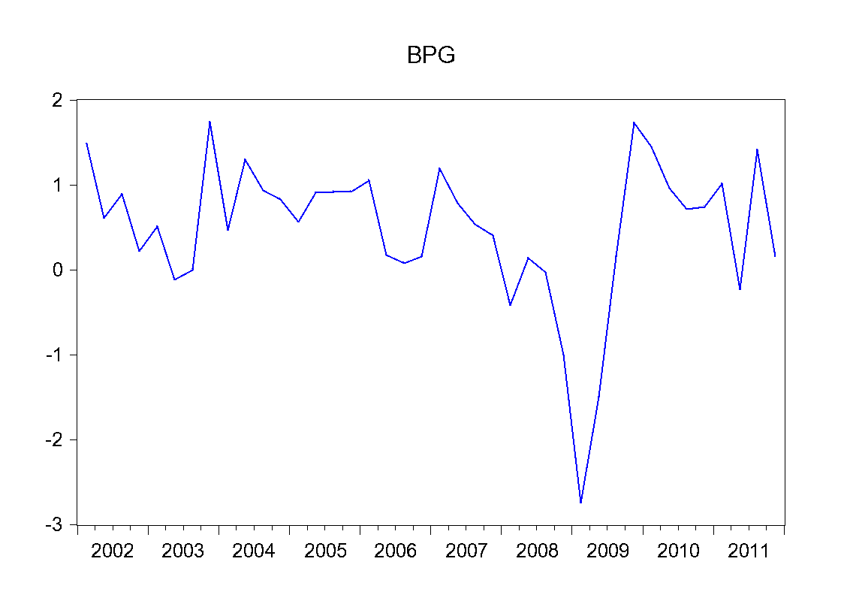
Graph 2
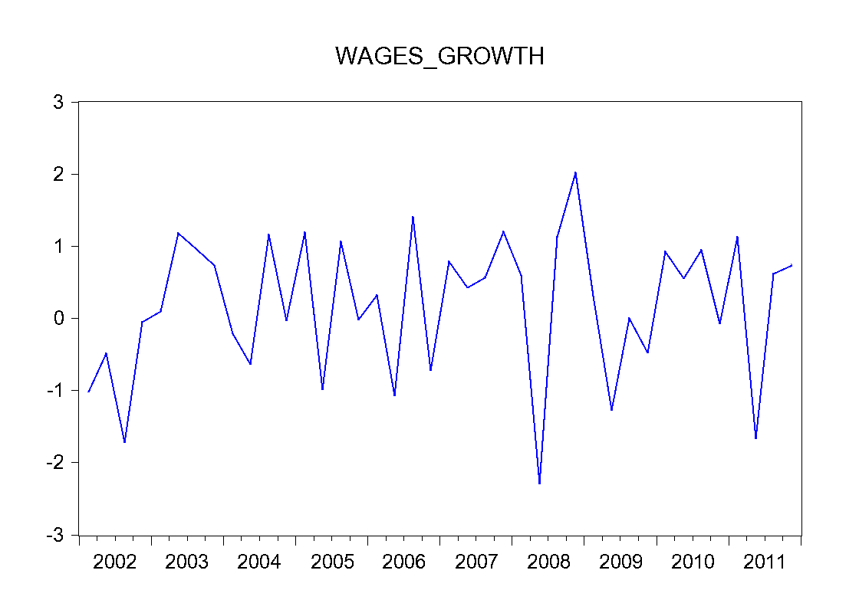
Graph 3

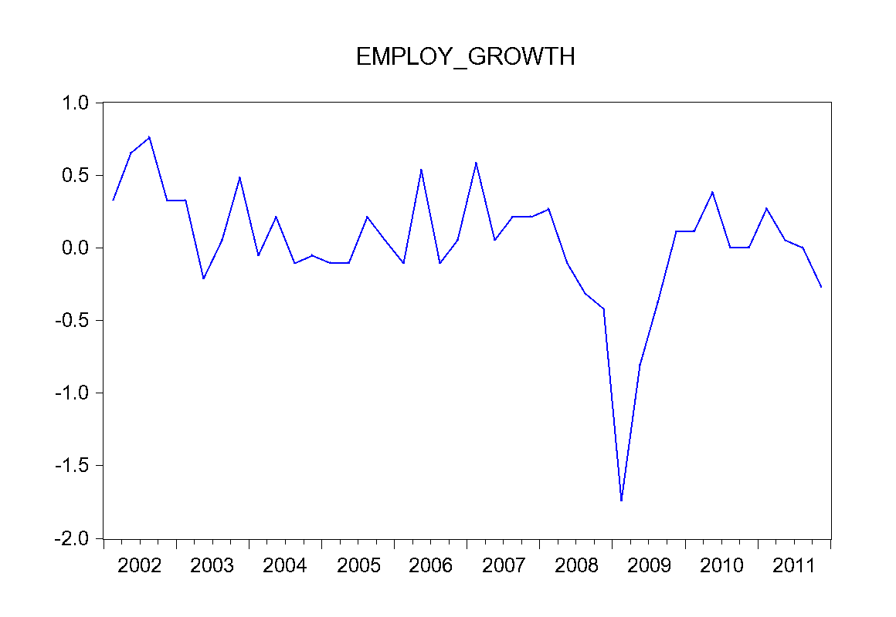

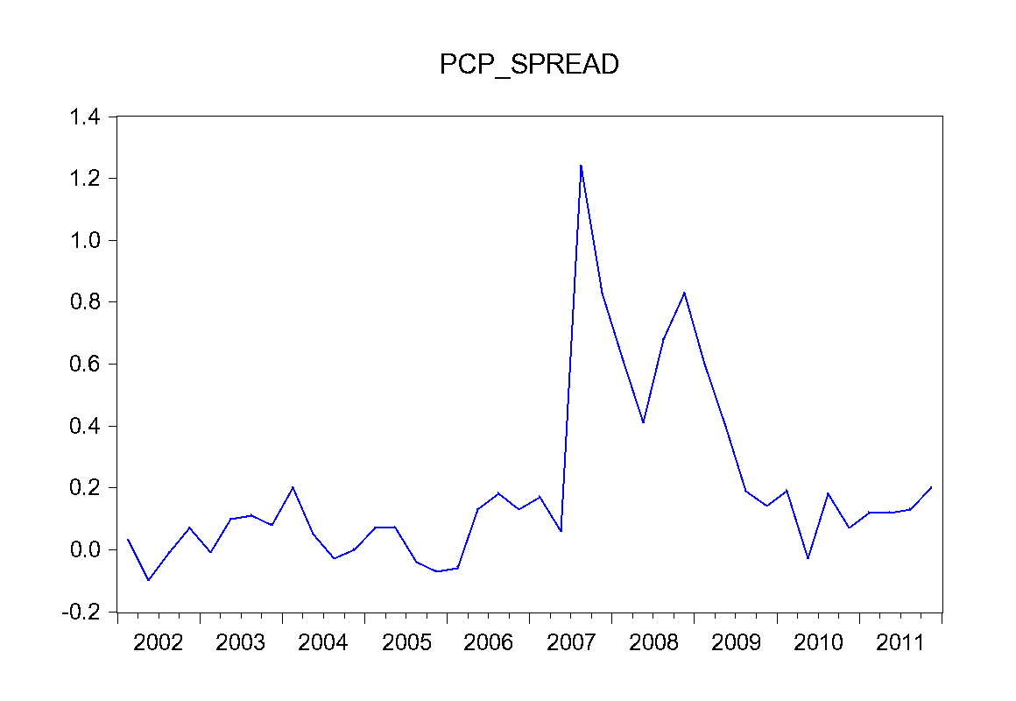
Graph 4

Graph 5
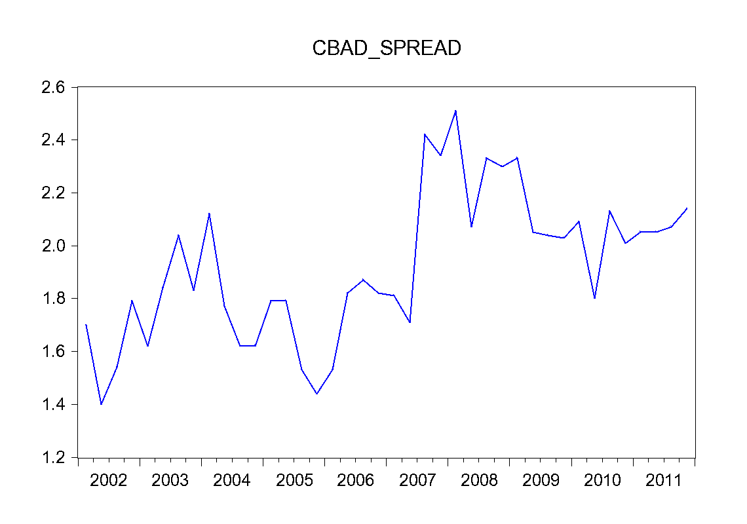
Graph 7
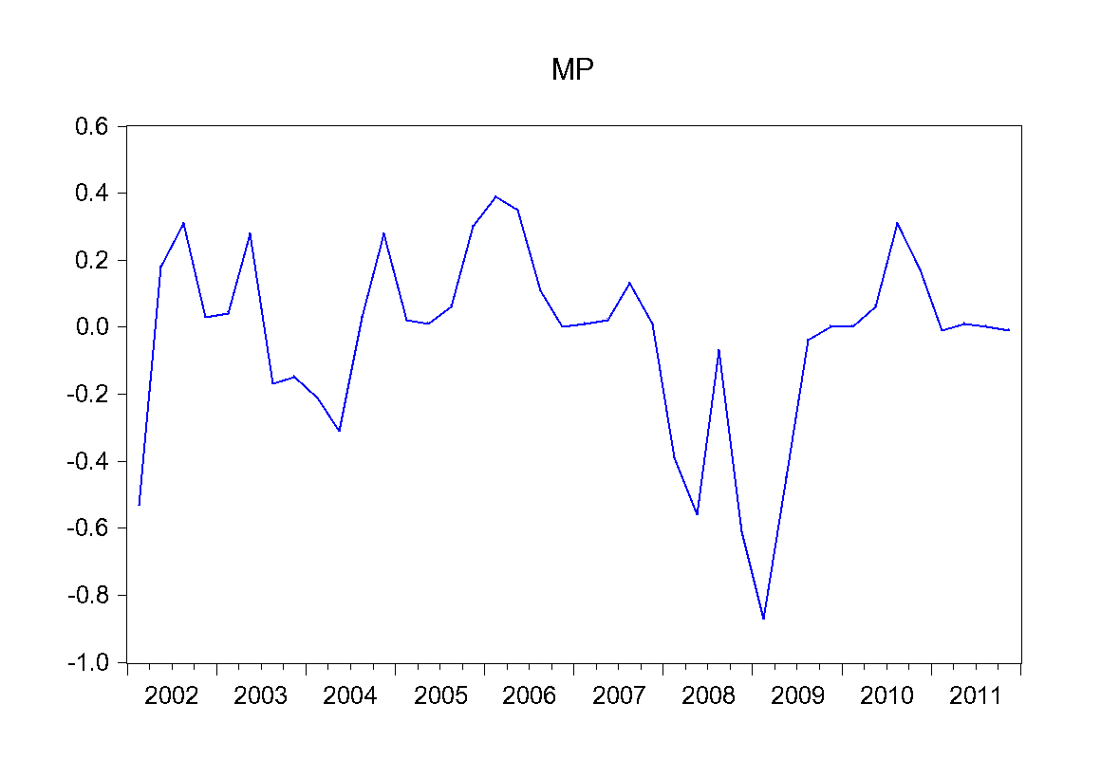

B.2 Dependent Variables
Graph 7
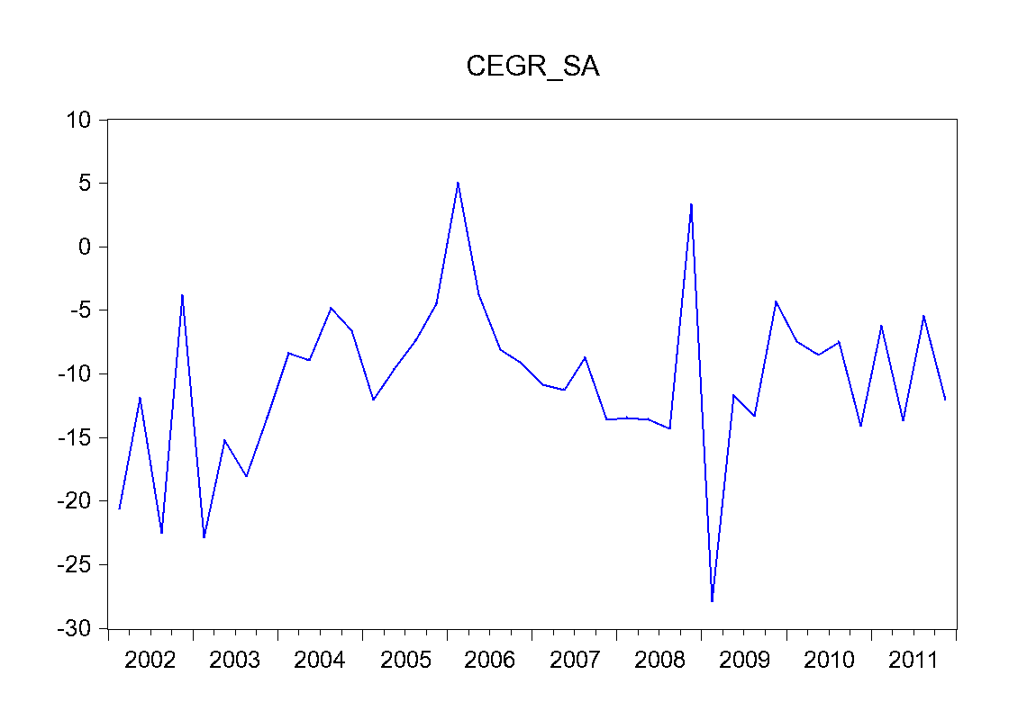
Graph 8
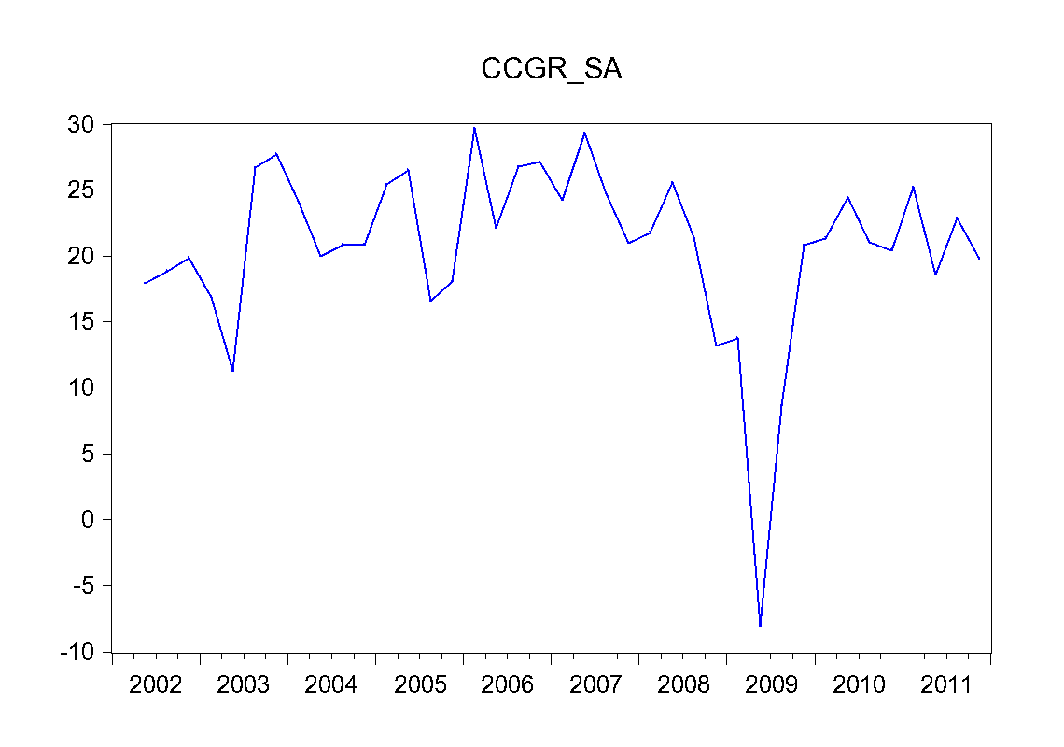

C Unit Root Test Outputs

C.1 Independent Variables

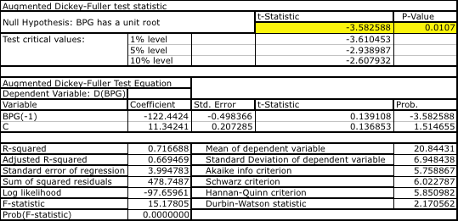
Table 1

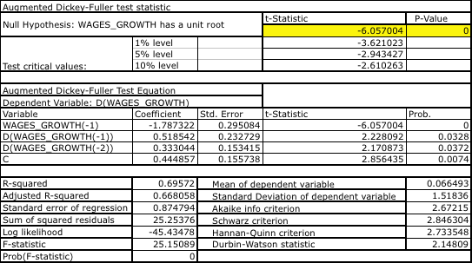
Table 2

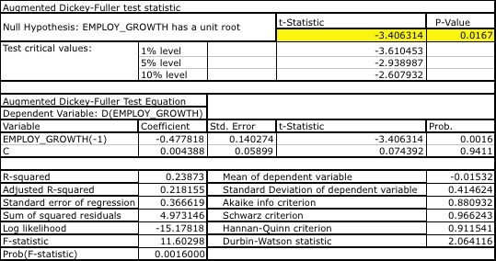
Table 3

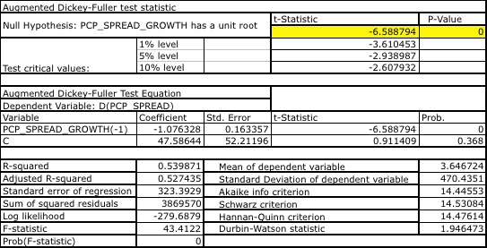
Table 4

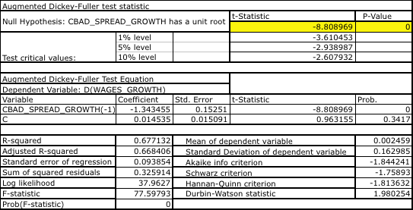
Table 5
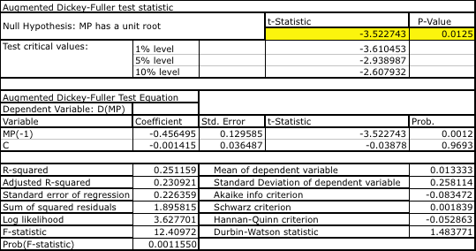
Table 6

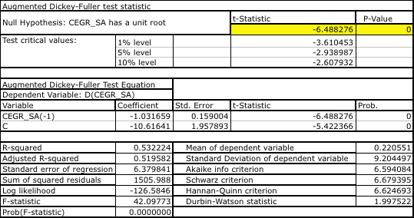
C.2 Dependent Variables
Table 7

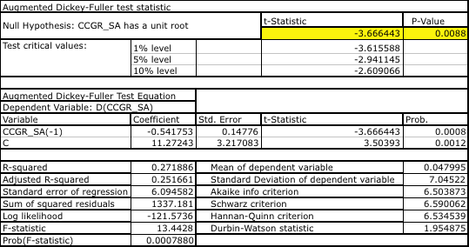
Table 8

D Regression Output Tables

D.1 Operation Earnings Growth Model Regression
Table 9

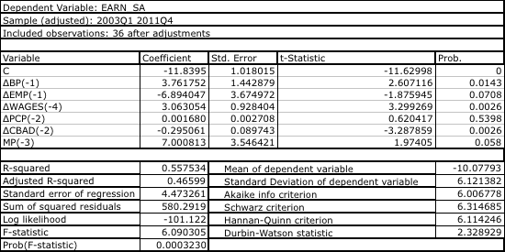
D.2 Capital Expenditure Growth Model Regression

Table 10
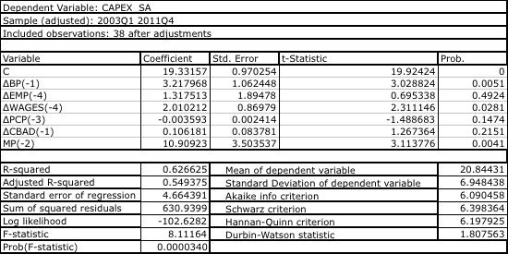

All proxies of Almeida, Campello and Weisbach’s indexes defined financially constrained firms consistently except for the KZ index.
Usually, the convention is to use the top (and bottom) 1/3, 30% or top 3 decentile to dichotomize firms using an index. Although the middle 40% of firms are ignored, this method helps create a clear polar dichotomization in the data behavior between the two groups of firms.
The use of cash flow sensitivities to identify constrained firms is advocated by Kaplan and Zingales, as well as by Fazzari and Athey.
The ESS_{k} is a measure of the intra-cluster variance.
A dendograph is a tree diagram that illustrates cluster formation.
The method was originally proposed by Aigner, Lovell, and Schmidt as well as by Meeusen and van den Broeck.
The first composite index includes the KZ-index, size, coverage ratio and dividend-payout ratio. The second includes the coverage ratio, dividend-payout ratio, commercial paper rating, and bond rating.
Given that the regression is conducted on the constrained portfolio’s median real earnings growth and meadian real capital expenditure growth, the dependent variable has only one observation per year for the earnings model and the capital expenditure model. This regression equation is a single observation panel data, which is equivalent to time series OLS.
The tobin’s q indicates the market’s belief of an asset’s value. Assuming the rationality of market prices, it can be used as a proxy to indicate good capital investment segments.
Lag summation variables are the sum of the value of the contemporaneous variables and three of their lags. Lag summation variables were included in the regression model for all of the aforementioned MACRO variables.
Both these datasets were acquired through the student library database access from the University of Ottawa. Note that CANSIM dataset codes can be found in part A of the appendix.
Unfortunately, data availability issues prevented from obtaining a larger sample.
The consequence of running regressions on non-stationary data is the possibility of finding spurious correlation: finding a statistical relationship between variables that have no direct causal connection.
We have omitted the trend variable in the model because our regressions yielded statistically insignificant trend coefficients.
In other words, the dependent variables for each quarter are the median earnings growth and capital expenditure growth from the portfolio of firms having market capitalization in the lowest 30%.
Real wages were acquired by discounting by the Canadian consumer price index.
The SA above the earnings variable indicates that it is seasonally adjusted.

